Latest Round-ups:
#30
Season 2021/22
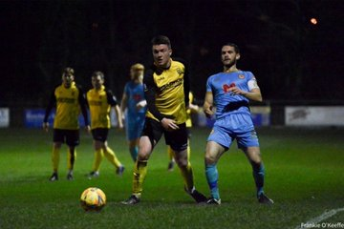
Les Phillips Cup: It was a big week of action on Tuesday and Wednesday, with plenty of goals and drama in the seven ties which took place. Wincanton were one of the sides to progress, with three different scorers helping them come from behind to beat Cheddar 3-1. After Ethan Reed’s deflected effort had put the visitors in front during the early stages, the Wasps hit back through Connor Williams, Tom Richardson and Cam Vere to send them through to the next round. The other game that evening was a tight affair involving two Premier Division sides, with Helston going through at the expense of Mousehole following a penalty shootout. Matt Wright’s lobbed finish had put Helston ahead after just four minutes, before a left-footed free kick was driven into the back of the net by Louis Price just prior to the interval to draw Mousehole level. It remained 1-1 throughout the second half, and with spot kicks the deciding factor, Mike Searle proved to be Helston’s hero, saving two penalties on their way to a 4-1 victory in the shootout. 24 hours later, Ali Boyer was the star of the shot for Cadbury Heath, scoring all three of his sides goals in their triumph over Odd Down. There was also a 3-0 win for Bitton away at Bishops Lydeard, with Matt Groves, Dean Griffiths and Ben Withey all getting their name on the scoresheet. It was a strong night in general for the visiting sides, and another one of those to progress was Saltash after they defeated Buckland 4-2 at Homers Heath (pictured below, courtesy of Frankie O’Keefe). Rubin Wilson struck in either half for the victorious Ashes, with Sam Hughes and Dave Barker also finding the back of the net during their successful trip to Devon. An entertaining clash at Raleigh Grove ended in a 3-2 victory for Bridgwater, but they were forced to battle back from a half-time deficit to knock out First Division leaders Sherborne. The in-form Zebras led 2-1 at the interval thanks to goals from Anthony Herrin and Ollie Hebbard, but they were unable to maintain their advantage, with Sam Crumb scoring Bridgy’s winning goal 15 minutes from time. By far the highest scoring encounter of the First Round took place at Oldland, with the home side falling to a wild 6-4 defeat at the hands of Clevedon. Both halves of football ended 3-2 in the visitors favour, with Archie Ferris scoring twice in the opening stages of the second period to really break the game open in Clevedon’s favour. On Saturday afternoon, Tavistock eased through to the next round, with the Premier Division leaders defeating the bottom side Bridport 6-0. Liam Prynn shows no signs of slowing down this season, and he plundered another hat-trick during the victory, with Tallan Burns and Josh Grant joining him on the scoresheet at Langsford Park.

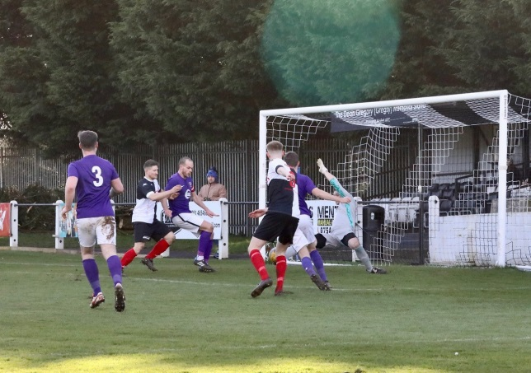
Premier Division: Alongside all of the league cup action, there was also a lone Premier Division fixture on Tuesday evening, with Keynsham running out 1-0 winners at home to Street. It was one of the usual suspects who scored the K’s crucial goal, with Will Hailston notching during the second half to help the hosts secure all three points. Heading into the weekend, and Bridgwater United made it three away wins on the bounce at Bitton, with a pair of second half goals from Jack Taylor leading them to a 2-0 victory. A half-volley from Taylor broke the deadlock five minutes after the interval, with the influential forward then adding his second from the spot late on after he had been hauled down in the opposition box. There was also a 2-0 win for Mousehole away at Brislington, in a repeat of the result from when these two sides met in January. Both goals came inside the opening half, with Louis Price and Mark Goldsworthy each finding the back of the net for the Cornish outfit. The comeback of the day belonged to Keynsham Town, with Will Hailston inspiring them to a 2-1 victory away at Saltash. After Sam Hughes had fired the Ashes in front at the beginning of the second half, the K’s started their fightback with their leading scorer Hailston grabbing the equaliser. Then, less than three minutes later, Hailston produced an excellent finish to turn the game in Keynsham’s favour, and they hung on during the final 20 minutes to secure their fourth consecutive victory in all competitions. Buckland Athletic ended a long winless run, claiming their first three points since New Year’s Day thanks to a 2-0 victory away at Wellington. Josh Webber’s flying header set the Bucks on their way after 16 minutes, before another headed finish, this time from Ryan Bush, doubled the visitors advantage midway through the second half. Millbrook’s late smash and grab stunned hosts Shepton Mallet, with the visitors striking in stoppage time to secure a 1-1 draw in Somerset. Following 82 goalless minutes, Mallet looked to have claimed the win when Aaron Seviour slammed the ball home after some excellent play in the build-up from teammate Jacob Sloggett. The hosts were then afforded the opportunity to double their lead, only for Nick Hewlett to see his penalty rebound back off the post, and Millbrook took full advantage, levelling the scores three minutes into added time through Josh Toulson. The points were also shared in the fixture at Kellaway Park where Helston and Clevedon battled out a 1-1 draw. The home side made a dream start to the contest, and led after just three minutes when Craig Veal tucked home an early penalty. Veal then had to spend five minutes either side of the break covering between the sticks when Helston keeper Mike Searle was sent to the sin bin. Having survived that period when they were down a man, Helston then conceded soon after, with a spectacular volley from Mitch Osmond securing a point for the Seasiders just before the hour mark.
Action from Shepton/Millbrook via Haydn Jones
First Division: Leaders Sherborne overcame a late rally away at Wells City to maintain their seven-point lead atop the division. The high-scoring Zebras were at their fluent best during the opening half, and led by three at the interval thanks to goals from Declan Cornish, Alex Murphy and Ash Guppy. Then, with 15 minutes left on the clock, Wells got themselves a way back into the game when Charlie Moon managed to pull a goal back for the home side. Adam Wright reduced the deficit to just one a couple of moments later, but then with the pressure being applied further, Sherborne put the game to bed with Murphy scoring his second of the afternoon to wrap up the 4-2 win.
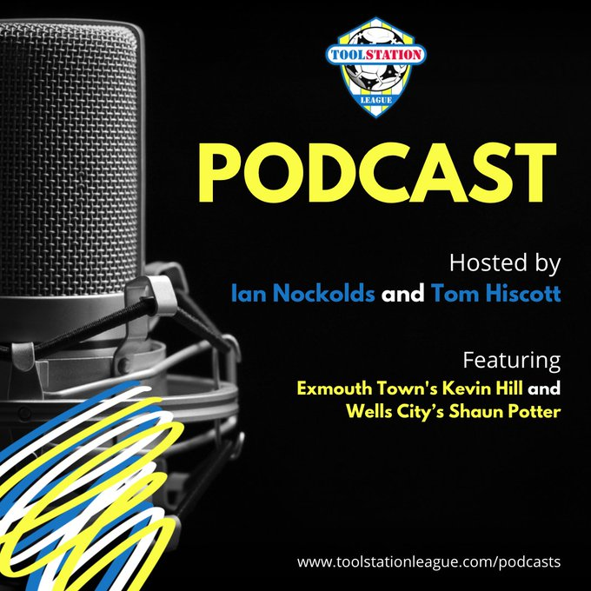
Second-placed Warminster were forced to come from behind in their 2-1 win over Cheddar, with skipper Ian Jeffery proving to be the difference between the two sides. Having trailed since the fifth minute, when Fin Biggs had fired Cheddar in front, the home side were awarded a penalty as the game headed into the final 20 minutes, with Jeffery converting his spot kick to make it 1-1. Then, less than five minutes later, Jeffery doubled his tally to take Warminster’s impressive winning streak into double figures. Welton Rovers survived a red card before scoring a late winner to edge to a 2-1 victory away at Boco. Having gone in front after 13 minutes through Toby Cole, everything seemed to unravel for Welton early in the second half, with Lewis Hunt booked twice in quick succession, just moments after the hosts had drawn level. The Green Army regrouped, and then ten-men managed to claim a late winner when Courtney Charles rose highest to head home Cam Allen’s corner. Fourth spot in the division now belongs to Wincanton Town after they registered a 3-1 win away at Odd Down. After goals from Dan Wise and Tom Richardson had put the Wasps in command, Luke Bryan halved the deficit for the Bath side on the hour mark. Wise was the hero on the day for Wincanton, and his second set piece goal of the day proved crucial, restoring his side’s two-goal advantage 15 minutes from time. The day’s early kickoff was an entertaining affair, with Bristol Telephones rescuing a half-time deficit to draw 3-3 with Longwell Green Sports. Zac Feltham claimed a brace for the visitors who moved into a 2-1 lead at the end of the first half, but the Phones battled back to grab a share of the points, with new signing Jack Creaney scoring a double of his own to make an instant impact for this new side. Tytherington and Hengrove also ended the weekend with one point apiece after drawing 0-0, while Bishop Sutton did well to claim a 2-2 draw at home to bottom side Devizes considering they were reduced to eight-men at Lakeview in a game littered with red, yellow and orange cards. A strong showing from Lebeq’s front-line saw them defeat Bishops Lydeard 5-1 to jump up a couple of spots into seventh. From the moment Josh Williams converted his 30th minute spot kick, Lebeq kicked into overdrive, with Neikell Plummer and Williams again striking soon after to make it 3-0 in no time at all. Paulo Borges pulled a goal back for the away side in first half stoppage time, but Lebeq ran away with the game in the closing stages with Jennison Williams notching a late brace. Another side who scored a big win were Oldland Abbotonians, with a strong second half showing helping them beat Gillingham Town 4-1. The opening goal was worth the wait, with Jake Reader firing into the bottom corner following a strong surging run from teammate Andy Nash. Reader then nodded home an Aaron Mansfield set piece to double the lead, before Nash and Cash Vinall added further gloss to the scoreline in the final 20 minutes. Portishead Town leapfrogged opponents Almondsbury in the league table after surging to a comfortable 4-1 win at Bristol Road.
Exmouth boss Kevin Hill joins the podcast this week, and starts by congratulating volunteers at the club who worked hard to get last Saturday’s game on. Hill also looks ahead to what could be a historic season for Town, while Wells City manager Shaun Potter comments on why his charges always seem to turn up against the better sides in the First Division.
http://toolstationleague.com/season-2021-22-podcast-episode-30/

Recent Results
Tuesday 22nd February 2022
Les Phillips Cup
Helston Athletic 1-1 Mousehole
Wincanton Town 3-1 Cheddar
Premier Division
Keynsham Town 1-0 Street 131

Wednesday 23rd February 2022
Les Phillips Cup
Bishops Lydeard 0-3 Bitton
Buckland Athletic 2-4 Saltash United 100
Cadbury Heath 3-0 Odd Down
Oldland Abbotonians 4-6 Clevedon Town
Sherborne Town 2-3 Bridgwater United

Saturday 26th February 2022
Premier Division
Bitton 0-2 Bridgwater United 92
Brislington 0-2 Mousehole 178
Helston Athletic 1-1 Clevedon Town
Saltash United 1-2 Keynsham Town 93
Shepton Mallet 1-1 Millbrook
Wellington 0-2 Buckland Athletic 87
First Division
AEK Boco 1-2 Welton Rovers
Bishop Sutton 2-2 Devizes Town 39
Bristol Telephones 3-3 Longwell Green Sports 25
Lebeq United 5-1 Bishops Lydeard
Odd Down 1-3 Wincanton Town 50
Oldland Abbotonians 4-1 Gillingham Town
Portishead Town 4-1 Almondsbury 41
Tytherington Rocks 0-0 Hengrove Athletic
Warminster Town 2-1 Cheddar 144
Wells City 2-4 Sherborne Town
Les Phillips Cup
Tavistock 6-0 Bridport

Leading Goalscorers (Stats courtesy of FA Fulltime Website)
All Competitions
Liam Prynn (Tavistock) – 36
Jack Taylor (Bridgwater) – 30
Luke Bryan (Odd Down) – 29
Oaklan Buck (Bishop Sutton) – 27
Jordan Harris (Exmouth) – 25
Will Hailston (Keynsham) – 25
Adam Wright (Wells) - 23
Rikki Sheppard (Millbrook) -22

Premier Division
Liam Prynn (Tavistock) – 30
Jack Taylor (Bridgwater) – 26
Jordan Harris (Exmouth) – 24
Will Hailston (Keynsham) – 20
Dean Griffiths (Bitton) – 18
Rikki Sheppard (Millbrook) -17

First Division
Luke Bryan (Odd Down) -28
Oaklan Buck (Bishop Sutton) -27
Adam Wright (Wells) -23
Bailey Croome (Tytherington) -20
Alex Murphy (Sherborne) - 19

Upcoming Fixtures
Tuesday 1st March 2022
Les Phillips Cup
Ashton & Backwell United vs Portishead Town 19:30KO
Hengrove Athletic vs Keynsham Town 19:30KO
Radstock Town vs Gillingham Town 19:30KO
Welton Rovers vs Wincanton Town 19:30KO
First Division
Tytherington Rocks vs Bristol Telephones 19:30KO

Wednesday 2nd March 2022
Premier Division
Street vs Saltash United 19:45KO
Les Phillips Cup
Warminster Town vs Lebeq United 19:45KO

Saturday 5th March 2022 (3pm kick-off unless noted)
Premier Division
Ashton & Backwell United vs Tavistock
Bridport vs Brislington
Buckland Athletic vs Saltash United
Cadbury Heath vs Bitton
Clevedon Town vs Helston Athletic
Keynsham Town vs Bridgwater United
Mousehole vs Ilfracombe Town
Shepton Mallet vs Street
Wellington vs Exmouth Town
First Division
AEK Boco vs Warminster Town
Almondsbury vs Cheddar
Bishops Lydeard vs Sherborne Town
Bristol Telephones vs Wincanton Town
Devizes Town vs Wells City
Gillingham Town vs Bishop Sutton
Longwell Green Sports vs Lebeq United
Radstock Town vs Portishead Town
Tytherington Rocks vs Odd Down
Welton Rovers vs Oldland Abbotonians
Emergency Fund for recent Storm Damage
We are aware that some clubs may have been impacted and suffered damage to their grounds, especially last Friday with storm Eunice.
The Football Stadia Improvement Fund, thanks to the support from the Premier League, are able to provide some financial assistance to clubs, for works not covered by Club’s insurance, through an emergency relief fund.
If any club is seeking support, please read the PDF document attached here which provides information on what is available to be funded and how to progress any request.

League Tables
 | PREMIER DIVISION | Played | Won | Drawn | Lost | GD | Points
1 | Tavistock | 27 | 18 | 6 | 3 | 44 | 60
2 | Exmouth Town | 26 | 16 | 5 | 5 | 40 | 53
3 | Mousehole | 24 | 16 | 3 | 5 | 31 | 51
4 | Bridgwater United | 27 | 15 | 3 | 9 | 25 | 48
5 | Helston Athletic | 25 | 12 | 8 | 5 | 19 | 44
6 | Ilfracombe Town | 26 | 13 | 5 | 8 | 13 | 44
7 | Keynsham Town | 28 | 12 | 8 | 8 | 12 | 44
8 | Bitton | 27 | 13 | 5 | 9 | 10 | 44
9 | Shepton Mallet | 28 | 11 | 8 | 9 | 27 | 41
10 | Saltash United | 25 | 12 | 5 | 8 | 25 | 41
11 | Clevedon Town | 28 | 10 | 11 | 7 | 13 | 41
12 | Buckland Athletic | 26 | 11 | 6 | 9 | 12 | 39
13 | Millbrook | 27 | 10 | 8 | 9 | 10 | 38
14 | Wellington | 26 | 7 | 7 | 12 | -15 | 28
15 | Brislington | 26 | 8 | 3 | 15 | -39 | 27
16 | Cadbury Heath | 28 | 7 | 2 | 19 | -34 | 23
17 | Street | 25 | 6 | 3 | 16 | -23 | 21
18 | Ashton & Backwell United | 26 | 4 | 4 | 18 | -33 | 16
19 | Bridport | 29 | 1 | 0 | 28 | -137 | 3

 | FIRST DIVISION | Played | Won | Drawn | Lost | GD | Points
1 | Sherborne Town | 31 | 22 | 6 | 3 | 65 | 72
2 | Warminster Town | 29 | 20 | 5 | 4 | 37 | 65
3 | Welton Rovers | 29 | 19 | 6 | 4 | 35 | 63
4 | Wincanton Town | 27 | 16 | 5 | 6 | 43 | 53
5 | Radstock Town | 30 | 15 | 7 | 8 | 6 | 52
6 | Odd Down | 31 | 13 | 7 | 11 | 7 | 46
7 | Lebeq United | 30 | 11 | 8 | 11 | 4 | 41
8 | Cheddar | 30 | 11 | 8 | 11 | 2 | 41
9 | Oldland Abbotonians | 27 | 13 | 2 | 12 | 0 | 41
10 | Wells City | 30 | 10 | 10 | 10 | 5 | 40
11 | Bishop Sutton | 31 | 11 | 7 | 13 | 1 | 40
12 | Tytherington Rocks | 31 | 10 | 9 | 12 | -11 | 39
13 | AEK Boco | 28 | 10 | 8 | 10 | -3 | 38
14 | Hengrove Athletic | 32 | 10 | 8 | 14 | -13 | 38
15 | Longwell Green Sports | 31 | 9 | 8 | 14 | -13 | 35
16 | Portishead Town | 29 | 11 | 4 | 14 | -1 | 34*
17 | Gillingham Town | 32 | 8 | 9 | 15 | -14 | 33
18 | Almondsbury | 29 | 10 | 2 | 17 | -22 | 32
19 | Bristol Telephones | 28 | 7 | 4 | 17 | -34 | 25
20 | Bishops Lydeard | 28 | 5 | 6 | 17 | -27 | 21
21 | Devizes Town | 29 | 4 | 3 | 22 | -67 | 12*

