Latest Round-ups:
#27
Season 2021/22
Midweek Action: Clevedon Town were the big winners on Tuesday in the Premier Division, scoring an impressive 2-1 victory away at Bridgwater. In front of a large crowd of 333, Alex Camm proved to be the difference maker for Clevedon, putting them ahead after half an hour with a cool finish. That lead didn’t last long however, and with half time on the horizon, the home side levelled through top scorer Jack Taylor. It was then left to Camm to help Town come away with the points, and not long after they had conceded, Archie Ferris laid the ball off for Camm who fired home to make it 2-1. In the other game that night, Ilfracombe and Saltash shared the points following a tight tussle which ended one apiece. Both goals came within five minutes of one another, and it was Saltash who managed to find the quick answer, scoring through Scott Crocker in the 70th minute, just a couple of moments after Jack Jenkins had broken the deadlock for the hosts.

There was plenty of late drama in the First Division, including in the fixture at Lakeview, where Hengrove pulled off an almighty comeback to beat Bishop Sutton 4-3. Having taken the lead through Danny Dodimead, Hengrove were quickly on the back foot, conceding three goals in the space of 15 minutes either side of the interval to Mason Dagger, Craig Wilson and Keith Kearney. Suddenly finding themselves 3-1 down, the away side struck twice in quick succession through Luke Crewe and Luco Ponsillo to level affairs with 20 minutes remaining. Then, deep into stoppage time, the visitors managed to steal all three points when Dodimead completed his brace. Welton were another side to produce a late winner, securing a much-needed victory over Odd Down at West Clewes. Having stumbled of late, Welton looked to have found a response, leading 2-0 thanks to Will Gould and a Saracen Yates own goal. The away side had other ideas however, and they managed to draw level just after the hour mark thanks to a couple of goals from Caelen Simpson and Curtis Dunn. That left the game in the balance, but then with only one minute of normal time remaining, Gould smashed home his second of the night to secure the win. Things were much simpler for Wells City, with Adam Wright and Charlie Crook both scoring hat-tricks in their 9-0 thumping of Bristol Telephones. The other game that evening saw substitute Sam Beresford equalise for Cheddar in their 2-2 draw at home to Bishops Lydeard, after goals from Paulo Borges and Jordan Hayman had put the Lyds in position for a rare away victory. 24 hours later, Ryan Sharpe’s brace, and another effort from top scorer Bailey Croome helped fire Tytherington to a 4-1 win at home to Radstock in the biggest surprise result of the midweek schedule.

Both Les Phillips Cup ties saw the home teams prevailing on Wednesday evening, with a double from substitute Levi Landricombe helping lead Exmouth to a 3-0 win over Wellington. The other game went the way of Helston Athletic, after both Jordan Bentley and Orlando Anker scored their first goals for the club in a 2-1 defeat of Millbrook.

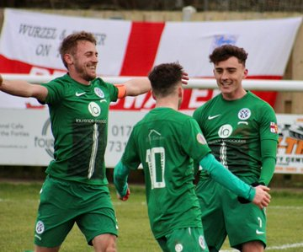
Premier Division: In a stunner at Springfield, debutant Ali Boyer made an unbelievable impact for Cadbury Heath, scoring a hat-trick in their 3-2 win over second-placed Exmouth. The visitors were unbeaten in eight matches heading into Saturday’s game, and after taking the lead inside the opening minute through Aaron Denny, few would have predicted what was to unfold. Boyer’s first goal of the afternoon came soon after Denny’s opener, but the Heath weren’t level for all that long, with Nathan Cooper striking midway through the first half to put the Devonians back in front. A second goal from Boyer soon after the interval set up an exciting second half, and it was the man on debut who struck again on the hour mark to cap a perfect performance. Exmouth weren’t the only top side to fall on Saturday, with fifth-placed Ilfracombe suffering a 3-1 defeat away at Clevedon. Cam Salmon had an excellent first half for the hosts, and after supplying the assist for Callum Eastwood’s opener, Salmon then whipped in a corner which Archie Ferris headed home to double the advantage. Ilfracombe grabbed a lifeline in added time at the end of the first half when Jack Langford scored with a header of his own, but they fell short in their comeback attempt with Mitch Osmond volleying home Clevedon’s third 15 minutes from time. Mousehole were the main beneficiary of those two results, and they have now won nine of their last ten league fixtures after putting Bridgwater to the sword at Trungle Parc (pictured left). After Mark Goldsworthy had fired them into a tenth minute lead, the Seagulls doubled their tally from the spot through Hayden Turner following a handball in the box. Turner’s second penalty of the afternoon made it 3-0 midway through the second half, with Tallan Mitchell adding his name to the scoresheet soon after. It was Jared Sims who added a fifth for the rampant hosts, before Bridgwater managed to claim a late consolation when George King struck with the final attack of the afternoon. There was much less jeopardy in the fixture at Bridport, where the bottom side conceded nine unanswered goals to Saltash. Sam Hughes and Scott Crocker each grabbed doubles for the away side, with Rubin Wilson scoring the goal of the day to make it 9-0 as time expired.

There was late drama in the highly-anticipated derby clash between Street and Shepton Mallet, where the away side claimed an injury time winner to complete their 2-1 comeback victory. Having fallen behind early in the second half to Harry Foster’s smart finish, Mallet got back on level terms ten minutes later when Joe Morgan smashed the ball into the back of the hosts net. Then, with the points looking destined to be shared, Mallet skipper Andy Martin nodded the ball home to spark joyous scenes for the away side and their travelling support. Helston were another away side who could celebrate a late victory, after they edged out Brislington by one goal to nil. After scoring from the bench in their midweek cup win, Helston’s Orlando Anker repeated the trick in Bristol, grabbing the only goal of the game nine minutes from time to secure full points.

In similar fashion, Wellington left it until the final moments before they secured a 1-0 win over Keynsham, with Jason Quick sending over a cross which was headed home by his twin brother Miles to snatch all the points. Millbrook brought an end to their four-match winless run by beating Ashton & Backwell United by three goals to two. Ashton twice cancelled out goals from Josh Toulson to leave the game evenly poised going into the final 20 minutes, but then in the final moments, substitute Charlie Knight popped up to score a vital winner for the visitors. Meanwhile in South Gloucestershire, Substitute Charlie Johansen salvaged a point for Buckland, striking midway through the second half to deny Bitton who had led since the 24th minute when Dean Griffiths had popped up to break the deadlock.

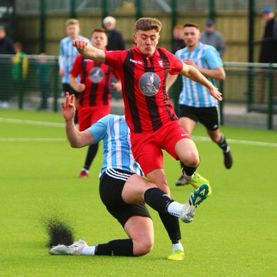
First Division: Unlike the Premier Division, those in the upper reaches of the First all enjoyed big wins, with the top four winning their matches by an aggregate of 19-4 against their overrun opponents. Table-toppers Sherborne show no signs of letting up, and are now unbeaten in 12 league fixtures after beating Oldland 4-0 at the Aitchison Playing Field. The opening goal came 24 minutes in, with Alex Murphy continuing his excellent run in front of goal to put the Zebras a goal to the good. Aaron White then doubled their lead eight minutes before the break, with Declan Cornish scoring either side of the interval to complete the victory. Welton Rovers are starting to find their footing again, and after a poor spell, they showed no mercy to hosts Gillingham, recording a 6-0 victory away from home. A dominant first half showing was behind Welton’s big win, and once Toby Cole had put them in front after 16 minutes, they continued to push forward, with Ben Wych doubling their advantage soon after. Cole struck again to make it 3-0 inside half an hour, and Chris Pile then brought down the curtain on a strong 45-minute spell when he grabbed a fourth for the away side. Despite losing keeper Joel Manning to a red card early in the second half, Welton managed to maintain their clean sheet, and their hard work was rewarded in stoppage time when Cam Allen twice beat the offside trap to complete the six-goal rout. Warminster Town were forced to do it the hard way, overturning a half-time deficit on their way to a 4-1 victory away at Longwell Green Sports. Having trailed since the 20th minute, Warminster made an ideal start to the second half, levelling through Core Gardner, before Conner McKay then completed the turnaround on the hour mark. Town stretched their unbeaten run in all competitions to 15 following this result, and they finished with a flourish thanks to a couple of late goals scored by Eben Mortimer-Taylor and sub James Vincent.
Action from Warminster’s 4-1 win over Longwell Green, courtesy of Jamie House (@Jimmer211993).

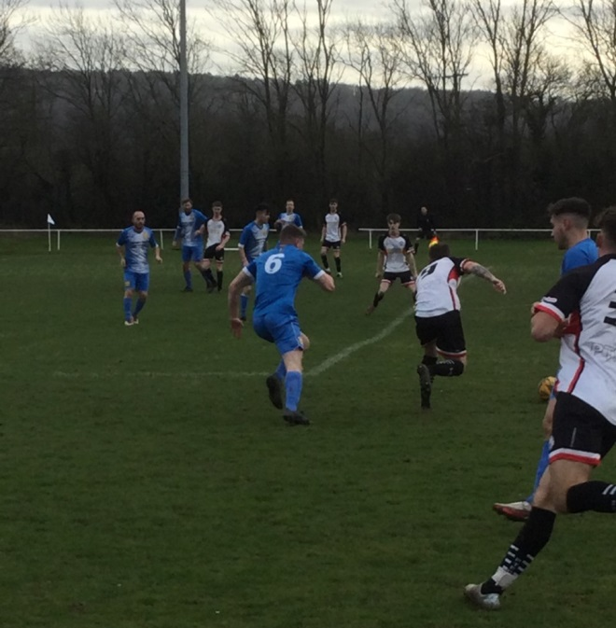
Fourth-placed Wincanton were involved in a seven-goal thriller in the day’s early kickoff, just about coming out on top at home to Lebeq United. A brace from Matt Garner, plus further goals from Connor Williams and Louis Irwin did the damage for the Wasps, but United forward Sacha Tong can feel unlucky to have been on the losing side after he claimed a terrific second half hat-trick. Tytherington ended their dream week with nine points from nine, after they scored twice in the final 20 minutes to complete a 3-1 win away at Hengrove. Following victories over Longwell Green and Radstock, a confident Rocks outfit started on the front foot at Hengrove, taking the lead after 28 minutes through Max Wilding. They were then hit by a sucker-punch at the end of the first half however, and headed into the second half all square after conceding to Jack Cousins in added time. Top scorer Bailey Croome is enjoying an excellent campaign, and after his direct free kick found the back of the net 20 minutes from time, Tytherington then pushed on to secure all three points when Ryan Sharpe came off the bench to extend their lead. Odd Down were denied at the death on their away day at Wells, conceding deep into stoppage time in a 1-1 draw at the Athletic Ground. After Luke Bryan had headed them in front after 65 minutes, they looked set to complete the double over Wells, but the hosts had other ideas, with Craig Herrod levelling affairs in the 97th minute. Almondsbury produced a strong fightback, scoring a pair of unanswered second half goals to beat Bishops Lydeard 2-1, while the fixtures between Bristol Telephones and Bishop Sutton, and also Portishead and Cheddar (pictured left, via John Pool) both finished goalless.

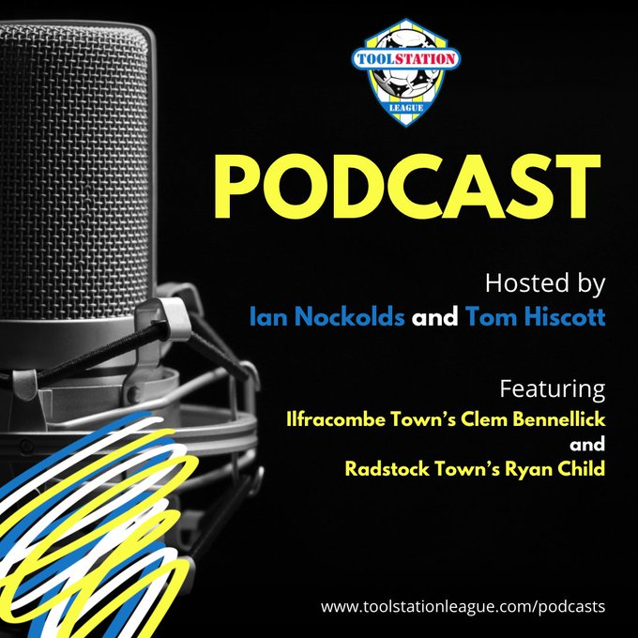
On the latest episode, Ilfracombe gaffer Clem Bennellick explains why it is important his side play with a smile on their faces. We also hear from Ryan Child of Radstock, who discusses the promotion battle in the First Division, including why he believes a potential play-off to decide who goes up could be brilliant for the Western League.
http://toolstationleague.com/season-2021-22-podcast-episode-27/

Recent Results
Tuesday 1st February 2022
Premier Division
Bridgwater United 1-2 Clevedon Town 333
Ilfracombe Town 1-1 Saltash United 115
First Division
Bishop Sutton 3-4 Hengrove Athletic 92
Cheddar 2-2 Bishops Lydeard 52
Wells City 9-0 Bristol Telephones
Welton Rovers 3-2 Odd Down 178

Wednesday 2nd February 2022
Les Phillips Cup
Exmouth Town 3-0 Wellington 202
Helston Athletic 2-1 Millbrook 167
First Division
Tytherington Rocks 4-1 Radstock Town

Saturday 5th February 2022
Premier Division
Ashton & Backwell United 2-3 Millbrook 98
Bitton 1-1 Buckland Athletic
Bridport 0-9 Saltash United 85
Brislington 0-1 Helston Athletic 122
Cadbury Heath 3-2 Exmouth Town 72
Clevedon Town 3-1 Ilfracombe Town
Mousehole 5-1 Bridgwater United
Street 1-2 Shepton Mallet
Wellington 1-0 Keynsham Town 65
First Division
Bishops Lydeard 1-2 Almondsbury 48
Bristol Telephones 0-0 Bishop Sutton 45
Gillingham Town 0-6 Welton Rovers 70
Hengrove Athletic 1-3 Tytherington Rocks 61
Longwell Green Sports 1-4 Warminster Town 207
Oldland Abbotonians 0-4 Sherborne Town 42
Portishead Town 0-0 Cheddar 45
Wells City 1-1 Odd Down
Wincanton Town 4-3 Lebeq United 63

Leading Goalscorers (Stats courtesy of FA Fulltime Website)
Premier Division
Liam Prynn (Tavistock) – 29
Dean Griffiths (Bitton) – 25
Jordan Harris (Exmouth) – 24
Jack Taylor (Bridgwater) – 21
Rikki Sheppard (Millbrook) -17

First Division
Oaklan Buck (Bishop Sutton) -23
Luke Bryan (Odd Down) -23
Craig Sheppard (Radstock) – 22
Toby Cole (Wincanton/Welton) -22
Adam Wright (Wells) - 21

All Competitions
Liam Prynn (Tavistock) – 32
Dean Griffiths (Bitton) – 27
Jordan Harris (Exmouth) – 26
Jack Taylor (Bridgwater) – 25
Oaklan Buck (Bishop Sutton) – 23
Luke Bryan (Odd Down) – 23
Rikki Sheppard (Millbrook) – 22

Upcoming Fixtures
Tuesday 8th February 2022
Les Phillips Cup
AEK Boco vs Almondsbury 19:30KO
Keynsham Town vs Wells City 19:45KO
Wincanton Town vs Cheddar 19:30KO

Wednesday 9th February 2022
Les Phillips Cup
Cadbury Heath vs Longwell Green Sports 19:30KO
First Division
Radstock Town vs Bishops Lydeard 19:45KO
Sherborne Town vs Devizes Town 19:30KO

Saturday 12th February 2022 (3pm kick-off unless noted)
Premier Division
Ashton & Backwell United vs Bridgwater United
Bitton vs Wellington
Clevedon Town vs Mousehole
Exmouth Town vs Shepton Mallet
Helston Athletic vs Bridport
Ilfracombe Town vs Street
Keynsham Town vs Millbrook
Saltash United vs Cadbury Heath
Tavistock vs Brislington
First Division
Bishops Lydeard vs Oldland Abbotonians
Cheddar vs AEK Boco
Devizes Town vs Lebeq United
Hengrove Athletic vs Radstock Town
Longwell Green Sports vs Odd Down
Sherborne Town vs Gillingham Town
Tytherington Rocks vs Bishop Sutton
Warminster Town vs Portishead Town
Welton Rovers vs Bristol Telephones
Wincanton Town vs Almondsbury
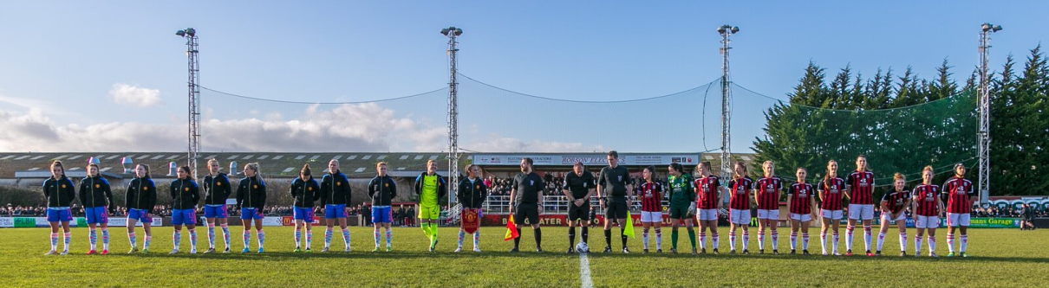

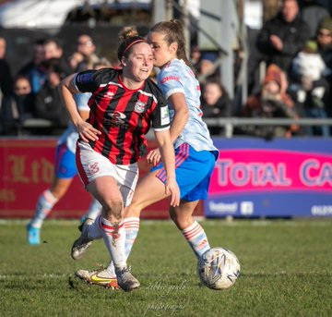
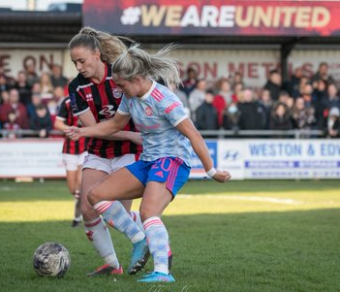
Last Sunday afternoon, Bridgwater United hosted Manchester United at Fairfax Park in the 4th round of the Women’s FA Cup on a famous afternoon for the club. Images courtesy of Debbie Gould.

Non-League Footballers Mental Health Championed by Bath Mind and the Toolstation Western League
The Toolstation Western League are working with Bath Mind to pilot a mental health partnership supporting the football family and players in particular. The six Western League sides located in Bath and North East Somerset have been offered specially created posters, promoting mental health support services designed to help younger people, which can be located into their home and away changing rooms.
Research conducted by the Toolstation Western League earlier this season highlighted that around a quarter of players had considered seeking help with a mental health issue. The subject of mental health was first tackled by the Western League in March 2020, when they launched their Think of a Fan campaign.
Chairman of the Western League, John Pool, explained: “Think of a Fan was our way of remembering that for many fans, football is more than just a game. It’s an important release, a chance to meet friends, get out of the house and have some fun.
Many people are still working through the loneliness and anxiety caused by lockdown, but we must not forget that our players are no different. They are as important to us as any members of our football family and this important partnership with Bath Mind is our way of supporting them.”
As well as changing room posters, Bath Mind have provided leaflets for fans, as well as programme adverts, highlighting the variety of support services they provide. If successful, this initial pilot will be extended by the Western League to cover all 40 Clubs across the South West of England, from Cornwall to Wiltshire.
Hannah Roper, Director of Business Development at Bath Mind, said: “We at Bath Mind are thrilled to be working in partnership with The Toolstation Western League, to support and promote positive mental health for the football community. Throughout the pandemic Bath Mind has been fighting an epidemic of mental ill-health. We have increased our services to meet the growing needs of our community, and help reduce pressure on NHS services. Through this pilot we hope to encourage everyone to talk about their mental health, seek help at an early stage and reduce the stigma associated with mental ill-health. As a local, independent charity, Bath Mind relies heavily on local fundraising to keep our services going, therefore we are grateful to The Toolstation Western League and their fans for their fundraising efforts.”

League Tables
 | PREMIER DIVISION | Played | Won | Drawn | Lost | GD | Points
1 | Tavistock | 26 | 17 | 6 | 3 | 41 | 57
2 | Exmouth Town | 24 | 14 | 5 | 5 | 38 | 47
3 | Mousehole | 22 | 15 | 2 | 5 | 29 | 47
4 | Ilfracombe Town | 25 | 13 | 5 | 7 | 15 | 44
5 | Bridgwater United | 25 | 13 | 3 | 9 | 20 | 42
6 | Bitton | 25 | 12 | 5 | 8 | 9 | 41
7 | Shepton Mallet | 25 | 11 | 7 | 7 | 29 | 40
8 | Helston Athletic | 23 | 11 | 7 | 5 | 13 | 40
9 | Saltash United | 23 | 11 | 5 | 7 | 23 | 38
10 | Millbrook | 25 | 10 | 7 | 8 | 16 | 37
11 | Clevedon Town | 25 | 9 | 9 | 7 | 12 | 36
12 | Buckland Athletic | 25 | 10 | 6 | 9 | 10 | 36
13 | Keynsham Town | 25 | 9 | 8 | 8 | 4 | 35
14 | Wellington | 23 | 7 | 7 | 9 | -9 | 28
15 | Brislington | 24 | 8 | 3 | 13 | -34 | 27
16 | Cadbury Heath | 27 | 7 | 2 | 18 | -31 | 23
17 | Street | 23 | 5 | 3 | 15 | -24 | 18
18 | Ashton & Backwell United | 25 | 4 | 4 | 17 | -30 | 16
19 | Bridport | 28 | 1 | 0 | 27 | -131 | 3

 | FIRST DIVISION | Played | Won | Drawn | Lost | GD | Points
1 | Sherborne Town | 27 | 18 | 6 | 3 | 52 | 60
2 | Welton Rovers | 28 | 18 | 6 | 4 | 34 | 60
3 | Warminster Town | 27 | 18 | 5 | 4 | 34 | 59
4 | Wincanton Town | 25 | 14 | 5 | 6 | 37 | 47
5 | Radstock Town | 28 | 13 | 7 | 8 | 3 | 46
6 | Odd Down | 29 | 12 | 7 | 10 | 4 | 43
7 | Cheddar | 28 | 11 | 7 | 10 | 3 | 40
8 | Tytherington Rocks | 28 | 10 | 8 | 10 | -4 | 38
9 | Wells City | 28 | 9 | 10 | 9 | 5 | 37
10 | AEK Boco | 26 | 10 | 7 | 9 | -2 | 37
11 | Bishop Sutton | 29 | 10 | 6 | 13 | -4 | 36
12 | Lebeq United | 28 | 9 | 8 | 11 | -1 | 35
13 | Oldland Abbotonians | 25 | 11 | 2 | 12 | -4 | 35
14 | Longwell Green Sports | 29 | 9 | 7 | 13 | -8 | 34
15 | Hengrove Athletic | 29 | 9 | 7 | 13 | -13 | 34
16 | Gillingham Town | 30 | 8 | 9 | 13 | -9 | 33
17 | Almondsbury | 26 | 10 | 2 | 14 | -13 | 32
18 | Portishead Town | 27 | 10 | 4 | 13 | -2 | 31*
19 | Bristol Telephones | 26 | 7 | 3 | 16 | -30 | 24
20 | Bishops Lydeard | 25 | 5 | 6 | 14 | -21 | 21
21 | Devizes Town | 26 | 4 | 2 | 20 | -61 | 11*

