Latest Round-ups:
Season 2021/22
#22
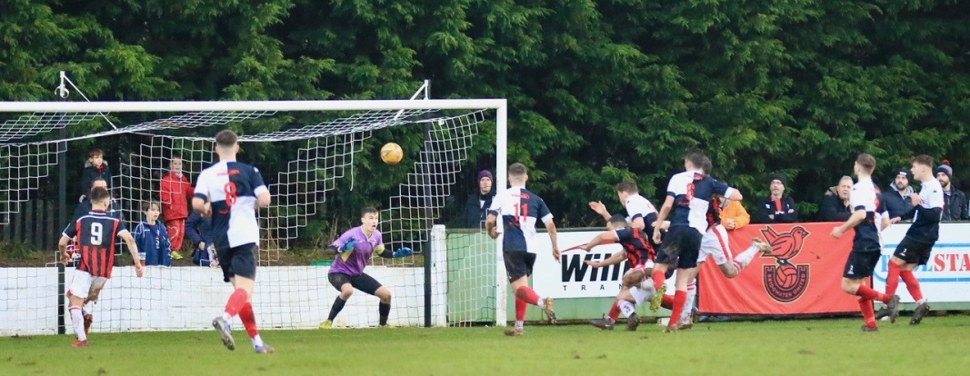
Premier Division: Home sides enjoyed the best of the festive period, with one stoppage time equaliser the only thing to deny them a 100% Boxing Day record. Leaders Tavistock were too hot to handle at Langsford Park, scoring all of their goals inside the opening quarter in their 3-0 triumph over Buckland. The Lambs became the first side to reach the 50-point mark this season, with an own goal, plus an early double from Dan Koita giving them their latest victory. Exmouth were another side who eased to a comfortable home win, with four different goalscorers helping them see off Bridport. Goals inside the opening 20 minutes from Ace High and Ben Steer put the hosts in control, with Aaron Denny and Jordan Harris completing the scoring after the interval. In a much tighter contest, two goals in the space of five second half minutes helped Shepton Mallet defeat Bridgwater 2-0 (pictured below, courtesy of Haydn Jones). Following a goalless hour, Aaron Seviour was hauled down in the United box, and Nick Hewlett smashed home the resulting penalty to put Mallet in front. Moments later, Finn Haines added a further goal for the home side, helping them join their visitors in the top half of the division. The only home side not to end the day with all three points were Saltash after they conceded at the death to draw 1-1 with Millbrook. A debut goal on the hour mark from Rubin Wilson had put the Ashes in charge, but they were hit by a late sucker-punch, with Josh Toulson grabbing a dramatic equaliser to salvage the visitors long unbeaten run.
Only two games beat the weather on Monday, with a pair of hat-trick heroes firing their sides to comfortable home wins. One of those teams were Clevedon Town who overturned an early deficit to beat Street by four goals to one at the Hand Stadium. A headed finish from Alessandro Costanza had given the Cobblers a tenth minute lead which was soon cancelled out by Archie Ferris who did well to convert Mitch Osmond’s cross. Ferris was then on target again just prior to half-time, with Glen Hayer prodding the ball home at the back post to make it 3-1 ten minutes into the second half. With 15 minutes remaining, Ferris was afforded the perfect opportunity to complete his treble, firing home from the penalty spot after teammate Ethan Feltham had been brought down in the area. For Brislington, it was Jordan Scadding who played a starring role in their 4-0 victory over Ashton & Backwell United. Having struck twice in quick succession midway through the first half, Scadding then completed his hat-trick in stoppage time after George Jones had made it 3-0 ten minutes into the second half.

First Division: Sherborne’s home clash with Radstock was the only one to survive on Boxing Day, and the hosts will be glad that it did after recording a 4-0 victory. The Zebras are now just five points off top spot following their latest win, with Tom Budden getting the ball rolling for the hosts ten minutes prior to half-time. Declan Cornish and Ollie Hebbard then stretched the lead to three early in the second half, before Anthony Herrin added some gloss to the scoreline in the closing stages. 24 hours later, second half goals from Lewis Graham and Seth Wain helped Warminster secure a 2-0 win away at Devizes, while AEK Boco triumphed by three goals to nil at Stockwood Lane against Bristol Telephones. The game of the day however, took place in front of a club record attendance of 756, with hosts Longwell Green Sports claiming a 4-3 win over Oldland Abbotonians. The only goal in the first half belonged to the visitors, with Aaron Mansfield firing them ahead after 29 minutes before a three-goal blitz turned the game on its head. Having levelled the scores in the 56th minute thanks to a deflected effort from Zac Cheetham, a Liam Oswin header just moments later completed the turnaround, with Kyle Parsons then adding a third on the hour mark. Oldland have a Parsons of their own however, and after Craig had turned the ball home to cut the deficit, Dave Patterson then struck in the 88th minute to draw the Abbots level. That wasn’t the end of the drama however, and with the points set to be shared, Longwell Green managed to put together a counter-attack which finished with Ethan Feltham slipping the ball home to spark wild scenes of joy for the bumper crowd.

Recent Results
Sunday 26th December 2021
Premier Division
Exmouth Town 4-0 Bridport 450
Saltash United 1-1 Millbrook 326
Shepton Mallet 2-0 Bridgwater United 375
Tavistock 3-0 Buckland Athletic 338
First Division
Sherborne Town 4-0 Radstock Town 211
Monday 27th December 2021
Premier Division
Brislington 4-0 Ashton & Backwell United 226
Clevedon Town 4-1 Street 188
First Division
Bristol Telephones 0-3 AEK Boco 120
Devizes Town 0-2 Warminster Town 187
Longwell Green Sports 4-3 Oldland Abbotonians 756

On the latest episode of the podcast, Ian has a conversation with Shepton Mallet’s joint manager, Craig Loxton, talking about his exciting young side and his hopes for a big second half to the campaign. Tytherington manager Jake Edwards also joins the show, reflecting on the learning curve his side have faced since joining the Western League, while also telling us about his journey into the Rocks dugout.
http://toolstationleague.com/season-2021-22-podcast-episode-21/

Upcoming Fixtures
Saturday 1st January 2022 (3pm Kick off unless noted)
Premier Division
Buckland Athletic vs Helston Athletic
Mousehole vs Exmouth Town
Street vs Shepton Mallet
First Division
Odd Down vs Longwell Green Sports
Oldland Abbotonians vs Bristol Telephones

Sunday 2nd January 2022
Premier Division
Bridgwater United vs Bridport 14:00KO
First Division
Radstock Town vs Wincanton Town 13:00KO

Monday 3rd January 2022 (3pm Kick off unless noted)
Premier Division
Ashton & Backwell United vs Cadbury Heath 13:00KO
Ilfracombe Town vs Saltash United 13:00KO
Keynsham Town vs Brislington
Millbrook vs Wellington
First Division
Hengrove Athletic vs Almondsbury
Warminster Town vs Wells City

Leading Goalscorers
Premier Division First Division
Liam Prynn (Tavistock) – 26 Luke Bryan (Odd Down) - 22 Dean Griffiths (Bitton) – 24 Oaklan Buck (Bishop Sutton) – 22
Jack Taylor (Bridgwater) – 20 Bailey Croome (Tytherington) - 18
Jordan Harris (Exmouth) – 19 Cameron Brown (Lebeq) – 17
Rikki Sheppard (Millbrook) – 16 Jake Slocombe (Welton) – 16

All Competitions
Liam Prynn (Tavistock) – 29
Dean Griffiths (Bitton) – 26
Luke Bryan (Odd Down) – 22
Oaklan Buck (Bishop Sutton) – 22
Jack Taylor (Bridgwater) – 21
Rikki Sheppard (Millbrook) – 21

(Stats courtesy of FA Fulltime Website)

League Tables
 | PREMIER DIVISION | Played | Won | Drawn | Lost | GD | Points
1 | Tavistock | 23 | 16 | 4 | 3 | 39 | 52
2 | Bitton | 21 | 12 | 3 | 6 | 14 | 39
3 | Exmouth Town | 20 | 11 | 5 | 4 | 33 | 38
4 | Mousehole | 18 | 12 | 2 | 4 | 23 | 38
5 | Helston Athletic | 19 | 10 | 7 | 2 | 19 | 37
6 | Ilfracombe Town | 20 | 11 | 4 | 5 | 12 | 37
7 | Bridgwater United | 21 | 11 | 3 | 7 | 19 | 36
8 | Saltash United | 20 | 10 | 4 | 6 | 15 | 34
9 | Shepton Mallet | 22 | 9 | 6 | 7 | 22 | 33
10 | Millbrook | 22 | 9 | 5 | 8 | 15 | 32
11 | Buckland Athletic | 21 | 9 | 5 | 7 | 12 | 32
12 | Keynsham Town | 21 | 8 | 7 | 6 | 4 | 31
13 | Clevedon Town | 21 | 6 | 8 | 7 | 7 | 26
14 | Brislington | 21 | 7 | 3 | 11 | -34 | 24
15 | Wellington | 19 | 6 | 4 | 9 | -10 | 22
16 | Cadbury Heath | 23 | 5 | 2 | 16 | -30 | 17
17 | Street | 19 | 5 | 1 | 13 | -21 | 16
18 | Ashton & Backwell United | 21 | 2 | 3 | 16 | -31 | 9
19 | Bridport | 24 | 1 | 0 | 23 | -108 | 3

 | FIRST DIVISION | Played | Won | Drawn | Lost | GD | Points
1 | Welton Rovers | 23 | 16 | 5 | 2 | 30 | 53
2 | Sherborne Town | 23 | 14 | 6 | 3 | 40 | 48
3 | Warminster Town | 23 | 14 | 5 | 4 | 21 | 47
4 | Wincanton Town | 21 | 11 | 4 | 6 | 29 | 37
5 | Cheddar | 23 | 11 | 4 | 8 | 5 | 37
6 | Odd Down | 24 | 11 | 4 | 9 | 3 | 37
7 | Radstock Town | 22 | 10 | 6 | 6 | 6 | 36
8 | AEK Boco | 23 | 9 | 6 | 8 | -2 | 33
9 | Bishop Sutton | 23 | 9 | 5 | 9 | 4 | 32
10 | Oldland Abbotonians | 22 | 10 | 2 | 10 | -1 | 32
11 | Lebeq United | 23 | 8 | 6 | 9 | -1 | 30
12 | Gillingham Town | 26 | 7 | 8 | 11 | -2 | 29
13 | Longwell Green Sports | 23 | 8 | 5 | 10 | -4 | 29
14 | Tytherington Rocks | 23 | 7 | 7 | 9 | -9 | 28
15 | Wells City | 20 | 6 | 7 | 7 | -5 | 25
16 | Almondsbury | 21 | 8 | 1 | 12 | -12 | 25
17 | Hengrove Athletic | 24 | 6 | 7 | 11 | -16 | 25
18 | Portishead Town | 22 | 8 | 3 | 11 | -1 | 24*
19 | Bishops Lydeard | 20 | 4 | 5 | 11 | -14 | 17
20 | Bristol Telephones | 19 | 5 | 2 | 12 | -16 | 17
21 | Devizes Town | 24 | 4 | 2 | 18 | -55 | 14

