Latest Round-ups:
#20
Season 2021/22
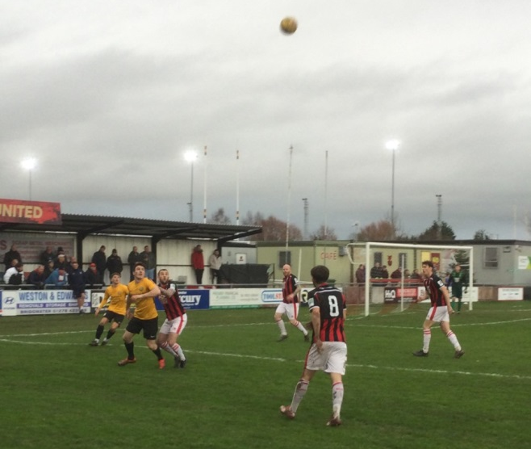
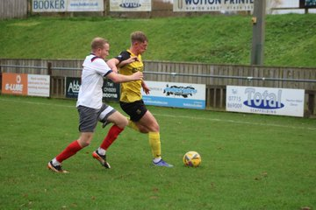
FA Vase: Clevedon Town stormed through to the fourth round of the competition, hitting Brixham for six in a dominant away performance. Following a relatively quiet first half, the visitors came to life with the interval on the horizon, scoring twice in quick succession through Freddie King and Syd Camper to move two goals ahead. Town didn’t rest on their laurels however, and made a dream start to the second period, stretching their lead to three thanks to a Camper volley within moments of the restart. An Alex Camm penalty pretty much ended the contest, with Glen Hayer and Archie Heywood adding the finishing touches late on. Clevedon will be joined in the hat for the next round by Buckland Athletic who saw off fellow Western League side Wellington by two goals to nil at Homers Heath. It took them until first half stoppage time to go ahead, with Owen Stockton providing the finishing touch for the home side. A fine effort from Charlie Johansen doubled Buckland’s tally early in the second half, with the only blemish a late red card given to Stockton after he collected his second yellow of the contest. Things weren’t so simple for Bridgwater, but they will also continue their progress in the competition after coming from behind to beat Bashley 2-1 (pictured left, courtesy of John Pool). Having fallen behind to Harry Bunce’s opener, Bridgwater grabbed a crucial equaliser three minutes before the break through Harry Horton. The winning goal then came ten minutes from time, with a wicked set piece from Jake Llewellyn finding the head of Ross Edwards who powered the ball home past the visiting keeper. Unfortunately, Keynsham’s run in the tournament has come to an end after they lost 4-3 on penalties following a goalless draw away at New Milton Town. It was a similar story for Street, who succumbed on spot kicks against Brockenhurst, after their tie finished 1-1 at the end of 90 minutes.
Players from Buckland and Wellington battle for possession during their FA Vase Third Round clash at Homers Heath.
Premier Division: Millbrook have now won six of their last seven in the league after easing to a 3-0 triumph away at second-placed Bitton on Saturday afternoon. After Ben Holter fired them in front after less than ten minutes, the visitors then doubled their tally on the half hour through top scorer Rikki Sheppard. It was another goal from star man Sheppard that completed the scoring for Millbrook, but they will be equally ecstatic at the other end of the field where the defensive unit have now produced seven straight shut-outs to help aid their winning run. Another side on top form right now are Mousehole, with their 1-0 victory at home to Shepton Mallet giving them their fifth win on the bounce. In a game with few chances, it was Callam McOnie who struck the vital goal 11 minutes from time, firing home a free kick to register another three points for the Cornish outfit. In a bottom-five battle at Springfield, Cadbury Heath edged further away from visitors Ashton & Backwell thanks to a comfortable 3-1 win. At the opposite end of the table, Helston moved up into third spot after securing a 1-1 draw away at Exmouth. Helston haven’t been beaten in 90 minutes since late August, but that record looked under threat when Exmouth went ahead early in the second half thanks to a penalty from the prolific Jordan Harris. The visitors have a reliable goalscorer of their own in Stu Bowker, and he came to the fore once again, cutting in from the right before firing home with his left peg to salvage a point for Steve Massey’s side. The points were also shared in Ilfracombe, where the hosts twice came from behind to claim a 2-2 draw with Brislington. Goals at the beginning of either half from Ash Kington and George Jones handed Brislington the chance to claim a surprise three points, but Town had other ideas, clawing them back on two occasions thanks to equalisers from both Jack Jenkins and Jack Langford.
First Division: A week after seeing their unbeaten run come to an end, Welton Rovers were five minutes away from staring at a two-game losing streak. Hosting a mid-table Bishop Sutton side, Welton found themselves both a goal and a man down after skipper Ben Wych was sent off in the closing stages, ten minutes after Oaklan Buck had fired the visitors ahead. The league leaders managed to regroup however, and after Joe Battrick managed to dig out a cross, Joe Ellis powered his head into the back of the net to rescue a point for the Green Army five minutes from time. Welton’s lead at the top of the division now sits at just nine points following another victory for second-place Warminster at home to Oldland Abbotonians. A goal in either half from Aaron Cockerill was the difference between the sides, with Oldland only scoring a late consolation in stoppage time after being outplayed for much of the afternoon. Third-place Sherborne Town registered their 12th league win of the campaign, scoring a pretty late winner to beat Almondsbury 2-1. Having gone ahead in the 20th minute through Sam Farthing, the Zebras were only in front for a matter of seconds with Isaac Flynn equalising straight from the resulting kickoff. Town finally moved back in front 18 minutes from time, with Henry Lawrence-Napier rising highest to head home an in-swinging corner. Wincanton Town produced the most-dominant display of the day, with Jamie Irwin scoring a hat-trick in their 6-1 victory away at Devizes. It wasn’t all easy going for the visitors, who despite going ahead inside 20 minutes through Irwin, were pegged back when Josh Cole levelled five minutes before the break. That goal seemed to jolt the Wasps into life, and after Dan Quirke restored their lead soon after Cole’s equaliser, they then extended their advantage in the 52nd minute following an instant impact from half-time substitute Conor Williams. Irwin then scored his second to stretch the lead further on the hour mark, with Dan Wise making amends for his earlier miss by firing home a late penalty for the away side. The final goal of the game came in stoppage time, with Irwin finding the back of the net for the third time to extend his side’s winning run to six matches.

Lebeq United were the last side to defeat Wincanton back in early October, and they also gained three points on Saturday afternoon thanks to a 3-2 win at home to Longwell Green Sports. The other side to continue their rise up the division were Odd Down, who left it late before sneaking past Gillingham Town by a goal to nil. The decisive moment came 14 minutes from time, with Man of the Match Shaquille Perkins produced a pin-point cross for teammate Josh Clark who did well to finish from inside the area. Just two weeks after beating the same opposition by two goals to one, Hengrove missed out on the chance to repeat the trick after they missed a late penalty in their 1-1 draw with Portishead. The Grove trailed in the early stages at the AVB Stadium, but got back on level terms towards the end of the first half through Jack Jones. It was then Jones who had an opportunity to help his side steal all three points, but he saw his late penalty saved as the game ended level. Tytherington’s clash with Radstock had to be abandoned at half-time due to floodlight failure, with the visitors leading 2-1 at the end of what had been an entertaining first half following goals from Rico Sobers and Morgan Skipp.
Recent Results
Saturday 11th December 2021
FA Vase Third Round
Bridgwater United 2-1 Bashley
Brixham 0-6 Clevedon Town
Buckland Athletic 2-0 Wellington 152
New Milton Town 0-0 (4-3 pens) Keynsham Town
Street 1-1 (2-4 pens) Brockenhurst
Premier Division
Bitton 0-3 Millbrook 42
Cadbury Heath 3-1 Ashton & Backwell United 52
Exmouth Town 1-1 Helston Athletic 246
Ilfracombe Town 2-2 Brislington 82
Mousehole 1-0 Shepton Mallet
First Division
Almondsbury 1-2 Sherborne Town 30
Devizes Town 1-6 Wincanton Town 82
Hengrove Athletic 1-1 Portishead Town 53
Lebeq United 3-2 Longwell Green Sports 33
Odd Down 1-0 Gillingham Town 25
Tytherington Rocks A-A Radstock Town
Warminster Town 2-1 Oldland Abbotonians
Welton Rovers 1-1 Bishop Sutton 93
On the latest podcast, Ian catches up with Helston Athletic manager, Steve Massey, who talks about the club’s exciting start to life in the Western League, and also his personal journey to the Blues dugout. Joe White of Almondsbury explains how his charges managed to become the first side to topple the previously unbeaten First Division leaders, Welton.
http://toolstationleague.com/season-2021-22-podcast-episode-19/

Upcoming Fixtures
Saturday 18th December 2021 (3pm Kick off unless noted)
Premier Division
Ashton & Backwell United vs Ilfracombe Town
Bridgwater United vs Exmouth Town
Bridport vs Millbrook
Buckland Athletic vs Brislington
Shepton Mallet vs Helston Athletic
Street vs Mousehole
Tavistock vs Keynsham Town
Wellington vs Saltash United
First Division
AEK Boco vs Radstock Town
Bishop Sutton vs Almondsbury
Bristol Telephones vs Hengrove Athletic
Gillingham Town vs Tytherington Rocks
Longwell Green Sports vs Bishops Lydeard
Odd Down vs Wells City
Portishead Town vs Devizes Town
Sherborne Town vs Cheddar
Welton Rovers vs Wincanton Town

Leading Goalscorers
Premier Division First Division
Dean Griffiths (Bitton) – 24 Luke Bryan (Odd Down) - 22
Liam Prynn (Tavistock) – 23 Oaklan Buck (Bishop Sutton) – 20
Jack Taylor (Bridgwater) – 20 Bailey Croome (Tytherington) - 18
Jordan Harris (Exmouth) – 16 Cameron Brown (Lebeq) – 16
Jake Slocombe (Welton) – 16

All Competitions
Dean Griffiths (Bitton) – 26
Liam Prynn (Tavistock) – 26
Luke Bryan (Odd Down) – 22
Jack Taylor (Bridgwater) - 21
Oaklan Buck (Bishop Sutton) – 20
Bailey Croome (Tytherington) – 18

(Stats courtesy of FA Fulltime Website)
Western League Christmas Shopping
A dedicated webpage has been set up, allowing clubs to promote their online shopping facilities so that fans can purchase merchandise.
Visit http://www.toolstationleague.com/club-shops to view a list of those clubs who have online shipping facilities.

League Tables
 | PREMIER DIVISION | Played | Won | Drawn | Lost | GD | Points
1 | Tavistock | 21 | 14 | 4 | 3 | 30 | 46
2 | Bitton | 21 | 12 | 3 | 6 | 14 | 39
3 | Helston Athletic | 18 | 10 | 7 | 1 | 21 | 37
4 | Bridgwater United | 19 | 11 | 3 | 5 | 23 | 36
5 | Ilfracombe Town | 19 | 11 | 3 | 5 | 12 | 36
6 | Mousehole | 17 | 11 | 2 | 4 | 19 | 35
7 | Exmouth Town | 18 | 9 | 5 | 4 | 27 | 32
8 | Buckland Athletic | 19 | 9 | 4 | 6 | 15 | 31
9 | Keynsham Town | 20 | 8 | 7 | 5 | 10 | 31
10 | Saltash United | 18 | 9 | 3 | 6 | 14 | 30
11 | Shepton Mallet | 20 | 7 | 6 | 7 | 18 | 27
12 | Millbrook | 20 | 8 | 4 | 8 | 4 | 28
13 | Clevedon Town | 20 | 5 | 8 | 7 | 4 | 23
14 | Wellington | 18 | 6 | 4 | 8 | -9 | 22
15 | Brislington | 19 | 6 | 2 | 11 | -38 | 20
16 | Cadbury Heath | 23 | 5 | 2 | 16 | -30 | 17
17 | Street | 17 | 5 | 1 | 11 | -14 | 16
18 | Ashton & Backwell United | 19 | 2 | 2 | 15 | -27 | 8
19 | Bridport | 22 | 1 | 0 | 21 | -93 | 3

 | FIRST DIVISION | Played | Won | Drawn | Lost | GD | Points
1 | Welton Rovers | 22 | 16 | 5 | 1 | 33 | 53
2 | Warminster Town | 22 | 13 | 5 | 4 | 19 | 44
3 | Sherborne Town | 21 | 12 | 6 | 3 | 33 | 42
4 | Cheddar | 22 | 11 | 4 | 7 | 8 | 37
5 | Wincanton Town | 20 | 10 | 4 | 6 | 26 | 34
6 | Odd Down | 23 | 10 | 4 | 9 | 1 | 34
7 | Radstock Town | 20 | 9 | 6 | 5 | 9 | 33
8 | Oldland Abbotonians | 21 | 10 | 2 | 9 | 0 | 32
9 | Lebeq United | 23 | 8 | 6 | 9 | -1 | 30
10 | AEK Boco | 21 | 8 | 6 | 7 | -4 | 30
11 | Bishop Sutton | 22 | 8 | 5 | 9 | 0 | 29
12 | Gillingham Town | 25 | 7 | 8 | 10 | -1 | 29
13 | Wells City | 19 | 6 | 7 | 6 | -3 | 25
14 | Almondsbury | 20 | 8 | 1 | 11 | -8 | 25
15 | Tytherington Rocks | 22 | 6 | 7 | 9 | -10 | 25
16 | Hengrove Athletic | 24 | 6 | 7 | 11 | -16 | 25
17 | Longwell Green Sports | 21 | 6 | 5 | 10 | -8 | 23
18 | Portishead Town | 21 | 7 | 3 | 11 | -5 | 21*
19 | Bishops Lydeard | 19 | 4 | 5 | 10 | -11 | 17
20 | Bristol Telephones | 18 | 5 | 2 | 11 | -13 | 17
21 | Devizes Town | 22 | 4 | 2 | 16 | -49 | 14

