Latest Round-ups:
#19
Season 2021/22
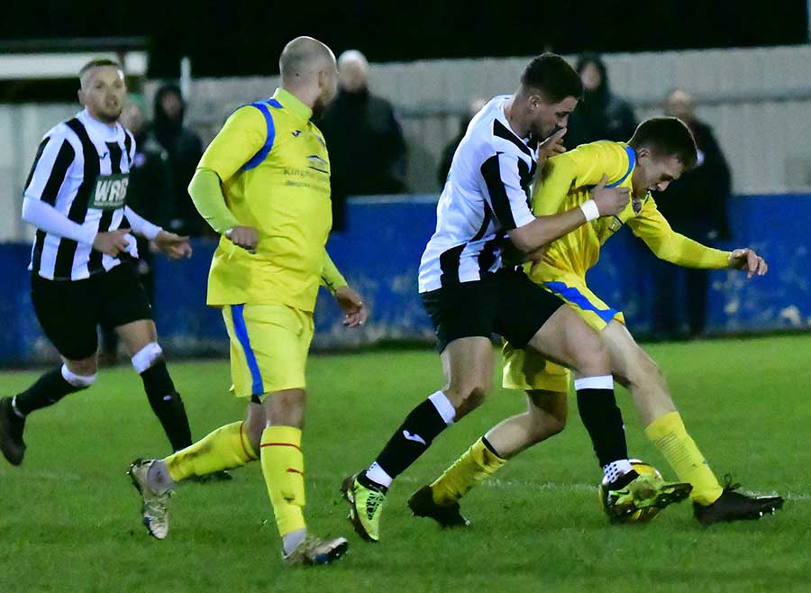
Midweek Action: On Tuesday evening, Welton Rovers reached the halfway point of their league season with their unbeaten record still intact. The runaway leaders of the First Division secured a 2-2 draw away at Longwell Green Sports, with goals from Jake Slocombe and Joe Garland helping them come from behind to lead going into the final ten minutes. The hosts managed to grab a share of the spoils, equalising five minutes from time to extend their tally of scoring twice in each match since their recent return to Shellards Road. In the other fixture that night, Radstock overcame an early deficit to beat Odd Down 4-2 in Bath. A brace inside the opening 20 minutes from top scorer Luke Bryan put the home side in a strong position, but the game was back in the balance at the half-hour mark when Rico Sobers scored his second of the contest. James Rustell followed up his four-goal effort at the weekend by scoring Radstock’s third, with Morgan Skipp then completing the scoring early in the second half following a mix-up in the home defence.
Action from Radstock Town’s midweek victory over Odd Down, courtesy of John Newport
Premier Division: The battle between the top two was as incredibly tight battle, with Tavistock just doing enough to secure the 1-0 win at home to Bitton. There was plenty of drama from the opening moments, with the away side awarded an early penalty, which Tavy keeper Josh Oak managed to keep out. The hosts seemed to gain momentum from that early let-off and took the lead ten minutes before the break when top scorer Liam Prynn converted a Dan Koita pull-back. There was plenty of big tackles during the second half, and Bitton suffered both a sin-binning and a red card, with Stuart Henderson’s charges holding on to claim the crucial victory. Mousehole were the biggest winners of the day, putting six past bottom side Bridport. The visitors have now won ten league matches this season, with a couple of spot kicks helping Hayden Turner to score a hat-trick in the one-sided victory. There was also goals for Louis Price, Callam McOnie and Mark Goldsworthy who have now won four on the bounce. That victory was a bit of a trend on Saturday, with many away sides ending the afternoon with all three points, including Millbrook who won at Brislington thanks to a second half double from Rikki Sheppard.

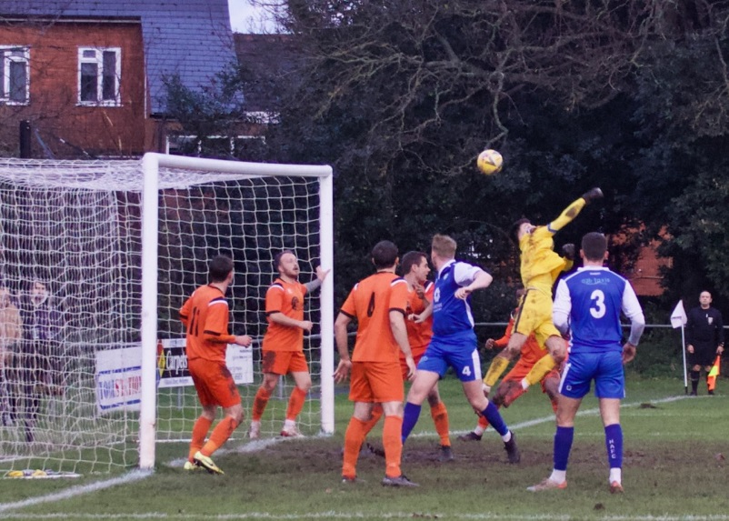
Third-placed Bridgwater didn’t have it all their own way in a 3-2 victory away at Cadbury Heath, with United never fully pulling away from their hosts. Goals inside the opening ten minutes from Jack Taylor and Morgan Williams made it seem as though Bridgwater would be in for a comfortable afternoon, only for Jon Invernizzi to pull one back for the Heath. Sam Hedges then headed United back into a two-goal advantage, only for Matt Huxley to strike once more for the underdogs in the 35th minute. The crucial moment in the game occurred just after Huxley’s effort, with Dan Winstone sent off for the Heath, and the Heath just fell short in their attempts at a comeback during a nervous second half. Helston produced an excellent fightback to win by three goals to one at Wellington. It was the Somerset side who led at the interval, with the ever-dangerous Theo Simpson tucking the ball home in the 31st minute having already come close on a couple of previous occasions. The Cornish outfit came out firing after the break, and having drawn level through Billy Tucker, the same man then scored again soon after following a foul on Stu Bowker inside the penalty area. Those two proved too tough to handle for the Wellington defence, and with 12 minutes remaining Tucker turned provider, putting the ball on a plate for Bowker to complete the scoring. A late strike from Aaron Denny helped Exmouth capture a 3-2 win away at Clevedon. After Robbie Powell saved Mitch Osmond’s 8th minute penalty, Clevedon kept the pressure up and got the goal their early dominance deserved soon after through Freddie King. The away side managed to regroup, and after top scorer Jordan Harris had pulled them level, they struck again through Ace High to take a lead into the break. The topsy-turvy nature of the game continued into the second half, and after Cameron Salmon had claimed an equaliser for the home side, Denny fired home a rocket from outside the area to hand Exmouth all three points. In a battle between two Devon sides, Ilfracombe claimed the bragging rights following a 3-1 win away at Buckland Athletic. It was a frantic start to the clash at Homers Heath, with Jack Langford’s fifth minute opener for Town cancelled out within a matter of moments by Levi Landricombe. Ilfracombe went back in front towards the end of the opening half through Joe Barker, and this time there was to be no fightback, with Liam Short wrapping up the win 15 minutes from time. Ashton & Backwell United ended their seven-match losing run, cancelling out goals from Jack Dancey and Callum Baker to claim a 2-2 draw at home to Keynsham.
Goalmouth action from Helston’s 3-1 win over Wellington.
First Division: At the 21st time of asking, Welton have finally tasted defeat in the league this season after falling to a 3-0 loss away at Almondsbury. Rovers were slow out of the blocks, and having seen Seb Scott break the deadlock after just six minutes, the league leaders were then reduced to ten men, with Jaiden Savery given his marching orders on the half-hour mark. Welton have fought back from some perilous positions during their unbeaten run, but it wasn’t to be on Saturday, with Joe White’s quickfire double at the end of the first half giving Almondsbury the famous victory.
Conner McKay played a starring role in second-placed Warminster’s 2-0 win away at Portishead. After sneaking the ball home in the 27th minute to break the deadlock, McKay then laid on the assist for teammate Lewis Graham who pushed the lead out to two just before the half-time interval. Another side to prevail by two goals to nil, was Devizes, who struck twice in the second half to pick up just their fourth win of the campaign. Having drawn a blank at home to Bristol Telephones during the opening 45 minutes, Devizes performed much better after the break, securing the win thanks to goals from Bevan Cross and Dylan Jones. The most back-and-forth game of the day took place down in Wincanton, where the hosts eventually claimed a 3-2 win over Cheddar. Town made a poor start to the game, falling behind in the fourth minute to Robbi Maggs, before responding well, and levelling affairs after quarter of an hour through Louis Irwin. A left-footed drive from Nathaniel Groom restored the Cheesemen’s lead midway through the first half, with a second-half penalty from Dan Wise making it 2-2 as the game headed into the final quarter. In what was an incredible finish to the game, Wincanton completed their comeback in stoppage time with Dan Dix somehow beating the offside trap before curling the ball home with his left foot. Another come-from-behind win took place at Bishop Sutton, where goals in either half from Luke Bryan and Luke Smith saw Odd Down cancel out Craig Wilson’s long range opener on their way to a last-gasp 2-1 triumph at Lakeview. Lebeq also won 2-1 on their travels, with goalscoring efforts from Jennison Williams and Zack Young helping them complete a snatch-and-grab win over Bishops Lydeard. There was a big win for Sherborne at home to Longwell Green Sports, with the Zebras putting five unanswered goals past their visitors. The scoring started early, with Henry Lawrence-Napier breaking through to score in the fifth minute, before Alex Murphy then doubled their advantage ten minutes later. Another Murphy goal at the beginning of the second half strengthened Sherborne’s grip on the game, with Aaron White and Matty Brown adding to their tally in the closing stages. Wells rebounded excellently from a pair of heavy defeats by beating Oldland Abbotonians 4-2 at the Athletic Ground. Having conceded 13 goals in their previous two games, heads could have dropped for the home side after they fell behind to Aaron Mansfield’s 7th minute volley. This game was different however, and after Adam Wright drew them level, they then moved ahead at the end of the first half through Tom Hill. Further goals from Harvey Hadrill and Charlie Moon saw Wells claim their first league win in more than two months, with Harley Prior scoring in stoppage time for the Abbots. Goals from Bailey Croome and Andy Peterson weren’t enough for Tytherington who drew 2-2 with AEK Boco, while Hengrove let a two-goal lead slip during their 2-2 draw at home to Gillingham Town.
The first podcast in December offers something a little different, as Ian chats with the Western League’s Fixture Secretary, George McCaffery, to help explain the new format for the Les Phillips Cup. We also hear from Longwell Green’s Chairman, John Gibbs, who talks about his club’s journey to redevelop their Shellards Road ground.
http://toolstationleague.com/season-2021-22-podcast-episode-18/

Recent Results
Tuesday 30th November 2021
First Division
Longwell Green Sports 2-2 Welton Rovers
Odd Down 2-4 Radstock Town 82
Saturday 4th December 2021
Premier Division
Ashton & Backwell United 2-2 Keynsham Town 65
Bridport 0-6 Mousehole 86
Brislington 0-2 Millbrook 68
Buckland Athletic 1-3 Ilfracombe Town 90
Cadbury Heath 2-3 Bridgwater United 70
Clevedon Town 2-3 Exmouth Town 102
Saltash United P-P Street
Tavistock 1-0 Bitton
Wellington 1-3 Helston Athletic 97
First Division
Almondsbury 3-0 Welton Rovers 36
Bishop Sutton 1-2 Odd Down 33
Bishops Lydeard 1-2 Lebeq United 37
Devizes Town 2-0 Bristol Telephones 65
Hengrove Athletic 2-2 Gillingham Town 40
Portishead Town 0-2 Warminster Town 47
Sherborne Town 5-0 Longwell Green Sports 84
Tytherington Rocks 2-2 AEK Boco
Wells City 4-2 Oldland Abbotonians
Wincanton Town 3-2 Cheddar 65
Player Survey Results
To review the responses of the recent Western League player survey, run by Cognisant Research, head to the following link on the official website:
http://toolstationleague.com/player-engagement-critical-to-the-future-of-the-non-league-game/

Western League Christmas Shopping
A dedicated webpage has been set up, allowing clubs to promote their online shopping facilities so that fans can purchase merchandise.
Visit http://www.toolstationleague.com/club-shops to view a list of those clubs who have online shipping facilities.

Upcoming Fixtures
Saturday 11th December 2021 (3pm Kick off unless noted)
FA Vase Third Round
Bridgwater United vs Bashley
Brixham vs Clevedon Town
Buckland Athletic vs Wellington
New Milton Town vs Keynsham Town
Street vs Brockenhurst
Premier Division
Bitton vs Millbrook
Cadbury Heath vs Ashton & Backwell United
Exmouth Town vs Helston Athletic
Ilfracombe Town vs Brislington
Mousehole vs Shepton Mallet
First Division
Almondsbury vs Sherborne Town
Bishops Lydeard vs AEK Boco
Devizes Town vs Wincanton Town
Hengrove Athletic vs Portishead Town
Lebeq United vs Longwell Green Sports
Odd Down vs Gillingham Town
Tytherington Rocks vs Radstock Town
Warminster Town vs Oldland Abbotonians
Wells City vs Bristol Telephones
Welton Rovers vs Bishop Sutton

Leading Goalscorers
Premier Division First Division
Dean Griffiths (Bitton) – 24 Luke Bryan (Odd Down) - 21
Liam Prynn (Tavistock) – 23 Oaklan Buck (Bishop Sutton) - 19
Jack Taylor (Bridgwater) – 20 Bailey Croome (Tytherington) - 18
Jordan Harris (Exmouth) – 15 Cameron Brown (Lebeq) – 16
Jake Slocombe (Welton) – 16

All Competitions
Dean Griffiths (Bitton) – 26
Liam Prynn (Tavistock) – 26
Luke Bryan (Odd Down) – 22
Jack Taylor (Bridgwater) - 21
Oaklan Buck (Bishop Sutton) – 19

(Stats courtesy of FA Fulltime Website)

League Tables
 | PREMIER DIVISION | Played | Won | Drawn | Lost | GD | Points
1 | Tavistock | 21 | 14 | 4 | 3 | 30 | 46
2 | Bitton | 20 | 12 | 3 | 5 | 17 | 39
3 | Bridgwater United | 19 | 11 | 3 | 5 | 23 | 36
4 | Helston Athletic | 17 | 10 | 6 | 1 | 21 | 36
5 | Ilfracombe Town | 18 | 11 | 2 | 5 | 12 | 35
6 | Mousehole | 16 | 10 | 2 | 4 | 18 | 32
7 | Exmouth Town | 17 | 9 | 4 | 4 | 27 | 31
8 | Buckland Athletic | 19 | 9 | 4 | 6 | 15 | 31
9 | Keynsham Town | 20 | 8 | 7 | 5 | 10 | 31
10 | Saltash United | 18 | 9 | 3 | 6 | 14 | 30
11 | Shepton Mallet | 19 | 7 | 6 | 6 | 19 | 27
12 | Millbrook | 19 | 7 | 4 | 8 | 1 | 25
13 | Clevedon Town | 20 | 5 | 8 | 7 | 4 | 23
14 | Wellington | 18 | 6 | 4 | 8 | -9 | 22
15 | Brislington | 18 | 6 | 1 | 11 | -38 | 19
16 | Street | 17 | 5 | 1 | 11 | -14 | 16
17 | Cadbury Heath | 22 | 4 | 2 | 16 | -32 | 14
18 | Ashton & Backwell United | 18 | 2 | 2 | 14 | -25 | 8
19 | Bridport | 22 | 1 | 0 | 21 | -93 | 3

 | FIRST DIVISION | Played | Won | Drawn | Lost | GD | Points
1 | Welton Rovers | 21 | 16 | 4 | 1 | 33 | 52
2 | Warminster Town | 21 | 12 | 5 | 4 | 18 | 41
3 | Sherborne Town | 20 | 11 | 6 | 3 | 32 | 39
4 | Cheddar | 22 | 11 | 4 | 7 | 8 | 37
5 | Radstock Town | 20 | 9 | 6 | 5 | 9 | 33
6 | Oldland Abbotonians | 20 | 10 | 2 | 8 | 1 | 32
7 | Wincanton Town | 19 | 9 | 4 | 6 | 21 | 31
8 | Odd Down | 22 | 9 | 4 | 9 | 0 | 31
9 | AEK Boco | 21 | 8 | 6 | 7 | -4 | 30
10 | Gillingham Town | 24 | 7 | 8 | 9 | 0 | 29
11 | Bishop Sutton | 21 | 8 | 4 | 9 | 0 | 28
12 | Lebeq United | 22 | 7 | 6 | 9 | -2 | 27
13 | Wells City | 19 | 6 | 7 | 6 | -3 | 25
14 | Almondsbury | 19 | 8 | 1 | 10 | -7 | 25
15 | Tytherington Rocks | 22 | 6 | 7 | 9 | -10 | 25
16 | Hengrove Athletic | 23 | 6 | 6 | 11 | -16 | 24
17 | Longwell Green Sports | 20 | 6 | 5 | 9 | -7 | 23
18 | Portishead Town | 20 | 7 | 2 | 11 | -5 | 20*
19 | Bishops Lydeard | 19 | 4 | 5 | 10 | -11 | 17
20 | Bristol Telephones | 18 | 5 | 2 | 11 | -13 | 17
21 | Devizes Town | 21 | 4 | 2 | 15 | -44 | 14

