Latest Round-ups:
Season 2021/22
#18
Midweek Action: On their much-anticipated return to Shellards Road, two goals from Aidan Sanfelice helped Longwell Green Sports twice come from behind to secure a 2-2 draw with Radstock. A huge crowd of 424 attended the fixture which saw Longwell Green play on their newly-laid 3G pitch for the first time. It was Joe Cooper of Radstock who struck first on Tuesday evening, with Sanfelice scoring soon after to get the hosts back on level terms. Town had been on a tricky run recently, and had suffered three consecutive defeats coming into this game, but they managed to retake the lead just before half-time when James Rustell scored from close range after Tom Pawley’s corner had been spilled into his path. Urged on by a raucous home support, Longwell Green grabbed a deserved point when Sanfelice completed his goalscoring double 17 minutes from time to bring the curtain down on a momentous night for the club.
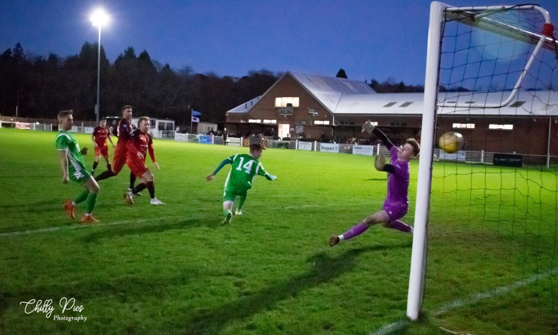
Premier Division: Sam Crumb was in the right place at the right time for Bridgwater, scoring from close range to lead his side to a 2-1 win at home to Ashton & Backwell. Going up against one of this season’s strugglers, Bridgwater looked to have done enough thanks to a 41st minute header from Jordan Greenwood. The visitors managed to get back on level terms however, and with time running out, Crumb found space at the back post to score a crucial winner for the Somerset side. The other fixture to be decided in the final moments took place at Trungle Parc, where Mousehole edged to a tense 2-1 win over Saltash. Having fallen behind to a 7th minute own-goal, the Ashes got themselves back on level terms early in the second half when Sam Farrant volleyed home. Then, with the game in stoppage time at the end of the game, Mousehole grabbed all three points on offer thanks to a dramatic winner from Mark Richards. Tavistock remain four points clear at the top after defeated Street by three goals to nil. Having taken the lead at the back-end of the first half through Josh Grant, the Lambs then had big reason to celebrate 17 minutes from time when youngster Harry Jeffery scored for the first time in his burgeoning career. At the age of 16, Jeffery scored the crucial second for Tavistock, with the league’s leading marksman Liam Prynn then adding to his tally in the 89th minute.
Western League top scorer Liam Prynn was on target again in Tavistock’s 3-0 win over Street. Image courtesy of Chris Chilcott.
Bitton remain locked into second spot after they eased to a 7-0 thumping of Bridport. It was only in the final quarter when the floodgates truly opened, and Bridport had enjoyed a strong first half showing before conceding goals to Matt Groves and Dean Griffiths just before the interval. There were further goals from Joe McLennan, Josh Egan and Jordan Williams for the rampant hosts, with Griffiths and Egan then adding the finish touches as the game headed towards the final few minutes. Doug Camilo’s well-executed looping header saw Wellington secure an impressive 1-0 victory away at Keynsham, while Ilfracombe and Clevedon battled out a goalless draw. Exmouth Town endured their worst day of the season to date, going down to a heavy 4-0 defeat away at Millbrook. The home side made a strong start to the game and led in the early stages, with Tom Payne converting from the penalty spot after teammate Josh Toulson had been hauled down in the box. It was then Toulson had scored at the perfect time for Millbrook, doubling their advantage right at the end of the first half. A third goal early in the second half from Jack Wood put even more separation between the sides, before Toulson completed a perfect day for him personally when he scored for the second time as the game headed into the final ten minutes. A late blitz from Shepton Mallet saw them pull away from hosts Brislington on their way to a 4-1 victory. After taking a 20th minute lead through Andy Martin, Mallet were then hauled back in by Bris when Josh Brace struck for them on the hour mark. The away side managed to find a second wind however, and once Nathan Legge restored their lead in the 80th minute, they didn’t look back. A long range free kick from Fin Wilkinson made it 3-1 late on, with an excellent piece of skill from Legge helping him lay on the injury time assist for Joe Morgan who rounded out the scoring. Buckland find themselves up in sixth spot, after goals from Tor Swann and Josh Webber handed them a 2-1 win at home to Cadbury Heath.
First Division: Welton are still yet to have conceded a goal at West Clewes this season following a 3-0 triumph over Tytherington on Saturday afternoon. As well as keeping their own goal intact, Rovers are also firing at the other end of the pitch, with Toby Cole scoring in either half of their win over the Rocks. Will Gould was also on target for Welton just before the break, volleying home to help give them a 16th win of the campaign. Third-placed Cheddar ended their mini blip, producing a strong first half showing on their way to a 2-0 victory over Odd Down at the Theatre of Cheese. Three consecutive home games without a win had seen Cheddar drop off the pace somewhat, but those struggles were put to bed on Saturday afternoon, with goals from Kris Bell and Nathaniel Green helping them capture all three points.

A four-goal outing from James Rustell helped spearhead Radstock’s huge 7-1 win at home to Wells City. The Town frontman was in scintillating form, handing Wells a second heavy defeat in the space of seven days following their 6-0 loss at Welton last weekend. Rico Sobers, Joe Cooper and Simon Millard were also on target for Radstock, helping consolidate their spot in the top six. Hengrove came out on top against Portishead in a tight bottom-half clash thanks to a late Jamie Godfrey penalty. After moving ahead in just the third minute through Danny Dodimead, Hengrove saw their advantage slip when Hamish Hurst headed home at the back post after just quarter of an hour. Following a long goalless spell, the game fell on the shoulders of substitute Godfrey, with the Hengrove man slamming home his 85th minute spot kick past the home keeper to register the 2-1 victory.

Relegation-threatened Bishops Lydeard twice came from behind to rescue a point during their 2-2 draw away at second-placed Warminster. The game suddenly sparked to life midway through the first half with Eben Mortimer-Taylor breaking the deadlock for the home side. No sooner had Charlie Melvin-Sparks drawn Lydeard level, they were on the back foot once again when Lewis Graham struck to restore Warminster’s lead. The fourth and final goal came 20 minutes from time, with Oscar Albano driving the ball home to secure what could be a crucial point for the Taunton-based outfit. Almondsbury have now won four of their last five, after goals either side of the interval from Alex Cumming and Joe White saw them beat Devizes 2-1 at Nursteed Road. Bishop Sutton are another side in strong form, and they have now won three on the spin, capitalising on an early penalty miss to beat Oldland 3-1 away from home. The Abbots were afforded the perfect opportunity to go ahead midway through the first half, but Cash Vinall dragged his penalty wide of the goal to give the visitors a huge let-off. That miss looked even more costly early in the second half when Craig Wilson rose highest to nod Sutton in front. A chipped finish from Liam Villis doubled Sutton’s advantage 18 minutes from time, and they finally wrapped up the victory soon after when Wilson found the back of the net for the second time. In Gloucestershire, Sacha Tong’s second half brace helped Lebeq secure a 2-2 draw at home to Sherborne. Having lost 4-2 against the same opposition earlier this season, Tong’s double cancelled out goals from Ollie Hebbard and Alex Murphy in an entertaining mid-season clash. Gillingham Town seemed to enjoy the fresh 3G surface, running out 4-2 winners away at Longwell Green Sports.
Recent Results
Tuesday 23rd November 2021
First Division
Longwell Green Sports 2-2 Radstock Town 424
Saturday 27th November 2021
Premier Division
Bitton 7-0 Bridport 31
Bridgwater United 2-1 Ashton & Backwell United 204
Brislington 1-4 Shepton Mallet 109
Buckland Athletic 2-1 Cadbury Heath 102
Ilfracombe Town 0-0 Clevedon Town 75
Keynsham Town 0-1 Wellington 115
Millbrook 4-0 Exmouth Town
Mousehole 2-1 Saltash United
Tavistock 3-0 Street
First Division
Bristol Telephones P-P Wincanton Town
Cheddar 2-0 Odd Down 64
Devizes Town 1-2 Almondsbury 58
Lebeq United 2-2 Sherborne Town 24
Longwell Green Sports 2-4 Gillingham Town 114
Oldland Abbotonians 1-3 Bishop Sutton 30
Portishead Town 1-2 Hengrove Athletic 64
Radstock Town 7-1 Wells City 59
Warminster Town 2-2 Bishops Lydeard 80
Welton Rovers 3-0 Tytherington Rocks 103
Les Phillips Cup 2021/22
The draw for the Preliminary and First Round draws of this season’s Les Phillips Cup took place at Shellards Road on Tuesday evening.
The format for the competition this season has been adjusted, and all information regarding these updates, as well as the draw itself, is available at the following link: http://toolstationleague.com/les-phillips-cup-2021-22/

On the latest episode of the podcast we catch up with Wellington manager, Tim Legg, to discuss their historic run in the FA Vase. Spencer Thomas of AEK Boco also joins the show to explain why fans can enjoy a welcoming reception at the Greenbank Recreation Ground and why his club are so committed to developing young players.
http://toolstationleague.com/season-2021-22-podcast-episode-17/

Upcoming Fixtures
Tuesday 30th November 2021
First Division
Longwell Green Sports vs Welton Rovers 19:30KO
Odd Down vs Radstock Town 19:45KO
Saturday 4th December 2021 (3pm Kick off unless noted)
Premier Division
Ashton & Backwell United vs Keynsham Town
Bridport vs Mousehole
Brislington vs Millbrook
Buckland Athletic vs Ilfracombe Town
Cadbury Heath vs Bridgwater United
Clevedon Town vs Exmouth Town
Saltash United vs Street
Tavistock vs Bitton
Wellington vs Helston Athletic
First Division
Almondsbury vs Welton Rovers
Bishop Sutton vs Odd Down
Bishops Lydeard vs Lebeq United
Bristol Telephones vs Devizes Town
Hengrove Athletic vs Gillingham Town
Portishead Town vs Warminster Town
Sherborne Town vs Longwell Green Sports
Tytherington Rocks vs AEK Boco
Wells City vs Oldland Abbotonians
Wincanton Town vs Cheddar

League Tables
 | PREMIER DIVISION | Played | Won | Drawn | Lost | GD | Points
1 | Tavistock | 20 | 13 | 4 | 3 | 29 | 43
2 | Bitton | 19 | 12 | 3 | 4 | 18 | 39
3 | Bridgwater United | 18 | 10 | 3 | 5 | 22 | 33
4 | Helston Athletic | 16 | 9 | 6 | 1 | 19 | 33
5 | Ilfracombe Town | 17 | 10 | 2 | 5 | 10 | 32
6 | Buckland Athletic | 18 | 9 | 4 | 5 | 17 | 31
7 | Saltash United | 18 | 9 | 3 | 6 | 14 | 30
8 | Keynsham Town | 19 | 8 | 6 | 5 | 10 | 30
9 | Mousehole | 15 | 9 | 2 | 4 | 12 | 29
10 | Exmouth Town | 16 | 8 | 4 | 4 | 26 | 28
11 | Shepton Mallet | 19 | 7 | 6 | 6 | 19 | 27
12 | Clevedon Town | 19 | 5 | 8 | 6 | 5 | 23
13 | Millbrook | 18 | 6 | 4 | 8 | -1 | 22
14 | Wellington | 17 | 6 | 4 | 7 | -7 | 22
15 | Brislington | 17 | 6 | 1 | 10 | -36 | 19
16 | Street | 17 | 5 | 1 | 11 | -14 | 16
17 | Cadbury Heath | 21 | 4 | 2 | 15 | -31 | 14
18 | Ashton & Backwell United | 17 | 2 | 1 | 14 | -25 | 7
19 | Bridport | 21 | 1 | 0 | 20 | -87 | 3

 | FIRST DIVISION | Played | Won | Drawn | Lost | GD | Points
1 | Welton Rovers | 19 | 16 | 3 | 0 | 36 | 51
2 | Warminster Town | 20 | 11 | 5 | 4 | 16 | 38
3 | Cheddar | 21 | 11 | 4 | 6 | 9 | 37
4 | Sherborne Town | 19 | 10 | 6 | 3 | 27 | 26
5 | Oldland Abbotonians | 19 | 10 | 2 | 7 | 3 | 32
6 | Radstock Town | 19 | 8 | 6 | 5 | 7 | 30
7 | AEK Boco | 20 | 8 | 5 | 7 | -4 | 29
8 | Wincanton Town | 18 | 8 | 4 | 6 | 20 | 28
9 | Bishop Sutton | 20 | 8 | 4 | 8 | 1 | 28
10 | Odd Down | 20 | 8 | 4 | 8 | 1 | 28
11 | Gillingham Town | 23 | 7 | 7 | 9 | 0 | 28
12 | Lebeq United | 21 | 6 | 6 | 9 | -3 | 24
13 | Tytherington Rocks | 21 | 6 | 6 | 9 | -10 | 24
14 | Hengrove Athletic | 22 | 6 | 5 | 11 | -16 | 23
15 | Longwell Green Sports | 18 | 6 | 4 | 8 | -2 | 22
16 | Wells City | 18 | 5 | 7 | 6 | -5 | 22
17 | Almondsbury | 18 | 7 | 1 | 10 | -10 | 22
18 | Portishead Town | 19 | 7 | 2 | 10 | -3 | 20*
19 | Bishops Lydeard | 18 | 4 | 5 | 9 | -10 | 17
20 | Bristol Telephones | 17 | 5 | 2 | 10 | -11 | 17
21 | Devizes Town | 20 | 3 | 2 | 15 | -46 | 11

