Latest Round-ups:
#17
Season 2021/22
FA Vase: The Western League sides produced a really strong showing in this weekend’s second round Vase fixtures, starting with Tavistock’s 5-1 win away at Brixham on Friday evening. It was a pair of usual suspects who fired the Lambs through to the third round, with Josh Grant and Liam Prynn sharing the five goals. It was Grant who scored the opening goal in either half, but strike partner Prynn went one better, grabbing yet another hat-trick, with Tavy’s fifth and final goal coming late on when Grant broke free before teeing up Prynn to complete his treble.
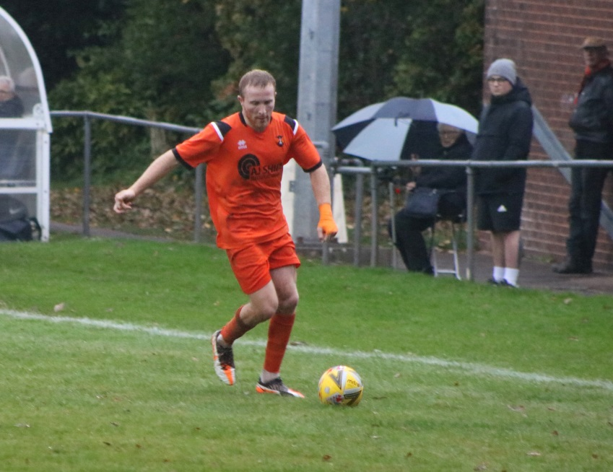
On Saturday, Wellington rebounded from a slow start to beat Christchurch 5-2. Despite going ahead through Scott Merritt in the ninth minute, Wellington soon found themselves on the back foot following a quickfire double from Finn Lowe and James King. New signing Theo Simpson then took over the contest for Wellington, levelling the scores after 31, before restoring the hosts’ lead with a terrific individual goal just before the break. A penalty six minutes into the second half saw the influential Simpson complete his hat-trick, with Jack Champion then adding a late fifth for the Tangerines. Buckland Athletic also progressed to the next round after beating Falmouth Town 3-1 at Homers Heath. It looked good for the Bucks who went ahead after half an hour when Josh Webber fired into the bottom right corner, but Falmouth regrouped and managed to level the scores in the final moments of the first half. Fortunately, the home side found a second wind after the interval, with Cieran Bridger restoring their lead in the 64th minute before Richard Groves wrapped up the victory. Things were a little bit simpler for Clevedon, who were never really put under pressure in their 4-1 win away at Bemerton Heath Harlequins. From the moment Archie Ferris pounced to fire them in front, Clevedon maintained their attacking intent, with Ethan Feltham doubling their advantage just before the interval. Alex Camm then struck early in the second half to make it 3-0, before Syd Camper added a fourth on a memorable afternoon for the Seasiders.
Jason Quick in action for Wellington during their impressive 5-2 win over Christchurch in the FA Vase.

Two goals from Will Hailston proved to be crucial for Keynsham who made it five out of five for Toolstation League sides against irregular opponents in this round of the Vase. Having trailed early away at Liskeard, the K’s ended the first half on top with a Hailston penalty followed soon after by a Stefan Lee goal for 2-1. Hailston then struck again 18 minutes from time, helping book Keynsham’s first passage through to the third round in 18 years. In the all-Western League ties, a Jordan Greenwood header helped Bridgwater sneak past Mousehole by a goal to nil, while Street saw off First Division visitors Oldland Abbotonians thanks to a penalty shootout. After Craig Woodman had cancelled out Leigh Bailey’s opener for the Cobblers, the hosts just about managed to progress following a 5-4 victory on the resulting spot kicks.

Premier Division: In a reduced league schedule, Helston continued their excellent run of form, edging past Shepton Mallet by a 1-0 scoreline. The decisive moment came early in the second half, with Ryan Turner volleying the ball into the back of the net after being teed up by teammate Stu Bowker. Another side performing strongly at the moment are Millbrook, and they have now won three of their last four after seeing off Cadbury Heath by three goals to nil. Having led for much of the contest following Josh Toulson’s early opener, Millbrook finally wrapped up victory in the final quarter, with skipper Tom Payne and Rikki Sheppard scoring in quick succession to hold off the Heath. There was also a 3-0 victory for Exmouth at home to Brislington, with Jordan Harris scoring in either half following on from Dan Cullen’s opener midway through the first half. Things were even more one-sided at the Kimberley Stadium where Saltash eased to a 5-0 win over basement dwellers Bridport. Reece Thomson’s excellent form continued in the early stages, with his pair of first half goals taking his personal tally to six in his last three encounters. Reece Brown then scored his first goal for the Ashes to make it 3-0 midway through the second half, with Dave Barker and Alex Cairo adding further goals in the final 15 minutes. Second-placed Bitton closed the gap at the top thanks to a hard-fought 3-2 win away at Ashton & Backwell United. Having beaten the same opposition 4-2 earlier this season, Bitton took control of the game at the Lancer Scott Stadium following goals either side of the interval from Matt Groves and Dean Griffiths. The hosts then pulled a goal back 20 minutes from time, but Bitton had the desired response, with Joe McLennan smashing home from the edge of the box to restore their two-goal advantage. Ashton & Backwell clawed their way back into the contest once more, claiming a second goal late on, but that was as good as it got for them and they remain rooted in 18th spot.
First Division: Welton show no signs of letting up in their pursuit of a remarkable points total, with their latest win coming in the shape of a 6-0 result at home to Wells City. A first-half hat trick from Will Gould was the catalyst for Rovers’ 15th league win of the campaign, in the process ending Wells’ eight-match unbeaten run. Recent addition Toby Cole added another couple of goals to his increasing tally, before Courtney Charles completed the scoring 20 minutes from time. Warminster remain in second spot after they secured a 2-0 win away at Bishops Lydeard. Following a quiet 40-odd minutes or so, Warminster went ahead on the cusp of half-time, with Jack Miluk doing enough to hit the back of the net. Town only wrapped up victory late in the piece, with a Craig Sheppard penalty completing the two-goal victory.
Sherborne Town are now up into third after they claimed a 3-0 triumph on the road against Hengrove. The Zebras had Declan Cornish to thank for the three points, with the forward opening the scoring towards the end of the first half, before he then added a second in the 50th minute. That left teammate Jack Cutmore to add the finishing touches, with his late third leading the visitors to successive away victories. AEK Boco ended a six-match winless run by beating Tytherington Rocks 2-0, while Gillingham Town stormed to a comprehensive 5-1 win at home to Bristol Telephones. There were plenty of other high-scoring victories too on Saturday afternoon, with Odd Down beating bottom-side Devizes behind a hat-trick from Luke Bryan. Having struck twice in the first half to hand the visitors a two-goal lead, Bryan then completed his treble midway through the second half, before substitute Shaquille Perkins helped the visitors pull away when he added a late fourth. Another hat-trick hero was Bishop Sutton’s Oaklan Buck, with his goals helping fire them past Lebeq by four goals to two at Lakeview. The game didn’t start in ideal fashion for Sutton who fell behind in the early stages, but they soon hit back with Buck levelling the scores, before Craig Wilson fired them into a 2-1 lead after less than 20 minutes. A back-post header from Buck extended the home side’s lead just before the break, with his third coming soon after the interval to all-but wrap up the three points. Cheddar struck late to salvage a 3-3 draw at home to Portishead in what proved to be one of the most entertaining games of the day. It took a while for the opening goal to arrive, but when it did it was worth waiting for, with Chris Coombs unleashing a rasping drive from long-range to put the Cheesemen in front after 35 minutes. That really kicked the game into life, and with the ensuing attack, Portishead hit back instantly through Joe Fitzgerald, before Cheddar then went straight back down the other end and retook the lead through Joe Woodley in what was a frantic end to the half. Despite falling behind in the manner in which they did, Portishead regrouped well and came out all guns firing in the second half, suddenly finding themselves 3-2 ahead following a quickfire double from Fitzgerald and Josh Honey within ten minutes of the restart. Cheddar were desperate not to suffer a third-successive home defeat, and they had Woodley to thank for claiming a share of the spoils in the closing stages, with his second of the afternoon drawing the hosts level with less than ten minutes left on the clock. Wincanton Town have now won four on the bounce, and are unbeaten in seven, after they defeated Almondsbury 4-0. A third-minute effort from Dan Quirke set the visitors on their way, with Cam Allen then doubling their advantage after only 20 minutes. Dan Wise’s penalty made it 3-0 after only half-an-hour, and Wincanton seemed to take their foot off the pedal somewhat, with Louis Irwin claiming their fourth and final goal in stoppage time at the end of the game.
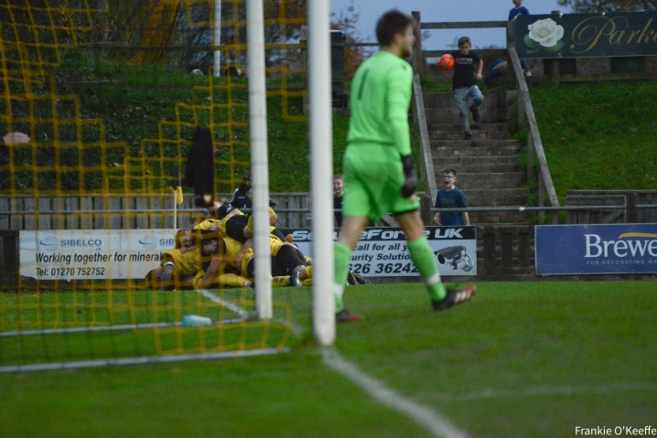
Buckland players celebrate during their victory over Falmouth.
Images courtesy of Frankie O’Keeffe (@FrankieOKeeffe)
Recent Results
Friday 19th November 2021
FA Vase – Second Round
Brixham 1-5 Tavistock

Saturday 20th November 2021
FA Vase – Second Round
Bemerton Heath Harlequins 1-4 Clevedon Town
Bridgwater United 1-0 Mousehole
Buckland Athletic 3-1 Falmouth Town 302
Liskeard Athletic 2-3 Keynsham Town
Street 1-1 (5-4 pens) Oldland Abbotonians
Wellington 5-2 Christchurch 51
Premier Division
Ashton & Backwell United 2-3 Bitton 72
Exmouth Town 3-0 Brislington 370
Helston Athletic 1-0 Shepton Mallet 165
Millbrook 3-0 Cadbury Heath
Saltash United 5-0 Bridport 144
First Division
AEK Boco 2-0 Tytherington Rocks 98
Almondsbury 0-4 Wincanton Town 18
Bishop Sutton 4-2 Lebeq United 32
Bishops Lydeard 0-2 Warminster Town 54
Cheddar 3-3 Portishead Town 88
Devizes Town 2-4 Odd Down 100
Gillingham Town 5-1 Bristol Telephones 50
Hengrove Athletic 0-3 Sherborne Town 55
Welton Rovers 6-0 Wells City 178

On the latest Podcast, a pair of league leading managers speak to Ian Nockolds, starting with Tavistock’s Stuart Henderson who explains why consistency will be key to his side maintaining their title charge. Tom Smith of Welton then joins the show to talk about the psychology he is using to maintain Rovers’ unbeaten start to the season.
http://toolstationleague.com/season-2021-22-podcast-episode-16/

Upcoming Fixtures
Tuesday 23rd November 2021
First Division
Longwell Green Sports vs Radstock Town 19:30KO
Saturday 27th November 2021 (3pm Kick off unless noted)
Premier Division
Bitton vs Bridport
Bridgwater United vs Ashton & Backwell United
Brislington vs Shepton Mallet
Buckland Athletic vs Cadbury Heath
Ilfracombe Town vs Clevedon Town
Keynsham Town vs Wellington
Millbrook vs Exmouth Town
Mousehole vs Saltash United
Tavistock vs Street
First Division
Bristol Telephones vs Wincanton Town
Cheddar vs Odd Down
Devizes Town vs Almondsbury
Lebeq United vs Sherborne Town
Longwell Green Sports vs Gillingham Town
Oldland Abbotonians vs Bishop Sutton
Portishead Town vs Hengrove Athletic
Radstock Town vs Wells City
Warminster Town vs Bishops Lydeard
Welton Rovers vs Tytherington Rocks

Leading Goalscorers
Premier Division First Division
Liam Prynn (Tavistock) – 21 Oaklan Buck (Bishop Sutton) 19
Jack Taylor (Bridgwater) - 19 Luke Bryan (Odd Down) – 19
Dean Griffiths (Bitton) - 19 Bailey Croome (Tytherington) - 17
Jack Fillingham (Shepton) - 14 Cameron Brown (Lebeq) – 15
Will Hailston (Keynsham) - 14 Jake Slocombe (Welton) - 15

All Competitions
Liam Prynn (Tavistock) – 28
Dean Griffiths (Bitton) – 21
Jack Taylor (Bridgwater) - 20
Oaklan Buck (Bishop Sutton) – 19
Luke Bryan (Odd Down) – 19

(Stats courtesy of FA Fulltime Website)

League Tables
 | PREMIER DIVISION | Played | Won | Drawn | Lost | GD | Points
1 | Tavistock | 19 | 12 | 4 | 3 | 26 | 40
2 | Bitton | 18 | 11 | 3 | 4 | 11 | 36
3 | Helston Athletic | 16 | 9 | 6 | 1 | 19 | 33
4 | Ilfracombe Town | 16 | 10 | 1 | 5 | 10 | 31
5 | Bridgwater United | 17 | 9 | 3 | 5 | 21 | 30
6 | Saltash United | 17 | 9 | 3 | 5 | 15 | 30
7 | Keynsham Town | 18 | 8 | 6 | 4 | 11 | 30
8 | Exmouth Town | 15 | 8 | 4 | 3 | 30 | 28
9 | Buckland Athletic | 17 | 8 | 4 | 5 | 16 | 28
10 | Mousehole | 14 | 8 | 2 | 4 | 11 | 26
11 | Shepton Mallet | 18 | 6 | 6 | 6 | 16 | 24
12 | Clevedon Town | 18 | 5 | 7 | 6 | 5 | 22
13 | Millbrook | 17 | 5 | 4 | 8 | -5 | 19
14 | Wellington | 16 | 5 | 4 | 7 | -8 | 19
15 | Brislington | 16 | 6 | 1 | 9 | -33 | 19
16 | Street | 16 | 5 | 1 | 10 | -11 | 16
17 | Cadbury Heath | 20 | 4 | 2 | 14 | -30 | 14
18 | Ashton & Backwell United | 16 | 2 | 1 | 13 | -24 | 7
19 | Bridport | 20 | 1 | 0 | 19 | -80 | 3

 | FIRST DIVISION | Played | Won | Drawn | Lost | GD | Points
1 | Welton Rovers | 18 | 15 | 3 | 0 | 33 | 48
2 | Warminster Town | 19 | 11 | 4 | 4 | 16 | 37
3 | Sherborne Town | 18 | 10 | 5 | 3 | 27 | 35
4 | Cheddar | 20 | 10 | 4 | 6 | 7 | 34
5 | Oldland Abbotonians | 18 | 10 | 2 | 6 | 5 | 32
6 | AEK Boco | 20 | 8 | 5 | 7 | -4 | 29
7 | Wincanton Town | 18 | 8 | 4 | 6 | 20 | 28
8 | Odd Down | 19 | 8 | 4 | 7 | 3 | 28
9 | Radstock Town | 17 | 7 | 5 | 5 | 1 | 26
10 | Bishop Sutton | 19 | 7 | 4 | 8 | -1 | 25
11 | Gillingham Town | 22 | 6 | 7 | 9 | -2 | 25
12 | Tytherington Rocks | 20 | 6 | 6 | 8 | -7 | 24
13 | Lebeq United | 20 | 6 | 5 | 9 | -3 | 23
14 | Wells City | 17 | 5 | 7 | 5 | 1 | 22
15 | Longwell Green Sports | 16 | 6 | 3 | 7 | 0 | 21
16 | Portishead Town | 18 | 7 | 2 | 9 | -2 | 20*
17 | Hengrove Athletic | 21 | 5 | 5 | 11 | -17 | 20
18 | Almondsbury | 17 | 6 | 1 | 10 | -11 | 19
19 | Bristol Telephones | 17 | 5 | 2 | 10 | -11 | 17
20 | Bishops Lydeard | 17 | 4 | 4 | 9 | -10 | 16
21 | Devizes Town | 19 | 3 | 2 | 14 | -45 | 11

