Latest Round-ups:
#16
Season 2021/22
Midweek Action: In the only league fixture to take place during the week, Bridgwater came from behind to beat Wellington 3-1 in front of a mega crowd of 376. The Tuesday night clash started well for the away side, and they went ahead after just 19 minutes when the in-form Jake Quick headed home. Bridgwater weren’t behind for long however, and got back on level terms soon after falling behind, with Nick Woodrow scoring from close range. The home side continued to push forward, and after coming close on a number of occasions at the beginning of the second half, they finally went ahead just after the hour mark with Jordan Greenwood forcing home a header at the far post. United finally wrapped up the points in stoppage time, with Tom Llewellyn grabbing their third, recently returning to the field after he had spent a short spell in the sin-bin as the game headed into the final ten minutes.
Premier Division: Liam Prynn continues to lead the charge for league leaders Tavistock, with the in-form frontman hitting a hat-trick in the Devonians 5-0 win away at Cadbury Heath. After Josh Grant fired the Lambs ahead from the spot after 17 minutes, Prynn took over, scoring twice in the first half to give the visitors what felt like an unassailable three-goal lead. He then claimed his hat-trick goal on the hour mark, with a stoppage time strike from Lewis Dawe completing the scoring. Bitton now sit seven points off the top after they suffered a 4-0 loss at home to an ever-improving Mousehole outfit. The opening half was a pretty tight affair, but it was the visitors who managed to go in-front with Louis Price forcing the ball home in the 20th minute. Price was also on target during a much more one-sided second half, which also saw Hayden Turner notch a brace of his own for Mousehole who are now unbeaten in four. Third-place now belongs to Ilfracombe Town after they defeated Devon rivals Buckland Athletic by two goals to nil. Having scored a hat-trick last week, Liam Short followed that up against Buckland by firing the home side into an early lead, with Jack Langford then tapping home their second at the beginning of the second half. It was much more dramatic for Helston in their pursuit of three points, with two late penalties helping them come from behind to hand Street a 2-1 defeat at Kellaway Park. After the Cobblers went ahead on the hour mark, Helston looked to have rescued a point ten minutes from time when Stu Bowker slotted home a penalty. Then, with the game headed towards stoppage time, Billy Tucker was fouled in the box once again, and the reliable Bowker stepped up to convert from 12 yards out to pinch all three points. Bridgwater United also produced a comeback to overcome hosts Brislington, with a dominant second-half performance eventually leading them to a 5-1 victory. Bris made a dream start to the encounter, going ahead in the 14th minute through Josh Brace, but they were soon up against it after defender Harry Tobin was given a straight red card midway through the first half. Mark Duffy had already equalised by the time Tobin was given his marching orders, and the extra man finally made a difference five minutes after the interval when a deflected Adnan Hiroli cross was turned home by Jack Taylor. Unfortunately for Brislington, they ran out of steam in the final quarter hour, with Duffy, Jake Llewellyn and Ross Edwards all adding to their deficit.
Keynsham Town were another top-six outfit to win big away from home, scoring twice in either half to topple Bridport by four goals to nil. Sam Jones and Will Hailston struck at either end of the first half to put the K’s in control by the midway point of the contest, and the second half then belonged to Dan Cottle, with the visiting forward maintaining his fine run of form with a pair of excellent finishes as Town rolled to a big win. Saltash United have now won half of their 16 league fixtures, with Reece Thomson starring for the Ashes in their 3-1 victory away at Ashton & Backwell. After heading home in the tenth minute to break the deadlock, Thomson then capitalised on a blistering run from teammate Alex Cairo to make it 2-0 to the visitors inside the opening quarter. Sam Hughes stretched the lead to three on the hour mark, and that goal ended up being pretty important as it helped to stave off an attempted late fightback from the home side who have now lost five league games on the spin. Clevedon registered a league-high seventh draw of the campaign, battling out a goalless stalemate with Millbrook at the Hand Stadium, while Jack Fillingham’s 62nd minute header saw Shepton claim a 1-1 draw at home to Wellington after the Tangerines had taken an early lead through Jake Quick.
First Division: Welton’s remarkable season shows no signs of letting up, and they now have 45 points from a possible 51, after beating Cheddar 4-1 at Bowdens Park. (pictured right, courtesy of John Pool). Sitting in second spot before kickoff, the Cheesemen were no match for Welton who led after 16 minutes when Will Gould linked up well with Toby Cole before firing past the home keeper. After providing the assist for the opener, Cole then got on the scoresheet himself, making it 2-0 to the runaway leaders midway through the first half. The game was then put to bed in a five-minute spell at the beginning of the second half, with Rovers’ leading scorer Jake Slocombe scoring a quickfire double to make it 4-0, prior to Robbie Maggs claiming a late consolation for the hosts. At the opposite end of the table, the bottom two also shared a field on Saturday afternoon, and it was Bishops Lydeard who enjoyed a late rally to beat Devizes 3-0 at Nursteed Road. Following 75 goalless minutes, Adam Willis struck for the away side who hadn’t tasted victory in over a month. That goal really seemed to kick them into life, and after Willis doubled his tally soon after the opener, Paulo Borges then scored to give them three goals in the space of eight minutes to kill off any hopes Devizes had of producing a late fightback. It is now Warminster who find themselves in second spot behind Welton, after goals either side of the interval from Eben Mortimer-Taylor and Jack Miluk led them to a 2-0 victory away at Odd Down in Bath. In the day’s early kickoff, Portishead toppled Gillingham Town by three goals to nil, with Rob Latham and Josh Honey doing all of the heavy lifting during a one-sided second half at Bristol Road. Sherborne Town will soon be known as the comeback kings after they came from two goals down to secure a 3-2 victory away at Bristol Telephones. Having scored three times in the closing stages to draw 3-3 against Odd Down seven days previously, Sherborne found themselves in another perilous position on Saturday after goals from Dhani Golding and Jacob Saunders handed the Phones a 2-0 advantage at the break. The Zebras began their fightback early in the second half with Declan Cornish halving the deficit, and they then got back on level terms ten minutes from time thanks to Anthony Herrin’s equaliser. Sherborne left it until stoppage time before completing their turnaround, with a long ranger from Jack Cutmore doing the business for the Dorset side.
There was also a comeback of sorts from Bishop Sutton who overturned an early deficit to beat Boco 2-1 at Lakeview. After falling behind in the early stages, Oaklan Buck then levelled for the hosts inside 15 minutes, with Craig Wilson smashing home the winner on the cusp of half-time. Another tight affair which ended with the home side prevailing took place at Almondsbury, where an Isaac Flynn header midway through the first half saw them beat Longwell Green Sports 1-0. Oldland Abbotonians responded well to last weekend’s heavy defeat by beating fellow top-six outfit Radstock 3-2 in an entertaining affair at the Aitchison Playing Field. Having gone ahead thanks to a calm finish from Owen McCallum midway through the first half, Oldland let their lead slip with the visitors scoring twice to move in front just before the hour mark. Oldland’s Cash Vinall played a huge role in the comeback win, first teeing up Jacob Reeder who scored the O’s equaliser after 68 minutes, and Vinall was then on hand once more, assisting Craig Parsons’ debut goal which turned out to be the match-winner 15 minutes from time. Elsewhere, goals from Connor Williams and Tom Richardson handed Wincanton a 2-0 win away at Tytherington, while Hengrove now have 20 points from 20 games after defeating Lebeq 2-1 at Oaklands Park.
Recent Results
Tuesday 9th November 2021
Premier Division
Bridgwater United 3-1 Wellington 376

Saturday 13th November 2021
Premier Division
Ashton & Backwell United 1-3 Saltash United 80
Bitton 0-4 Mousehole 105
Bridport 0-4 Keynsham Town 86
Brislington 1-5 Bridgwater United
Cadbury Heath 0-5 Tavistock 102
Clevedon Town 0-0 Millbrook 103
Helston Athletic 2-1 Street 154
Ilfracombe Town 2-0 Buckland Athletic 125
Shepton Mallet 1-1 Wellington
First Division
Almondsbury 1-0 Longwell Green Sports 21
Bishop Sutton 2-1 AEK Boco 76
Bristol Telephones 2-3 Sherborne Town 36
Cheddar 1-4 Welton Rovers 74
Devizes Town 0-3 Bishops Lydeard 104
Lebeq United 1-2 Hengrove Athletic 25
Odd Down 0-2 Warminster Town 87
Oldland Abbotonians 3-2 Radstock Town
Portishead Town 3-0 Gillingham Town 44
Tytherington Rocks 0-2 Wincanton Town

Upcoming Fixtures
Saturday 20th November 2021 (3pm Kick off unless noted)
FA Vase – Second Round
Bemerton Heath vs Clevedon Town
Bridgwater United vs Mousehole
Brixham vs Tavistock
Buckland Athletic vs Falmouth Town
Liskeard Athletic vs Keynsham Town
Street vs Oldland Abbotonians
Wellington vs Christchurch
Premier Division
Ashton & Backwell United vs Bitton
Exmouth Town vs Brislington
Helston Athletic vs Shepton Mallet
Millbrook vs Cadbury Heath
Saltash United vs Bridport
First Division
AEK Boco vs Tytherington Rocks
Almondsbury vs Wincanton Town
Bishop Sutton vs Lebeq United
Bishops Lydeard vs Warminster Town
Cheddar vs Portishead Town
Devizes Town vs Odd Down
Gillingham Town vs Bristol Telephones
Hengrove Athletic vs Sherborne Town
Welton Rovers vs Wells City
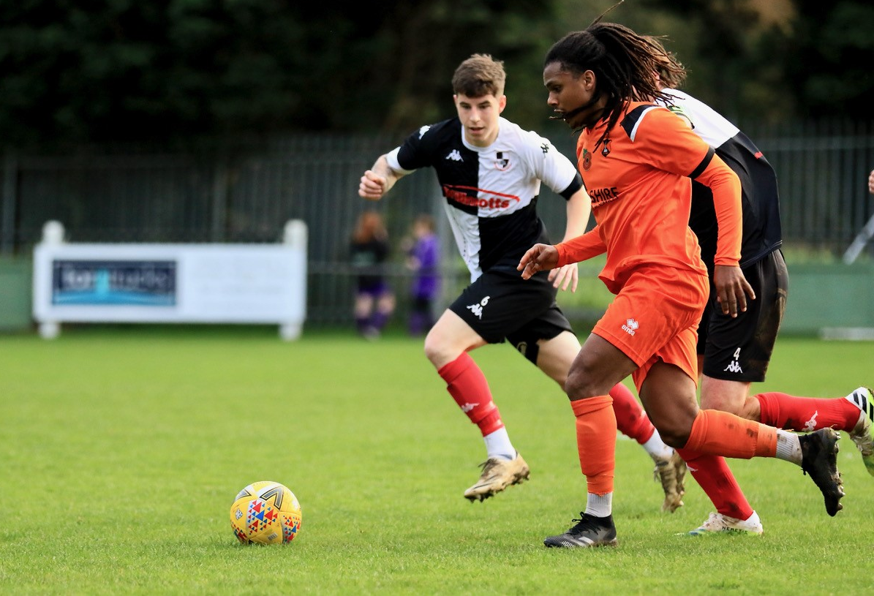

Action from Wellington’s 1-1 draw with Shepton Mallet, courtesy of Haydn Jones.
Leading Goalscorers
Premier Division First Division
Liam Prynn (Tavistock) – 21 Oaklan Buck (Bishop Sutton) 16
Dean Griffiths (Bitton) – 18 Bailey Croome (Tytherington) - 16
Jack Taylor (Bridgwater) - 18 Luke Bryan (Odd Down) – 16
Cameron Brown (Lebeq) – 14

All Competitions
Liam Prynn (Tavistock) – 22
Dean Griffiths (Bitton) – 20
Jack Taylor (Bridgwater) - 20
Luke Bryan (Odd Down) – 16
Bailey Croome (Tytherington) – 16
Rikki Sheppard (Millbrook) – 16
Jack Fillingham (Shepton Mallet) - 16
Oaklan Buck (Bishop Sutton) – 16
(Stats courtesy of FA Fulltime Website)
League Tables
On this week’s podcast, Keynsham manager John Allen explains how careful recruitment has helped his side at both ends of the pitch, while Gillingham Town’s Paul Down gives us a whistle-stop tour of the club’s new Woodwater Lane ground.
http://toolstationleague.com/season-2021-22-podcast-episode-15/
 | PREMIER DIVISION | Played | Won | Drawn | Lost | GD | Points
1 | Tavistock | 19 | 12 | 4 | 3 | 26 | 40
2 | Bitton | 17 | 10 | 3 | 4 | 10 | 33
3 | Ilfracombe Town | 16 | 10 | 1 | 5 | 10 | 31
4 | Bridgwater United | 17 | 9 | 3 | 5 | 21 | 30
5 | Helston Athletic | 15 | 8 | 6 | 1 | 18 | 30
6 | Keynsham Town | 18 | 8 | 6 | 4 | 11 | 30
7 | Buckland Athletic | 17 | 8 | 4 | 5 | 16 | 28
8 | Saltash United | 16 | 8 | 3 | 5 | 10 | 27
9 | Mousehole | 14 | 8 | 2 | 4 | 11 | 26
10 | Exmouth Town | 14 | 7 | 4 | 3 | 27 | 25
11 | Shepton Mallet | 17 | 6 | 6 | 5 | 17 | 24
12 | Clevedon Town | 18 | 5 | 7 | 6 | 5 | 22
13 | Wellington | 16 | 5 | 4 | 7 | -8 | 19
14 | Brislington | 15 | 6 | 1 | 8 | -30 | 19
15 | Millbrook | 16 | 4 | 4 | 8 | -8 | 16
16 | Street | 16 | 5 | 1 | 10 | -11 | 16
17 | Cadbury Heath | 19 | 4 | 2 | 13 | -27 | 14
18 | Ashton & Backwell United | 15 | 2 | 1 | 12 | -23 | 7
19 | Bridport | 19 | 1 | 0 | 18 | -75 | 3
 | FIRST DIVISION | Played | Won | Drawn | Lost | GD | Points
1 | Welton Rovers | 17 | 14 | 3 | 0 | 27 | 45
2 | Warminster Town | 18 | 10 | 4 | 4 | 14 | 34
3 | Cheddar | 19 | 10 | 3 | 6 | 7 | 33
4 | Sherborne Town | 17 | 9 | 5 | 3 | 24 | 32
5 | Oldland Abbotonians | 18 | 10 | 2 | 6 | 5 | 32
6 | Radstock Town | 17 | 7 | 5 | 5 | 1 | 26
7 | AEK Boco | 19 | 7 | 5 | 7 | -6 | 26
8 | Wincanton Town | 17 | 7 | 4 | 6 | 16 | 25
9 | Odd Down | 18 | 7 | 4 | 7 | 1 | 25
10 | Tytherington Rocks | 19 | 6 | 6 | 7 | -5 | 24
11 | Lebeq United | 19 | 6 | 5 | 8 | -1 | 23
12 | Wells City | 16 | 5 | 7 | 4 | 7 | 22
13 | Bishop Sutton | 18 | 6 | 4 | 8 | -3 | 22
14 | Gillingham Town | 21 | 5 | 7 | 9 | -6 | 22
15 | Longwell Green Sports | 16 | 6 | 3 | 7 | 0 | 21
16 | Hengrove Athletic | 20 | 5 | 5 | 10 | -14 | 20
17 | Portishead Town | 17 | 7 | 1 | 9 | -2 | 19*
18 | Almondsbury | 16 | 6 | 1 | 9 | -7 | 19
19 | Bristol Telephones | 16 | 5 | 2 | 9 | -7 | 17
20 | Bishops Lydeard | 16 | 4 | 4 | 8 | -8 | 16
21 | Devizes Town | 18 | 3 | 2 | 13 | -43 | 11

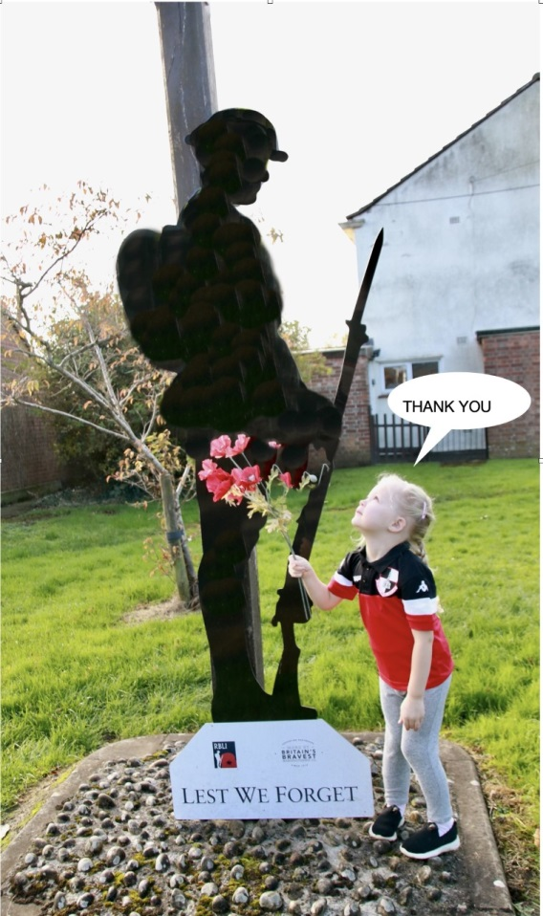

A young Shepton Mallet fan paying respects ahead of Remembrance Sunday. Courtesy of Haydn Jones

