Latest Round-ups:
Season 2021/22
#15
Midweek Action: Longwell Green Sports grabbed a statement win on Tuesday evening in the First Division, inflicting a 4-1 defeat on Cheddar. It was actually the home side who went in front after 34 minutes through Ollie Hucker, but they soon found themselves on the back foot following a quickfire double before the break from Scott O’Brien and Ben Mitchell. Zak Feltham then added a third for Longwell Green on the hour mark, before Mitchell struck again with ten minutes remaining to cap off an excellent performance from the away side. There was also a big come-from-behind win for Wincanton, with Connor Williams scoring twice in their 3-2 defeat of Sherborne. It was the Zebras who made much the better start to the contest, and they led by two goals to nil thanks to efforts from Alex Murphy and Henry Lawrence-Napier. A straight red card after 30 minutes to Brett Cotterill threatened to undo all of the good work by the visitors, and they found themselves level soon after the interval following a brace from first-half substitute Williams. Then, with the game heading into the final moments, Wincanton finally made the extra man pay dividends, with Tom Richardson scoring the winning goal. There was also late drama in Wells, where Jack Miluk scored in the final couple of minutes to rescue a point for Warminster, cancelling out a first half penalty from Adam Wright to secure the 1-1 draw. 24 hours later, the points were also shared between AEK Boco and Hengrove, with the sides failing to break one another down in a goalless draw.
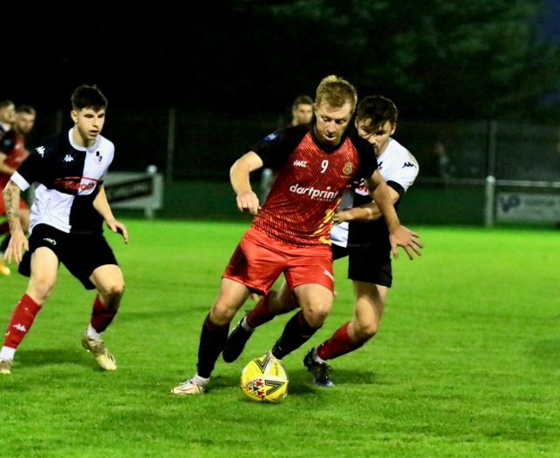
Premier Division: Leaders Tavistock overcame a tough clash away at Shepton Mallet, with Liam Prynn’s double finally helping them pull off the 4-2 victory. The Lambs made the perfect start in Somerset, taking the lead inside a minute thanks to an expertly taken volleyed finish from Josh Robins. The game then came to life at the end of the first half, with Joe Morgan levelling for the hosts in the 35th minute, before Prynn struck to restore Tavistock’s lead soon after. Another equaliser came in the form of a Jack Fillingham header at the far post, only for the Lambs to hit back again with Dan Koita scoring in first half stoppage time for a 3-2 advantage at the interval. That was how it remained for the majority of the second half, before Prynn curled home his second of the afternoon in the closing stages while Shepton had been pushing for a late equaliser. Second-place Bitton were also successful on their travels, with a 57th minute penalty from Jack Ball helping them squeeze past Street by a goal to nil.
Two-goal hero Liam Prynn in action for Tavistock during their win over Shepton Mallet, courtesy of Haydn Jones.

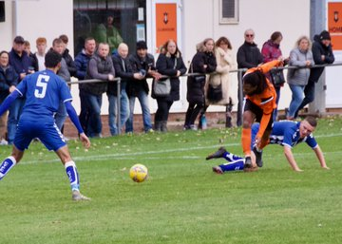
Another side to prevail by a 1-0 scoreline were Millbrook, who have now doubled their season win tally in the previous seven days. After toppling Ilfracombe a week ago, Millbrook followed it up with another victory over top-half opposition in Bridgwater, with a header at the back post 15 minutes from time by Ross Hamilton giving them the shock win. Things were slightly more one-sided for Exmouth, who scored twice in either half of their 4-0 victory over Ashton & Backwell. After 37 goalless minutes, the home side scored twice in quick succession through Mark Lever and Aaron Denny to lead by two at the break. Lever then struck again on the hour mark to put the result beyond doubt, with Jordan Harris completing the scoring midway through the second half. Mousehole have now secured ten points from a possible 12 after overturning an early deficit on their way to a 4-1 win at home to Cadbury Heath. Having fallen behind to Josh Williams’ 12th minute opener, Mousehole hit back, taking a 2-1 lead thanks to goals from Callam McOnie and Hayden Turner. Regular goal-getter Mark Goldsworthy added a third for the home side, before recent signing Louis Price scored on his debut to wrap up the victory, with Matt Huxley sent off late in the piece for the Heath. Keynsham were another side to produce a come-from-behind win on Saturday afternoon, with Dan Cottle scoring in both halves of their 2-1 victory at home to Buckland. The away side went ahead after 14 minutes in spectacular fashion, with Cieran Bridger firing home from all of 30 yards, prior to Cottle’s first of the game which came in the form of a beautiful curled finish. The game was then decided early in the second half, with man of the match Cottle completing his brace to hand Buckland their first defeat since mid-September. A terrific hat-trick from Liam Short led Ilfracombe to a 4-0 win away at bottom-side Bridport, with the unplayable forward scoring Town’s first three of the game, before Ollie Stevens added a fourth in the final 20 minutes. In the only draw of the day in the Premier Division, Syd Camper’s long distance effort rescued a point for Clevedon after they had fallen behind in the tenth minute to a Sam Towler penalty for hosts Wellington.
Action from the 1-1 draw between Clevedon & Wellington, courtesy of AroundWelly.

First Division: With Welton not in action this weekend, Cheddar trimmed the gap atop the division to nine points thanks to a 3-1 win away at AEK Boco. On the back of the heavy midweek defeat, Cheddar rebounded well, with a brace from Steve Holland and a goal at the end of the opening half from Callum Laird helping lead them to victory. At Raleigh Grove, Sherborne staged a remarkable comeback, scoring three times in the final quarter hour to draw 3-3 against Odd Down. The Zebras were far from their best for large periods of the game, and having trailed to Luke Bryan’s 27th minute opener, further goals from Ash Robinson, and then Bryan again saw them three down heading into the closing stretch. From the moment Brett Cotterill pulled a goal back, Sherborne seemed to gain belief, with Henry Lawrence Napier then scoring their second as the game headed into stoppage time. The hosts continued to pile on the pressure, and with the final kick of the game, Anthony Herrin tucked home a spot kick to grab an unlikely point.
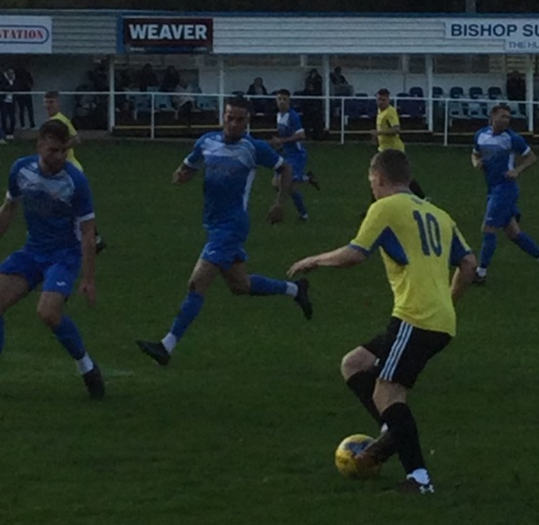
There was also a dramatic tie in Taunton, where Hengrove twice came from behind to grab a 2-2 draw away at Bishops Lydeard. The opening ten minutes saw Zac Ryder go from hero to zero for the hosts, with his fifth minute opener followed up soon after by a straight red card to give Hengrove an extra man for over 80 minutes of the contest. They finally made that advantage count at the end of the first half, when Luco Ponsillo managed to force the ball home for a share of the half-time spoils. Incredibly, Lydeard moved back ahead five minutes after the interval following a stunning bicycle kick from outside the area by Jordan Hayman, but they were unable to hang on to their lead, with the ten men conceding a late equaliser to Ponsillo. Wincanton scored a couple of late goals to add some gloss to their victory at Oldland, with Town eventually running out 4-0 winners. It was Cam Vere’s headed effort at the end of the first half that looked to have decided the encounter before Winky finished strongly, with Dan Quirke, Connor Williams and Dan Wise all scoring in the final 15 minutes to make the scoreline look a little one-sided. Almondsbury may have produced the performance of the day, with the 19th placed side coming from behind to win 2-1 away at Radstock. After falling behind on the hour mark, the Almonds levelled ten minutes later thanks to an Andy Williams rocket, before completing their turnaround in the closing stages when standout performer Isaac Flynn smashed the ball home. Longwell Green Sports leapfrogged hosts Bishop Sutton after Liam Oswin’s 89th minute header gave them a 1-0 win at Lakeview (image on the right, courtesy of John Pool), while Bristol Telephones also moved up a couple of spots into 16th thanks to a 1-0 victory over Portishead. Two penalty saves by keeper Ahmed Quammi weren’t enough for Lebeq who fell to a 2-1 loss away at Warminster. Having gone ahead against the run of play after 30 minutes through Jack Young, they were clawed back just before the break thanks to a lobbed finish by the in-form Jack Miluk. The second half was all about the penalty head-to-head between Quammi and Warminster’s Ian Jeffery. Amazingly, Town were awarded three spot kicks during the second period, with Jeffery successful on his first attempt, but he was then thwarted twice in the final 12 minutes, yet it didn’t prove costly with Lebeq unable to rally at the other end of the field. Gillingham Town enjoyed comfortably their biggest success in front of goal this season, crushing bottom side Devizes 9-2. Their previous high this season had seen them score three goals, and they achieved that inside 15 minutes on Saturday against their undermatched visitors who had looked to have turned a corner in recent weeks. James Boyland notched a hat-trick for the Gills, with Elliot Bevis also netting twice and the two Aaron’s Rodriguez, and Lane-Leney each adding to the hosts tally. There was nothing to split the mid-table duo of Wells and Tytherington, with neither side able to break the deadlock in a goalless draw at the Athletic Ground.

Recent Results
Tuesday 2nd November 2021
First Division
Cheddar 1-4 Longwell Green Sports 43
Wells City 1-1 Warminster Town 32
Wincanton Town 3-2 Sherborne Town 180

Wednesday 3rd November 2021
First Division
AEK Boco 0-0 Hengrove Athletic

Saturday 6th November 2021
Premier Division
Bridgwater United 0-1 Millbrook
Bridport 0-4 Ilfracombe Town 126
Exmouth Town 4-0 Ashton & Backwell United
Keynsham Town 2-1 Buckland Athletic 115
Mousehole 4-1 Cadbury Heath
Shepton Mallet 2-4 Tavistock 176
Street 0-1 Bitton
Wellington 1-1 Clevedon Town 85
First Division
AEK Boco 1-3 Cheddar 155
Bishop Sutton 0-1 Longwell Green Sports 60
Bishops Lydeard 2-2 Hengrove Athletic
Bristol Telephones 1-0 Portishead Town 34
Gillingham Town 9-2 Devizes Town 62
Oldland Abbotonians 0-4 Wincanton Town 32
Radstock Town 1-2 Almondsbury 62
Sherborne Town 3-3 Odd Down
Warminster Town 2-1 Lebeq United 72
Wells City 0-0 Tytherington Rocks 42

On the latest episode of the podcast, Clevedon’s manager Alex White comments on the overall strength of the Premier Division and Craig Mawford of Cheddar says his side are still targeting top spot, but that he would back his charges in a potential promotion play-off come season’s end.
http://toolstationleague.com/season-2021-22-podcast-episode-14/

Upcoming Fixtures
Tuesday 9th November 2021
Premier Division
Bridgwater United vs Wellington 19:45KO

Saturday 13th November 2021 (3pm Kick off unless noted)
Premier Division
Ashton & Backwell United vs Saltash United
Bitton vs Mousehole
Bridport vs Keynsham Town
Brislington vs Bridgwater United
Cadbury Heath vs Tavistock
Clevedon Town vs Millbrook
Helston Athletic vs Street
Ilfracombe Town vs Buckland Athletic
Shepton Mallet vs Wellington
First Division
Almondsbury vs Longwell Green Sports
Bishop Sutton vs AEK Boco
Bristol Telephones vs Sherborne Town
Cheddar vs Welton Rovers
Devizes Town vs Bishops Lydeard
Lebeq United vs Hengrove Athletic
Odd Down vs Warminster Town
Oldland Abbotonians vs Radstock Town
Portishead Town vs Gillingham Town
Tytherington Rocks vs Wincanton Town

Leading Goalscorers
Premier Division First Division
Dean Griffiths (Bitton) – 18 Bailey Croome (Tytherington) - 16
Jack Taylor (Bridgwater) - 18 Luke Bryan (Odd Down) – 16 Liam Prynn (Tavistock) – 18 Oaklan Buck (Bishop Sutton) 15
Cameron Brown (Lebeq) – 14
Jake Slocombe (Welton) - 13

All Competitions
Dean Griffiths (Bitton) – 20
Jack Taylor (Bridgwater) - 19
Liam Prynn (Tavistock) – 19
Bailey Croome (Tytherington) – 16
Rikki Sheppard (Millbrook) – 16
Oaklan Buck (Bishop Sutton) – 15
(Stats courtesy of FA Fulltime Website)
League Tables
 | PREMIER DIVISION | Played | Won | Drawn | Lost | GD | Points
1 | Tavistock | 18 | 11 | 4 | 3 | 21 | 37
2 | Bitton | 16 | 10 | 3 | 3 | 14 | 33
3 | Buckland Athletic | 16 | 8 | 4 | 4 | 18 | 28
4 | Ilfracombe Town | 15 | 9 | 1 | 5 | 8 | 28
5 | Helston Athletic | 14 | 7 | 6 | 1 | 17 | 27
6 | Keynsham Town | 17 | 7 | 6 | 4 | 7 | 27
7 | Exmouth Town | 14 | 7 | 4 | 3 | 27 | 25
8 | Bridgwater United | 15 | 7 | 3 | 5 | 15 | 24
9 | Saltash United | 15 | 7 | 3 | 5 | 8 | 24
10 | Shepton Mallet | 16 | 6 | 5 | 5 | 17 | 23
11 | Mousehole | 13 | 7 | 2 | 4 | 7 | 23
12 | Clevedon Town | 17 | 5 | 6 | 6 | 5 | 21
13 | Brislington | 14 | 6 | 1 | 7 | -26 | 19
14 | Wellington | 14 | 5 | 3 | 6 | -6 | 18
15 | Street | 15 | 5 | 1 | 9 | -10 | 16
16 | Millbrook | 15 | 4 | 3 | 8 | -8 | 15
17 | Cadbury Heath | 18 | 4 | 2 | 12 | -22 | 14
18 | Ashton & Backwell United | 14 | 2 | 1 | 11 | -21 | 7
19 | Bridport | 18 | 1 | 0 | 17 | -71 | 3

 | FIRST DIVISION | Played | Won | Drawn | Lost | GD | Points
1 | Welton Rovers | 16 | 13 | 3 | 0 | 24 | 42
2 | Cheddar | 18 | 10 | 3 | 5 | 10 | 33
3 | Warminster Town | 17 | 9 | 4 | 4 | 12 | 31
4 | Sherborne Town | 16 | 8 | 5 | 3 | 23 | 29
5 | Oldland Abbotonians | 17 | 9 | 2 | 6 | 4 | 29
6 | Radstock Town | 16 | 7 | 5 | 4 | 2 | 26
7 | AEK Boco | 18 | 7 | 5 | 6 | -5 | 26
8 | Odd Down | 17 | 7 | 4 | 6 | 3 | 25
9 | Tytherington Rocks | 18 | 6 | 6 | 6 | -3 | 24
10 | Lebeq United | 18 | 6 | 5 | 7 | 0 | 23
11 | Wincanton Town | 16 | 6 | 4 | 6 | 14 | 22
12 | Wells City | 16 | 5 | 7 | 4 | 7 | 22
13 | Gillingham Town | 20 | 5 | 7 | 8 | -3 | 22
14 | Longwell Green Sports | 15 | 6 | 3 | 6 | 1 | 21
15 | Bishop Sutton | 17 | 5 | 4 | 8 | -4 | 19
16 | Bristol Telephones | 15 | 5 | 2 | 8 | -6 | 17
17 | Hengrove Athletic | 19 | 4 | 5 | 10 | -15 | 17
18 | Portishead Town | 16 | 6 | 1 | 9 | -5 | 16*
19 | Almondsbury | 15 | 5 | 1 | 9 | -8 | 16
20 | Bishops Lydeard | 15 | 3 | 4 | 8 | -11 | 13
21 | Devizes Town | 17 | 3 | 2 | 12 | -40 | 11

