Latest Round-ups:
Season 2021/22
#13
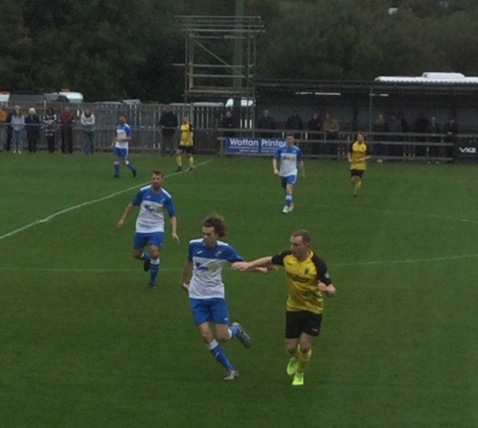
FA Vase: There will be plenty of Western League representation in the second round following a strong showing on Saturday which included Keynsham’s 3-2 win away at Newquay. Having gone ahead midway through the first half thanks to Jordan Metters, Keynsham found themselves trailing soon after the interval. The K’s regrouped well however, and after levelling through Dan Cottle, it was then left to Metters to score the decisive fifth goal of the game, confirming their spot in the next round. They will be joined in the second round by Buckland, who capitalised on an early missed penalty to defeat visitors Camelford 3-0. After seeing the visitors blaze their third minute spot kick over the bar, Buckland grabbed the lead inside the opening quarter when Ryan Bush rounded the keeper before tapping home. Richard Groves made no such mistake with his penalty, making it 2-0 to Buckland early in the second half, before Charlie Johansen wrapped up victory in the closing stages. Street were the other big winners, surging to a 4-1 victory away at Tuffley Rovers behind goals from Harry Foster, Jordan Lovibond, Kyle Strange and Anele Ncube. Unfortunately, Bitton won’t be progressing any further in this season’s Vase following a 4-2 loss at home to New Milton Town, while runaway First Division leaders Welton Rovers conceded two minutes from time to lose 2-1 away at Brimscombe & Thrupp. Penalty shootouts also weren’t overly kind to the Western League contingent, with both Ashton & Backwell, and Cadbury Heath knocked out following spot kick defeats at the hands of Bemerton Heath Harlequins and Hamworthy respectively. One side who were celebrating at the end of a shootout were Oldland Abbotonians after they drew 2-2 with Helston. In a lively affair, Ryan Turner’s diving header had given Helston a 28th minute lead, before the hosts levelled at the end of the first half through Casey Woodman. Stu Bowker’s 72nd minute goal looked to have been enough for Helston, but Oldland managed to find time to take the game to penalties when Frank Gingell converted Own McCallum’s late cross. The home side were successful with all five of their penalties to progress at the expense of their Premier Division visitors. A slightly more one-sided clash in South Cornwall saw Mousehole topple Wells City 4-0, with Callam McOnie’s explosion at the beginning of the second half giving him a hat-trick in the big win. In a clash involving two Premier Division sides, Wellington struck late to secure a 2-1 win away at Millbrook. After falling behind to John Styring’s opener, Wellington drew level in the 52nd minute when Josh Baker swivelled in the box before firing home. The game looked destined to be decided on spot kicks, but fortunately for the away side, Miles Quick was able to find enough space and time in the box to drive the ball home and break Millbrook hearts.
Action from Buckland’s win over Camelford, courtesy of John Pool.
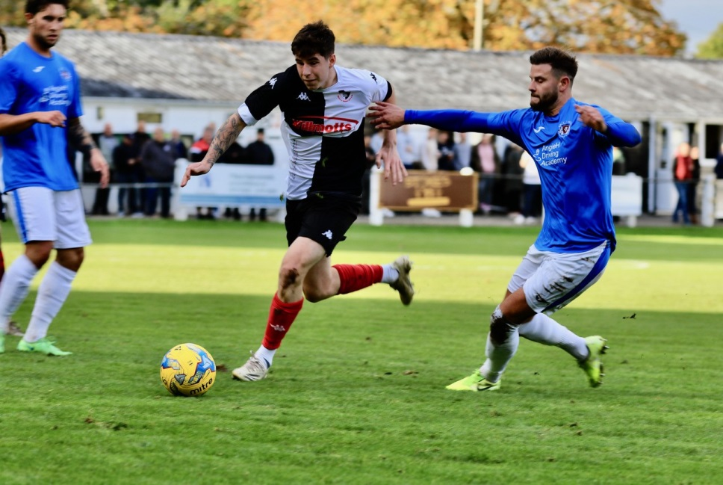
Premier Division: The league action got underway in front of a bumper crowd on Friday night, with 567 fans in attendance to enjoy the 1-1 draw between Bridgwater and Tavistock at Fairfax Park. United have been in excellent form over the last couple of weeks, and it was them who went ahead when Jordan Greenwood smashed the ball home from close range midway through the first half. The league leaders looked to the bench for impact, and found it in the form of Dan Koita, who scored his first goal for the club to rescue a point 14 minutes from time. The following day, Exmouth handed Saltash a rare home defeat, coming from behind to win by two goals to one at the Kimberley Stadium. The Ashes flew out of the blocks at three o’clock, taking just two minutes to go ahead when Alex Cairo’s driven effort deflected in off a defender. A terrific lobbed finish from Morgan Cullen drew the visitors level after 33 minutes, with Mark Lever then completing the turnaround early in the second half. Saltash keeper Ryan Rickard kept his side in the game when saving an Aaron Denny penalty 20 minutes from time, but it proved not to be costly to the relief of the away side. Another side to win on their travels was Brislington, where George Jones played a starring role in their 4-3 triumph over Shepton Mallet. It was Jones who broke the deadlock on Saturday afternoon, finishing well in the 19th minute after he received a cross from former Mallet forward Asa White. A headed effort from Jack Fillingham drew the hosts level, before Lewis Dunn struck to restore Brislington’s advantage after half an hour. Mallet started the second half on top, forcing home an equaliser through Tyrone Tucker-Dixon, before Jones increased his influence on the game. A foul on Jones in the area saw the reliable Simon Prangley put Bris 3-2 up from the spot, and then less than two minutes later, Jones added his second goal of the afternoon to extend the lead. That fourth Brislington goal proved crucial in the overall outcome, after Finn Haines pulled a goal back in stoppage time, with Brislington holding on to end the month on a high. It was also a positive afternoon in Clevedon, where Archie Ferris struck a hat-trick to lead the home side to a 5-0 win over Bridport. After scoring twice in the first half, Ferris completed his treble on the hour mark, making it 3-0 after turning home Jack Goodall’s cross. There were further goals from Freddie King and Alex Camm for Clevedon in what was just their fourth league win of the season.
Action from the entertaining Premier Division clash between Shepton Mallet and Brislington, courtesy of Haydn Jones.

First Division: Longwell Green Sports made it back-to-back 2-0 wins on Friday night after securing victory at home to Bristol Telephones. James Horrocks scored for the second consecutive match, putting them ahead from the spot, before Zac Cheetham doubled their lead, helping them to leapfrog their visitors in the table. Saturday’s highest scorers were Cheddar, with a pair of Callum Laird penalties helping them to secure a 4-0 win at home to Devizes. The two spot kicks gave Devizes a massive hill to climb, and they weren’t capable, with Jamie Laird and then Harry Taylor adding further goals during a one-sided second half display. Hengrove produced another impressive showing to win 2-0 away at Gillingham Town, with Pete Sheppard and Jack Cousins notching the all-important goals. Portishead Town were another bottom half side to register three points after they won 2-1 away at Bishops Lydeard, while the fixture between Sherborne and Tytherington ended goalless. There was late drama at Lebeq, where they scored five minutes from time to secure a 3-2 win at home to Bishop Sutton, while a pair of quickfire goals early in the second half from Joe White and Andy Williams saw Almondsbury hold on to beat Odd Down 2-1.
Recent Results
Friday 22nd October
Premier Division
Bridgwater United 1-1 Tavistock 567
First Division
Longwell Green Sports 2-0 Bristol Telephones

Saturday 23rd October 2021
FA Vase
Ashton & Backwell United 0-0 (4-5 pens) Bemerton Heath Harlequins 119
Bitton 2-4 New Milton Town 53
Brimscombe & Thrupp 2-1 Welton Rovers
Buckland Athletic 3-0 Camelford 125
Cadbury Heath 1-1 (5-6 pens) Hamworthy United 65
Millbrook 1-2 Wellington
Mousehole 4-0 Wells City
Newquay 2-3 Keynsham Town
Oldland Abbotonians 2-2 (5-3 pens) Helston Athletic
Tuffley Rovers 1-4 Street
Premier Division
Clevedon Town 5-0 Bridport 96
Saltash United 1-2 Exmouth Town 178
Shepton Mallet 3-4 Brislington 152
First Division
Almondsbury 2-1 Odd Down 16
Bishops Lydeard 1-2 Portishead Town 53
Cheddar 4-0 Devizes Town 72
Gillingham Town 0-2 Hengrove Athletic 57
Lebeq United 3-2 Bishop Sutton 36
Sherborne Town 0-0 Tytherington Rocks 104
Upcoming Fixtures
Friday 29th October 2021
Premier Division
Tavistock vs Exmouth Town
Saturday 30th October 2021 (3pm Kick off unless noted)
Premier Division
Bridgwater United vs Street
Brislington vs Buckland Athletic
Helston Athletic vs Ashton & Backwell United
Keynsham Town vs Cadbury Heath
Millbrook vs Ilfracombe Town
Saltash United vs Clevedon Town
Shepton Mallet vs Mousehole
Wellington vs Bridport
First Division
Almondsbury vs Bristol Telephones
Devizes Town vs Bishop Sutton
Gillingham Town vs Bishops Lydeard
Hengrove Athletic vs Oldland Abbotonians
Odd Down vs Radstock Town
Portishead Town vs Wells City
Sherborne Town vs AEK Boco
Tytherington Rocks vs Cheddar
Warminster Town vs Longwell Green Sports
Wincanton Town vs Welton Rovers

Leading Goalscorers
Premier Division First Division
Dean Griffiths (Bitton) – 18 Bailey Croome (Tytherington) - 16
Jack Taylor (Bridgwater) -17 Oaklan Buck (Bishop Sutton) 15
Liam Prynn (Tavistock) – 16 Luke Bryan (Odd Down) – 14
Cameron Brown (Lebeq) – 13
Jake Slocombe (Welton) - 13
The latest podcast catches up with Mousehole manager Jake Ash who looks back on their recent victory over Clevedon, while Wincanton’s Chris Wise comments on the legacy that COVID has had on player availability.
http://toolstationleague.com/season-2021-22-podcast-episode-12/

League Tables
 | PREMIER DIVISION | Played | Won | Drawn | Lost | GD | Points
1 | Tavistock | 16 | 10 | 3 | 3 | 19 | 33
2 | Bitton | 15 | 9 | 3 | 3 | 13 | 30
3 | Buckland Athletic | 14 | 8 | 3 | 3 | 19 | 27
4 | Ilfracombe Town | 13 | 8 | 1 | 4 | 5 | 25
5 | Helston Athletic | 13 | 6 | 6 | 1 | 16 | 24
6 | Bridgwater United | 14 | 7 | 3 | 4 | 16 | 24
7 | Saltash United | 14 | 7 | 3 | 4 | 9 | 24
8 | Shepton Mallet | 14 | 6 | 4 | 4 | 19 | 22
9 | Exmouth Town | 12 | 6 | 3 | 3 | 23 | 21
10 | Keynsham Town | 15 | 5 | 6 | 4 | 5 | 21
11 | Mousehole | 11 | 6 | 1 | 4 | 4 | 19
12 | Brislington | 13 | 6 | 0 | 7 | -26 | 18
13 | Clevedon Town | 15 | 4 | 5 | 6 | 4 | 17
14 | Street | 14 | 5 | 1 | 8 | -9 | 16
15 | Wellington | 12 | 4 | 2 | 6 | -7 | 14
16 | Cadbury Heath | 16 | 4 | 2 | 10 | -18 | 14
17 | Millbrook | 13 | 2 | 3 | 8 | -10 | 9
18 | Ashton & Backwell United | 12 | 2 | 1 | 9 | -16 | 7
19 | Bridport | 16 | 1 | 0 | 15 | -66 | 3

 | FIRST DIVISION | Played | Won | Drawn | Lost | GD | Points
1 | Welton Rovers | 15 | 13 | 2 | 0 | 24 | 41
2 | Cheddar | 15 | 8 | 3 | 4 | 6 | 27
3 | Oldland Abbotonians | 15 | 8 | 2 | 5 | 7 | 26
4 | Radstock Town | 15 | 7 | 5 | 3 | 3 | 26
5 | Sherborne Town | 13 | 7 | 4 | 2 | 21 | 25
6 | AEK Boco | 15 | 7 | 4 | 4 | 0 | 25
7 | Warminster Town | 14 | 7 | 3 | 4 | 10 | 24
8 | Odd Down | 15 | 7 | 2 | 6 | 3 | 23
9 | Tytherington Rocks | 16 | 6 | 5 | 5 | 2 | 23
10 | Lebeq United | 16 | 6 | 4 | 6 | 1 | 22
11 | Wells City | 14 | 5 | 5 | 4 | 7 | 20
12 | Bishop Sutton | 15 | 5 | 4 | 6 | -2 | 19
13 | Gillingham Town | 18 | 4 | 6 | 8 | -10 | 18
14 | Portishead Town | 15 | 6 | 1 | 8 | -4 | 16*
15 | Wincanton Town | 13 | 4 | 3 | 6 | 9 | 15
16 | Longwell Green Sports | 12 | 4 | 3 | 5 | -2 | 15
17 | Hengrove Athletic | 16 | 4 | 3 | 9 | -14 | 15
18 | Bristol Telephones | 14 | 4 | 2 | 8 | -7 | 14
19 | Almondsbury | 14 | 4 | 1 | 9 | -9 | 13
20 | Bishops Lydeard | 13 | 3 | 2 | 8 | -11 | 11
21 | Devizes Town | 15 | 2 | 2 | 11 | -34 | 8

