Latest Round-ups:
Season 2021/22
#11
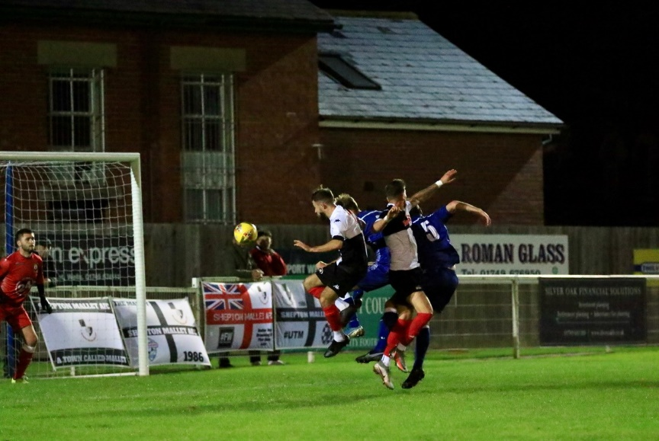
Midweek Action: Gillingham Town maintained their strong home form in Tuesday’s First Division clash with Warminster, edging to a 1-0 victory at Woodwater Lane. Elliot Bevis has been crucial so far this season, and he scored the only goal of the game, with the visitors failing to find the back of the net for just the second time this season. 24 hours later, Mousehole made it four wins on the bounce in the Premier Division after beating Saltash 3-1 at the Kimberley Stadium. Two goals from Josh Magin inside the opening half-hour put Mousehole in control, before Alex Cairo trimmed the deficit at the beginning of the second half. The visitors finally wrapped up victory ten minutes from time when Jack Calver struck, handing the Ashes a rare home defeat. There was also plenty of action in the Somerset Premier Cup during the week, with Ashton & Backwell’s 5-4 penalty shootout win away at Taunton Town the pick of the results. Both Radstock and Portishead also prevailed on spot kicks, but it wasn’t such good news for Street who fell to Larkhall after drawing 1-1 at the end of normal time. Goals from Ethan Feltham and Syd Camper weren’t quite enough for Clevedon who suffered a 3-2 home defeat against Bath City, while three second half goals helped Bishops Lydeard overturn a half-time deficit to beat Hengrove 3-1. In the tie of the round, First Division outfit Wells City knocked out their higher-ranked local rivals Shepton Mallet, prevailing by three goals to two at the Athletic Ground. Charlie Crook, Sam Stone and Charlie Moon were all on target for the hosts, with Anthony Costanza and Dawid Regula striking after the break for Shepton. It was a memorable night for Keynsham’s Matt Brown who struck a hat-trick in his side’s 3-2 win away at Wincanton. On what was his 198th appearance for the club, Brown reached a century of goals for the K’s with his opener, before scoring twice more on the night to book their spot in the next round.
Goalmouth action from Wells City’s 3-2 Somerset Cup victory over Shepton Mallet, courtesy of Haydn Jones.

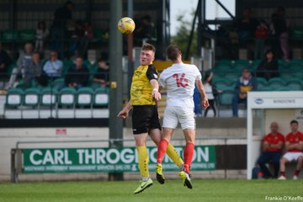
Premier Division: On a high-scoring Saturday afternoon, the game of the day most likely took place at the Kimberley Stadium where Saltash came from behind to defeat Bitton 4-3. After falling behind to Jack Ball’s 11th minute header, the Ashes hit back to lead after half an hour thanks to excellent finishes from Callum Martindale and Sam Farrant. Ball then found himself free to head home his second of the game, before teammate Jordan Whittaker struck in first half stoppage time to put the visitors ahead at the interval. The Ashes came out with a purpose in the second half, and having drawn level in the 62nd minute through Tom Harris, they then scored the crucial seventh goal of the contest when Dave Barker’s cross ended up nesting in the visitors net. Bridgwater United have now scored 13 goals in their last two games, scoring three in either half of their 6-2 victory over Mousehole. Jack Taylor struck a first half brace for the hosts, adding to Tom Llewellyn’s early header, before Mike Duffy volleyed home their fourth in the 59th minute. The visitors kept battling, scoring twice in the final quarter-hour through Callum McOnie and Steve Burt, but they were always well out of sight, with substitute Nick Woodrow, and Adnan Hiroli adding goals for the rampant United side. Things were even more one-sided in Brislington, where the hosts where demolished by Exmouth who scored seven times after the interval on their way to an 11-0 scoreline. Aaron Denny claimed a hat-trick for the away side, with other goals coming from Jordan Harris, Ben Steer, Ace High and second half sub Ethan Slater. Buckland are now up into second spot after claiming a 3-1 win at home to Millbrook. In a repeat of the result between the two sides four weeks previously, Buckland had to come from behind to secure maximum points after Rikki Sheppard fired Millbrook into an eighth minute lead. That was how it stayed until five minutes into the second half, when Josh Webber broke through before slotting home to level affairs. A red card to captain Tom Payne seemed to derail the away side who conceded a penalty which was slotted home by Richard Groves, before Ryan Bush then finished off a counter attack to wrap up victory for the Bucks. Leaders Tavistock were held to a goalless draw by Helston Athletic, while Street secured a much-needed win after Harry Foster’s 29th minute header helped them beat Cadbury Heath 1-0. Shepton Mallet bounced back from a pair of recent defeats by easing to a 4-1 victory away at Ilfracombe Town. A defensive blunder helped Mallet build a lead, with Leon Legge stealing in to nudge them in front, before Finn Haines headed home their second a couple of minutes later. Jack Fillingham then fired them three goals to the good before Ollie Stevens pulled a goal back ten minutes into the second half. Shepton left it late before adding their final goal, with Tyrone Tucker-Dixon wrapping up the big win which saw them leapfrog their hosts up into fifth spot.
Action from Buckland vs Millbrook , courtesy of Frankie O’Keeffe.

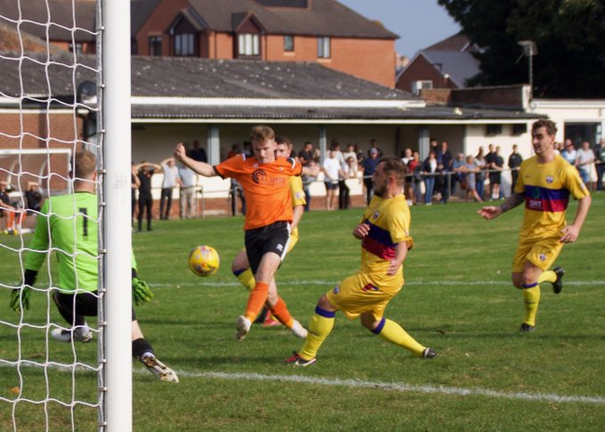
Wellington got the better of Ashton & Backwell for the second time this season, with all the goals in their 3-2 win coming during an entertaining first 45 minutes. Having gone in front after just two minutes through Miles Quick, Welly were soon on the back foot when Brad Skidmore levelled for the visitors. Miles’ brother Jake then thumped the ball in off the bar to put Wellington back in front, but they were unable to maintain their lead once again, with Joe Bishop tucking home a penalty after half an hour. The decisive goal occurred in first half stoppage time, when Jake Quick scoring for the second time after rounding the visiting keeper before rolling the ball into an empty net. The points were shared in Clevedon, where visitors Keynsham salvaged a 2-2 draw despite trailing by two early in the second half. A deflected Syd Camper effort gave the hosts a second minute lead, which then became 2-0 in the opening stages of the second half when Glen Hayer converted a Camper corner. Will Hailston’s excellent season in front of goal continued, with the K’s front man halving the deficit, but in the ensuing melee which followed his goal, teammate George Rooke was given his marching orders. Incredibly, it was the ten men who managed to force home an equaliser, with debutant Dan Cottle scoring four minutes from time to rescue a point in what looked like a lost cause for much of the afternoon.
Wellington on the attack against Ashton & Backwell United.
First Division: On Friday evening, Longwell Green Sports almost ended their two-month wait for a victory, but let slip a two-goal lead before drawing 2-2 with Cheddar. Zac Cheetham was among the scorers for Longwell Green, who went into the break two goals to the good and well on their way to a much-needed three points. Cheddar however came out rejuvenated in the second half, and managed to grab a share of the spoils thanks to goals from Robbi Maggs and substitute Kristian Bell. On Saturday, Welton Rovers added another three points to their ever-growing tally, with the still unbeaten league leaders relying on a new face to beat AEK Boco 2-0. Toby Cole has been one of Wincanton’s main sources for goals over the past couple of seasons before joining the Green Army earlier this week. Given a starting role, Cole made an instant impact for Welton, putting them ahead after just 20 minutes against a Boco outfit who have continued to impress this season. Cole then completed an almost perfect debut, scoring his second in the closing stages with a dinked finish to confirm the 2-0 win which means Welton have now kept seven clean sheets on the bounce at West Clewes. In a surprising result, Portishead Town came out on top in a seven-goal thriller at home to second placed Oldland Abbotonians. Despite making a poor start which saw them concede to Mitchell Dann after just four minutes, Portishead soon hit the front, leading midway through the first half thanks to goals from Callum Townsend and Elliot Ripley. A Rob Latham goal stretched the lead further, before Oldland pulled a goal back in the early stages of the second half through Aaron Mansfield. Latham was on target once more to restore Portishead’s two-goal advantage, and that proved crucial when Mansfield struck again in the closing stages for Oldland.
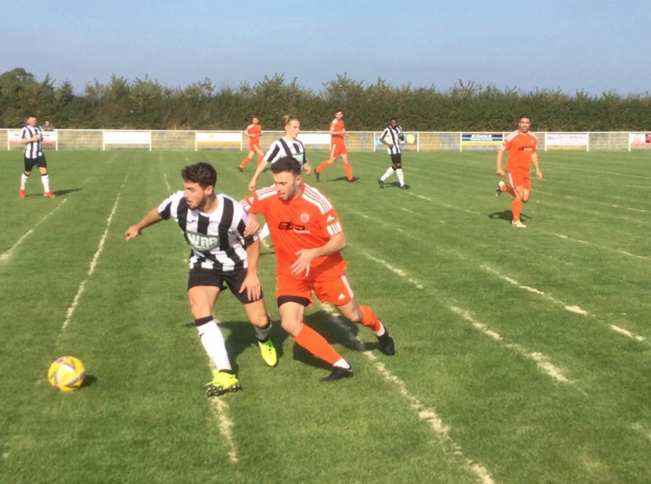
It was a strong showing from a couple of other sides who started the day in the bottom half, including Bishops Lydeard who struck late before beating Bristol Telephones 3-2. A relatively quiet first half came to life in the moments before the break, with Lydeard forward Paulo Borges scoring twice in quick succession to give his side control of the game. The Phones haven’t been on a great run of late, but they should good resolve, storming back into the game during the second half, levelling ten minutes from time. The hosts had the last laugh however, and after putting his side two goals to the good earlier in the afternoon, Borges was on hand to score again in the 88th minute to complete his hat-trick in victorious fashion. Another player to hit a treble on Saturday was Bailey Croome, with the Tytherington Rocks’ leading marksman joining Laurence Lefevre on the scoresheet during their 4-2 win away at bottom-side Devizes. Cameron Brown was the third player to notch a hat-trick, helping lead Lebeq to a 4-1 win over Wincanton. Lebeq would take a two-goal lead to the break thanks to a pair of goals from Brown, with the man of the match then adding a third early in the second half to extend the home side’s advantage. A debut goal from Jennison Williams put the result beyond doubt, with Dan Quirke nabbing a late consolation for Wincanton. Odd Down produced a second half fightback to defeat Gillingham Town 2-1, ending a three-match losing streak in the process. Having fallen behind after just 12 minutes, the Bath side got back on level terms soon after the break through Josh Clark, before a winner five minutes from time from Bradley Norris saw the visitors snatch all three points. Jacob Mead’s eighth minute effort wasn’t quite enough for Wells City who were forced to make do with a 1-1 draw at home to Hengrove, while top-six duo Radstock and Warminster battled out a 2-2 draw at the Southfields Rec. The points were also shared at Lakeview, where Bishop Sutton came back to draw 1-1 with the in-form Sherborne.
Players from Gillingham and Odd Down in action on Saturday afternoon. Image courtesy of John Pool.

On this week’s podcast, we hear from Ilfracombe Town manager Clem Bennellick who is delighted about his side’s start to the campaign. Hengrove’s Jamie Hillman also joins the show to discuss how his club have managed to turn around their season in recent weeks.
http://toolstationleague.com/season-2021-22-podcast-episode-10/

Recent Results
Tuesday 5th October 2021
First Division
Gillingham Town 1-0 Warminster Town 64
Somerset Premier Cup
Bishop Sutton 1-1 (1-3 pens) Radstock Town
Hengrove Athletic 1-3 Bishops Lydeard
Portishead Town 0-0 (6-5 pens) Wellington
Street 1-1 (5-6 pens) Larkhall Athletic
Taunton Town 1-1 (4-5 pens) Ashton & Backwell United
Wells City 3-2 Shepton Mallet
Wincanton Town 2-3 Keynsham Town

Wednesday 6th October 2021
Premier Division
Saltash United 1-3 Mousehole 192
Somerset Premier Cup
Clevedon Town 2-3 Bath City

Friday 8th October 2021
First Division
Longwell Green Sports 2-2 Cheddar

Saturday 9th October 2021
Premier Division
Bridgwater United 6-2 Mousehole 401
Brislington 0-11 Exmouth Town 89
Buckland Athletic 3-1 Millbrook 155
Clevedon Town 2-2 Keynsham Town 140
Helston Athletic 0-0 Tavistock 272
Ilfracombe Town 1-4 Shepton Mallet 127
Saltash United 4-3 Bitton
Street 1-0 Cadbury Heath
Wellington 3-2 Ashton & Backwell United 105
First Division
Bishop Sutton 1-1 Sherborne Town 52
Bishops Lydeard 3-2 Bristol Telephones 56
Devizes Town 2-4 Tytherington Rocks 102
Gillingham Town 1-2 Odd Down 70
Lebeq United 4-1 Wincanton Town 17
Portishead Town 4-3 Oldland Abbotonians 39
Radstock Town 2-2 Warminster Town 97
Wells City 1-1 Hengrove Athletic
Welton Rovers 2-0 AEK Boco 202

Upcoming Fixtures
Tuesday 12th October 2021
Premier Division
Bitton vs Shepton Mallet 19:30KO
First Division
Wincanton Town vs Gillingham Town 19:30KO

Saturday 16th October 2021 (3pm Kick off unless noted)
Premier Division
Ashton & Backwell United vs Street
Bitton vs Helston Athletic
Bridport vs Tavistock
Cadbury Heath vs Millbrook
Exmouth Town vs Brislington
Ilfracombe Town vs Keynsham Town
Mousehole vs Clevedon Town
Shepton Mallet vs Saltash United
Wellington vs Bridgwater United
First Division
AEK Boco vs Lebeq United
Bishops Lydeard vs Longwell Green Sports
Bristol Telephones vs Welton Rovers
Cheddar vs Almondsbury
Hengrove Athletic vs Devizes Town
Odd Down vs Portishead Town
Radstock Town vs Gillingham Town
Tytherington Rocks vs Sherborne Town
Wells City vs Warminster Town
Wincanton Town vs Bishop Sutton

Leading Goalscorers
Premier Division First Division
Dean Griffiths (Bitton) – 18 Bailey Croome (Tytherington) - 16
Jack Taylor (Bridgwater) -16 Oaklan Buck (Bishop Sutton) 14
Liam Prynn (Tavistock) – 12 Luke Bryan (Odd Down) - 12

All Competitions
Dean Griffiths (Bitton) – 20
Jack Taylor (Bridgwater) - 17
Bailey Croome (Tytherington) – 16
Rikki Sheppard (Millbrook) – 15
Oaklan Buck (Bishop Sutton) – 14
Liam Prynn (Tavistock) – 13
Sam Hughes (Saltash) – 13
Luke Bryan (Odd Down) - 12
(Stats courtesy of FA Fulltime Website)
League Tables
 | PREMIER DIVISION | Played | Won | Drawn | Lost | GD | Points
1 | Tavistock | 14 | 9 | 2 | 3 | 12 | 29
2 | Buckland Athletic | 14 | 8 | 3 | 3 | 19 | 27
3 | Bitton | 13 | 8 | 2 | 3 | 12 | 26
4 | Helston Athletic | 12 | 6 | 5 | 1 | 16 | 23
5 | Shepton Mallet | 11 | 6 | 4 | 1 | 22 | 22
6 | Ilfracombe Town | 12 | 7 | 1 | 4 | 3 | 22
7 | Saltash United | 12 | 6 | 3 | 3 | 9 | 21
8 | Keynsham Town | 14 | 5 | 6 | 3 | 7 | 21
9 | Bridgwater United | 12 | 6 | 2 | 4 | 13 | 20
10 | Exmouth Town | 11 | 5 | 3 | 3 | 22 | 18
11 | Mousehole | 10 | 5 | 1 | 4 | 3 | 16
12 | Brislington | 12 | 5 | 0 | 7 | -27 | 15
13 | Clevedon Town | 13 | 3 | 5 | 5 | 0 | 14
14 | Wellington | 11 | 4 | 2 | 5 | -4 | 14
15 | Street | 13 | 4 | 1 | 8 | -10 | 13
16 | Cadbury Heath | 15 | 3 | 2 | 10 | -19 | 11
17 | Millbrook | 12 | 2 | 3 | 7 | -9 | 9
18 | Ashton & Backwell United | 11 | 2 | 1 | 8 | -15 | 7
19 | Bridport | 14 | 1 | 0 | 13 | -54 | 3

 | FIRST DIVISION | Played | Won | Drawn | Lost | GD | Points
1 | Welton Rovers | 14 | 12 | 2 | 0 | 21 | 38
2 | Oldland Abbotonians | 15 | 8 | 2 | 5 | 7 | 26
3 | Warminster Town | 14 | 7 | 3 | 4 | 10 | 24
4 | AEK Boco | 14 | 7 | 3 | 4 | 0 | 24
5 | Sherborne Town | 11 | 7 | 2 | 2 | 21 | 23
6 | Radstock Town | 14 | 6 | 5 | 3 | 1 | 23
7 | Tytherington Rocks | 14 | 6 | 3 | 5 | 2 | 21
8 | Cheddar | 13 | 6 | 3 | 4 | 0 | 21
9 | Wells City | 14 | 5 | 5 | 4 | 7 | 20
10 | Odd Down | 13 | 6 | 2 | 5 | 2 | 20
11 | Bishop Sutton | 13 | 5 | 4 | 4 | 5 | 19
12 | Lebeq United | 14 | 5 | 3 | 6 | 0 | 18
13 | Gillingham Town | 15 | 4 | 5 | 6 | -6 | 17
14 | Bristol Telephones | 12 | 4 | 2 | 6 | -2 | 14
15 | Portishead Town | 13 | 5 | 1 | 7 | -3 | 13*
16 | Hengrove Athletic | 14 | 3 | 3 | 8 | -15 | 12
17 | Wincanton Town | 11 | 3 | 2 | 6 | -8 | 11
18 | Bishops Lydeard | 11 | 3 | 2 | 6 | -8 | 11
19 | Almondsbury | 12 | 3 | 1 | 8 | -8 | 10
20 | Longwell Green Sports | 10 | 2 | 3 | 5 | -6 | 9
21 | Devizes Town | 13 | 1 | 2 | 10 | -31 | 2

