Latest Round-ups:
#6
Season 2021/22
Midweek Action: On Bank Holiday Monday, there was late drama at The Tannery Ground where Street defeated Bridgwater 2-1 thanks to a stoppage time penalty. With Street leading thanks to Harry Foster’s second half strike, the visitors looked like they had done enough to claim a point when Jordan Greenwood drew them level in the 92nd minute. However, that still left enough time for the Cobblers to mount a late attack of their own, and after being awarded a spot kick, Jordan Lovibond made no mistake to claim all three points. Tavistock claimed their fifth league win of the campaign after beating Mousehole 2-1 at Trungle Parc. Goals in either half from Josh Grant proved pivotal for the Lambs, with the hosts falling just short despite Marc Goldsworthy scoring 20 minutes from time. There was a penalty bonanza at Homers Heath, where Buckland Athletic came out on top against Exmouth to solidify their spot in the top three. Jordan Harris followed up his hat-trick from the weekend by opening the scoring for Town after 15 minutes when he stroked home an early penalty. The home side then evened it up with Ben Carter scoring a penalty of his own before the interval. Unsurprisingly somewhat, the third and final goal also came from the spot, with Carter stepping up once more to tip the game in Buckland’s balance.
Helston’s strong away form continued at Millbrook, where Kai Cornish played a starring role in their 3-0 win. After providing the assist for Craig Veal’s opener, Cornish then struck twice in the second half to help Helston claim all three points. The comeback of the day belonged to Ilfracombe Town who overturned an early two-goal deficit to beat Saltash United 3-2. The Ashes made a strong start to the contest and seemed to be in the ascendancy thanks to goals in the opening quarter from Sam Hughes and Dave Barker. Ilfracombe’s Harry Stevens then took over, scoring twice to draw his side level, before skipper Jack Jenkins hit the winner to stun their hosts. Goals in the final 20 minutes from Kain Edmondson and Simon Prangley fired Brislington to a 2-0 win away at Cadbury Heath, while Ashton & Backwell United secured their first point of the season after drawing 0-0 with the unbeaten Shepton Mallet. The biggest win of the day came for Keynsham who beat strugglers Bridport 6-2, and at the Hand Stadium, Clevedon produced a second-half fightback to draw 2-2 with fellow mid-table side Wellington. An early brace from Jake Quick put the visitors in the driving seat, but the Seasiders hit back, with Syd Camper halving the deficit before Archie Ferris then slammed home the leveller 20 minutes from time.
Bishop Sutton returned to winning ways on Monday in the First Division, scoring a couple of first half goals on their way to a 2-1 victory over Portishead. Mason Dagger claimed the opening goal of the game, finishing well from a tight angle, before Cam Shorney then doubled the hosts tally from outside the area. The away side pulled a goal back before the interval, but Sutton held out during the final hour to rebound well from Saturday’s defeat. There was a fifth league win of the season for Oldland Abbotonians who defeated a struggling Hengrove outfit by three goals to nil. Frank Gingell’s fifth minute header set Oldland on their way, with Adam Mahdi and Aaron Mansfield adding further goals during a solid second half performance. Another side racking up the wins are AEK Boco, with the Western League newbies claiming a narrow 1-0 victory away at Almondsbury. The vital goal came from the spot, with Nathan Hall making no mistake from 12 yards to continue his side’s unbeaten start to the campaign. Unfortunately, Devizes are on the other end of the form book and remain without a victory so far, after goals from Brad Miles and Elliot Bevis saw them lose 2-1 at home to Gillingham Town. There was also a 2-1 victory for Bishops Lydeard, with goals from Adam Willis and Paulo Borges early in the second half helping them beat Wells City to stretch their winning run to two matches.
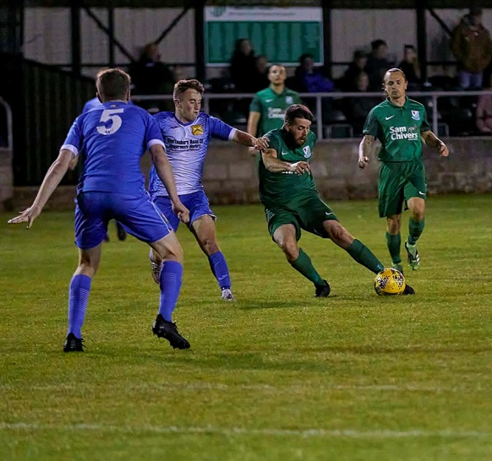
Radstock ran out 3-2 winners at home to Sherborne in an entertaining affair, condemning the Zebras to their first defeat of the campaign. Craig Sheppard scored in either half for the home side, with George Walker-Wiltshire also getting on the scoresheet, while Alex Murphy and Aaron White both found the back of the net in defeat for the unfortunate Sherborne. Tytherington Rocks seem to be very much feast of famine at the moment, with their 4-1 win away at Longwell Green Sports helping them leapfrog their hosts on the league ladder. The Rocks are capable of conceding plenty of goals, but are also proving to be strong at the other end of the field also, with Nathan Croot, Ethan Johnson, Ryan Sharpe and Rahib Rehman all scoring in Monday afternoon’s victory. Unfortunately, the fixture between Bristol Telephones & Lebeq was abandoned followed a bad injury to one of the visitors playing X1.
Despite seeing striker Courtney Charles sent off after just seven minutes, First Division leaders Welton Rovers extended their unbeaten run to nine games thanks to a 3-0 win over Cheddar on Tuesday evening. The early setback kept Rovers quiet during much of the first half, before a stunning strike from 25 yards out by Jaiden Savery put them ahead in the 38th minute. James Batchelor then scored from a similar distance soon after the interval, with the prolific Jake Slocombe completing the scoring 15 minutes from time. 24 hours later, there was another big home win, with Warminster putting four past Odd Down. Seth Wain scored in either half for the home side, with Alex Churchyard and Lewis Graham also finding the back of the net.
Action from Welton’s midweek win over Cheddar courtesy of Mark Pile.
FA Cup: All three remaining Western League sides were knocked out of this season’s FA Cup following defeats against higher-ranked opposition. Exmouth were beaten 3-1 at Bolitho Park against Truro City, with Rocky Neal, Ryan Brett and Tyler Harvey all scoring in the first half for the home side. Shepton Mallet capitulated at home to Taunton, conceding five goals after the interval on their way to a humbling 8-1 loss, with Toby Holmes notching a hat-trick for the away side. Ten-man Bridgwater threatened a late fightback away at Baskingstoke, only to concede twice in the closing stages to lose 4-1 at the Winklebury Sports Complex. Having conceded a brace of goals to Conor Lynch either side of the interval, Bridgy’s task then got even tougher when Mike Duffy was dismissed on the hour mark. The hosts missed a penalty to put the game beyond doubt, and Bridgwater capitalised, with Nick Woodrow halving the arrears with around ten minutes remaining. Throwing extra men forward in the search of an equaliser, United were picked off, with D’Andre Brown and then Lynch giving the scoreline a more one-sided look.
Premier Division: In a game which went down to the wire, Saltash scored twice in the final five minutes to complete a dramatic 3-2 turnaround win at home to Buckland. Having fallen behind to an early Ryan Bush header, Saltash saw Dave Barker’s 20th minute penalty saved, before eventually getting back on level terms when Sam Hughes struck on his 400th appearance for the club. The Ashes didn’t have long to celebrate and were on the back foot once more when Owen Stockton fired home an unstoppable drive from more than 20 yards out to put the away side back in front. With the game now into the final ten minutes, Saltash were awarded a lifeline when the referee awarded them a penalty for handball in the box, with Chris Menhenhick making no mistake from 12 yards out to level the scores. Rob Farkins was sent off for his protestations following the award of the spot kick, and the ten men of Buckland were unable to hold out against their rampant hosts with Barker crossing for Hughes to make it 3-2 deep into stoppage time. Mousehole flew out of the blocks at home to Millbrook, scoring three times in the opening quarter of an hour on their way to a 5-1 victory. Tallan Mitchell, Mark Goldsworthy and Callam Mconie all scored during the early stages to put Mousehole in complete control, with Jake Foster seemingly giving the visitors a slight foothold five minutes before the interval. That positivity didn’t last long however, with Goldsworthy restring the three-goal buffer in the 43rd minute, before Mitchell added a fifth goal midway through the second half to wrap up victory. Harry Stevens and Liam Short each scored twice during Ilfracombe’s 5-2 win at home to Bridport, while Helston beat Cadbury Heath 2-0 thanks to goals in the final 20 minutes from Craig Veal and Stu Bowker.

Brislington moved into the top half following an impressive 3-2 win at home to league-leaders Bitton on Saturday afternoon. George Jones was the hero for Bris, scoring in either half for the hosts after Jordan Scadding had put them in front during the opening 20 minutes. Bitton were always in the contest, and saw goals from Dean Griffiths and Josh Egan keep them close, but they couldn’t find a late equaliser and succumbed to their first loss this season. Tavistock took advantage of that Bitton defeat, and now find themselves level atop the division after beating Wellington 3-1 at Langsford Park. The slightly delayed kickoff didn’t disrupt Tavistock who took the lead inside ten minutes of the opening kickoff through Tallan Burns. A strong response from Welly saw youngster Josh Baker level for them at the beginning of the second half, but the Lambs found a second wind, scoring twice more through Josh Grant and Liam Prynn to secure all three points.
Ashton & Backwell gained local bragging rights, scoring a late winner on their way to a 3-2 derby triumph away at Clevedon, while Keynsham maintained their strong start, cancelling out Harry Foster’s early opener to claim a 1-1 draw away at Street.
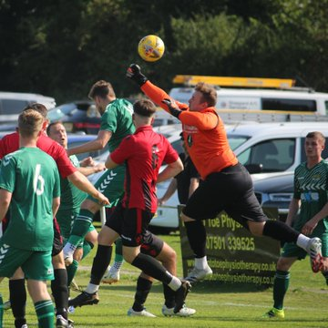
First Division: Welton Rovers just about hung onto their unbeaten start, scoring three minutes from time to secure a 1-1 draw away at Tytherington Rocks. The early season pacesetters trailed for much of the contest following Perran Blundell’s opener, but managed to remain undefeated when Joe Garland grabbed a last-gasp equaliser from close range. It has been a slightly underwhelming start for Wells City, but they enjoyed a strong showing on Saturday, scoring five unanswered goals to secure a come-from-behind 5-1 win over Bishop Sutton. After falling behind to the prolific Oaklan Buck, it was all one-way traffic with Ross Padfield, Craig Herrod and Callum Ham all finding the scoresheet to add to Adam Wright’s double. Sherborne rebounded well after suffering their first defeat earlier this week, easing to a 3-0 win away at Boco. Going up against their unbeaten hosts, Sherborne made a strong start with Sam Farthing handing them a 7th minute lead. Anthony Herrin then doubled the Zebras advantage ten minutes before the break, with Ash Guppy completing the scoring late on. Wincanton secured a much-needed victory away at Bishops Lydeard, cancelling out Mark Cornish’s 14th minute opener before storming away during the second half to eventually win by four goals to two. Toby Dolton Cole and Brett Cotterill each struck twice for the away side to settle the contest, with Wincanton moving up a couple of spots following their inauspicious start to date. Things have been much more encouraging for Warminster during the first month of the season and that continued when they claimed a 3-0 win away at Hengrove. A fifth minute header from Alex Churchyard set the ball rolling for Town, with Lewis Graham making it 2-0, before Seth Wain completed the scoring with an acrobatic effort midway through the second half. Second half strikes from Tom Bevan and James Boyland led Gillingham Town to a 2-0 win at home to Longwell Green Sports, while Odd Down salvaged a point when Caelen Simpson scored late on to help them draw 1-1 in Bath against Bristol Telephones. The points were also shared in the top-four clash between Cheddar and Oldland, with all four goals scored during a frantic first half at Bowdens Park. A win would have seen Oldland jump up to second spot, and despite going ahead twice thanks to a brace from Owen McCallum, they were clawed back on each occasion by the Cheesemen for whom Dean Chrisostomu and Adam Jones found the back of the net. Almondsbury are finally in the winner’s circle this season, defeating fellow struggles Devizes 3-1 and at Bristol Road, two goals early in the second half saw Radstock come from behind to win 2-1 away at Portishead Town.
Action from Warminster’s 3-0 victory away at Hengrove, courtesy of Jamie House (@Jimmer211993)
Recent Results
Monday 30th August
Premier Division
Ashton & Backwell United 0-0 Shepton Mallet 90
Buckland Athletic 2-1 Exmouth Town 223
Cadbury Heath 0-2 Brislington 85
Clevedon Town 2-2 Wellington 116
Keynsham Town 6-2 Bridport 109
Millbrook 0-3 Helston Athletic
Mousehole 1-2 Tavistock 171
Saltash United 2-3 Ilfracombe Town
Street 2-1 Bridgwater United
First Division
Almondsbury 0-1 AEK Boco 64
Bishop Sutton 2-1 Portishead Town 60
Bishops Lydeard 2-1 Wells City
Bristol Telephones A-A Lebeq United 74
Devizes Town 1-2 Gillingham Town 123
Longwell Green Sports 1-4 Tytherington Rocks
Oldland Abbotonians 3-0 Hengrove Athletic 77
Radstock Town 3-2 Sherborne Town
Tuesday 31st August 2021
First Division
Welton Rovers 3-0 Cheddar 237
Wednesday 1st September 2021
First Division
Warminster Town 4-0 Odd Down 128

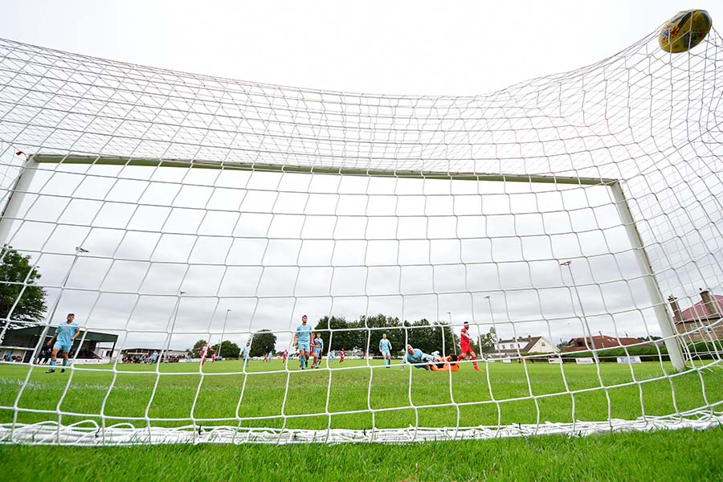

A goalmouth image taken by John Newport during Radstock’s recent win over Sherborne.

Saturday 4th September 2021
FA Cup
Baskingstoke 4-1 Bridgwater Town
Shepton Mallet 1-8 Taunton Town
Truro City 3-1 Exmouth Town
Premier Division
Brislington 3-2 Bitton 106
Clevedon Town 2-3 Ashton & Backwell United 96
Helston Athletic 2-0 Cadbury Heath 115
Ilfracombe Town 5-2 Bridport
Mousehole 5-1 Millbrook
Saltash United 3-2 Buckland Athletic
Street 1-1 Keynsham Town
Tavistock 3-1 Wellington
First Division
AEK Boco 0-3 Sherborne Town 231
Almondsbury 3-1 Devizes Town 31
Bishops Lydeard 2-4 Wincanton Town 68
Cheddar 2-2 Oldland Abbotonians 92
Gillingham Town 2-0 Longwell Green Sports 49
Hengrove Athletic 0-3 Warminster Town 76
Odd Down 1-1 Bristol Telephones 28
Portishead Town 1-2 Radstock Town 66
Tytherington Rocks 1-1 Welton Rovers
Wells City 5-1 Bishop Sutton

On the most recent episode of the Podcast, Bitton manager Dan Langdon looks at his sides impressive start to the season, while Radstock’s Ryan Child hopes his side can push on following their impressive Bank Holiday victory.
http://toolstationleague.com/season-2021-22-podcast-episode-5/

Upcoming Fixtures
Tuesday 7th September 2021
Premier Division
Bitton vs Ashton & Backwell United 19:30KO
Bridgwater United vs Ilfracombe Town 19:45KO
Bridport vs Wellington 19:45KO
Brislington vs Street 19:30KO
Keynsham Town vs Clevedon Town 19:45KO
Millbrook vs Buckland Athletic 19:45KO
Shepton Mallet vs Cadbury Heath 19:30KO
Tavistock vs Helston Athletic 19:45KO

Wednesday 8th September 2021
Premier Division
Exmouth Town vs Saltash United 19:30KO

Saturday 11th September 2021 (3pm kick-off unless noted)
FA Vase – First Qualifying Round
Almondsbury vs Cheltenham Saracens
Bradford Town vs Wincanton Town
Brislington vs Fleet Town
Devizes Town vs Badshot Lea
Elburton Villa vs Welton Rovers
Exmouth Town vs Shepton Mallet
Farnham Town vs Warminster Town
Hengrove Athletic vs Ascot United
Ilfracombe Town vs Bishop Sutton
Radstock Town vs Arundel
Ringwood Town vs Bridport
Saltash United vs Cullompton Rangers
Sherborne Town vs Verwood Town
Stonehouse Town vs Ashton & Backwell United
Torrington vs Bishops Lydeard
Premier Division
Buckland Athletic vs Bridgwater United
Cadbury Heath vs Mousehole
Helston Athletic vs Keynsham Town
Millbrook vs Clevedon Town
Street vs Tavistock
Wellington vs Bitton
First Division
AEK Boco vs Portishead Town
Bristol Telephones vs Gillingham Town
Odd Down vs Tytherington Rocks
Oldland Abbotonians vs Lebeq United
Wells City vs Longwell Green Sports

League Tables
 | PREMIER DIVISION | Played | Won | Drawn | Lost | GD | Points
1 | Bitton | 8 | 6 | 1 | 1 | 13 | 19
2 | Tavistock | 9 | 6 | 1 | 2 | 9 | 19
3 | Keynsham Town | 9 | 4 | 4 | 1 | 10 | 16
4 | Buckland Athletic | 8 | 4 | 3 | 1 | 10 | 15
5 | Helston Athletic | 7 | 4 | 2 | 1 | 10 | 14
6 | Saltash United | 8 | 4 | 2 | 2 | 9 | 14
7 | Shepton Mallet | 7 | 3 | 4 | 0 | 18 | 13
8 | Ilfracombe Town | 7 | 4 | 0 | 3 | 2 | 12
9 | Brislington | 8 | 4 | 0 | 4 | -9 | 12
10 | Exmouth Town | 6 | 3 | 2 | 1 | 12 | 11
11 | Bridgwater Town | 6 | 3 | 1 | 2 | 4 | 10
12 | Wellington | 6 | 2 | 2 | 2 | -4 | 8
13 | Mousehole | 6 | 2 | 1 | 3 | 0 | 7
14 | Clevedon Town | 8 | 1 | 4 | 3 | -2 | 7
15 | Street | 8 | 2 | 1 | 5 | -6 | 7
16 | Cadbury Heath | 10 | 1 | 2 | 7 | -19 | 5
17 | Millbrook | 6 | 1 | 1 | 4 | -7 | 4
18 | Ashton & Backwell United | 7 | 1 | 1 | 5 | -11 | 4
19 | Bridport | 10 | 1 | 0 | 9 | -39 | 3

 | FIRST DIVISION | Played | Won | Drawn | Lost | GD | Points
1 | Welton Rovers | 10 | 8 | 2 | 0 | 16 | 26
2 | Cheddar | 9 | 6 | 1 | 2 | 6 | 19
3 | Warminster Town | 9 | 5 | 2 | 2 | 10 | 17
4 | Oldland Abbotonians | 10 | 5 | 2 | 3 | 3 | 17
5 | Sherborne Town | 7 | 5 | 1 | 1 | 18 | 16
6 | Bishop Sutton | 9 | 5 | 1 | 3 | 6 | 16
7 | AEK Boco | 8 | 4 | 3 | 1 | 2 | 15
8 | Radstock Town | 10 | 4 | 3 | 3 | -2 | 15
9 | Odd Down | 9 | 4 | 2 | 3 | 1 | 14
10 | Wells City | 9 | 3 | 2 | 4 | 1 | 11
11 | Lebeq United | 8 | 3 | 2 | 3 | -1 | 11
12 | Gillingham Town | 8 | 3 | 2 | 3 | -3 | 11
13 | Tytherington Rocks | 9 | 3 | 2 | 4 | -4 | 11
14 | Bristol Telephones | 7 | 3 | 1 | 3 | 2 | 10
15 | Portishead Town | 8 | 3 | 1 | 4 | -1 | 10
16 | Longwell Green Sports | 8 | 2 | 2 | 4 | -4 | 8
17 | Wincanton Town | 6 | 2 | 1 | 3 | 5 | 7
18 | Bishops Lydeard | 9 | 2 | 1 | 6 | -9 | 7
19 | Hengrove Athletic | 9 | 1 | 2 | 6 | -14 | 5
20 | Almondsbury | 9 | 1 | 1 | 7 | -9 | 4
21 | Devizes Town | 9 | 0 | 2 | 7 | -23 | 2

