Latest Round-ups:
#5
Season 2021/22
Midweek Action: Millbrook’s run in the FA Cup came to an end during the week after they fell to a 2-1 defeat in their replay against Willand Rovers. Two goals early in the second half ended Millbrook’s hopes, with a late consolation from Jason Richards not quite enough for them to force extra-time.

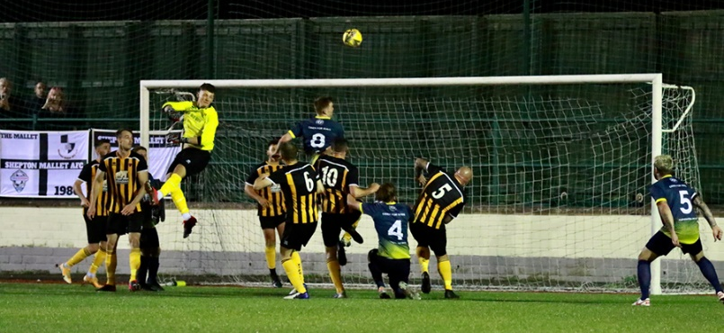
In the Premier Division, Bitton overturned a half-time deficit to beat Street 2-1 on Tuesday evening. Harry Foster’s opener put Street in command at the interval, but the hosts regrouped, and after Dean Griffiths chipped home to level the scores, the same man then converted from the spot 20 minutes from time to complete the turnaround. Bridgwater United maintained their strong start to the campaign, with goals inside the opening ten minutes from Adnan Hiroli and Jack Taylor leading them to a 2-0 win away at Bridport. The other big winners that night were Tavistock, after a brace from Liam Prynn, plus a goal from Josh Grant handed them a 3-0 victory at home to Ilfracombe Town. Elsewhere, Keynsham and Shepton Mallet remain among the early pacesetters following their 2-2 draw at the AJN Stadium. The visitors will be the happier of the two sides, after goals in the final 15 minutes from Nick Hewlett and Dawid Regula helped them snatch a share of the spoils. For Keynsham, a 33rd minute red card to Harley Purnell made their task a little bit too tough, with goals from Jack Dancey and Matt Brown giving them a two-goal lead they were unable to hang on to. The following evening, all three fixtures ended in draws, with the top-seven clash between new boys Saltash and Helston failing to produce a goal during the 90 minutes. Exmouth Town were denied victory at the death by Buckland Athletic, with the visitors scoring a last-minute equaliser to maintain their unbeaten start. Town looked set to hand Buckland their first defeat of the campaign thanks to a first-half goal from Owen Howe, but with the final whistle imminent, Ryan Bush found the back of the net to salvage a point for his side. Cadbury Heath and Clevedon Town drew 2-2 for the second time in the space of three weeks, after the visitors struck in the 89th minute to end their three-match losing run. The Heath enjoyed strong spells for much of the match, and led on two occasions thanks to a double from Dean Preddie, but they let their advantage slip each time, with Ethan Feltham levelling in first-half stoppage time, before the same man then smashed home his second in the closing stages following strong work from teammate Archie Ferris.
Goalmouth action from Keynsham’s midweek draw with Shepton Mallet, courtesy of Haydn Jones.
Premier Division: This week’s Friday night offering saw Wellington claim a 2-0 win away at Street thanks to an excellent first half performance. Josh Baker’s diving header set the visitors on their way after 18 minutes, with Jake Quick then capitalising on a defensive error to double their advantage after half an hour.
It was a special afternoon for Bridgwater’s Jack Taylor, who struck a hat-trick in his sides 3-0 win at home to Saltash. Sitting on 99 goals for the club, Taylor took no time at all in reaching three figures, poking the ball home after just ten minutes to put the hosts ahead. Taylor then doubled his tally from the spot at the end of the first half, before completing a perfect afternoon for the frontman when he headed home his third five minutes after the interval. Exmouth also had plenty to celebrate on Saturday afternoon, with two members of their squad hitting trebles in their 8-1 thumping of Cadbury Heath. Incredibly, it was the away side who went ahead in the fourth minute through Dean Preddie, but that was as good as it got for the Heath, with Aaron Denny scoring twice to put Town 2-1 up midway through the first half. Jordan Harris then took over towards the end of the first half, scoring twice in quick succession, before Ben Steer added two more in the opening stages of the second period. With the game heading towards it’s denouement, both Harris and Steer found time to complete their hat-tricks on a one-sided afternoon at the King George V Ground. Syd Camper played a starring role for Clevedon Town, with the influential forward playing a role in all of his side’s goals during a 4-2 win away at Brislington. It was all Clevedon in the opening stages, and after Camper had fired them in front after 20 minutes, they were awarded a penalty with the opportunity to double their advantage. Alex Camm’s spot kick was saved by Jason Matthews in the Brislington net, however the hosts were soon punished once again with Camper producing an exquisite chip which gave Matthews no chance of stopping. Early in the second half, Kieron Proctor nipped in to pull a goal back for the home side, claiming his first goal for the club in the process. Camper then turned provider during a five-minute blitz which all-but decided the outcome of the game, with Sam Hedges powering home his corner in the 61st minute, before Elliot Nicholson got on the end of a Camper through ball before tucking the ball home. Proctor struck again midway through the second half, but the Seasiders managed to hang on to claim their first three points of the season at the sixth time of asking.

The points were shared at Langsford Park, where Millbrook twice came from a goal back to claim a 2-2 draw against Tavistock. There was a fearsome pace to the game, with plenty of action in the early stages, much of which revolved around Tavistock’s Josh Grant. After he had put the home side in front in the tenth minute, Grant then had the chance to double his tally from the spot but was denied by Sam Borthwick in the Millbrook goal. Unfortunately for Borthwick, he was injured in the aftermath of that penalty save and had to be replaced, but his teammates responded well and were soon back on level terms thanks to Jake Foster. A goal early in the second half from Liam Prynn restored the Lambs advantage, but they were denied the victory after Rikki Sheppard curled home a fine leveller 15 minutes from time. Ilfracombe battled back from a couple of 3-0 losses, by beating Mousehole 2-0 thanks to a strong second half showing. Following a goalless opening hour, Ollie Stevens bundled the ball home to put the home side in front, with Liam Short slotting home soon after to wrap up the win.

There was a tense basement battle at St Mary’s Field, where Bridport held off a late tirade from Ashton & Backwell to eventually prevail by two goals to one. The game came to life just after the hour mark, with Bridport taking a rare lead thanks to a goal from Riley Greenwood-Neate. On the back of seven straight losses, confidence can’t have been high among the Bridport ranks, and they only managed to hold onto their lead for less than five minutes, with Ashton equalising following an unstoppable 35-yard drive from Conor Hartley. A push inside the area saw Bridport awarded a penalty which Dan Baggs converted to restore the Bees advantage, but they still had 15 minutes to hold out for their first three points of the season. United huffed and puffed but were unable to find the elusive goal in the closing stages, with Baggs proving to be a hero at both ends of the field when he produced a vital goal-line clearance late on. At the other end of the table, Bitton strengthened their lead atop the division thanks to a 4-2 win away at Helston Athletic. After Craig Veal put the home side in front in the third minute, Bitton turned the tables, with Dean Griffiths scoring a quick brace prior to Jack Ball’s first goal for the club. Matt Groves then extended the lead to 4-1, before a Stu Bowker penalty followed by a Sean Keet red card gave Bitton a few headaches during the final 20 minutes. Having drawn 2-2 during the midweek round of fixtures, Shepton Mallet and Keynsham shared the spoils once again after battling out a goalless draw.

First Division: Welton’s outstanding start to the season shows no sign of letting up after they ran out 5-2 winners away at Oldland Abbotonians. Goals early in either half from Jake Slocombe, plus an effort from Will Gould put the Green Army three ahead against an Oldland side who started the day inside the top six. A special moment for Chris Pile saw the substitute score on his 200th appearance for the club, with Slocombe then completing his hat-trick in stoppage time after Oldland had threatened an unlikely comeback late on. Cheddar hung on by the barest of margins to beat Wincanton Town 3-2, giving them their sixth win of the campaign. Tom Richardson’s far post header had levelled the scores late in the first half after Ethan Reed had put the Cheesemen ahead, with a long-range effort from Rick Bennett restoring the hosts lead early in the 50th minute. It was then Harry Turner’s turn to equalise for the visitors, before Callum Laird did just enough to roll the ball home for Cheddar, giving them a 3-2 lead as the game headed towards the closing stages. Seven minutes into stoppage time, Wincanton’s pressure finally paid off when they were awarded a penalty, but Kieran Webster was up to the challenge, just about doing enough to stop the ball crossing the line to preserve Cheddar’s win. In the battle of Bishop’s, Lydeard caused an early-season shock, winning 2-1 at Lakeview against the in-form Bishop Sutton. It was the visiting Lydeard side who went ahead 17 minutes into the game when Doug Camilo beat four defenders before smashing the ball home. The unstoppable Oaklan Buck scored his seventh goal in three games to draw Sutton level, but the away side hit back instantly, with Jack Bryant tucking home a 43rd minute penalty to eventually see the Lyds secure their first three-point haul of the season. Another side to taste victory for the first time this month were Gillingham Town after goals from Elliot Bevis, Aaron Rodriguez and Tom Bevan helped them beat Radstock 3-1.

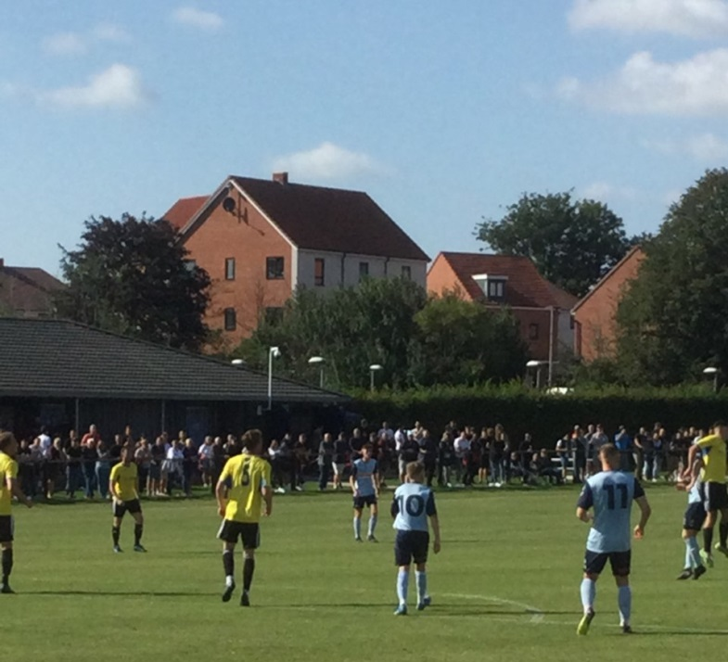
A double from Dan Parslow proved vital for Portishead, as they held off the challenge of Odd Down to win 3-1. Parslow struck at the beginning of both halves to put Posset two goals ahead, with Callum Townsend then extending the advantage further before the Bath side scored a late consolation through Cameron New. Lebeq United were also victors by the same 3-1 scoreline, with Cameron Brown, Rick Davis and Dan Payne all getting on the scoresheet in their win over Warminster. Adam Wright and Thomas Smith scored the crucial goals for Wells City in their 2-0 win at home to Almondsbury, while Bristol Telephones recovered from an early tenth minute deficit to beat Hengrove Athletic 4-1. In a terrific local derby, AEK Boco defeated Longwell Green Sports 3-2 to maintain their unbeaten start to life in the Western League. Having trailed at half-time, Boco were then then reduced to ten men before producing a dominant 20-minute spell during the second-half which saw them surge ahead. The away side moved within a goal late on, but were unable to make the extra man count as Boco prevailed in front of the large crowd. Unfortunately, the fixture between Sherborne and Tytherington Rocks had to be abandoned during the first half due to a serious injury sustained by Rocks player Tom Rummels.
A large crowd take in the derby between AEK Boco & Longwell Green Sports, courtesy of John Pool.
Recent Results
Tuesday 24th August 2021
FA Cup Preliminary Round Replay
Millbrook 1-2 Willand Rovers
Premier Division
Bitton 2-1 Street 78
Bridport 0-2 Bridgwater United 147
Keynsham Town 2-2 Shepton Mallet 194
Tavistock 3-0 Ilfracombe Town

Wednesday 25th August 2021
Premier Division
Cadbury Heath 2-2 Clevedon Town 68
Exmouth Town 1-1 Buckland Athletic 261
Saltash United 0-0 Helston Athletic

Friday 27th August 2021
Premier Division
Street 0-2 Wellington

Saturday 28th August 2021
Premier Division
Bridgwater United 3-0 Saltash United 402
Bridport 2-1 Ashton & Backwell United 128
Brislington 2-4 Clevedon Town 95
Exmouth Town 8-1 Cadbury Heath 227
Helston Athletic 3-4 Bitton
Ilfracombe Town 2-0 Mousehole 101
Shepton Mallet 0-0 Keynsham Town 205
Tavistock 2-2 Millbrook 178
First Division
AEK Boco 3-2 Longwell Green Sports 285
Bishop Sutton 1-2 Bishops Lydeard 52
Cheddar 3-2 Wincanton Town 91
Gillingham Town 3-1 Radstock Town
Hengrove Athletic 1-4 Bristol Telephones 90
Lebeq United 3-1 Warminster Town 25
Oldland Abbotonians 2-5 Welton Rovers 75
Portishead Town 3-1 Odd Down 51
Sherborne Town A-A Tytherington Rocks
Wells City 2-0 Almondsbury 58

Bank Holiday Monday Fixtures

Monday 30th August (3pm kick-off unless noted)
Premier Division
Ashton & Backwell United vs Shepton Mallet
Buckland Athletic vs Exmouth Town
Cadbury Heath vs Brislington
Clevedon Town vs Wellington
Keynsham Town vs Bridport
Millbrook vs Helston Athletic
Mousehole vs Tavistock
Saltash United vs Ilfracombe Town
Street vs Bridgwater United
First Division
Almondsbury vs AEK Boco
Bishop Sutton vs Portishead Town
Bishops Lydeard vs Wells City
Bristol Telephones vs Lebeq United
Devizes Town vs Gillingham Town
Longwell Green Sports vs Tytherington Rocks
Oldland Abbotonians vs Hengrove Athletic
Radstock Town vs Sherborne Town 13:00KO

On the most recent episode of the Podcast, Shepton Mallet joint-manager John Durbin discussed his side’s famous FA Cup victory at Melksham, while Warminster’s Andy Crabtree explained the importance of being a community club.
http://toolstationleague.com/season-2021-22-podcast-episode-4/

Upcoming Fixtures

Tuesday 31st August 2021
First Division
Welton Rovers vs Cheddar 19:30KO
Wednesday 1st September 2021
First Division
Warminster Town vs Odd Down 19:45KO
Saturday 4th September 2021 (3pm kick-off unless noted)
FA Cup
Baskingstoke vs Bridgwater Town
Shepton Mallet vs Taunton Town
Truro City vs Exmouth Town
Premier Division
Brislington vs Bitton
Clevedon Town vs Ashton & Backwell United
Helston Athletic vs Cadbury Heath
Ilfracombe Town vs Bridport
Mousehole vs Millbrook
Saltash United vs Buckland Athletic
Street vs Keynsham Town
Tavistock vs Wellington
First Division
AEK Boco vs Sherborne Town
Almondsbury vs Devizes Town
Bishops Lydeard vs Wincanton Town
Cheddar vs Oldland Abbotonians
Gillingham Town vs Longwell Green Sports
Hengrove Athletic vs Warminster Town
Odd Down vs Bristol Telephones
Portishead Town vs Radstock Town
Tytherington Rocks vs Welton Rovers
Wells City vs Bishop Sutton

League Tables
 | PREMIER DIVISION | Played | Won | Drawn | Lost | GD | Points
1 | Bitton | 7 | 6 | 1 | 0 | 14 | 19
2 | Tavistock | 7 | 4 | 1 | 2 | 6 | 13
3 | Shepton Mallet | 6 | 3 | 3 | 0 | 18 | 12
4 | Buckland Athletic | 6 | 3 | 3 | 0 | 10 | 12
5 | Keynsham Town | 7 | 3 | 3 | 1 | 6 | 12
6 | Exmouth Town | 5 | 3 | 2 | 0 | 13 | 11
7 | Saltash United | 6 | 3 | 2 | 1 | 9 | 11
8 | Bridgwater United | 5 | 3 | 1 | 1 | 5 | 10
9 | Helston Athletic | 5 | 2 | 2 | 1 | 5 | 8
10 | Wellington | 4 | 2 | 1 | 1 | -2 | 7
11 | Clevedon Town | 6 | 1 | 3 | 2 | -1 | 6
12 | Ilfracombe Town | 5 | 2 | 0 | 3 | -2 | 6
13 | Brislington | 6 | 2 | 0 | 4 | -12 | 6
14 | Cadbury Heath | 8 | 1 | 2 | 5 | -15 | 5
15 | Millbrook | 4 | 1 | 1 | 2 | 0 | 4
16 | Mousehole | 4 | 1 | 1 | 2 | -3 | 4
17 | Street | 6 | 1 | 0 | 5 | -7 | 3
18 | Bridport | 8 | 1 | 0 | 7 | -32 | 3
19 | Ashton & Backwell United | 5 | 0 | 0 | 5 | -12 | 0

 | FIRST DIVISION | Played | Won | Drawn | Lost | GD | Points
1 | Welton Rovers | 8 | 7 | 1 | 0 | 13 | 22
2 | Cheddar | 7 | 6 | 0 | 1 | 9 | 18
3 | Sherborne Town | 5 | 4 | 1 | 0 | 16 | 13
4 | Bishop Sutton | 7 | 4 | 1 | 2 | 9 | 13
5 | Odd Down | 7 | 4 | 1 | 2 | 5 | 13
6 | Oldland Abbotonians | 8 | 4 | 1 | 3 | 0 | 13
7 | AEK Boco | 6 | 3 | 3 | 0 | 4 | 12
8 | Warminster Town | 7 | 3 | 2 | 2 | 3 | 11
9 | Lebeq United | 8 | 3 | 2 | 3 | -1 | 11
10 | Portishead Town | 6 | 3 | 1 | 2 | 1 | 10
11 | Bristol Telephones | 6 | 3 | 0 | 3 | 2 | 9
12 | Radstock Town | 8 | 2 | 3 | 3 | -4 | 9
13 | Longwell Green Sports | 6 | 2 | 2 | 2 | 1 | 8
14 | Wells City | 7 | 2 | 2 | 3 | -2 | 8
15 | Tytherington Rocks | 7 | 2 | 1 | 4 | -7 | 7
16 | Gillingham Town | 6 | 1 | 2 | 3 | -6 | 5
17 | Hengrove Athletic | 7 | 1 | 2 | 4 | -8 | 5
18 | Wincanton Town | 5 | 1 | 1 | 3 | 3 | 4
19 | Bishops Lydeard | 7 | 1 | 1 | 5 | -8 | 4
20 | Devizes Town | 7 | 0 | 2 | 5 | -20 | 2
21 | Almondsbury | 7 | 0 | 1 | 6 | -10 | 1

