Latest Round-ups:
Season 2021/22
#4
Midweek Action: Bridgwater finally booked their spot in the Preliminary round of the FA Cup after beating Brixham 2-1 on Tuesday evening. A curled effort from George King set United on their way in the first half, but they were pegged back midway through the second half when Josh Parry slotted home. The winner came via a set piece, with Tom Ellis’ long throw glanced home by Jacob Spence to set up a clash with Ilfracombe in the next round.

There was another big win for Shepton Mallet in the Premier Division on Tuesday as they eased to a 5-0 triumph at home to Ashton & Backwell United. The hosts took a while to get going, and only broke the deadlock after 28 minutes with defender Joel Sisson scoring his first goal for the club. Jack Fillingham and Joe Morgan then scored toward the end of the first half to put Mallet three to the good, with Fillingham and Alessandro Costanza completing the scoring after half-time. Buckland also have ten points from their first four games, after beating bottom-side Bridport 4-0 at Homers Heath. A Richard Groves penalty was all that separated the sides at the break, before Buckland added some late gloss to the scoreline, with Nathan Cooper, Charlie Johansen and Frazer Clark each finding the back of the net during a one-sided second-half. Local bragging rights went to Brislington, after a Jordan Scadding goal five minutes after the interval helped them squeeze past Cadbury Heath, while a brace from Ryan Richards helped fire Tavistock to an impressive 4-2 victory away at Millbrook. 24 hours later, goals from Dean Griffiths and Joe McLennan helped Bitton overturn a half-time deficit away at Clevedon to prevail by two goals to one.

Oaklan Buck was the standout performer in the First Division during the midweek fixtures, with the Bishop Sutton frontman scoring an 18-minute hat-trick during his sides 4-1 win at home to Radstock. Buck did all his damage during a terrific spell in the first half which saw him put the game beyond doubt, with Sutton adding a fourth in stoppage time through Ben Hardidge. Welton completed their second successive 1-0 victory on Tuesday, with defender Joe Garland scoring the vital goal once again to see off the challenge of Wells City. Cheddar secured their fifth league win of the campaign, with Simon McElroy scoring in either half of their 4-2 victory away at Hengrove, while a stunning hat-trick from the in-form Luke Bryan helped fire Odd Down to an entertaining 5-2 win at home to Devizes. In the other game that evening, a pair of second half penalties saw Portishead twice battle back from a goal down to secure a 2-2 draw in their mid-table battle at Bristol Road against Tytherington Rocks. There were fewer goals in the fixtures on Wednesday evening, but Oldland Abbotonians won’t be upset about that, with an exquisite finish from Owen McCallum handing them a 1-0 win at home to struggling Almondsbury. There was a goalless stalemate between Warminster and Sherborne, while at Oaklands Park, Lebeq and AEK Boco maintained their solid starts to the season following a 1-1 draw.
FA Cup: A trio of Western League sides confirmed their place in the next round of the FA Cup after claiming impressive victories on Saturday afternoon. Shepton Mallet toppled higher-ranked opposition to progress, holding on to claim a 1-0 win away at Melksham Town. The crucial moment came two minutes after the interval, with Jack Fillingham sliding the ball home to give Mallet a famous cup triumph. Exmouth Town will join them in the draw for the next stage of the competition after overturning an early deficit to beat Bristol Manor Farm 2-1. The Devonians made the worst possible start to the tie, falling behind inside 45 seconds following a well-taken free kick by Jamie Bird for the visitors. Fortunately, Town didn’t take long to get back on level terms, with Aaron Denny levelling in the fifth minute, before Ben Steer struck early in the second half to complete the turnaround. In an all-Western League clash, Jack Taylor played a starring role in Bridgwater United’s 3-0 win over Ilfracombe Town. The home side went ahead midway through the first half, with the influential Taylor finding teammate George King in the area who then finished with aplomb. Taylor then nodded home a Jake Llewellyn free kick to double their advantage, with Adnan Hiroli using his chest to direct the ball into the net early in the second half from another Taylor cross to complete the scoring. An understrength Tavistock side were beaten 3-0 by Mangotsfield Town to bow out of the competition, while Mousehole couldn’t capitalise on taking an early lead through Hayden Turner, eventually falling to a 3-1 defeat at home to Plymouth Parkway. A stirring performance from Millbrook will see them face Willand Rovers in a replay next week after they came from behind on three occasions to draw 3-3. Goals from the in-form Rikki Shepherd had twice clawed Millbrook back into the contest following goals from the hosts, but all the hard work looked to have been undone when Will Richards volleyed home for Willand with 11 minutes remaining. Millbrook never gave up though, and in stoppage time, Tom Payne’s corner went straight into the home team’s net to set up next week’s rematch at Jenkins Park.
Shepton Mallet players celebrate going ahead in their cup tie at Melksham. Photo courtesy of Haydn Jones.

Premier Division: Two away sides managed to score eight goals on Saturday afternoon, with Bitton and Saltash both dismantling their hosts while maintaining their unbeaten starts to the campaign. For Bitton, it was a very comfortable 90 minutes, with the new league leaders scoring four times in either half on their way to an 8-1 win over Bridport. The trio of Ash Kington, Joe McLennan and Sean Keet all scored in both halves to complete goalscoring doubles, with a curled finish from Ben Withey and a Dean Griffiths effort rounding out the scoring. For Saltash United, their 8-0 win away at Brislington came in difficult circumstances, after they lost Tom Cleveland to a bad leg injury early in the contest. Following a delay of over half an hour while Cleveland received medical attention, the Ashes hit the ground running, with Sam Hughes proving to be close to unplayable, notching a 32-minute hat-trick to put his side three goals to the good. Hughes scored twice more after the interval to take his personal tally to five, with Reece Thompson, Dave Barker and debutant Alex Cairo also finding the back of the net during a rampant final quarter.

The remaining clashes were all much tighter affairs, with Cadbury Heath and Wellington each registering their first three points of the season thanks to a pair of 3-2 victories. Heath were twice pegged back by visitors Street before prevailing in Bristol, with Jordan Lovibond notching twice for the defeated Cobblers. An early Ben Whitecross had put Heath ahead only for Lovibond to equalise from long range, with Matt Huxley restoring the hosts advantage after just 17 minutes. Lovibond then struck again early in the second half, before the home side put enough pressure on the Street backline to force an own-goal which proved to be decisive. Wellington’s first win of the season came away at Ashton & Backwell, with Miles Quick scoring the fifth goal of the contest to decide the outcome. The Tangerines had gained a strong foothold in the opening half hour, with Josh Baker following up an earlier own goal to put them two goals in front. Brad Skidmore then struck either side of the interval to draw the sides level, before Quick made it 3-2 thanks a smart set-piece from teammate Sam Towler. Buckland and Keynsham still remain among the early season pacesetters following their 2-2 draw at Homers Heath. A Ryan Bush goal after 17 minutes had set the Bucks on their way in the early stages, before efforts from Will Hailston and Nat Brown turned the game in the visitors favour. The ever-reliable Richard Groves curled the ball home to grab a share of the spoils, with the Buckland skipper helping maintain their unbeaten start.
First Division: Another starring performance from Oaklan Buck helped consolidate Bishop Sutton’s strong start to the season with a 3-0 win away at Almondsbury. The frontman scored three times during their midweek victory, and incredibly, he followed it up with another treble in Saturday’s victories over the Almonds, scoring twice at the end of the first half, before adding his third with 20 minutes remaining to cap a near perfect week for player and team alike. Odd Down are another side who have enjoyed early-season success and they defeated Oldland 2-0 in Bath despite losing the influential Luke Bryan early in the first half. The away side had issues themselves, and were reduced to ten men after just 23 minutes, with Odd Down taking advantage following first half goals from Reeko Best and Jack Metcalf. Sherborne’s unbeaten start remains intact after they twice came from behind to beat Lebeq 4-2. The Zebras trailed 2-1 at the break before producing a powerful second half performance which saw Josh Williams equalise in the 49th minute following a long-range free kick, before further goals from Ollie Hebbard and Ash Guppy completed the turnaround.

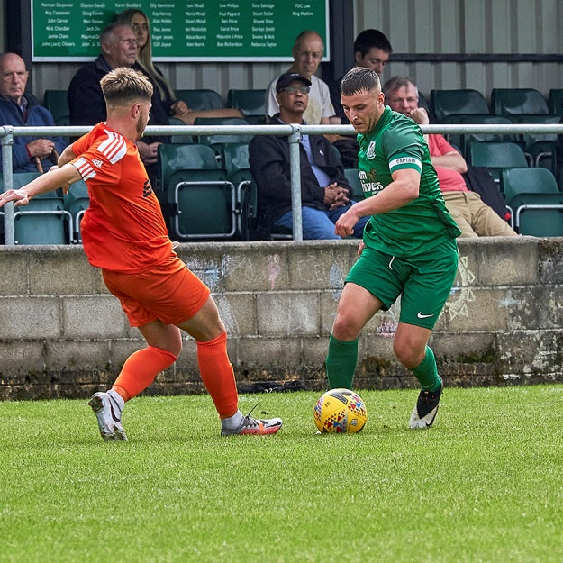
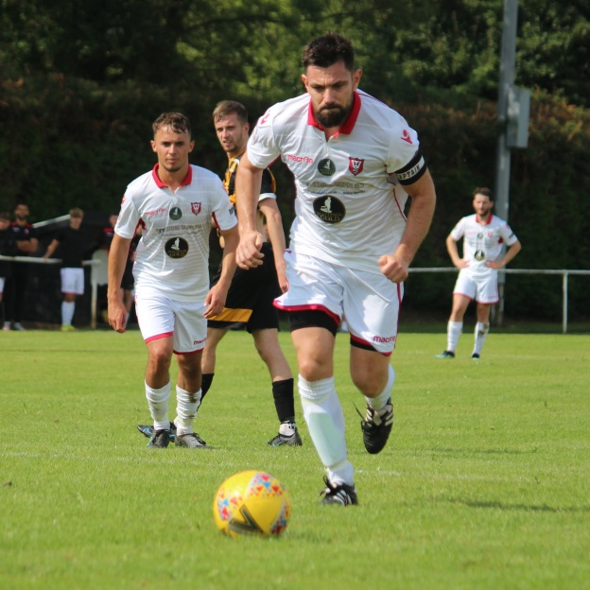
A remarkable opening 20 minutes in Gloucestershire, saw Warminster captain Ian Jeffery convert three penalties during their 4-0 win away at Tytherington Rocks. Most remarkably of all however, was the fact that all three spot kicks were awarded for fouls on Town’s tricky winger Conner McKay by the Rocks full-back. Jeffery and Warminster were not finished there however, and with half-time approaching, the away side were awarded another penalty which the skipper tucked home to compound a disappointing afternoon for the Rocks. Welton’s 100% start was brought to an end after they were held to a goalless draw by Gillingham Town, while AEK Boco and Wells City juked out a 2-2 draw at Greenbank Road. The points were also shared in the fixture between Radstock and Hengrove, with the home side drawing level 20 minutes from time after Danny Dodimead had put Athletic in position to claim an elusive away win. Devizes’ disappointing month continued away at Wincanton Town where they were put to the sword after being handed a heavy 9-1 defeat. There were no goals between minutes 24 and 68, but unfortunately for Devizes, the start and end of the game saw goals aplenty, with Cameron Allen, Brett Cotterill and a Matt Garner double putting the Wasps four ahead in the opening quarter. Allen struck twice more in the closing stages to complete his hat-trick, with a Dan Wise brace and Harry Barnes wonder goal helping secure Wincanton’s first league victory of the season in stunning circumstances. A topsy-turvy encounter eventually saw Bristol Telephones run out 3-2 victors over Bishops Lydeard to end a three-match losing streak. Goals either side of the break from Jamie Lewis and Billy Padfield put the Phones in control, before a powerful strike from Jack Bryant at the beginning of the second half helped Lydeard half the deficit. The away side suddenly found themselves on the front foot, and after a red card was brandished to the Phones, Adam Willis struck an equaliser to take advantage of the extra man. Despite going close on a couple of occasions, Lydeard were stunned in the closing stages when they conceded a penalty which was converted by Dhani Golding to hand the hosts all three points.
Action from Welton Rovers clash with Gillingham Town, courtesy of Mark Pile.
Warminster’s Ian Jeffery slots home one of his penalties, image courtesy of Jamie House.

Recent Results
Tuesday 17th August 2021
FA Cup
Bridgwater United 2-1 Brixham 223
Premier Division
Brislington 1-0 Cadbury Heath 136
Buckland Athletic 4-0 Bridport 100
Millbrook 2-4 Tavistock
Shepton Mallet 5-0 Ashton & Backwell United 150
First Division
Bishop Sutton 4-1 Radstock Town 65
Hengrove Athletic 2-4 Cheddar 80
Odd Down 5-2 Devizes Town 51
Portishead Town 2-2 Tytherington Rocks 32
Wells City 0-1 Welton Rovers
Wednesday 18th August 2021
Premier Division
Clevedon Town 1-2 Bitton 128
First Division
Lebeq United 1-1 AEK Boco 75
Oldland Abbotonians 1-0 Almondsbury 59
Warminster Town 0-0 Sherborne Town

Saturday 21st August 2021
FA Cup Preliminary Round
Bridgwater United 3-0 Ilfracombe Town
Exmouth Town 2-1 Bristol Manor Farm 313
Mangotsfield United 3-0 Tavistock
Melksham Town 0-1 Shepton Mallet
Mousehole 1-3 Plymouth Parkway
Willand Rovers 3-3 Millbrook
Premier Division
Ashton & Backwell United 2-3
Bridport 1-8 Bitton 107
Brislington 0-8 Saltash United 78
Buckland Athletic 2-2 Keynsham Town
Cadbury Heath 3-2 Street 45
First Division
AEK Boco 2-2 Wells City
Almondsbury 0-3 Bishop Sutton
Bristol Telephones 3-2 Bishops Lydeard
Odd Down 2-0 Oldland Abbotonians 50
Radstock Town 1-1 Hengrove Athletic 77
Sherborne Town 4-2 Lebeq United
Tytherington Rocks 0-4 Warminster Town
Welton Rovers 0-0 Gillingham Town 117
Wincanton Town 9-1 Devizes Town
Upcoming Fixtures
Tuesday 24th August 2021
FA Cup Preliminary Round Replay
Millbrook vs Willand Rovers 19:45KO
Premier Division
Bitton vs Street 19:30KO
Bridport vs Bridgwater United 19:45KO
Keynsham Town vs Shepton Mallet 19:45KO
Tavistock vs Ilfracombe Town 19:30KO
Wednesday 25th August 2021
Premier Division
Cadbury Heath vs Clevedon Town 19:30KO
Exmouth Town vs Buckland Athletic 19:30KO
Saltash United vs Helston Athletic 19:30KO
Friday 27th August 2021
Premier Division
Street vs Wellington 19:30KO

Saturday 28th August 2021 (3pm kick-off unless noted)
Premier Division
Bridgwater United vs Saltash United
Bridport vs Ashton & Backwell United
Exmouth Town vs Cadbury Heath
Helston Athletic vs Bitton
Ilfracombe Town vs Mousehole
Shepton Mallet vs Keynsham Town
Tavistock vs Millbrook
First Division
AEK Boco vs Longwell Green Sports
Bishop Sutton vs Bishops Lydeard
Cheddar vs Wincanton Town
Gillingham Town vs Radstock Town
Hengrove Athletic vs Bristol Telephones
Lebeq United vs Warminster Town
Oldland Abbotonians vs Welton Rovers
Portishead Town vs Odd Down
Sherborne Town vs Tytherington Rocks
Wells City vs Almondsbury

