Latest Round-ups:
Season 2021/22
#3
Midweek Action: After battling out a stalemate in their tie the previous Saturday, Shepton Mallet made an impactful start to their FA Cup replay with Andover New Street, scoring twice in the opening 11 minutes to shell-shock their hosts. Mallet shot out of the blocks, scoring inside the opening minute through Callum Gould, before he then turned provider, sending in a cross which Nick Hewlett nodded home. An excellent volleyed finish from Harvey Baker extended Shepton’s in first half stoppage-time, before substitute Nathan Legge completed the scoring late on with an audacious 40 yard lob. Unfortunately, Brislington will not be joining Shepton in the Preliminary round after they suffered a 3-1 defeat at the hands of Brimscombe & Thrupp.

24 hours later, an absolutely incredible spell midway through the second half from Millbrook saw them overturn a 3-0 deficit to knock out Saltash United in a wild Cornish derby. The Ashes looked to be home and dry after 55 minutes of the tie, after two goals from Sam Hughes and an effort from Sam Farrant put them three goals to the good. But from the moment Rikki Shepherd pulled a goal back, the visitors couldn’t stop scoring and were suddenly in the ascendancy. Dave Youldon followed up Shepherd’s first effort, with the front man then adding his second with the next attack to draw the side’s level. Millbrook didn’t stop there however, and all of a sudden they were in front, with Josh Toulson scoring their fourth goal in the space of just five minutes. Tom Payne then added a fifth for the rampant visitors before Saltash regrouped somewhat, pulling a goal back through Charlie Elkington to set up a frantic final 12 minutes. It was Millbrook who grabbed the tenth and final goal of a thrilling contest however, with substitute Ed Goodman scoring in stoppage time to complete a memorable night at the Kimberley Stadium.

In league matters, Street claimed their first three points of the campaign after coming from behind to win 4-1 at Bridport. Goals from Harry Foster and Jordan Lovibond overturned the early deficit, with a Foster penalty and an Ollie Pearson tap-in completing the victory. Tuesday’s other Premier Division clash saw Tavistock defeat Mousehole 3-0, with Liam Prynn, Josh Grant and Tallan Burns all getting on the scoresheet. The following evening, Keynsham secured their third successive victory, after a brace from Will Hailston helped them overcome Cadbury Heath 2-1 at Springfield.

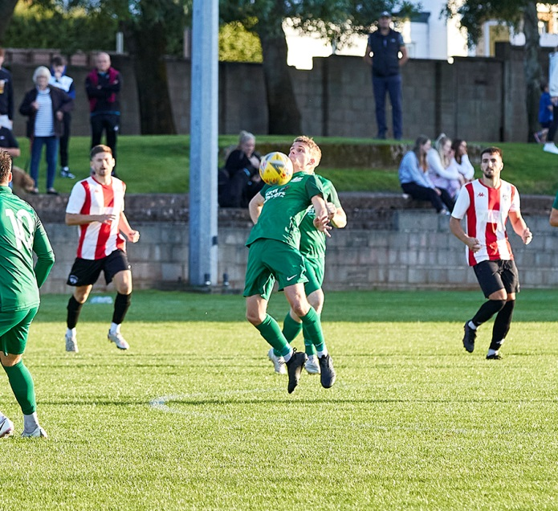
Welton Rovers continue to be the early pacesetters in the First Division after they eased to a 3-0 win at home to Devizes Town on Tuesday evening thanks to goals from Joe Ellis, Courtney Charles and Chris Pile. Cheddar are another side to have started strongly, and first half goals from Robbi Maggs and Harry Taylor saw them beat a previously unbeaten Bishop Sutton side 2-0 at Bowdens Park. Portishead beat Almondsbury by the same scoreline thanks to a pair of late goals, while Odd Down collected their first three points of the campaign after beating Bishops Lydeard 4-2 in Bath behind a double from Reeko Best and another goal from the impressive Luke Bryan. Wednesday’s big winners were Oldland, for whom Cash Vinall scored two exquisite goals in their 4-1 win over Tytherington Rocks, while Radstock and Longwell Green battled out a 1-1 draw at the Southfields Rec. Elsewhere, Lebeq United pulled off a brilliant comeback to defeat Bristol Telephones by three goals to two. The Phones looked destined for all three points thanks to goals from Dhani Golding and Craig Parsons, but Lebeq had other ideas, eventually running out winners after Fabian McCarthy, Adam Mahdi and Jack Baber each found the back of the net at Oaklands Park.
Action from Welton Rovers midweek victory over Devizes, courtesy of Mark Pile.
Premier Division: The weekend action got underway on Friday evening in Tavistock, where the hosts took an early lead before falling to a 2-1 defeat against Bridgwater United. It was Josh Grant who put the Lambs ahead after just 19 minutes, smashing the ball past the visiting keeper, but crucially Bridgwater managed to get level just before the interval when Jack Taylor reacted quickest to a loose ball in the area. The winning moment came 15 minutes from time, with Josh Wadham firing home from long range to give Town their first victory of the season.

The pick of Saturday’s games occurred at Keynsham where a dramatic finish saw Helston come away with all three points following a 3-2 victory. The visitors made a solid start, taking an early lead through Stu Bowker, only to be pegged back almost instantly when Sam Jones levelled for the K’s. Bowker turned provider for Helston’s second, producing an excellent cross for Kai Cornish to restore their advantage midway through the first half. Will Hailston has hit the ground running this season, and he struck again to put Keynsham in position to grab a point, but Archie Reay had other ideas, striking the fatal blow three minutes from time to tip the balance in Helston’s favour.
Saltash United rebounded from their midweek cup capitulation, scoring twice in the final 20 minutes to secure a 3-1 win away at Clevedon. The Ashes must have feared the worse after an hour when their hosts levelled through Ethan Feltham after Dave Barker had fired them into an early lead from the spot. They responded much better to conceding this time around however, and after Sam Hughes had restored their lead in the 70th minute, they Cornish outfit wrapped up victory in stoppage time thanks to an effort from Tom Cleveland. There was also a 3-1 triumph for Exmouth away at Ashton & Backwell United as they joined a large group of teams on seven points. Ace High’s opener at the end of the opening period put Exmouth in control, but a mix-up at the back allowed the home side to get back on level terms through Brad Skidmore. A Dan Cullen header then restored Town’s advantage, before Aaron Denny struck 12 minutes from time to give Exmouth their third away win in the space of ten days. 3-1 was also the victory margin for Bitton, with Matt Groves, Dean Griffiths and Adam Carter all scoring in their win over Brislington, while Shepton Mallet and Buckland both remain unbeaten following their goalless draw. Both Bridport and Cadbury Heath remain without a victory this season after falling at the hands of a pair of recent additions to the Western League. For Bridport, their fourth consecutive loss saw them concede three times at the break in a 4-0 defeat away at Millbrook. Ben Holter struck in either half to give the home side a two-goal lead, with Rikki Shepherd making it 3-0 before Ben Applegate completing the scoring deep into stoppage-time. Ilfracombe Town’s second half comeback condemned Cadbury Heath to a 2-1 defeat at Springfield after Dean Preddie had put the home side ahead in the 38th minute. An equaliser ten minutes after the interval from Liam Short gave the Bluebirds a foothold in the contest, with Kevin Squire’s spot kick soon after helping to complete the turnaround.
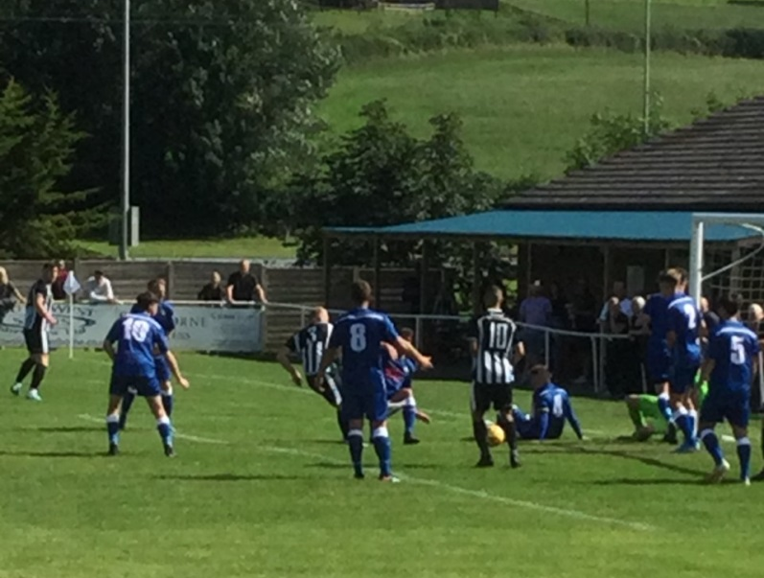
First Division: Welton Rovers made it five wins from five on Saturday afternoon, beating Hengrove by the slenderest of margins at West Clewes. It may have been Welton’s poorest performance of the season to date, but they still gained maximum points thanks to a header in first-half stoppage time from Joe Garland. Sherborne Town have prevailed in each of their three league fixtures to date, scoring all five of their goals before the break in their big win over Wells City. After taking a ninth minute lead through Alex Murphy, Sherborne were pegged back by the visitors who have endured a slightly sluggish start to their campaign. It didn’t take long for the Zebras to move back in front via Declan Cornish, with Murphy and Cornish then both finding the back of the net again to stretch the lead before Ash Guppy completed the scoring three minutes before half-time.
Goalmouth action from Wells City’s 5-1 defeat away at Sherborne, courtesy of John Pool.
Another side to hit five were Tytherington Rocks, with the Gloucestershire side overturning an early deficit to see off Gillingham Town. Having trailed inside the opening five minutes, Tytherington went about repairing the damage, and managed to forge ahead just after the half-hour mark thanks to a brace from Bailey Croome. Matt Hoare then added to the lead just before the interval, with second-half strikes from Perran Blundell and Jack Sheppard-Cozens wrapping up the points. AEK Boco are another of the new Western League sides who have hit the ground running, and they now have seven points from a possible nine after claiming an impressive 3-1 win away at Warminster.
Cheddar’s opening day defeat is now a distant memory, with the Cheesemen now up in second spot after beating Devizes 1-0. The decisive moment came towards the end of the first half, with Robbi Maggs scoring against the run of play to give Cheddar their fourth win on the bounce. Oldland Abbotonians will also be pleased with their start to the season, finding themselves in third spot following a 4-1 triumph away at Lebeq. Goals from Rico Sobers, Craig Sheppard and Ali Sen led Radstock to a 3-1 win away at Bishops Lydeard, while on Friday night there was a stalemate between Longwell Green and Almondsbury at Shellards Road. Odd Down continue to show encouraging signs, winning 2-1 away at Bristol Telephones to move into the top half. After scoring a double in midweek, Reeko Best picked up where he left off, firing the Bath side ahead after only 17 minutes. The home side responded well after the break, deservedly drawing level through Craig Parsons, but they could do nothing about Odd Down’s winner, with the in-form Luke Bryan curling home an excellent free-kick to snatch away all three points.

On the latest podcast, Bridgwater manager Dave Pearse tells us how many teams he thinks can challenge for the Premier Division title, and the Chairman of Sherborne Town, John Bowers talks about the strong link he believes exists between getting things right on and off the pitch. Ian and Tom also have a look at the recent league and cup action.
http://toolstationleague.com/season-2021-22-podcast-episode-3/

Recent Results
Tuesday 10th August 2021
FA Cup – Extra Preliminary Round
Andover New Street 0-4 Shepton Mallet
Brimscombe & Thrupp 3-1 Brislington
Premier Division
Bridport 1-4 Street 130
Tavistock 3-0 Mousehole
First Division
Almondsbury 0-2 Portishead Town 36
Cheddar 2-0 Bishop Sutton 98
Odd Down 4-2 Bishops Lydeard 30
Welton Rovers 3-0 Devizes Town 155
Wednesday 11th August 2021
FA Cup – Extra Preliminary Round
Saltash United 4-6 Millbrook 222
Premier Division
Cadbury Heath 1-2 Keynsham Town 75
Exmouth Town Wellington
First Division
Lebeq United 3-2 Bristol Telephones 71
Oldland Abbotonians 4-1 Tytherington Rocks 54
Radstock Town 1-1 Longwell Green Sports 72
Friday 13th August 2021
Premier Division
Tavistock 1-2 Bridgwater United
First Division
Longwell Green Sports 0-0 Almondsbury

Saturday 14th August 2021
Premier Division
Ashton & Backwell United 1-3 Exmouth Town 88
Bitton 3-1 Brislington 121
Cadbury Heath 1-2 Ilfracombe Town 41
Clevedon Town 1-3 Saltash United 103
Keynsham Town 2-3 Helston Athletic 95
Millbrook 4-0 Bridport
Shepton Mallet 0-0 Buckland Athletic 122
First Division
Bishops Lydeard 1-3 Radstock Town 54
Bristol Telephones 1-2 Odd Down 60
Devizes Town 0-1 Cheddar 123
Lebeq United 1-4 Oldland Abbotonians 35
Sherborne Town 5-1 Wells City 124
Tytherington Rocks 5-1 Gillingham Town
Warminster Town 1-3 AEK Boco 117
Welton Rovers 1-0 Hengrove Athletic 110
Upcoming Fixtures
Tuesday 17th August 2021
FA Cup
Bridgwater United vs Brixham 19:45KO
Premier Division
Brislington vs Cadbury Heath 19:30KO
Buckland Athletic vs Bridport 19:30KO
Millbrook vs Tavistock 19:45KO
Shepton Mallet vs Ashton & Backwell United 19:30KO
First Division
Bishop Sutton vs Radstock Town 19:30KO
Hengrove Athletic vs Cheddar 19:30KO
Odd Down vs Devizes Town 19:45KO
Portishead Town vs Tytherington Rocks 19:30KO
Wells City vs Welton Rovers 19:30KO
Wednesday 18th August 2021
Premier Division
Clevedon Town vs Bitton 19:30KO
First Division
Lebeq United vs AEK Boco 19:30KO
Oldland Abbotonians vs Almondsbury 19:45KO
Warminster Town vs Sherborne Town 19:45KO

Saturday 21st August 2021 (3pm kick-off unless noted)
FA Cup Preliminary Round
Exmouth Town vs Bristol Manor Farm
Mangotsfield United vs Tavistock
Melksham Town vs Shepton Mallet
Mousehole vs Plymouth Parkway
Willand Rovers vs Millbrook
Premier Division
Brislington vs Saltash United
First Division
AEK Boco vs Wells City
Almondsbury vs Bishop Sutton
Bristol Telephones vs Bishops Lydeard
Cheddar vs Longwell Green Sports
Odd Down vs Oldland Abbotonians
Radstock Town vs Hengrove Athletic
Sherborne Town vs Lebeq United
Tytherington Rocks vs Warminster Town
Welton Rovers vs Gillingham Town
Wincanton Town vs Devizes Town

