Latest Round-ups:
Season 2021/22
#2
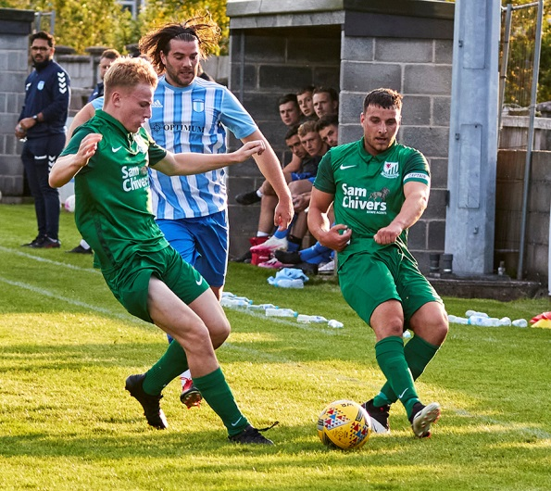
Midweek Action: Shepton Mallet backed-up their opening day victory with another one-sided performance at home to Bridport on Tuesday evening in the Premier Division. Dawid Regula and substitute Joe Morgan each bagged doubles for Mallet who eventually ran out 7-0 winners. Buckland were also in excellent goalscoring form during the opening set of midweek fixtures, putting six past Wellington at Homer’s Heath. Cieran Badger, Frazer Clark and Charlie Johansen all struck for the hosts, but the main man was Nathan Cooper who fired home a superb hat-trick. In a clash between two of the new Western League sides, goals from Callum McOnie and Tallan Mitchell helped Mousehole beat Millbrook 2-0, while a crowd of 324 saw Bridgwater and Bitton battle out a goalless draw. Tavistock secured all three points away at Ilfracombe after goals from Liam Prynn and Warren in either half saw them claim a 2-1 win, and Keynsham secured local bragging rights after a pair of early goals from Will Hailston helped them win 3-0 away at Brislington. 24 hours later, Exmouth Town laid down an early marker, winning 4-0 away at Street thanks in part to a goalscoring brace from Ben Steer. Clevedon Town overcame an early two-goal deficit to claim a 2-2 draw at home to Cadbury Heath, with Ollie Babbington’s penalty on the hour mark completing their comeback. A huge crowd of 441 was in attendance to watch Helston’s clash against Saltash where the points were eventually shared following a 1-1 draw. The home side snatched the half-time lead with Ryan Turner putting them ahead in the 44th minute, but the Ashes came back refreshed after the break, with Callum O’Brien drawing them level when his glancing header found the back of the net.
In the First Division, Bishop Sutton were Tuesday’s big winners, with goals from Cameron Shorney, Oaklan Buck, Mason Dagger and late substitute Luke Trowbridge firing them to a 4-1 triumph away at Portishead. Goals in either half from Chris Pile and Jake Slocombe helped Welton maintain their winning start thanks to a 2-0 defeat of Longwell Green, with Lebeq beating Tytherington Rocks by the same scoreline thanks to efforts from Rick Davis and Elan Plummer.
Action from Tuesday’s clash between Welton & Longwell Green courtesy of Mark Pile.
Cheddar roared back from a two-goal half-time deficit to beat new-boys Gillingham Town 3-2. After a pair of James Boyland goals had put the Cheesemen firmly on the back-foot, but they produced an excellent second-half performance to claim victory, with Callum Laird, Simon McElroy and substitute Finlay Biggs each getting on the scoresheet.
Wincanton were another side to battle back from a perilous position, scoring an injury-time penalty at the end of the 90 minutes to rescue a 2-2 draw at home to Warminster. With the game level at the break, Aaron Cockerill struck from long range to restore Warminster’s advantage, but it was Wincanton who had the last word when Dan Wise converted his spot kick in stoppage time to salvage a point. There was also a 2-2 draw at Hengrove, where Luke Bryan equalised in either half to help Odd Down secure their first point of the campaign. Goals from Harvey Hadrill and Adam Wright were the difference at the Athletic Ground where Wells City defeated visitors Bishops Lydeard 2-0. The following evening, Craig Parsons’ brilliant hat-trick gave Bristol Telephones a comfortable 4-1 win over Oldland Abbotonians, and Devizes Town registered their second 2-2 draw of the young season after goals from the two Matt’s, Lever and Swann helped them capture a point away at Radstock.
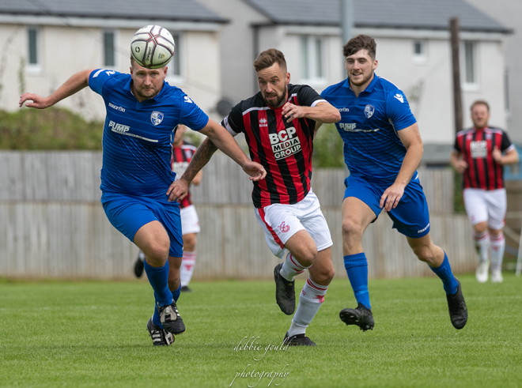
Cup Action: In the Extra Preliminary Round of the FA Cup, there were mixed results for Western League sides, with Bridgwater’s 2-1 win away at Brixham among the standouts. Having seen their hosts balloon a penalty over the crossbar, Bridgwater had no such troubles from 12 yards, with the ever-reliable Jake Llewellyn converting to put them in front at the interval. George King then doubled Bridgwater’s lead before a late consolation gave Brixham fans something to cheer. Tavistock were another side to flex their muscles away from home, twice coming from behind to beat AFC St Austell 3-2. Warren Daw cancelled out an early St Austell strike, before the home side went ahead once more towards the end of the first half. Teigan Rosenquest gave the Lambs a perfect start to the second period with his equaliser, before Liam Prynn struck nine minutes from time to book his side’s spot in the next round. There was no such success for Odd Down, Clevedon and Keynsham who all suffered defeats on their travels, while a Lewis Putnam brace condemned Bitton to a 2-0 loss at the hands of Oxhey Jets in Hertfordshire. Ashton & Backwell United were also unable to break down their hosts Ardley United who progressed to the next round alongside a Fleet Town outfit for whom Mal Thomas scored twice in the second half to knock out Bridport.
Jack Taylor of Bridgwater challenges for possession during their cup win away at Brixham, courtesy of Debbie Gould.

There were some thoroughly entertaining clashes between Western League sides, with Ilfracombe Town just about doing enough to come out on top in a seven-goal thriller against Wellington. Brothers Miles and Jake Quick each scored for Wellington during an entertaining opening half, with Joe Barker scoring twice for the home side to leave the game deadlocked after 45 minutes. Wellington then went in front thanks to a Sam Towler penalty, before goals in the final quarter from Jack Jenkins and Kevin Squire saw Ilfracombe storm home. Two Premier League big-hitters met at Homers Heath, where a James Richards winner 20 minutes from time saw Exmouth sneak past hosts Buckland. Following an Ace High opener in the 26th minute, substitute Nathan Cooper made an instant impact for the Bucks, levelling the scores with his first touch. It was then left to Richards to restore Exmouth’s advantage and they managed to keep their hosts at bay to move on to the next stage of the competition. Mousehole will join Exmouth in the hat for the Preliminary Round draw after beating Helston Athletic in front a huge crowd. The fans in attendance at Trungle Parc enjoyed a strong showing from the home side, with Hayden Turner scoring twice in their eventual 3-1 victory. Millbrook and Saltash United will also hope to progress, but will need a replay after battling out a 2-2 draw, while Shepton Mallet and Brislington both face the same fate after drawing their home clashes against Andover New Street and Brimscombe & Thrupp respectively. Cadbury were denied in the battle of the Heath’s, conceding twice early in the second half to lose at home to Flackwell, while Street will need to rebound quickly in their league campaign after conceding six goals in the first half of their 8-0 defeat at the hands of Fareham Town.

First Division: Welton Rovers made it three wins from three in the opening week of the season after scoring twice in the final 20 minutes to close out a 3-1 victory away at Bishops Lydeard. Rovers carried the confidence from their other wins into this fixture and led inside the third minute thanks to an early opener from James Batchelor. The home side found their stride during the second half and grabbed a deserved leveller when Doug Camilo slotted home. In Jake Slocombe, Welton have one of the premium goalgetters in the early stages of the season, and he continued to lead their charge, firstly firing home a sensational free-kick to restore their lead, before adding another goal in stoppage time to take his tally to four goals. Sherborne Town are the other side who maintain a 100% winning record after the opening seven days, with their mauling of Devizes making it two 6-1 victories to open their campaign. A first-half brace from Sam Farthing sandwiched an effort from Alex Murphy to give the Zebras a comfortable three-goal lead at the interval. Devizes attempted to make a comeback, trimming their deficit thanks to a Rhys Talmash effort, but that was as close as they came, with Murphy, Ollie Hebbard and an own goal completing the one-sided affair. Hengrove Athletic picked up their first three points of the season, beating Wincanton by four goals to one at the AVB Stadium. Giorgio Mancini put the hosts a goal to the good at the interval, and they pushed on in the second half with Pete Sheppard adding to a fine brace from Danny Dodimead for the victorious Grove.
Things aren’t so rosy for Almondsbury who remain winless following a 2-1 defeat away at AEK Boco despite the efforts of Ashley Knight. His equaliser 20 minutes from time looked to have secured a point for the Almonds, but it wasn’t to be, as Boco ran out winners thanks to goals from Harrison Kyte and Harry Madge.
Oldland Abbotonians produced a strong comeback to beat Wells City 2-1, with Clayton Woodman levelling from the spot early in the second half, before Frank Gingell popped up to slam home the decisive third goal of a hard-fought contest. Bishop Sutton have made a promising beginning to their season, with a 4-1 win over Tytherington Rocks making it seven points from a possible nine for them. Sutton dominated for much of the first half and led by three at the break, after Sol Shearer, Liam Villis and Oaklan Buck all managed to beat the visiting keeper. The Rocks got on the scoresheet early in the second half thanks to a Bailey Croome penalty, but Sutton were too strong to allow a fightback, with Buck adding his second of the game in the final ten minutes to preserve the victory. Goals from Alex Grimshaw, Liam Oswin and Ali Bamford saw Longwell Green Sports claim a 3-0 win away at Portishead Town, while Warminster beat Radstock 2-0 at Weymouth Street thanks to goals either side of the break Alex Churchyard and Corey Gardener. Goals in either half from Cameron Brown helped Lebeq claim a 2-2 draw away at Gillingham Town, after the home side had managed to build a two-goal lead inside the opening half-hour following a quickfire double from Iwan Walters. Cheddar made it back-to-back wins, capitalising on the early dismissal of Keiron Golding to beat Bristol Telephones 4-1 in Stockwood. Golding was sent off after conceding a penalty inside the opening twenty minutes, with Callum Laird slotting home the resulting spot kick to put the Cheesemen in front. Fin Biggs then struck from long range to double their advantage before the Phones struck early in the second half through Craig Parsons to threaten a fightback. It wasn’t to be though, and after Kyle Sampson had restored Cheddar’s two-goal lead, they then added a late fourth through Simon McElroy to complete their victory.
Episode 2 of the Western League Podcast looks back at the opening round of fixtures, catching up with Saltash boss Dane Bunney and Welton manager Tom Smith to reflect on their starts to the season.
http://toolstationleague.com/season-2021-22-podcast-episode-2/

Recent Results
Tuesday 3rd August 2021
Premier Division
Bridgwater Town 0-0 Bitton 324
Brislington 0-3 Keynsham Town 196
Buckland Athletic 6-1 Wellington 132
Ilfracombe Town 1-2 Tavistock 140
Millbrook 0-2 Mousehole 193
Shepton Mallet 7-0 Bridport 139
First Division
Cheddar 3-2 Gillingham Town 68
Hengrove Athletic 2-2 Odd Down 89
Portishead Town 1-4 Bishop Sutton 62
Tytherington Rocks 0-2 Lebeq United
Wells City 2-0 Bishops Lydeard 54
Welton Rovers 2-0 Longwell Green Sports
Wincanton Town 2-2 Warminster Town 118
Wednesday 4th August 2021
Premier Division
Clevedon Town 2-2 Cadbury Heath 110
Helston Athletic 1-1 Saltash United 441
Street 0-4 Exmouth Town 85
First Division
Bristol Telephones 4-1 Oldland Abbotonians 93
Radstock Town 2-2 Devizes Town 90

Saturday 7th August 2021
FA Cup Extra Preliminary Round
AFC St Austell 2-3 Tavistock
Alresford Town 3-0 Odd Down
Ardley United 2-0 Ashton & Backwell United
Bishops Cleeve 6-1 Clevedon Town
Bridport 1-2 Fleet Town 175
Brislington 3-3 Brimscombe & Thrupp 106
Brixham 1-2 Bridgwater Town
Buckland Athletic 1-2 Exmouth Town 219
Cadbury Heath 0-2 Flackwell Heath 74
Fareham Town 8-0 Street
Ilfracombe Town 4-3 Wellington
Millbrook 2-2 Saltash United 113
Mousehole 3-1 Helston Athletic
Oxhey Jets 2-0 Bitton
Shepton Mallet 0-0 Andover New Street 258
Tring Athletic 3-0 Keynsham Town

First Division
AEK Boco 2-1 Almondsbury
Bishop Sutton 4-1 Tytherington Rocks 47
Bishops Lydeard 1-3 Welton Rovers 66
Bristol Telephones 1-4 Cheddar 45
Devizes Town 1-6 Sherborne Town 102
Gillingham Town 2-2 Lebeq United 28
Hengrove Athletic 4-1 Wincanton Town 76
Oldland Abbotonians 2-1 Wells City 42
Portishead Town 0-3 Longwell Green Sports 57
Warminster Town 2-0 Radstock Town 118

Upcoming Fixtures
Tuesday 10th August 2021
FA Cup – Extra Preliminary Round
Andover New Street vs Shepton Mallet 19:45KO
Premier Division
Bridport vs Street 19:45KO
Tavistock vs Mousehole 19:45KO
First Division
Almondsbury vs Portishead Town 19:30KO
Cheddar vs Bishop Sutton 19:45KO
Odd Down vs Bishops Lydeard 19:45KO
Welton Rovers vs Devizes Town 19:30KO
Wednesday 11th August 2021
FA Cup – Extra Preliminary Round
Brimscombe & Thrupp vs Brislington 19:45KO
Saltash United vs Millbrook 19:30KO
Premier Division
Cadbury Heath vs Keynsham Town 19:30KO
Exmouth Town vs Wellington 19:30KO
First Division
Lebeq United vs Bristol Telephones 19:30KO
Oldland Abbotonians vs Tytherington Rocks 19:45KO
Radstock Town vs Longwell Green Sports 19:45KO
Friday 13th August 2021
Premier Division
Tavistock vs Bridgwater United 19:45KO
First Division
Longwell Green Sports vs Almondsbury 19:30KO

Saturday 14th August 2021 (3pm kick-off unless noted)
Premier Division
Ashton & Backwell United vs Exmouth Town
Bitton vs Brislington
Cadbury Heath vs Ilfracombe Town
Clevedon Town vs Saltash United
Keynsham Town vs Helston Athletic
Millbrook vs Bridport
Mousehole vs Street
Shepton Mallet vs Buckland Athletic

First Division
Bishops Lydeard vs Radstock Town
Bristol Telephones vs Odd Down
Devizes Town vs Cheddar
Lebeq United vs Oldland Abbotonians
Sherborne Town vs Wells City
Tytherington Rocks vs Gillingham Town
Warminster Town vs AEK Boco
Welton Rovers vs Hengrove Athletic

