Latest Round-ups:
Season 2021/22
#1
Premier Division: Among the new boys joining the Western League this season, Helston Athletic hit the ground running fastest with a thumping 7-1 victory away at Bridport. Matty Buchan was the star of the show, bagging a hat-trick for the visitors, with a brace from Kai Cornish, plus further goals from Phil Cattran and Stu Bowker leading them to the big win. Shepton Mallet were another away side to dominate their opponents, with four first-half goals leading them to a 6-0 triumph over Cadbury Heath. Jack Fillingham opened the scoring inside three minutes, before adding a 25th minute penalty to double Shepton’s advantage. Aaron Seviour then extended the lead to three, before an own-goal in first half stoppage time condemned the Heath to an insurmountable half-time deficit. Further goals came from Joe Morgan and Dawid Regula to hand Mallet a near perfect start to the new campaign. Keynsham will also be pleased with how things started for them, after goals from George Rooke, Will Hailston and Harley Purnell saw them defeat promoted side Ashton & Backwell United. Cornish outfit Saltash opened their season with all three points, after second half efforts from Callum O’Brien and Scott Crocker helped them see off the challenge of Tavistock at the Kimberley Stadium.

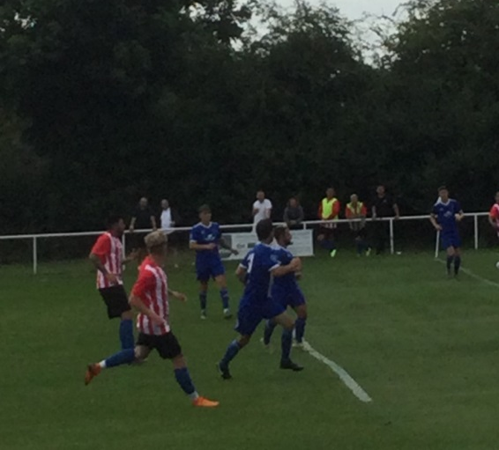
There was a ridiculously early contender for game of the season in Bridgwater where the home side succumbed to a 4-3 defeat at the hands of Buckland Athletic. The hosts fell behind after just 15 minutes to Nathan Cooper’s opener, only for Harry Horton to force home the equaliser not long after. Richard Groves looked to have given Buckland a big boost leading up to half-time when he restored their advantage, but Bridgy hit back again through ever-prolific frontman Jack Taylor. The game eventually tipped in the visitors balance around the hour mark when they scored a quick-fire double, with Adnan Hiroli’s 84th minute strike proving too late for Town to produce another comeback. Goals after the break from Ben Withey and Adam Carter helped Bitton come from behind to beat Ilfracombe 3-2, while a double from George Jones fired Brislington to an impressive-looking 3-1 victory away at Street.
Action from Bitton’s 3-2 victory over Ilfracombe courtesy of John Pool.

Miles Quick was unfortunate not too end up on the winning side down in Penzance where his Wellington side relied on his goals to register a 3-3 draw away at Mousehole. Quick twice put Welly ahead in the first half, only for the home side to hit back through Steve Burt and James Devine to leave the game in the balance after 45 minutes. Josh Magin then gave Mousehole their first lead of the match early in the second half, before a stoppage time equaliser from Quick saw him complete his hat-trick, rescuing a point for the Tangerines in the process. The points were also shared in Exmouth, where two goals from Ben Steer weren’t enough for the hosts in their 2-2 draw with Clevedon. Steer struck either side of the break to overturn Ollie Babbington’s 25th minute opener, but Clevedon kept pushing, finally securing a late point when Jack Jones nodded home their leveller three minutes from time.

First Division: Sherborne Town are the early leaders in the First Division after putting six past an under-par Hengrove. The Zebras shot out of the blocks to start the new season, leading by two goals inside the opening five minutes after both George Mapletoft and Alex Murphy found the back of the net. Hengrove grabbed a lifeline after half an hour through debutant Jude McCarthy, before Sherborne stormed home, with Steve Burton’s looping header the first of a four-goal second half for the hosts. Henry Lawrence Napier put the result beyond doubt when he made it 4-1, with further goals in the closing stages from Ollie Hebbard and Tom Beeson completing the scoring. Another side to open their account with maximum points were Portishead Town, with a double from Dan Parslow helping them to a 3-0 triumph away at Western League returnees Gillingham Town. There was also a two-goal effort from Bailey Croome which helped Tytherington Rocks fight off a late challenge from Cheddar to win by two goals to one, while Oldland Abbotonians and new boys AEK Boco battled out a goalless draw. Corey Garner’s solitary goal gave Warminster Town a 1-0 win over Almondsbury, and there was also a hard-fought victory for Radstock Town, with Tom Pawley and an Ali Sen free kick helping them beat Lebeq United 2-1.
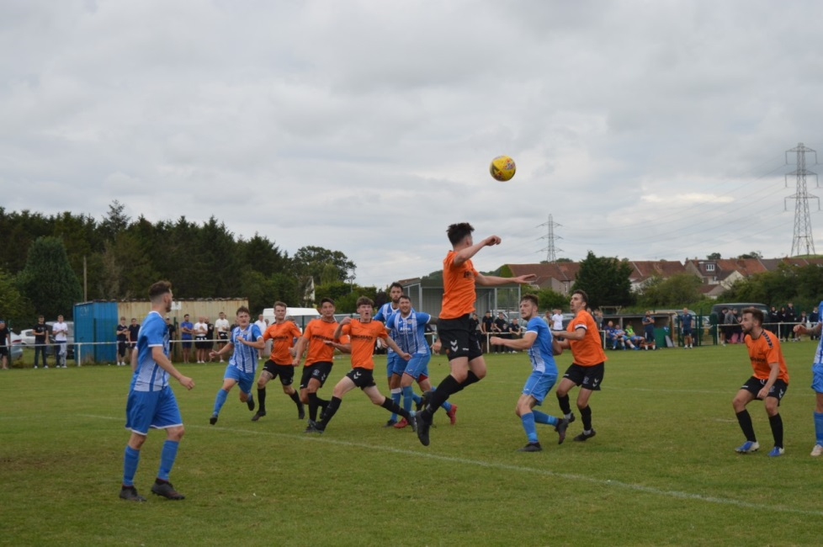

Action from the First Division clash between Oldland and Boco, courtesy of Andy Meaden.

A whirlwind start in the clash between Wincanton and Longwell Green saw both sides score twice inside the opening 16 minutes, before the visitors from Bristol eventually ran out 3-2 victors. After falling behind to Tom Richardson’s second minute header, Longwell Green turned the game on its head in no time at all, with Josh James and Louis Ward scoring for the visitors. Toby Dolton Cole picked up where he left off last season, equalising for Town, but he was then sent off during the second half as Wincanton fell to defeat following a well-taken winner by Toby Watson. Welton Rovers were also victorious on their travels, with a late winner from Chris Pile helping them beat Odd Down 2-1 in Bath. After Jake Slocombe had put the Green Army in front, the hosts drew level five minutes after the break when Luke Bryan converted coolly from the penalty spot. It was then left to Pile to decide the destination of the points, with the diminutive winger slotting home in the closing stages to hand Odd Down an opening day defeat. Two first half goals from Sol Shearer weren’t enough for Bishop Sutton after they were pegged back in a 2-2 draw at home to Wells City, with Bishops Lydeard and Devizes also beginning their seasons with the same scoreline. There were plenty of similarities in how the two games played out, with Lydeard building a two-goal lead over the visitors thanks to efforts from George Sinnott and Rhys Ford. Devizes grabbed a lifeline at the end of the first half through Rhys Talmash, and then with just five minutes left on the clock, Jordan Kirk cushioned the ball home to hand his side a share of the spoils.
Recent Results
Saturday 31st July 2021
Premier Division
Bitton 3-2 Ilfracombe Town 87
Bridgwater United 3-4 Buckland Athletic 346
Bridport 1-7 Helston Athletic 143
Cadbury Heath 0-6 Shepton Mallet 112
Exmouth Town 2-2 Clevedon Town 276
Keynsham Town 3-0 Ashton & Backwell United 126
Mousehole 3-3 Wellington
Saltash United 2-0 Tavistock 231
Street 1-3 Brislington 107
First Division
Bishop Sutton 2-2 Wells City 65
Bishops Lydeard 2-2 Devizes Town 102
Cheddar 1-2 Tytherington Rocks 71
Gillingham Town 0-3 Portishead Town 56
Lebeq United 1-2 Radstock Town 30
Odd Down 1-2 Welton Rovers 68
Oldland Abbotonians 0-0 AEK Boco 209
Sherborne Town 6-1 Hengrove Athletic 152
Warminster Town 1-0 Almondsbury 128
Wincanton Town 2-3 Longwell Green Sports
Upcoming Fixtures
Tuesday 3rd August 2021
Premier Division
Bridgwater Town vs Bitton 19:45KO
Brislington vs Keynsham Town 19:30KO
Buckland Athletic vs Wellington 19:30KO
Ilfracombe Town vs Tavistock 19:30KO
Millbrook vs Mousehole 19:45KO
Shepton Mallet vs Bridport 19:30KO
First Division
Cheddar vs Gillingham Town 19:45KO
Hengrove Athletic vs Odd Down 19:30KO
Portishead Town vs Bishop Sutton 19:30KO
Tytherington Rocks vs Lebeq United 19:30KO
Wells City vs Bishops Lydeard 19:30KO
Welton Rovers vs Longwell Green Sports 19:30KO
Wincanton Town vs Warminster Town 19:30KO
Wednesday 4th August 2021
Premier Division
Clevedon Town vs Cadbury Heath 19:30KO
Helston Athletic vs Saltash United 19:45KO
Street vs Exmouth Town 19:30KO
First Division
Bristol Telephones vs Oldland Abbotonians 19:30KO
Radstock Town vs Devizes Town 19:45KO

Saturday 7th August 2021 (3pm kick-off unless noted)
FA Cup Extra Preliminary Round
AFC St Austell vs Tavistock
Alresford Town vs Odd Down
Ardley United vs Ashton & Backwell United
Bishops Cleeve vs Clevedon Town
Bridport vs Fleet Town
Brislington vs Brimscombe & Thrupp
Brixham vs Bridgwater Town
Buckland Athletic vs Exmouth Town
Cadbury Heath vs Flackwell Heath
Fareham Town vs Street
Ilfracombe Town vs Wellington
Millbrook vs Saltash United
Mousehole vs Helston Athletic
Oxhey Jets vs Bitton
Shepton Mallet vs Andover New Street
Tring Athletic vs Keynsham Town

First Division
AEK Boco vs Almondsbury
Bishop Sutton vs Tytherington Rocks
Bishops Lydeard vs Welton Rovers
Bristol Telephones vs Cheddar
Devizes Town vs Sherborne Town
Gillingham Town vs Lebeq United
Hengrove Athletic vs Wincanton Town
Oldland Abbotonians vs Wells City
Portishead Town vs Longwell Green Sports
Warminster Town vs Radstock Town

If you missed last week’s season preview on the Podcast, be sure to check it out at the following link: http://toolstationleague.com/season-2021-22-podcast-episode-1/

Ian catches up with South West Sports News journalist, Ross Reid, and we also head from League Fixture Secretary George McCaffery who explains how the league will be managing fixtures as we continue to live with Covid.

