Latest Round-ups:
Season 2020/21
#13
Premier Division: Bridgwater Town stormed to victory in the final fixture before Christmas, dominating throughout in their 5-0 thumping of Odd Down. After Jack Taylor had headed them in front on the quarter-hour mark, Bridgy had to wait until first half stoppage time before doubling their advantage following an excellent run and finish from Mike Duffy. Taylor then struck again from the penalty spot to extend their lead, with the prolific frontman completing his hat-trick thanks to a lovely cross from Ben Kirk. Town added a fifth seven minutes from time, with Jordan Greenwood heading home Tom Fry’s corner to condemn the Bath side to their tenth defeat of the season.
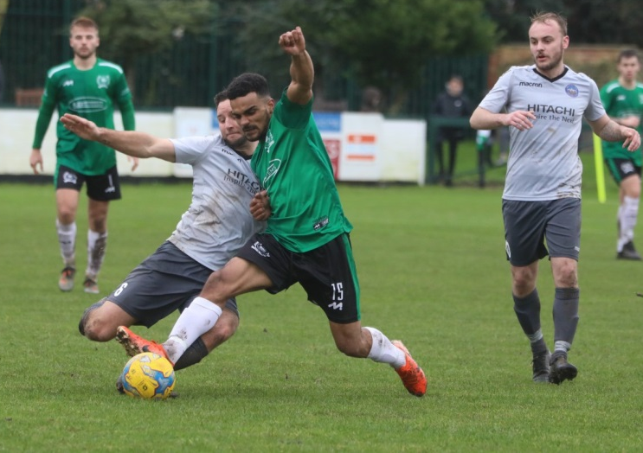
Keynsham Town made it two wins from two since returning from the enforced break, beating Brislington 3-1 on Boxing Day to continue their ascendancy up the table. James Dancey was the standout performer for the hosts, scoring in either half to give his side a two-goal lead. Jamie Noble then struck during the closing stages to make it 3-0, before Brislington grabbed a consolation five minutes from time. In another of the Boxing Day fixtures to survive, Clevedon followed up their victory in the Vase last week by beating Chipping Sodbury 3-0 at the Hand Stadium. The hosts made a strong start, taking a 17th minute lead, when the clipped cross from Jay Murray fell perfectly for Ethan Feltham who headed home. Callum Gould then took over for Clevedon, doubling their tally from long range towards the end of the first half, before then wrapping things up in the closing stages thanks to a pristine chipped finish. Westbury held out for a 1-0 win at home to Bradford, moving up to sixth thanks to Joe Stradling’s goal inside the opening ten minutes. In the other Premier Division fixture, debutant Jake Quick make an instant impact for new club Wellington, scoring in either half to lead the Somerset side to a 2-0 triumph away at Bridport. It took Quick just 24 minutes to open his account, with the former Bishops Lydeard forward then adding his second seven minutes from time to hand Wellington all three points.
Action from Westbury’s Boxing Day clash with Bradford, courtesy of Martin Pearce.
On Bank Holiday Monday, Brislington bounced back from their defeat at Keynsham by beating bottom side Chipping Sodbury 2-0. A pair of first half goals proved enough for the visitors, with Simon Prangley scoring an early penalty, before Cam Brown tucked home their second after 29 minutes thanks to a cross from influential forward Kane Simpson. In the other fixture, Shepton Mallet returned to action with a bang, scoring three times after the interval to win 4-1 away at Westbury. After Fin Haines had fired Shepton in front, the hosts gained parity in first half stoppage time when Jamie Jordan got the vital touch on a loose ball. Joe Morgan then took over for the away side, placing a low drive into the bottom corner for 2-1, which he then followed up with a silky individual goal to put some distance between the sides. Mallet had suffered a heavy defeat in their last match before lockdown, so returning with a big win will have pleased all at the club, and the victory was wrapped up in the closing stages when Aaron Cockerill slammed the ball home from the edge of the area.
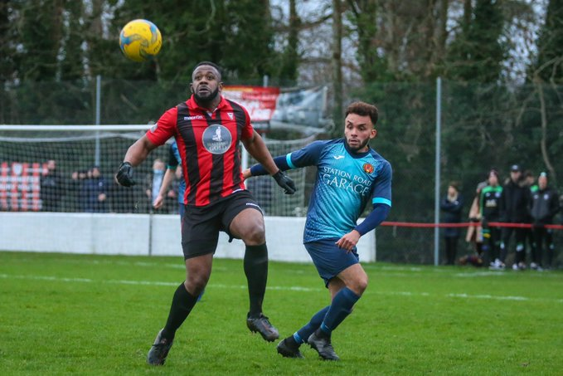
First Division: Welton Rovers suffered their first loss of the campaign at the hands of Radstock Town who have now won three on the spin. Morgan Marsh scored a Boxing Day double for the away side, with prolific James Rustell also finding the back of the net to put the former league leaders to the sword at West Clewes. It is Corsham who will find themselves top of the pile at the end of 2020 after they came from behind to beat Warminster 2-1 at Weymouth Street. Following a goalless first half, sixth-placed Warminster kicked into action after the interval and broke the deadlock within three minutes of the restart thanks to an own goal, before last week’s hat-trick hero Gary Higdon headed home to level for the Quarrymen. Corsham then nabbed all three points thanks to Will Stead who reacted quickest to the loose ball, after Leigh Rogers had seen his spot kick saved by Tom Drewitt in the Warminster goal.
Action from Corsham’s 2-1 win away at Warminster, courtesy of John Cuthbertson.
FA Vase: Tavistock booked their place in the fourth round of the Vase after storming to a 4-0 win away at Buckland. The Lambs were dominant for much of the contest, scoring twice in either half to progress, with Jack Crago and Liam Prynn putting them two goals to the good at the interval. Tallan Burns then extended the lead to three, before second-half sub Jordan Annear lobbed the home keeper form the halfway line to complete the scoring 15 minutes from time.

On Sunday, Bridgwater followed up their one-sided victory in the league with a dramatic penalty shootout triumph away at Brimscombe & Thrupp. By coming from behind twice during the 90 minutes, and then winning 5-4 on spot kicks, Town have reached the fourth round of the competition for the first time in 16 years. Ben Kirk tapped home Bridgwater’s first equaliser midway through the first half, only for the hosts to retake the lead early in the second period. With less than six minutes remaining, Tom Fry produced a moment of magic, whipping home a free kick from 25 yards out to make it 2-2, sending the game to penalties. An early miss from Sam Crumb put Town in a perilous position, but Jake Viney came to the rescue, and his second save proved to be the winning moment to set up a tie with Tavistock in January.
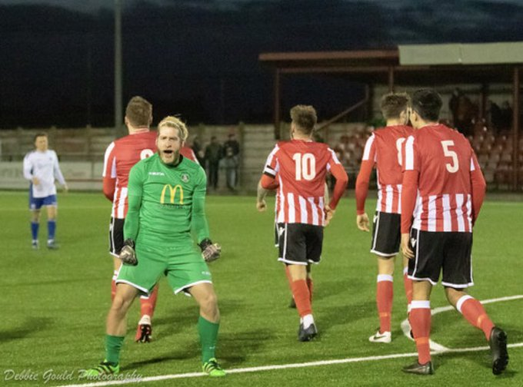
Jake Viney celebrates Bridgwater’s dramatic spot kick victory. Image courtesy of Debbie Gould.

Recent Results
Tuesday 22nd December 2020
Premier Division
Odd Down 0-5 Bridgwater Town
Saturday 26th December 2020
Premier Division
Bridport 0-2 Wellington
Clevedon Town 3-0 Chipping Sodbury Town
Keynsham Town 3-1 Brislington
Westbury United 1-0 Bradford Town
First Division
Warminster Town 1-2 Corsham Town
Welton Rovers 0-3 Radstock Town
Sunday 27th December 2020
FA Vase Third Round
Brimscombe & Thrupp 2-2 (4-5 pens) Bridgwater Town
Monday 28th December 2020
Premier Division
Chipping Sodbury Town 0-2 Brislington
Westbury United 1-4 Shepton Mallet
Upcoming Fixtures
Wednesday 30th December 2020
Premier Division
Clevedon Town vs Plymouth Parkway
Saturday 2nd January 2021 (3pm kick-off unless noted)
Premier Division
Bitton vs Exmouth Town
Bradford Town vs Cadbury Heath
Bridgwater Town vs Westbury United
Bridport vs Hallen
Brislington vs Odd Down
Buckland Athletic vs Wellington
Cribbs vs Street
Plymouth Parkway vs Keynsham Town
Roman Glass St George vs Tavistock
Shepton Mallet vs Clevedon Town
First Division
Almondsbury vs Portishead Town
Ashton & Backwell United vs Lebeq United
Bristol Telephones vs Warminster Town
Calne Town vs Hengrove Athletic
Cheddar vs Bishop Sutton
Corsham Town vs Welton Rovers
Longwell Green Sports vs Wincanton Town
Radstock Town vs Devizes Town
Tuesday 5th January 2021 2020
Premier Division
Bridport vs Bradford Town 19:45KO
Buckland Athletic vs Hallen 19:30KO
Keynsham Town vs Westbury United 19:45KO
Odd Down vs Wellington 19:30KO
Tavistock vs Cribbs 19:30KO
First Division
Cheddar vs Almondsbury 19:30KO
Hengrove Athletic vs Calne Town 19:30KO
Longwell Green Sports vs Warminster Town 19:30KO
Wednesday 6th January 2021
First Division
Bristol Telephones vs Devizes Town 19:30KO
Radstock Town vs Wincanton Town 19:30KO

 | PREMIER DIVISION | Played | Won | Drawn | Lost | GD | Points
1 | Plymouth Parkway | 13 | 11 | 2 | 0 | 40 | 35
2 | Tavistock | 11 | 8 | 1 | 2 | 16 | 25
3 | Exmouth Town | 11 | 8 | 0 | 3 | 16 | 23
4 | Clevedon Town | 13 | 7 | 3 | 3 | 8 | 24
5 | Cribbs | 12 | 7 | 2 | 3 | 8 | 23
6 | Westbury United | 12 | 7 | 2 | 3 | 5 | 23
7 | Street | 13 | 7 | 1 | 5 | 7 | 22
8 | Roman Glass St George | 12 | 7 | 0 | 5 | 4 | 21
9 | Buckland Athletic | 15 | 6 | 3 | 6 | 1 | 21
10 | Bridgwater Town | 12 | 6 | 1 | 5 | 3 | 19
11 | Bitton | 8 | 6 | 0 | 2 | 16 | 18
12 | Bradford Town | 14 | 5 | 3 | 6 | -1 | 18
13 | Shepton Mallet | 11 | 4 | 4 | 3 | 1 | 16
14 | Keynsham Town | 13 | 4 | 3 | 6 | -3 | 15
15 | Brislington | 12 | 4 | 2 | 6 | -7 | 14
16 | Cadbury Heath | 10 | 4 | 0 | 6 | -5 | 12
17 | Wellington | 14 | 3 | 3 | 8 | -14 | 12
18 | Odd Down | 14 | 3 | 1 | 10 | -28 | 10
19 | Hallen | 14 | 2 | 3 | 9 | -12 | 9
20 | Bridport | 10 | 1 | 0 | 9 | -25 | 3
21 | Chipping Sodbury Town | 12 | 0 | 2 | 10 | -30 | 2

 | FIRST DIVISION | Played | Won | Drawn | Lost | GD | Points
1 | Corsham Town | 10 | 9 | 1 | 0 | 22 | 28
2 | Welton Rovers | 11 | 8 | 2 | 1 | 17 | 26
3 | Calne Town | 9 | 8 | 0 | 1 | 17 | 24
4 | Ashton & Backwell United | 10 | 7 | 1 | 2 | 12 | 23
5 | Wincanton Town | 12 | 6 | 2 | 4 | 6 | 20
6 | Warminster Town | 11 | 6 | 1 | 4 | 11 | 19
7 | Radstock Town | 10 | 6 | 0 | 4 | 4 | 18
8 | Wells City | 10 | 5 | 1 | 4 | 2 | 16
9 | Bishop Sutton | 10 | 5 | 1 | 4 | -1 | 16
10 | Almondsbury | 11 | 5 | 1 | 5 | -6 | 16
11 | Lebeq United | 9 | 4 | 2 | 3 | 3 | 14
12 | Portishead Town | 10 | 4 | 2 | 4 | 2 | 14
13 | Sherborne Town | 11 | 4 | 1 | 6 | -2 | 13
14 | Bristol Telephones | 9 | 4 | 0 | 5 | -1 | 12
15 | Hengrove Athletic | 9 | 3 | 3 | 3 | -2 | 12
16 | Cheddar | 10 | 4 | 0 | 6 | -3 | 12
17 | Bishops Lydeard | 11 | 1 | 1 | 9 | -16 | 4
18 | Oldland Abbotonians | 9 | 1 | 0 | 8 | -15 | 3
19 | Longwell Green Sports | 10 | 0 | 1 | 9 | -23 | 1
20 | Devizes Town | 10 | 0 | 1 | 9 | -27 | 1

