Round-ups:
Season 2020/21
#9
Midweek Action: Brislington came out on top in one of the games of the season on Tuesday evening, surviving a second half comeback from Clevedon Town to eventually prevail by five goals to four. After Syd Camper had nodded Clevedon into a 7th minute lead, the home side hit back and led at the interval thanks to goals from Zack Littlejohn and Kriss Miller. The game looked to be resolved around the hour mark, when a pair of quickfire goals from Harry Tobin and Neikell Plummer handed the home side a commanding 4-1 advantage. Clevedon then orchestrated a stunning comeback, and after goals from Callum Gould and Ethan Feltham reduced the deficit to one, Jay Murray squared the ball for Mitch Osmond who levelled the scores. Three goals in five minutes had seemingly given the Seasiders all the momentum heading into the final 20 minutes, but Brislington managed to find a second wind, and set piece king Jayden Nielsen provided a pin-point cross for Conor McCormack to head home the ninth and deciding goal of the contest. The other two Premier Division clashes on Tuesday evening saw impressive away victories, with Cadbury Heath surviving a red card to keeper Ollie Jones in their 3-0 win over Odd Down. Having taken a 17th minute lead through debutant Brae Williams, Heath were rocked midway through the first half when Jones was dismissed for handling the ball outside his area. With no goalkeeper available on the bench, midfielder Scott Robson took the gloves for the remainder of the contest, pulling off a couple of key saves to keep the hosts at bay. Liam Oswin drilled home a second for the visitors just after the hour mark, and then with time expiring, the ten-men completed their incredible performance when George Boon won the ball deep in Odd Down territory before slipping the ball into the empty net. Street were the other big winners, scoring four first half goals in their 6-1 rout of Keynsham Town. Jordan Lovibond struck in either half for the Cobblers, with Henry Lawrence-Napier, Kameron Andrews and Alessandro Costanza also scoring during a dominant opening 45 minutes. Pat Davidson pulled a goal back for the well-beaten K’s who conceded a sixth in stoppage time when substitute Connor Linham scored his first ever goal for Street. In the First Division’s lone midweek fixture, Bristol Telephones handed Longwell Green Sports another heavy defeat, running out victors by five goals to two. Luke Palmer grabbed a brace, with further goals coming from Ali Boyer, Jacob Saunders and Sam Hemmings to give the upwardly mobile Phones their third consecutive league victory.

On Wednesday evening, Tavistock gained revenge over Devon rivals Exmouth by claiming a 3-2 victory at Langsford Park. Since suffering a 4-1 defeat against the same opponent last month, Tavistock have reeled off six wins from their seven league fixtures to move into the top three. Ben Steer had put Exmouth ahead, before goals from Tyler Elliott and Jack Crago turned the game in the Lambs favour. The visitors were then reduced to ten men when skipper Dave Rowe was given a straight red, and Tavistock capitalised instantly with Liam Prynn making it 3-1. Ace High struck 15 minutes from time to set up a nervy final 15 minutes, but the hosts held on to secure all three points.
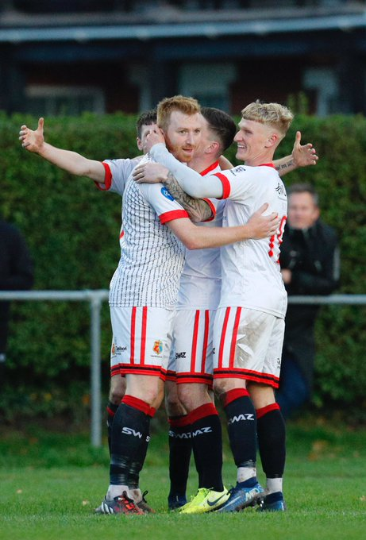
FA Vase: Cribbs produced a sterling fightback in the final 15 minutes to claim a 4-3 win over Newport from the Isle of Wight. After going ahead early through Josh Bennett, Cribbs found themselves 2-1 down at the beginning of the second half following goals from visiting forwards Connor Kelly and Jordan Browne. Steve Murray got the home side back on level terms, but they soon fell behind once again when a scrambled finish made it 3-2 to the Wessex League side. With 15 minutes left on the clock, Cribbs moved back on level terms thanks to Danny Webb, with sustained pressure from the hosts finally paying off in the closing stages when Murray struck for the second time to complete the turnaround. Another memorable fightback occurred at the Hand Stadium, where Clevedon scored twice in the final quarter to beat Whitchurch United 2-1. Nick Yeomans’ 20th minute goal had seen Clevedon trail for much of the contest, but after Ethan Feltham smashed home an equaliser in the 76th minute, the home side then grabbed a dramatic late winner when the in-form Jay Murray rounded the keeper before slotting home. Tavistock (pictured celebrating on the left) were another Western League outfit to book their spot in the next round, after a pair of quick-fire second half goals from Jack Crago and Liam Prynn handed them a 2-1 win away at Lymington Town. Things didn’t go as well for Keynsham who saw Harry McGrath score a hat-trick in their 4-0 defeat at home to Bashley, while Bridgwater beat First Division leaders Welton 5-0 at Fairfax Park. All of the early damage was done by Tom Fry who got on the end of two set-pieces to give Town a two-goal lead at the interval. The second half was then all about Jack Taylor, who made it 3-0 from the spot, before adding two more goals after the hour mark to complete a fine treble.

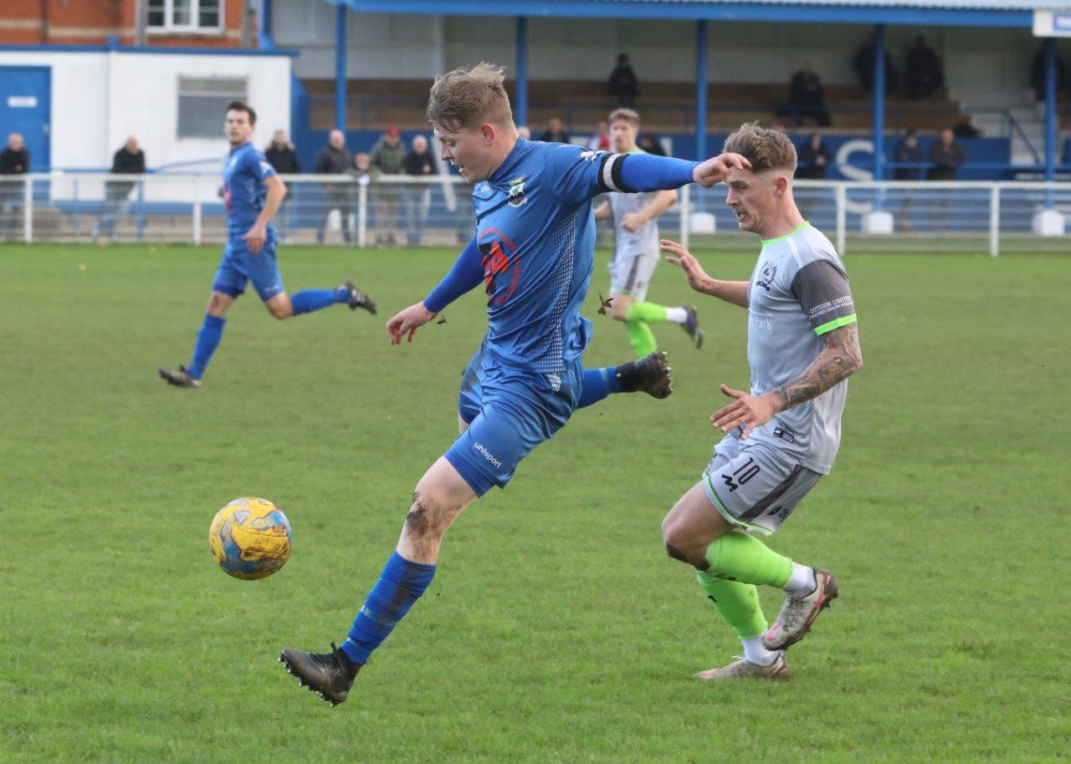
Wells City were rewarded for making their pitch playable, overturning a two-goal deficit early in the second half to knock out Westbury on penalties. After Will Thomson had put the Premier Division side in front during first half stoppage time, the visitors looked to be out of sight when Jamie Jordan tucked home their second soon after the interval. Wells had other ideas though, and after pulling to within a goal, they then equalised soon after with a delightful chipped finish. It was the lower-ranked side who came closest to scoring the fifth goal, but that didn’t materialise and the contest was decided on penalties. Both Josh Ferguson and Will Thomson were unsuccessful with their spot kicks, while Wells only failed once from 12 yards, meaning the Somerset outfit were the ones to book their passage through to the second round.
Action from Wells City’s FA Vase clash with Westbury United. Image courtesy of Martin Pearce.

League Action: Exmouth Town moved up to fourth in the Premier Division after beating Wellington 2-0 in Devon. Ben Steer was the Exmouth matchwinner, opening the scoring after just 12 minutes, before volleying home at the beginning of the second half to complete the victory. Meanwhile, Hallen secured just their second league win from 13 matches by crushing Bridport 5-0. In a truly dominant display from the hosts, Sacha Tong scored twice inside the opening 12 minutes thanks to a pair of excellent assists from Jordan Ricketts and Cory Simpson. That duo then continued to impress, with Simpson making it 3-0 after quarter of an hour, before Ricketts added the hosts fourth after just 20 minutes. After going close on a number of occasions, Hallen finally added a fifth early in the second half when Luke Hall-Cousins added his name to the scoresheet.

Warminster were the big winners in the Saturday’s First Division fixtures, adding five goals after the break on their way to a 6-0 thrashing of bottom-side Devizes. The only goal in the first half was finished off by Jack Miluk, who took advantage of some fine play by Eben Mortimer-Taylor before tucking home. The hosts then took over during the second period, with Seth Wain setting them on their way with an excellent long-range effort. It was then George Butler’s turn to add to the scoring, making it 3-0 just before the hour, with Wain completing his brace soon after. A rare goal from Jordan De Silva, plus a late effort from Martin Johnson completed the six-goal victory for Warminster who now sit fifth in the table.
Corsham Town missed out on the opportunity to go top, but did maintain their unbeaten start after coming from two down to draw 2-2 away at Wincanton. The home side had won six of their last eight in the league, and they positioned themselves to add another three points when Connor Williams put them in front five minutes before the break. Things turned back in Corsham’s favour three minutes after falling behind, when the hosts were reduced to ten men after Harry Turner was shown his second yellow card. The ten men came out of strong after the interval, and against the odds they managed to double their lead when Toby Cole fired home. Corsham had won seven from seven coming into this fixture, and they began their fightback on the hour mark when a cushioned header from Gary Higdon nestled in the back of the net. A couple more chances came and went for the Reds, but they eventually made the extra man count with Higdon’s left-footed effort drawing them level 15 minutes from time. The other game to beat the weather also finished two-apiece, with Almondsbury twice coming from behind to scrape a draw with Bishops Lydeard. Following a goalless opening half, the away team went ahead in stunning fashion when Mark Cornish rifled home from 20 yards. Another fine finish from outside the box by Ben Harrington drew the Almonds level, but Lydeard hit back almost instantly with Luke Boyle tapping home to restore their slender lead. That advantage was soon cancelled out once again, and Almondsbury secured a share of the points when previous goalscorer Harrington turned provider for Ashley Knight who made no mistake with the finish.
Clevedon’s assistant manager Lee Rendall explains his club’s unique management model and Wells’ joint-manager Tom Clifford-Jones discusses the lessons learnt from their inconsistent start to the season.
The broadcast can be found at the following link: http://toolstationleague.com/podcast-episode-8/

Cribbs overturned a late deficit to progress to the next round of the FA Vase at the expense of Newport (IOW). Image courtesy of John Pool.
Latest Results
Tuesday 27th October 2020
Premier Division
Brislington 5-4 Clevedon Town
Keynsham Town 1-6 Street
Odd Down 0-3 Cadbury Heath
First Division
Bristol Telephones 5-2 Longwell Green Sports
Wednesday 28th October 2020
Premier Division
Tavistock 3-2 Exmouth Town
Saturday 31st October 2020
FA Vase – First Round
Bishops Cleeve P-P Shepton Mallet
Bridgwater Town 5-0 Welton Rovers
Brimscombe & Thrupp P-P Longwell Green Sports
Brockenhurst P-P Street
Cheddar P-P Ashton & Backwell United
Clevedon Town 2-1 Whitchurch United
Cribbs 4-3 Newport (IOW)
Fareham Town P-P Roman Glass St George
Keynsham Town 0-4 Bashley
Lymington Town 1-2 Tavistock
Millbrook P-P Sherborne Town
Wells City 2-2 (4-3 pens) Westbury United
Premier Division
Bradford Town P-P Brislington
Cadbury Heath P-P Chipping Sodbury Town
Exmouth Town 2-0 Wellington 231
Hallen 5-0 Bridport 104
Odd Down P-P Plymouth Parkway
First Division
Almondsbury 2-2 Bishops Lydeard 28
Bristol Telephones P-P Bishop Sutton
Oldland Abbotonians P-P Portishead Town
Radstock Town P-P Calne Town
Warminster Town 6-0 Devizes Town
Wincanton Town 2-2 Corsham Town

Upcoming Fixtures
Tuesday 3rd November 2020
Premier Division
Brislington vs Tavistock 19:30KO
Chipping Sodbury Town vs Westbury United 19:30KO
Cribbs vs Odd Down 19:30KO
First Division
Bristol Telephones vs Calne Town 19:45KO
Hengrove Athletic vs Welton Rovers 19:30KO
Portishead Town vs Wells City 19:30KO

Wednesday 4th November 2020
Premier Division
Exmouth Town vs Keynsham Town 19:30KO
Plymouth Parkway vs Street 19:45KO
Wellington vs Bridgwater Town 19:45KO
First Division
Oldland Abbotonians vs Ashton & Backwell United 19:45KO
Sherborne Town vs Bishop Sutton 19:30KO

Saturday 7th November 2020 (3pm kick-off unless noted)
Premier Division
Bridport vs Bradford Town
Brislington vs Bitton
Buckland Athletic vs Hallen
Cadbury Heath vs Exmouth Town
Clevedon Town vs Plymouth Parkway
Keynsham Town vs Westbury United
Odd Down vs Wellington
Shepton Mallet vs Chipping Sodbury Town
Tavistock vs Cribbs
First Division
Bishop Sutton vs Oldland Abbotonians
Bishops Lydeard vs Ashton & Backwell United
Calne Town vs Sherborne Town
Corsham Town vs Lebeq United
Devizes Town vs Almondsbury
Longwell Green Sports vs Radstock Town
Portishead Town vs Wincanton Town
Warminster Town vs Hengrove Athletic
Wells City vs Cheddar
Welton Rovers vs Bristol Telephones

Premier Division Standings
 | Team | Played | Won | Drawn | Lost | GD | Points
1 | Plymouth Parkway | 12 | 10 | 2 | 0 | 32 | 32
2 | Street | 12 | 7 | 1 | 4 | 15 | 22
3 | Tavistock | 10 | 7 | 1 | 2 | 14 | 22
4 | Exmouth Town | 10 | 7 | 0 | 3 | 12 | 21
5 | Clevedon Town | 12 | 6 | 3 | 3 | 5 | 21
6 | Buckland Athletic | 15 | 6 | 3 | 6 | 1 | 21
7 | Cribbs | 11 | 6 | 2 | 3 | 6 | 20
8 | Bitton | 8 | 6 | 0 | 2 | 16 | 18
9 | Bradford Town | 12 | 5 | 3 | 4 | 2 | 18
10 | Roman Glass St George | 11 | 6 | 0 | 5 | 2 | 18
11 | Westbury United | 9 | 5 | 2 | 2 | 6 | 17
12 | Bridgwater Town | 11 | 5 | 1 | 5 | -2 | 16
13 | Shepton Mallet | 10 | 3 | 4 | 3 | -2 | 13
14 | Cadbury Heath | 10 | 4 | 0 | 6 | -5 | 12
15 | Brislington | 9 | 3 | 2 | 4 | -5 | 11
16 | Odd Down | 11 | 3 | 1 | 7 | -18 | 10
17 | Keynsham Town | 11 | 2 | 3 | 6 | -7 | 9
18 | Hallen | 13 | 2 | 3 | 8 | -10 | 9
19 | Wellington | 12 | 2 | 3 | 7 | -14 | 9
20 | Bridport | 9 | 1 | 0 | 8 | -23 | 3
21 | Chipping Sodbury Town | 9 | 0 | 2 | 7 | -24 | 2

First Division Standings
 | Team | Played | Won | Drawn | Lost | GD | Points
1 | Welton Rovers | 9 | 7 | 2 | 0 | 16 | 23
2 | Corsham Town | 8 | 7 | 1 | 0 | 20 | 22
3 | Ashton & Backwell United | 9 | 6 | 1 | 2 | 9 | 20
4 | Wincanton Town | 12 | 6 | 2 | 4 | 6 | 20
5 | Warminster Town | 9 | 6 | 1 | 2 | 13 | 19
6 | Calne Town | 7 | 6 | 0 | 1 | 10 | 18
7 | Wells City | 9 | 5 | 1 | 3 | 5 | 16
8 | Almondsbury | 11 | 5 | 1 | 5 | -6 | 16
9 | Radstock Town | 9 | 5 | 0 | 4 | 1 | 15
10 | Lebeq United | 8 | 4 | 2 | 2 | 8 | 14
11 | Portishead Town | 10 | 4 | 2 | 4 | 2 | 14
12 | Bristol Telephones | 8 | 4 | 0 | 4 | 5 | 12
13 | Hengrove Athletic | 8 | 3 | 3 | 2 | 2 | 12
14 | Sherborne Town | 10 | 4 | 0 | 6 | -2 | 12
15 | Cheddar | 10 | 4 | 0 | 6 | -3 | 12
16 | Bishop Sutton | 8 | 4 | 0 | 4 | -6 | 12
17 | Bishops Lydeard | 11 | 1 | 1 | 9 | -16 | 4
18 | Oldland Abbotonians | 9 | 1 | 0 | 8 | -15 | 3
19 | Longwell Green Sports | 10 | 0 | 1 | 9 | -23 | 1
20 | Devizes Town | 9 | 0 | 1 | 8 | -26 | 1

