Round-ups:
Season 2020/21
#7
Midweek Action: In one of their toughest fixtures so far this season, Plymouth Parkway continue to stretch their lead atop the Premier Division after beating Buckland 2-1 at Homers Heath on Tuesday evening. Parkway went ahead at the beginning of the second half thanks to a driven finish by Matt Wright, before Callum Hall doubled their advantage from long range. The home side pulled a goal back 20 minutes from time through Ryan Keates, but the league leaders held out to extend their unbeaten start. A goal in either half from Troy Simpson helped Roman Glass St George defeat the struggling Hallen 3-0 to end their four-match losing run. A flicked finish in the 29th minute saw Simpson put the visitors in front, before Ryan Radford extended the lead from the spot to register his first goal this term. Simpson saved the best for last, unleashing a powerful effort from long range to wrap up the victory in the closing stages, leaving Hallen winless after ten league games. Street’s strong start to the campaign shows no sign of letting up after they eased to a 3-0 win over Odd Down. With Jacob Dickens opening the scoring, the Cobblers then had Leighton Thomas to thank for their latest victory, with the in-form forward scoring either side of the interval at The Tannery. Home comforts continue to bear fruit for Shepton Mallet, with Nick Hewlett’s volleyed finish helping them edge to a 1-0 win over Bridport. Having played 12 games in all competitions so far this season, Mallet are unbeaten at the Playing Fields, but without a victory away from home in what has been a slightly underwhelming start to their campaign. Cribbs are a side who mirror Mallet’s home/away form, and they produced another strong showing at the Lawns, beating Keynsham 3-2 in an entertaining clash. The hosts enjoyed the better of the opening half and led by two at the break, with Ryan Crouch following up a long-range effort Dan Webb. Adey Harvey’s belting finish helped Keynsham trim the deficit ten minutes into the second half, before a right-footed strike from Ed Harrison found the far corner of the net to restore Cribbs’ two-goal advantage. Mike Grist set up a nervy finish when he turned the ball home in the final minutes, but Cribbs managed to keep their noses in front and secure all three points.
24 hours later, Bitton grabbed an eye-opening 5-1 win away at fellow top-five side Westbury. Having put his side in front during a cagey first half, Matt Barnes doubled his tally early in the second period to continue his impressive start. Matt Groves then struck with a half volley from 30 yards out to put Bitton three-goals to the good, before the hosts got on the board when Joe Stradling slid home. Bitton finished the stronger however, and registered their sixth league win thanks to a late brace from Aysa Corrick. Elsewhere on Wednesday, Clevedon made it five wins on the bounce in all competitions, after goals from Glen Hayer and Ethan Feltham helped them see off Wellington by two goals to nil at the Hand Stadium.
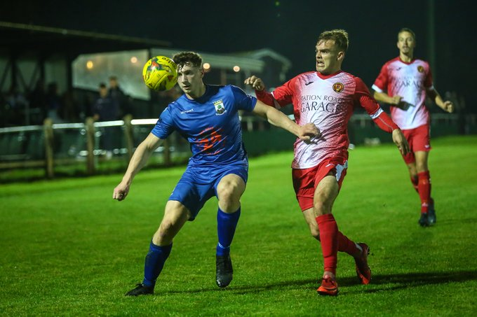
In the First Division, Welton’s excellent run of results continued with a 3-1 victory at home to Devizes. Courtney Charles was the difference between the sides during the first half, volleying home a cross from skipper Alex Wych to break the deadlock, before adding a second from close range after half an hour. Devizes remain rooted to the bottom of the table, but they gave themselves a glimmer of hope when reducing the arrears to set up a cagey second half. It took until the closing stages for Welton to finally put the tie to bed, with substitute Chris Pile slotting home from 12 yards after Charles had been fouled in the penalty area. Corsham made it four wins from in the league this season, beating Wells 2-1 in a tight contest at the Southbank Ground. A Leigh Rogers penalty separated the sides at the interval, before Wells responded, levelling during the second half to put Town’s 100% record at risk. The home side managed to eke out the victory, when the prolific Jamal Chevolleau was given too much space before rifling home to score the game’s decisive goal. At the opposite end of the table, Hengrove finally have their first league win this season after defeating Portishead Town 2-1. It took a while for the game to come to life, but the opening goal was worth waiting for, with a free kick from 20 yards out by Jack Jones finding the top corner to put Hengrove in front. A fearsome left-footed drive from Jack Sell levelled affairs midway through the second half, before Hengrove snatched the points, when visiting defender Alex Chapman deflected the ball into his own net following a wicked ball into the box from impact sub Danny Constable. Longwell Green’s tough start continued away at Almondsbury, where three first half goals led the hosts to a comfortable 4-1 victory. The influential combination of Alex Bisp and Ashley Knight was crucial for Almondsbury, with Bisp twice providing the final pass for Knight who beat the keeper on his way to a first half double. Sam Boulton also struck for the Almonds to make it 3-0, with Tauren Williams sliding home their fourth before the visitors claimed a consolation four minutes from time. On Wednesday evening, Callum Ham provided a standout performance to help fire Cheddar to a 3-1 win away at Radstock Town. A highly contested own goal cancelled out Ham’s first half opener, before the frontman turned provider, teeing up Steve Holland who put Cheddar 2-1 ahead. The points were then made safe in the closing stages, with Ham tucking home a penalty to claim his fifth goal in the space of four games.
Players from Wells and Corsham battle for possession during their First Division clash on Tuesday evening, courtesy of John Cuthbertson.
For an update on the Western League’s COVID-19 postponement protocols, please head to the following link on the website: http://toolstationleague.com/covid-19-postponement-update/
This page will clarify the league’s position regarding the pandemic and will answer many of the FAQ’s which have recently arisen.
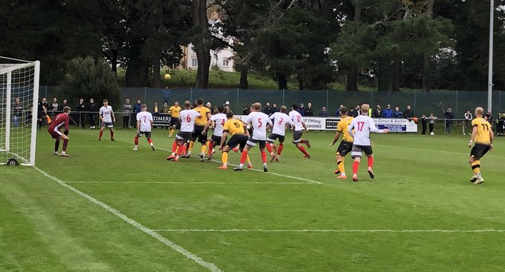
Premier Division: Wellington’s recent upturn in form shows no sign of letting up after they were unfortunate not to become the first side to beat Plymouth Parkway this season. Heading down to Bolitho Park, not many people would have given the Somerset outfit any chance of pulling off a result, but in the end they came within seven minutes of taking all three points. The visitors made a strong start and took a surprise lead in the opening quarter, when Miles Quick side footed the ball home from 12 yards out following a good run and cross by Glen Wright. With the game headed towards half-time, Parkway managed to get level, when Ryan Richards converted from the spot after the ball had hit Josh Champion’s arm inside the box. Welly shook off that disappointment, and got themselves back ahead in stoppage time at the end of the end of the first half through Jesse Howe after Dan Williams’ effort had rebounded back off the crossbar. With time running out, the shock result was within reach, but Parkway’s resilience shone through, and after substitute Billy Palfrey had been fouled inside the area, Richards struck from the spot for the second time to extend their unbeaten start. Roman Glass St George leapfrogged visitors Buckland up into the top five after the Bristol side overturned an early deficit to beat the Devon side 3-1. Things didn’t go to plan for the hosts in the first half, and they trailed for the majority of the first half after Buckland’s main man, Ryan Bush, continued his excellent start to the season in front of goal. The game was level heading into the interval however, and after going close on a couple occasions during the opening 45 minutes, Ben Bament finally managed to find the back of the net at the end of added time. It took only six minutes of the second half for Roman Glass to claim their first lead of the afternoon when Ryan Radford slotted into an empty net, and the win was finally confirmed in the closing stages when leading scorer Bament completed his double. Five minutes of dominance at the beginning of the second half was the difference between the two sides at the Hand Stadium, where Clevedon defeated Bridgwater 2-0. Following a goalless opening half, Clevedon provided a real spark after the break, with Jay Murray crossing for Mitch Osmond who headed home at the back post to break the deadlock. Just three minutes later, the duo were at it again, with Murray playing a one-two on the edge of the box with Osmond before placing the ball past Jake Viney in the Bridgwater goal. Bradford registered back-to-back wins for the first time this season after holding on to beat second placed Street by a goal to nil. The decisive goal came midway through the first half, and it was a regular source who provided the Bobcats winner, with Ross Lye firing home from the penalty spot after Jake Brown had been fouled inside the box.
Action from Wellington’s clash away at Plymouth Parkway.

The biggest winners of the day were Tavistock, who claimed a 7-1 win away at nine-man Odd Down. The red cards clearly didn’t help the home side, who levelled after 15 minutes through Jake Reader after Aaron Bentley had given the Lambs an early lead. It all went downhill from there for the Bath side however, with further goals before the break from Jack Crago, Josh Grant and Alex Cairo handing them a 4-1 deficit. Tavistock didn’t let up in the second half, and after Archie Morris was handed his marching orders, they made their hosts pay with Jordan Annear, Tallan Burns and Luke Brown each adding to the one-sided scoreline. Things were a little quieter in the bottom-half clash at Crown Fields, where Keynsham Town and Shepton Mallet battled out a goalless draw. Cribbs have made a knack out of producing fast starts this season, and they repeated the dose on Saturday afternoon at home to Brislington, scoring twice in the opening 15 minutes on their way to a 2-0 victory. It took just four minutes for the hosts to go in front, with Steve Murray instantly putting the visitors on the back foot. A headed effort from Ross McErlain then made it 2-0 ten minutes later, with Cribbs holding out for their third consecutive three points thanks to a late penalty miss from Brislington’s Jayden Nielsen.
First Division: Stuart Wood produced the individual performance of the day, saving two spot kicks to help Almondsbury claim a come-from-behind 2-1 win away at Portishead Town. Wood’s first major contribution came at the end of the first half, when he saved his first penalty, just moments after he had hauled down a Portishead forward. He was unable to do anything about Portishead’s opener at the beginning of the second half, but he did keep his side in the game soon after, when diving low to his left to save his second spot kick of the afternoon. Almondsbury capitalised on Wood’s heroics, and managed to level the scores on the hour mark, when Ashley Knight beat the home keeper after being played through by Dan Lane. Then, with less than ten minutes remaining, the Almonds secured all three points when Matt Davies squared the ball for Stuart Alexander who slipped the ball into the back of the home net. Another side enjoying themselves on their travels recently are Bristol Telephones, and they now have back-to-back league wins away from home after beating Sherborne Town 2-1. Two first half goals from Ali Boyer proved critical, with the Phones just about hanging on for the victory after Haydn Hodges had pulled a goal back for the Zebras in the opening stages of the second half. Welton Rovers are the new league leaders, after they struck in the ninth minute of stoppage time come out on top of a five-goal thriller away at Cheddar. The Cheesemen showed strong character to keep the game in the balance, with Danny Griffiths scoring their first equaliser at back end of the first half after they conceded to a set piece ten minutes before the interval. Welton retook the lead after an hour, when Jacob Watson scored his first goal for the club when he was found by a cross from Chris Pile. Watson went from hero to zero soon after however, when he was sent from the field for handling the ball on the line, with Cheddar’s Callum Ham converting the subsequent spot kick to make it 2-2. The drama continued deep into stoppage time, and it started with the referee brandishing his second red card, with the home side joining their visitors in ending the game with ten men.
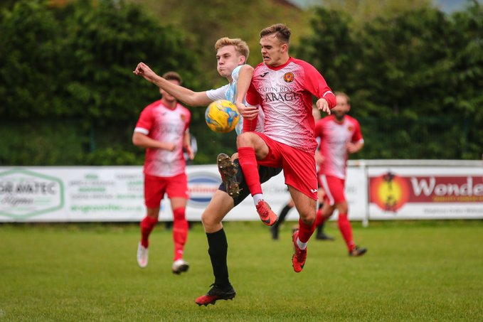
Welton sniffed blood, and within moments of the dismissal, they attacked down the right, with Kyle Box unleashing a strong driven effort from well outside the area which cannoned into the back of the net off the underside of the bar to add three more points to their increasing tally. The other two unbeaten records also remain intact, with Corsham continuing to impress following a 5-1 victory away at Longwell Green Sports. Town are now five from five to start the season, after a goal in either half from Gary Higdon, plus further strikes after the interval from Will Stead, Matt Jones and James Vincent led them to an easy win. Calne consolidated third spot, and extended their winning record, after Matty Jenkins first half double led them to a 2-0 win at home to Bishops Lydeard. There was also a goalscoring brace for Jack Jones in Hengrove’s 2-0 triumph away at Oldland Abbotonians, while debutant Cameron Allen scored twice to help Wincanton overturn a half-time deficit on their way to a 3-1 win over the luckless Devizes at Nursteed Road. Ashton & Backwell United slipped from top spot, but will be happy with their fightback, coming from two goals down to draw 2-2 at home to Wells City. The visitors made a strong start, with the influential Craig Herrod handing them an early lead, before he then teed up Harry Foster who doubled their advantage inside 20 minutes of the game kicking off. Two mistakes at the back were capitalised upon by the resolute Ashton side who remain unbeaten since the opening day of the season at the beginning of September. Radstock’s topsy-turvy start to the campaign continued at Lakeview, where a dominant performance saw them triumph by five goals to nil over Bishop Sutton. Just 24 hours after announcing the departure of former manager Nathan Farquharson, Radstock were outstanding in victory, with five different players finding the back of the net. Usual contributors such as Sam Gregory and James Rustell were among the goal-getters, with Omar Simpson, Rico Sobers and Morgan Skipp also beating the Sutton keeper.
Action from Corsham’s 5-1 win away at Longwell Green Sports. Image courtesy of John Cuthbertson.

On last week’s podcast, Ian caught up with Joe White and Lee Davidson, the mangers of Longwell Green and Bradford. There is also an interview with the Western League’s COVID officer George McCaffery, giving up an update on the latest guidance.
The latest broadcast is available at the following link: http://toolstationleague.com/podcast-episode-6/

Latest Results
Tuesday 13th October 2020
Premier Division
Buckland Athletic 1-2 Plymouth Parkway 289
Cribbs 3-2 Keynsham Town 97
Hallen 0-3 Roman Glass St George 116
Shepton Mallet 1-0 Bridport 146
Street 3-0 Odd Down 100
First Division
Almondsbury 4-1 Longwell Green Sports 49
Corsham Town 2-1 Wells City 121
Hengrove Athletic 2-1 Portishead Town 71
Welton Rovers 3-1 Devizes Town

Wednesday 14th October 2020
Premier Division
Clevedon Town 2-0 Wellington 118
Westbury United 1-5 Bitton 127
First Division
Radstock Town 1-3 Cheddar 96

Saturday 17th October 2020
Premier Division
Bradford Town 1-0 Street 135
Clevedon Town 2-0 Bridgwater Town 148
Cribbs 2-0 Brislington 86
Keynsham Town 0-0 Shepton Mallet
Odd Down 1-7 Tavistock 89
Plymouth Parkway 2-2 Wellington 298
Roman Glass St George 3-1 Buckland Athletic 60
First Division
Ashton & Backwell United 2-2 Wells City
Bishop Sutton 0-5 Radstock Town 70
Calne Town 2-0 Bishops Lydeard 105
Cheddar 2-3 Welton Rovers 83
Devizes Town 1-3 Wincanton Town
Longwell Green Sports 1-5 Corsham Town
Oldland Abbotonians 0-2 Hengrove Athletic 53
Portishead Town 1-2 Almondsbury
Sherborne Town 1-2 Bristol Telephones 134

Upcoming Fixtures
Monday 19th October 2020
First Division
Wells City vs Warminster Town 19:30KO

Tuesday 20th October 2020
Premier Division
Bitton vs Brislington 19:30KO
Chipping Sodbury Town vs Bradford Town 19:45KO
Cribbs vs Buckland Athletic 19:45KO
Hallen vs Odd Down 19:30KO
First Division
Bristol Telephones vs Longwell Green Sports 19:30KO
Corsham Town vs Oldland Abbotonians 19:30KO
Hengrove Athletic vs Bishop Sutton 19:30KO

Wednesday 21st October 2020
Premier Division
Exmouth Town vs Shepton Mallet 19:30KO
Wellington vs Tavistock 19:45KO
First Division
Sherborne Town vs Cheddar 19:30KO

Saturday 24th October 2020 (3pm kick-off unless noted)
Premier Division
Bitton vs Keynsham Town
Bridgwater Town vs Chipping Sodbury Town
Clevedon Town vs Bridport
Exmouth Town vs Hallen
Plymouth Parkway vs Cadbury Heath
Roman Glass St George vs Bradford Town
Shepton Mallet vs Brislington
Street vs Westbury United
Tavistock vs Odd Down
Wellington vs Cribbs
First Division
Ashton & Backwell United vs Hengrove Athletic
Bishop Sutton vs Devizes Town
Bishops Lydeard vs Sherborne Town
Bristol Telephones vs Lebeq United
Cheddar vs Calne Town
Corsham Town vs Almondsbury
Radstock Town vs Portishead Town
Wells City vs Oldland Abbotonians
Welton Rovers vs Warminster Town
Wincanton Town vs Longwell Green Sports

Premier Division Standings
 | Team | Played | Won | Drawn | Lost | GD | Points
1 | Plymouth Parkway | 11 | 9 | 2 | 0 | 29 | 29
2 | Street | 10 | 6 | 1 | 3 | 11 | 19
3 | Bitton | 8 | 6 | 0 | 2 | 16 | 18
4 | Clevedon Town | 10 | 5 | 3 | 2 | 4 | 18
5 | Roman Glass St George | 11 | 6 | 0 | 5 | 2 | 18
6 | Buckland Athletic | 13 | 5 | 3 | 5 | 1 | 18
7 | Westbury United | 9 | 5 | 2 | 2 | 6 | 17
8 | Tavistock | 8 | 5 | 1 | 2 | 12 | 16
9 | Exmouth Town | 6 | 5 | 0 | 1 | 12 | 15
10 | Bradford Town | 11 | 4 | 3 | 4 | 0 | 15
11 | Cribbs | 9 | 4 | 2 | 3 | 4 | 14
12 | Bridgwater Town | 10 | 4 | 1 | 5 | -7 | 13
13 | Odd Down | 9 | 3 | 1 | 5 | -13 | 10
14 | Keynsham Town | 10 | 2 | 3 | 5 | -2 | 9
15 | Shepton Mallet | 8 | 2 | 3 | 3 | -3 | 9
16 | Cadbury Heath | 8 | 3 | 0 | 5 | -5 | 9
17 | Wellington | 10 | 2 | 3 | 5 | -12 | 9
18 | Brislington | 7 | 2 | 1 | 4 | -6 | 7
19 | Hallen | 10 | 0 | 3 | 7 | -16 | 3
20 | Bridport | 7 | 1 | 0 | 6 | -16 | 3
21 | Chipping Sodbury Town | 7 | 0 | 2 | 5 | -17 | 2

First Division Standings
 | Team | Played | Won | Drawn | Lost | GD | Points
1 | Welton Rovers | 8 | 6 | 2 | 0 | 13 | 20
2 | Ashton & Backwell United | 8 | 6 | 1 | 1 | 9 | 19
3 | Calne Town | 6 | 6 | 0 | 0 | 11 | 18
4 | Wincanton Town | 10 | 5 | 1 | 4 | 1 | 16
5 | Corsham Town | 5 | 5 | 0 | 0 | 15 | 15
6 | Almondsbury | 9 | 5 | 0 | 4 | -5 | 15
7 | Lebeq United | 8 | 4 | 2 | 2 | 8 | 14
8 | Portishead Town | 9 | 4 | 2 | 3 | 4 | 14
9 | Warminster Town | 6 | 4 | 1 | 1 | 8 | 13
10 | Wells City | 7 | 4 | 1 | 2 | 4 | 13
11 | Radstock Town | 8 | 4 | 0 | 4 | -1 | 12
12 | Bristol Telephones | 7 | 3 | 0 | 4 | 2 | 9
13 | Cheddar | 8 | 3 | 0 | 5 | 0 | 9
14 | Bishop Sutton | 6 | 3 | 0 | 3 | -4 | 9
15 | Hengrove Athletic | 6 | 2 | 2 | 2 | -1 | 8
16 | Sherborne Town | 8 | 2 | 0 | 6 | -8 | 6
17 | Oldland Abbotonians | 7 | 1 | 0 | 6 | -8 | 3
18 | Bishops Lydeard | 9 | 1 | 0 | 8 | -14 | 3
19 | Longwell Green Sports | 8 | 0 | 1 | 7 | -15 | 1
20 | Devizes Town | 7 | 0 | 1 | 6 | -19 | 1

