Round-ups:
#6
Season 2020/21
Midweek Action: Bitton continued their climb up the Premier Division table after defeating Street 4-2 at The Tannery. Both sides have started their seasons strongly, but it was Bitton who made early inroads on Tuesday evening with Dean Griffiths scoring twice inside the opening 20 minutes. The visitors continued to impress, extending their lead to three through Matt Barnes, before Kyle Strange pulled a goal back for Street one minute before the interval. Barnes struck for the second time at the beginning of the second half to kill off any hopes of a Street comeback, but the home side had the last word, with Leighton Thomas scoring 20 minutes from time. Having drawn 1-1 in their previous meeting less than a month ago, Tavistock earned this season’s bragging rights over Buckland thanks to a 5-1 win away at Homers Heath. The Devon derby started well for Buckland who led after just five minutes when Ben Carter capitalised on a defensive error to fire the hosts in front. Tavistock were back on level terms after quarter of an hour, when Jack Crago struck, and it remained one-apiece until a crazy final ten minutes ensued. Crago was integral to the Lambs late blitz, scoring twice in the space of three minutes to complete his hat-trick and help his side lead 3-1. Second half substitute Tallan Burns added a fourth for the visitors, before Josh Grant completed the scoring in stoppage time, capping a wild ending to the game in front of a very healthy midweek crowd. The 262 in attendance at Fairfax Park would enjoy a home victory, with second half goals from Mark Armstrong and Conor Bryant leading Bridgwater to a hard-fought 2-1 win over Wellington.

Welton just about hung on to their unbeaten start in the First Division, scoring twice in the final 20 minutes to salvage a 2-2 draw away at the winless Longwell Green Sports. The home side made a dream start, leading by two goals to nil after just 12 minutes, but they relinquished their grip on the contest somewhat at the end of the first half when they reduced to ten men. Rovers begun their fightback 20 minutes from time, when Chris Pile looped in a corner from the left, with Courtney Charles on hand to clatter home the ball with his left foot. Then, with five minutes left on the clock, Welton completed their fightback when a volley on the edge of the box from Lewis Coleman deflected off a luckless Longwell Green defender into the bottom corner of the net. Wells City produced a fine comeback of their own, scoring three times in the final 20 minutes to eventually beat Devizes 4-2 at Nursteed Road. Devizes have had a tough start this term, and the hosts came close to grabbing their first three points of the season after goals from Paul Gittins and Charlie Strickland handed them a late 2-1 lead. Wells ended the game strongly, picking up their fourth win from five, with Harry Foster, Craig Herrod, Harvey Hadrill and James Bayliss all getting on the scoresheet.

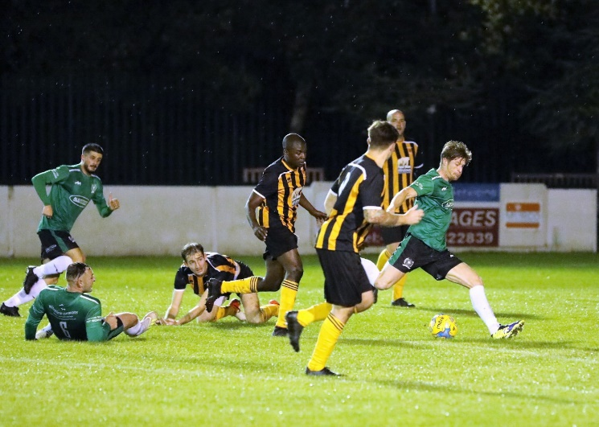
Postponements meant that there was limited action on Wednesday evening, but two Premier Division clashes beat the weather and were rewarded with three-figure crowds. Westbury continued their strong start to the season at home to Keynsham, scoring twice in the second half to secure a 2-0 win. The opener came in the opening moments of the second period, with Mark Robinson pouncing on a mistake directly from the kick-off to put the hosts in front. The Wiltshire side wrapped up the three points late on, with Sam Jordan firing home following a surging run up the field from Josh Ferguson. Clevedon Town were Wednesday’s other big winners after they triumphed by two goals to nil away at Roman Glass St George. It took 28 minutes for the deadlock to be broken, and it came via a set-piece, with Glen Hayer smashing the ball into the roof of the net after he got on the end of a deep corner from Morgan Davies. Then, with time in the first half winding down, Jay Murray trapped a long ball over the top before rounding the home keeper and finishing into the empty net.
Action from Westbury’s midweek victory at home to Keynsham. Image courtesy of Martin Pearce.
Premier Division: Plymouth Parkway extended their unbeaten start to the season with a comfortable 4-1 win at home to Bridgwater Town. After Matt Wright had put them ahead in the 17th minute, Parkway took control of the fixture just before the break, scoring twice in quick succession to put some distance between the sides. River Allen curled home the second after receiving the ball on the edge of the box, before Craig Veal then added their third in first half stoppage time. Allen was at it again in the 63rd minute, adding his second from the penalty spot, with the visitors claiming a late consolation through Jake Llewellyn. Buckland Athletic held off a fightback from Bitton to secure a 3-2 win, enabling them to leapfrog all the way up to second on the table. An unbelievable start to the game saw the visitors score three times inside the opening 15 minutes to completely shell-shock a Bitton side who were riding a three-match winning run. The scoring started early, with debutant JJ Evans making an instant impact for the Devon outfit, before a towering header from Austen Booth made it 2-0 in no time at all. Having seen Gavin Collins extend the lead to three after just 14 minutes, Bitton began their comeback soon after when Dean Griffiths tapped home. The home side made a dream start to the second half, pulling to within a goal when Matt Barnes found the back of the net, but Buckland dug deep over the final 45 minutes to confirm the victory. A late charge from Bradford Town fired them to an impressive 4-1 win away at Tavistock. Liam Prynn cancelled out Charlie Walton’s opener to get the Lambs back on level terms, but Bradford found a second wind and managed to restore their lead when Ross Lye fired home from the penalty spot. An own goal put the Bobcats two in front, and then with the final kick of the match, Lye converted his second spot kick to wrap up the three points.
Wellington’s recent improvements continue to bear fruit, and they made it two wins in the space of three games by beating Roman Glass St George 2-1. The Tangerines enjoyed the best of the first half, and found themselves a goal to the good when Ollie Holman slipped the ball home following a smart one-two with teammate Jack Lewis. Roman Glass responded well, drawing level at the beginning of the second half through Troy Simpson, but it was Wellington who pushed on to claim the points, with Holman producing a delightful curled finish to score the winner 20 minutes from time.
First Division: In the battle between the bottom two, Bishops Lydeard claimed a much-needed victory over Devizes to capture their first points of the season. In truth, it wasn’t much of a contest, with Lydeard scoring four times before the interval during a 5-1 win which all began with Mark Cornish’s 10th minute opener. Jack Kelly then doubled the hosts lead less than ten minutes later before Town pulled a goal back. A fierce drive from outside the area by Amauri Ruiz restored Lydeard’s advantage towards the end of the first half, before Luke Boyle made it 4-1 a couple of moments later. Having had a rough start of things, the Lyds will have enjoyed this morale boosting win, which ended on a high when debutant Alves Jesus scored their fifth after entering the field as a second half substitute. At the opposite end of the table, Warminster rebounded from a couple of bad results by beating Almondsbury 3-0. Martin Johnson was the star of the show for the home side, scoring in both halves, with George Butler also getting his name on the scoresheet thanks to an assist from Ian Jeffery. Top five rivals Portishead and Lebeq remain level on points following their 1-1 draw at Bristol Road, while Wincanton defeated Bishop Sutton 1-0 to register their fourth win in five outings.
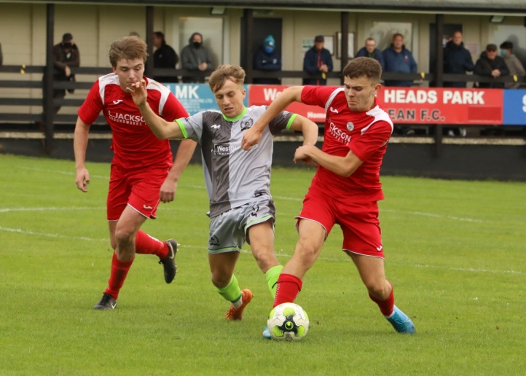
FA Vase: It was an encouraging day for a number of Western League clubs in the FA Vase on Saturday, with the likes of Shepton Mallet and Cheddar moving on to the first round proper following big wins. For Mallet, five different goalscorers helped them see off the challenge of Torrington on their way to a 5-1 win. Tyson Pollard handed them a perfect start in the second minute, before a defensive blunder allowed the visitors a path back into the game. Matty Morris gave Shepton the lead back, before Fin Haines, Jake Fillingham and Joe Morgan added the finishing touches to a strong home performance. Meanwhile, the Cheesemen held off a late fightback to knock out Ivybridge, with two second half goals from Callum Ham adding to Ollie Hucker’s opener, who broke the deadlock on what was his 100th appearance for the club. Westbury also rolled onto the next round after Josh Ferguson’s goal on the hour mark saw them win 1-0 away at Horndean, while Longwell Green Sports snuck past Bovey Tracey by two goals to one.
Westbury battle for possession during their 1-0 win away at Horndean, courtesy of Martin Pearce.
In one of the all-Western League clashes, Keynsham smashed First Division outfit Oldland 5-0 behind a hat-trick from Matt Brown. Having led by Jordan Metters’ solitary goal at the interval, Keynsham dominated thereafter with Brown’s treble plus a further goal from Adey Harvey completing the victory. Sam Stone’s long range screamer kick-started Wells City’s 3-0 home win over Bristol Telephones. Craig Herrod followed up Stone’s opener with a cool finish to make it 2-0, before a second half penalty from Alex Camm completed the win. An incident-packed contest between Street and Hengrove ended with the Premier Division outfit earning a 2-0 victory over their lower-ranked visitors. Things started horrendously for Hengrove who had Giorgio Mancini given his marching orders after just 12 minutes, and soon after they conceded a penalty. Harry Thomas-Baker was up to the challenge however, and the visiting keeper saved the spot kick to maintain his clean sheet. Street then received a red card of their own, when Jayden Corbidge collected his second yellow at the end of the first half to set up an intriguing second period. It was the Cobblers who produced the goods when it mattered most, and they moved onto the next round thanks to a pair of strong finishes from Kyle Strange and Kameron Andrews. Bridport were beaten by 3-1 at home by Ilfracombe, while Brislington couldn’t capitalise on an early red card and lost to the ten men of St Blazey by three goals to nil. Hallen and Sacha Tong left their attempted comeback too little time to materialise, falling to a 2-1 loss away at Millbrook, but things were more rosy for Welton, with the in-form Green Army beating Elburton Vila 1-0 thanks to an early strike from Lewis Russell. There was also a big win for Clevedon Town, with Syd Camper and Elliot Nicholson both laying on assists for Jay Murray who scored in either half of their 2-0 triumph away at Axminster.

Action from Clevedon’s victory away at Axminster, courtesy of John Pool

On last week’s podcast, Ian caught up with Plymouth Parkway manager Lee Hobbs and Tom Smith of Welton to get their thoughts on the promotion races in either division. The latest broadcast can be found at the following link:
http://toolstationleague.com/podcast-episode-5/

Latest Results
Tuesday 6th October 2020
Premier Division
Bridgwater Town 2-1 Wellington 262
Buckland Athletic 1-5 Tavistock 220
Street 2-4 Bitton 115
First Division
Devizes Town 2-4 Wells City 88
Longwell Green Sports 2-2 Welton Rovers 168

Wednesday 7th October 2020
Premier Division
Roman Glass St George 0-2 Clevedon Town 152
Westbury United 2-0 Keynsham Town 114

Saturday 10th October
FA Vase
Axminster 0-2 Clevedon Town
Bridport 1-3 Ilfracombe
Cheddar 3-2 Ivybridge
Horndean 0-1 Westbury United
Longwell Green Sports 2-1 Bovey Tracey
Millbrook 2-1 Hallen
Oldland Abbotonians 0-5 Keynsham Town
Shepton Mallet 5-1 Torrington
St Blazey 3-0 Brislington
Street 2-0 Hengrove Athletic
Wells City 3-0 Bristol Telephones
Welton Rovers 1-0 Elburton Villa
Premier Division
Bitton 2-3 Buckland Athletic 121
Plymouth Parkway 4-1 Bridgwater Town 296
Tavistock 1-4 Bradford Town
Wellington 2-1 Roman Glass St George
First Division
Bishops Lydeard 5-1 Devizes Town 65
Portishead Town 1-1 Lebeq United
Warminster Town 3-0 Almondsbury
Wincanton Town 1-0 Bishop Sutton 86

Upcoming Fixtures
Tuesday 13th October 2020
Premier Division
Buckland Athletic vs Plymouth Parkway 19:30KO
Cribbs vs Keynsham Town 19:45KO
Hallen vs Roman Glass St George 19:30KO
Shepton Mallet vs Bridport 19:30KO
Street vs Odd Down 19:30KO
First Division
Almondsbury vs Longwell Green Sports 19:30KO
Corsham Town vs Wells City 19:45KO
Hengrove Athletic vs Portishead Town 19:30KO

Wednesday 14th October 2020
Premier Division
Clevedon Town vs Wellington 19:30KO
Tavistock vs Exmouth Town 19:30KO
Westbury United vs Bitton 19:30KO
First Division
Radstock Town vs Cheddar 19:30KO
Sherborne Town vs Bishop Sutton 19:30KO

Saturday 17th October (3pm kick-off unless noted)
Premier Division
Bradford Town vs Street
Bridport vs Westbury United
Clevedon Town vs Bridgwater Town
Cribbs vs Brislington
Keynsham Town vs Shepton Mallet
Odd Down vs Exmouth Town
Plymouth Parkway vs Wellington
Roman Glass St George vs Buckland Athletic
First Division
Ashton & Backwell United vs Wells City
Bishop Sutton vs Radstock Town
Calne Town vs Bishops Lydeard
Cheddar vs Welton Rovers
Devizes Town vs Wincanton Town
Longwell Green Sports vs Corsham Town
Oldland Abbotonians vs Hengrove Athletic
Portishead Town vs Almondsbury
Sherborne Town vs Bristol Telephones
Warminster Town vs Lebeq United

Premier Division Standings
 | Team | Played | Won | Drawn | Lost | GD | Points
1 | Plymouth Parkway | 9 | 8 | 1 | 0 | 28 | 25
2 | Buckland Athletic | 11 | 5 | 3 | 3 | 4 | 18
3 | Westbury United | 8 | 5 | 2 | 1 | 10 | 17
4 | Street | 8 | 5 | 1 | 2 | 9 | 16
5 | Bitton | 7 | 5 | 0 | 2 | 12 | 15
6 | Exmouth Town | 6 | 5 | 0 | 1 | 12 | 15
7 | Tavistock | 7 | 4 | 1 | 2 | 6 | 13
8 | Bridgwater Town | 9 | 4 | 1 | 4 | -5 | 13
9 | Clevedon Town | 8 | 3 | 3 | 2 | 0 | 12
10 | Bradford Town | 10 | 3 | 3 | 4 | -1 | 12
11 | Roman Glass St George | 9 | 4 | 0 | 5 | -3 | 12
12 | Odd Down | 7 | 3 | 1 | 3 | -4 | 10
13 | Cadbury Heath | 8 | 3 | 0 | 5 | -5 | 9
14 | Cribbs | 7 | 2 | 2 | 3 | 1 | 8
15 | Keynsham Town | 8 | 2 | 2 | 4 | -1 | 8
16 | Wellington | 8 | 2 | 2 | 4 | -10 | 8
17 | Brislington | 6 | 2 | 1 | 3 | -4 | 7
18 | Shepton Mallet | 6 | 1 | 2 | 3 | -4 | 5
19 | Hallen | 9 | 0 | 3 | 6 | -13 | 3
20 | Bridport | 6 | 1 | 0 | 5 | -15 | 3
21 | Chipping Sodbury Town | 7 | 0 | 2 | 5 | -17 | 2

First Division Standings
 | Team | Played | Won | Drawn | Lost | GD | Points
1 | Ashton & Backwell United | 7 | 6 | 0 | 1 | 9 | 18
2 | Calne Town | 5 | 5 | 0 | 0 | 9 | 15
3 | Welton Rovers | 6 | 4 | 2 | 0 | 10 | 14
4 | Lebeq United | 8 | 4 | 2 | 2 | 8 | 14
5 | Portishead Town | 7 | 4 | 2 | 1 | 6 | 14
6 | Warminster Town | 6 | 4 | 1 | 1 | 8 | 13
7 | Wincanton Town | 9 | 4 | 1 | 4 | -1 | 13
8 | Wells City | 5 | 4 | 0 | 1 | 5 | 12
9 | Corsham Town | 3 | 3 | 0 | 0 | 10 | 9
10 | Bishop Sutton | 5 | 3 | 0 | 2 | 1 | 9
11 | Radstock Town | 6 | 3 | 0 | 3 | -4 | 9
12 | Almondsbury | 7 | 3 | 0 | 4 | -9 | 9
13 | Bristol Telephones | 6 | 2 | 0 | 4 | 1 | 6
14 | Cheddar | 6 | 2 | 0 | 4 | -1 | 6
15 | Sherborne Town | 7 | 2 | 0 | 5 | -7 | 6
16 | Oldland Abbotonians | 6 | 1 | 0 | 5 | -6 | 3
17 | Bishops Lydeard | 8 | 1 | 0 | 7 | -12 | 3
18 | Hengrove Athletic | 4 | 0 | 2 | 2 | -4 | 2
19 | Longwell Green Sports | 6 | 0 | 1 | 5 | -8 | 1
20 | Devizes Town | 5 | 0 | 1 | 4 | -15 | 1

