Round-ups:
Season 2020/21
#5
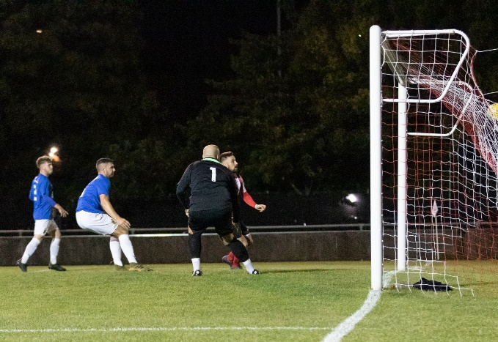
Midweek Action: Despite scoring four goals on Tuesday evening, Jake Slocombe couldn’t lead Chipping Sodbury to their first victory of the season, after Hallen produced a late fightback to salvage a 4-4 draw. In a battle between two of the winless sides, Slocombe put the home side in complete control, scoring twice from the spot, before adding a third soon after to complete a five-minute hat trick around the half-hour mark. Sacha Tong pulled a goal back for Hallen in the early stages of the season half, before Slocombe struck once again to give the Sods a 4-1 lead with less than 20 minutes remaining. Rob Latham trimmed the deficit, before Hallen really started to pile on the pressure in the closing stages, pulling to within one goal when Cory Simpson bundled the ball home. In the 89th minute, the visitors completed their comeback, with Martin Stowell heading home to grab a share of the spoils. Elsewhere, it was a good night for home sides in the Premier Division, with a pair of second half goals from Jordan Metters leading Keynsham to a 2-0 win over Bradford Town. There was also a 2-0 victory for Bitton, with Aysa Corrick scoring, and then laying on the assist for Harrison Kyte in their defeat of Cribbs. Jack Taylor’s fifth minute header (pictured right, courtesy of Debbie Gould) was the difference between the teams at Fairfax Park, where Bridgwater snuck past Buckland in what ended up being a feisty encounter. The other fixture on Tuesday saw Odd Down gain revenge over their FA Vase conquerors Brislington with a 3-2 win at the Lew Hill Memorial Ground. After falling behind to Jayden Nielsen’s 20th minute penalty, Josh Clark and David Ishi each struck towards the end of the first half to tip the balance in the Bath side’s favour. Clark then scored his second to make it 3-1, with Neikell Plummer heading home for the visitors midway through the second half.
The following evening, Plymouth Parkway continued their free-scoring start to the season, with River Allen and Craig Veal each bagging doubles in their 6-1 win away at Wellington. The visitors flew out of the blocks and led by two goals inside 13 minutes thanks to a long-range effort from Allen, and a strong headed finish from Veal. Glen Wright offered hope for Wellington when he struck in his first game back from injury, but that hope was quickly put to bed when Veal restored Parkway’s two-goal advantage. Allen completed his brace towards the end of the first half, before goals from Billy Palfrey and Levi Landricombe completed the scoring after interval.
There was also a big win for Exmouth Town who responded well after falling behind early to beat Bridport 4-1 at Southern Road. After Leon Wood’s delicately placed header had handed the away side a surprise tenth minute lead, Exmouth hit back a couple of moments later thanks to a drilled finish from Max Gillard. The large crowd were treated to a strong second half display from the hosts, with Mark Lever handing them their first lead in the 52nd minute, before youngster Dan Cullen and substitute Ben Steer adding further goals in the closing stages. Clevedon Town secured their first league win of the season at the sixth time of asking, with a late blunder from Shepton Mallet’s keeper allowing them to register a 2-1 victory. The Seasiders led for much of the contest following Archie Ferris’ 20th minute header, but then with the game heading into the final ten minutes, Mallet managed to force home an equaliser. Clevedon pushed for victory, and after pressurising the visitors back line, the ball found its way to Mitch Osmond who tapped the ball into the back of the net to grab all three points. The four-game winning run of Roman Glass St George was brought to an abrupt halt at home to Westbury United after they suffered a heavy 4-1 defeat. Having gone more than 350 minutes without conceding a goal, Roman Glass were shell-shocked by their visitors from Wiltshire who scored four times before the break in their commanding win. After Dan Price had put them in front, further goals from Sam Jordan, Steve Hulbert and Joe Stradling gave helped Westbury storm into a four-goal lead. The only slight blip on the evening for Westbury came in the closing stages when Sam Wentland’s header denied them a clean sheet, but the three points have put them amongst the early season frontrunners. Street have also enjoyed plenty of early season success, and that continued away at Cadbury Heath, where goals inside the opening 20 minutes from Jakob Dickens, Leighton Thomas and Kyle Strange helped them ease to a 3-1 victory.
Calne Town maintained their winning start in the First Division on Tuesday, hitting their straps early to earn a 3-0 victory away at Bishop Sutton. The home side had won both of their previous league fixtures, but were no match for the Lilywhites who led after just 11 minutes through Lewis McCarron. Matty Jenkins then doubled their lead, before a headed effort from Jay Walters made it 3-0 inside half an hour to make it four wins from four for Calne. Portishead also added three points to their tally thanks to an away win, with second half goals from Jack Sell and Rob Sivers allowing them beat Bishops Lydeard 2-1 at Cothelstone Road. Welton Rovers clung onto their unbeaten start, with a late header from skipper Alex Wych helping them secure a 1-1 draw away at Wincanton. The home side took the lead just before half-time through Louis Irwin, but then with five minutes remaining, a ball into the area from Kyle Box just about found the head of Wych who deflected the ball home to rescue a point. Elsewhere that evening, Hengrove and Devizes are still looking for their first victories of the season after battling out a goalless draw.
On Wednesday, Radstock Town rebounded extremely well following their harrowing 7-2 defeat against Corsham by beating Oldland Abbotonians 4-2 at the Southfields Rec. Two goals from Owen McCallum gave Oldland hope of ending their losing streak, before a second goal on the night from James Rustell pushed Radstock into a 3-2 lead. Following a foul on the edge of the box, Ali Sen whipped his left-footed free-kick into the bottom corner of the visitors net to wrap up victory late on for the Miners.
Wells City came out on top in a tight contest away at Sherborne, winning 3-2 to just about extend their 100% start. Having twice gone ahead through Ben Robertson and Dale Hunt, Wells couldn’t hold onto their lead’s at Raleigh Grove, with Alex Murphy and Tom Beeson doing enough to equalise for the home side. A third goal from the visitors proved decisive, and it came from last season’s leading scorer Harry Foster who reacted quickest to a penalty save from Jason Hutchings to force the ball home.
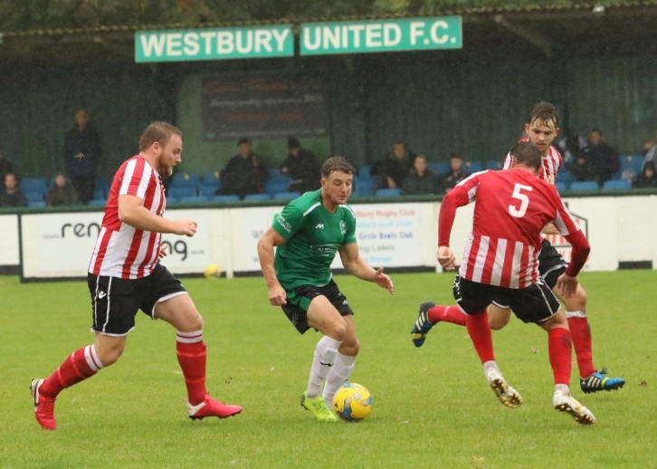
Premier Division: An incredible individual performance from Jordan Harris fired Exmouth Town to a huge 6-1 victory away at Bradford to extend their winning run. Things didn’t start well for the visitors who fell behind after just 16 minutes when Liam Watson scored following a goalmouth scramble in the Exmouth area. A powerful header from Ace High got the Devon side back on level terms, before Harris asserted himself on the contest, scoring twice in quick succession to make it 3-1. Things got worse for the Bobcats when they conceded a penalty in stoppage time at the end of the first, and Harris was the man to convert from 12 yards, completing his hat-trick in the space of just eight minutes. Exmouth didn’t let up during the second half, with Harris striking once more as they eventually ran out victors by six goals to one. Bitton collected their fourth league win of the season at home to Odd Down, with the in-form Dean Griffiths bagging a hat-trick for the home side. Plymouth Parkway continue to lead the way atop he division, but they were made to battle on their way to a 3-1 home win over Shepton Mallet. The table toppers missed a couple of early opportunities, but didn’t have to wait long until breaking the deadlock, with Ryan Lane firing them in front after 15 minutes. Mallet began to create a few chances of their own, but were unable to break down the home defence, and they were made to pay on the hour mark when Ryan Richards converted from the penalty spot. Mike Williams added a late third for Parkway, before the visitors grabbed the goal their performance deserved, with Nathan Legge finishing well. Tavistock came out on top in a tight contest against Roman Glass St George, with Josh Grant scoring the only goal of the game 15 minutes from time to lead the Lambs to a crucial three points. A long range effort from Joe Stradling earned Westbury a point at home to Bridgwater, with the home side twice coming from behind to gain a 2-2 draw at Meadow Lane. After Archie Sturdy had given Bridgwater an early lead from outside the box, Westbury were awarded a penalty which Sam Jordan converted at the first time of asking to level affairs. The prolific Jack Taylor restored the visitors lead at the back end of the first half, but they were unable to hang on for the victory, with Stradling lobbing Jake Viney from over 40 yards after the keeper had raced from his goal to clear a through ball.
Westbury on the attack during their 2-2 draw with Bridgwater, courtesy of Martin Pearce.
Clevedon Town fought off a late fightback attempt from Keynsham to secure just their second league win of the season. Sam Iles was involved in all of the game’s big moments, and after scoring at the start of the second half to put Clevedon in front, he then volleyed home Elliot Nicholson’s cross to make it 2-0. With five minutes left on the clock, Iles was ruled to have used his hands to stop a goalbound effort, and was dismissed to leave his side with ten men. Jordan Metters tucked home the resulting penalty, but Keynsham were unable to find an equaliser as the Seasiders clung on for the three points.
It was a similar story for Buckland who held off an attempted late comeback from Brislington to secure a 2-1 win. After Ryan Keates has scored from close range to put Buckland ahead, a low driven finish from Ryan Bush then added a second midway through the second half. The home side gave themselves a little bit of hope in the closing stages, but couldn’t quite find a second goal after Jayden Nielsen had halved the deficit from the penalty spot. Cribbs had little trouble in seeing off Cadbury Heath at The Lawns, with Steve Murray scoring twice during their 4-0 win. It took the home side less than three minutes to go in front through Ross McErlain, with Murray then doubling their tally after they had missed an opportunity from the spot. Murray then struck for the second time to make it 3-0 before half-time, with a late header from Ryan Crouch adding the finishing touches to an excellent team performance. Having gone the entire month of September without picking up a victory, Wellington made a winning start to October after beating Hallen 2-1. In an astonishing start to the fixture, Wellington stunned their hosts, with George Sinnott taking just 32 seconds to break the deadlock when he got on the end of a cross from teammate Josh Champion. Despite losing a man to a red card at the beginning of the second half, Hallen found themselves level as the game headed towards the final quarter thanks to Sacha Tong. The winning goal was certainly worth the wait for Wellington, with Miles Quick beating a couple of defenders before sliding the ball past the home keeper to end their winless start.

First Division:
Welton Rovers made another early-season statement, beating Almondsbury by six goals to nil which helped to maintain their unbeaten start to the campaign. The Green Army struck three times in either half in a well-balanced victory, with Matt Curnock and Kyle Box putting them two goals to the good after just 13 minutes. Dawid Regula added a brace to last weekend’s hat-trick, with Courtney Charles and Chris Pile also hitting the target after the interval.
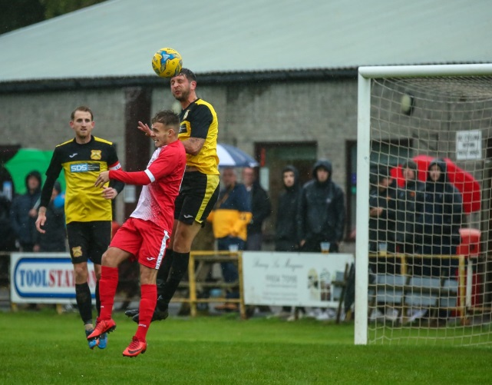
Another of the early-season frontrunners are Calne Town, and they added a fifth straight win, with Nathan Davis’ 61st minute free kick helping them sneak past Wells City by a solitary goal to nil. Corsham are another side continuing to rack up wins, and they made it three on the spin away at Cheddar on Saturday afternoon (pictured right, courtesy of John Cuthbertson). Lewis Powell made the biggest impact at the beginning of the match, and after heading the visitors ahead after three minutes, he then doubled his tally midway through the opening period. Before long, Corsham had a third goal to their name, with Jamal Chevolleau slotting the ball home after the ball had been flicked on to him by strike partner Gary Higdon. The Cheesemen have endured some early season struggles, and despite suffering a fourth defeat, there was a positive end to the fixture for them with Joe Woodley heading home at the near post.
League leaders Ashton & Backwell were forced to overturn a half-time deficit on their way to a 3-1 victory over Radstock. With the visitors enjoying a surprise lead on the scoreboard, Ashton surged back into the contest and extending their winning run to six matches thanks to goals from Saul Jarret, George Jones and Joe Bishop. Bristol Telephones laid waste to Devizes Town at Nursteed Road, scoring six second half goals on their way to a thumping 7-1 victory. The sides were level at the interval, but it was a complete mismatch after the break, with Ali Boyer, Martin Blacker, Jack Cox, Will Boyer, Fraser Devlin and James Griffiths, all scoring for the Phones. Goals from Shah Bhakerd and Conor Hartley led fourth-placed Lebeq to a 2-0 victory over Oldland Abbotonians, while Sherborne defeated the struggling Longwell Green 1-0 following Alex Murphy’s goal towards the end of the first half. Portishead grabbed an equaliser with the final kick of the game to draw 2-2 in their top-six battle against Warminster, while set piece goals finished off by Harry Turner and Connor Williams during the first half saw Wincanton win 2-0 away at Hengrove. In a game which went with the early-season form guide, Bishop Sutton’s strong forward line helped them defeat lowly Bishops Lydeard 4-1 at Lakeview. The first half belonged to top scorer Oaklan Buck who struck twice, before Callum Baker took on the baton after the break, scoring a brace of his own to make it three wins from four to start their season.
On the latest podcast, Exmouth manager Kevin Hill talks about the early season fixture pile-up, while Wincanton’s Chris Pile explains how his side are fighting back after a difficult start on and off the pitch. To listen to the latest broadcast, head to this page on the Western League site: http://toolstationleague.com/podcast-episode-4/

Latest Results
Tuesday 29th September 2020
Premier Division
Bitton 2-0 Cribbs 101
Bridgwater Town 1-0 Buckland Athletic 231
Chipping Sodbury Town 4-4 Hallen
Keynsham Town 2-0 Bradford Town 172
Odd Down 3-2 Brislington 69
First Division
Bishop Sutton 0-3 Calne Town 86
Bishops Lydeard 1-2 Portishead Town 63
Hengrove Athletic 0-0 Devizes Town 73
Wincanton Town 1-1 Welton Rovers
Wednesday 30th September 2020
Premier Division
Cadbury Heath 1-3 Street 88
Clevedon Town 2-1 Shepton Mallet 98
Exmouth Town 4-1 Bridport 155
Roman Glass St George 1-4 Westbury United 89
Wellington 1-6 Plymouth Parkway 157
First Division
Radstock Town 4-2 Oldland Abbotonians 67
Sherborne Town 2-3 Wells City 86

Saturday 3rd October
Premier Division
Bitton 5-0 Odd Down 98
Bradford Town 1-6 Exmouth Town 107
Bridport P-P Chipping Sodbury Town
Brislington 1-2 Buckland Athletic 65
Clevedon Town 2-1 Keynsham Town 117
Cribbs 4-0 Cadbury Heath 79
Hallen 1-2 Wellington 68
Plymouth Parkway 3-1 Shepton Mallet 298
Tavistock 1-0 Roman Glass St George 113
Westbury United 2-2 Bridgwater Town 78
First Division
Ashton & Backwell United 3-1 Radstock Town 77
Bishop Sutton 4-1 Bishops Lydeard 35
Calne Town 1-0 Wells City 76
Cheddar 1-3 Corsham Town 74
Devizes Town 1-7 Bristol Telephones 88
Hengrove Athletic 0-2 Wincanton Town 50
Lebeq United 2-0 Oldland Abbotonians 38
Longwell Green Sports 0-1 Sherborne Town 50
Portishead Town 2-2 Warminster Town 53
Welton Rovers 6-0 Almondsbury
Upcoming Fixtures
Tuesday 6th October 2020
Premier Division
Bridgwater Town vs Wellington 19:15KO
Brislington vs Hallen 19:30KO
Buckland Athletic vs Tavistock 19:30KO
Chipping Sodbury Town vs Cribbs 19:45KO
Odd Down vs Cadbury Heath 19:45KO
Shepton Mallet vs Bradford Town 19:30KO
Street vs Bitton 19:30KO
First Division
Bristol Telephones vs Calne Town 19:45KO
Devizes Town vs Wells City 19:30KO
Longwell Green Sports vs Welton Rovers 19:30KO
Wednesday 7th October 2020
Premier Division
Exmouth Town vs Plymouth Parkway 19:30KO
Roman Glass St George vs Clevedon Town 19:30KO
Westbury United vs Keynsham Town 19:30KO
First Division
Oldland Abbotonians vs Portishead Town 19:45KO
Saturday 10th October (3pm kick-off unless noted)
FA Vase
Axminster vs Clevedon Town
Bridport vs Ilfracombe
Cadbury Heath vs Ashton & Backwell United
Cheddar vs Ivybridge
Horndean vs Westbury United
Longwell Green Sports vs Bovey Tracey
Millbrook vs Hallen
Oldland Abbotonians vs Keynsham Town
Shepton Mallet vs Torrington
Sherborne Town vs Exmouth Town
St Blazey vs Brislington
Street vs Hengrove Athletic
Wells City vs Bristol Telephones
Welton Rovers vs Elburton Villa
Premier Division
Bitton vs Buckland Athletic
Odd Down vs Chipping Sodbury Town
Plymouth Parkway vs Bridgwater Town
Tavistock vs Bradford Town
Wellington vs Roman Glass St George
First Division
Bishops Lydeard vs Devizes Town
Corsham Town vs Calne Town
Portishead Town vs Lebeq United
Warminster Town vs Almondsbury
Wincanton Town vs Bishop Sutton
Premier Division Standings
 | Team | Played | Won | Drawn | Lost | GD | Points
1 | Plymouth Parkway | 8 | 7 | 1 | 0 | 25 | 22
2 | Street | 7 | 5 | 1 | 1 | 11 | 16
3 | Exmouth Town | 6 | 5 | 0 | 1 | 12 | 15
4 | Buckland Athletic | 9 | 4 | 3 | 2 | 7 | 15
5 | Westbury United | 7 | 4 | 2 | 1 | 8 | 14
6 | Bitton | 5 | 4 | 0 | 1 | 11 | 12
7 | Roman Glass St George | 7 | 4 | 0 | 3 | 0 | 12
8 | Tavistock | 5 | 3 | 1 | 1 | 5 | 10
9 | Bridgwater Town | 7 | 3 | 1 | 3 | -3 | 10
10 | Odd Down | 7 | 3 | 1 | 3 | -4 | 10
11 | Clevedon Town | 7 | 2 | 3 | 2 | -2 | 9
12 | Bradford Town | 9 | 2 | 3 | 4 | -4 | 9
13 | Cadbury Heath | 8 | 3 | 0 | 5 | -5 | 9
14 | Cribbs | 7 | 2 | 2 | 3 | 1 | 8
15 | Keynsham Town | 7 | 2 | 2 | 3 | 1 | 8
16 | Brislington | 6 | 2 | 1 | 3 | -4 | 7
17 | Shepton Mallet | 6 | 1 | 2 | 3 | -4 | 5
18 | Wellington | 6 | 1 | 2 | 3 | -10 | 5
19 | Hallen | 9 | 0 | 3 | 6 | -13 | 3
20 | Bridport | 6 | 1 | 0 | 5 | -15 | 3
21 | Chipping Sodbury Town | 7 | 0 | 2 | 5 | -17 | 2

First Division Standings
 | Team | Played | Won | Drawn | Lost | GD | Points
1 | Ashton & Backwell United | 7 | 6 | 0 | 1 | 9 | 18
2 | Calne Town | 5 | 5 | 0 | 0 | 9 | 15
3 | Welton Rovers | 5 | 4 | 1 | 0 | 10 | 13
4 | Lebeq United | 7 | 4 | 1 | 2 | 8 | 13
5 | Portishead Town | 6 | 4 | 1 | 1 | 6 | 13
6 | Warminster Town | 5 | 3 | 1 | 1 | 5 | 10
7 | Wincanton Town | 8 | 3 | 1 | 4 | -2 | 10
8 | Corsham Town | 3 | 3 | 0 | 0 | 10 | 9
9 | Wells City | 4 | 3 | 0 | 1 | 3 | 9
10 | Bishop Sutton | 4 | 3 | 0 | 1 | 2 | 9
11 | Radstock Town | 6 | 3 | 0 | 3 | -4 | 9
12 | Almondsbury | 6 | 3 | 0 | 3 | -6 | 9
13 | Bristol Telephones | 6 | 2 | 0 | 4 | 1 | 6
14 | Cheddar | 6 | 2 | 0 | 4 | -1 | 6
15 | Sherborne Town | 7 | 2 | 0 | 5 | -7 | 6
16 | Oldland Abbotonians | 6 | 1 | 0 | 5 | -6 | 3
17 | Hengrove Athletic | 4 | 0 | 2 | 2 | -4 | 2
18 | Devizes Town | 3 | 0 | 1 | 2 | -9 | 1
19 | Longwell Green Sports | 5 | 0 | 0 | 5 | -8 | 0
20 | Bishops Lydeard | 7 | 0 | 0 | 7 | -16 | 0

