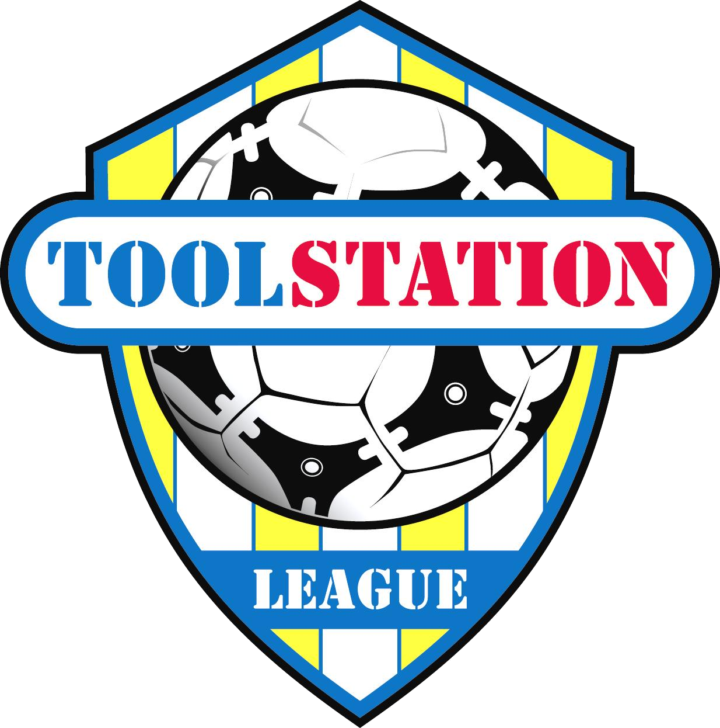
Bristol Telephones Football Club
Stockwood Lane,
Stockwood,
Bristol, BS14 8SJ
Telephone: 01275 891776

COVID-19 Risk Assessment

General

- Please follow the FA and Government guidance on COVID-19 at all times.
- Before leaving home, if anyone intending to attend Bristol Telephones F.C has COVID-19 symptoms, please do not attend. Please stay at home. The person with the COVID-19 symptoms should inform the NHS Test and Trace System of their COVID-19 symptoms.
- We would advise that anyone with underlying health conditions does not attend Bristol Telephones F.C.
- Bristol Telephones F.C/BTRA (the main club) will keep adequate stocks of PPE and hand sanitiser
- BTRA Club will be cleaned regularly.

Hazard

A person contracting COVID-19 at Bristol Telephones F.C/ BTRA

Who Might be Harmed?

- Club Officials
- Volunteers
- Players
- Team Management
- Coaches
- Physios
- Match Officials
- Bar Staff
- Cleaners

Control Measures

Travel

Everybody attending Bristol Telephones F.C/BTRA should travel individually or with people from their support bubble.

Arrival

Everyone should use the hand sanitiser on arrival at Bristol Telephones F.C/BTRA

Car Parking

Where possible cars should be parked with a sensible distance between them, preferably a minimum distance of 1 metre should be maintained.

Pay Booth

Please us the hand sanitiser provided at the entrance to the ground. Currently contactless entry is not available so cash only, however please endeavour to have the correct monies to limit the use of change

Changing Rooms

Hand sanitiser will be provided and should be used on entering and leaving the changing rooms

When allowed the use of changing rooms should be limited to a maximum of 5 players at a time and those players should socially distance.

A MAXIMUM of 2 people to use the showers at any one time.

Only one person at a time to use the toilets.

Player Conduct

- No handshakes
- No chewing gum
- No spitting
- No group celebrations

First Aid/Physio

Where a player or someone else requires attention the First Aider/ Physio should wear appropriate PPE when attending

Spectators

Maximum Ground capacity has been set at 300 by the F.A.. Spectators are requested and expected to adhere to social distancing and maintain a 2 metre distancing from other persons not of your own household or bubble.
Spectators are requested to use the hand sanitiser on entering and exiting the ground and if they enter the main club to provide their name and contact details for the purpose of NHS track and Trace purposes.(see below). The club has registered for the NHS track and trace app and people who are able are asked to scan in using the QR code

Clubhouse

- Everyone should use the hand sanitiser at the clubhouse entrance.
- Everyone should provide their name and mobile number for NHS Test and Trace at the signing-in desk at the clubhouse entrance. Where possible please use the NHS QR code to register.
- The tables will be two metres apart at all times and a MAXIMUM of four persons should sit at a table.
- Everyone should try to keep the two metre social distancing between other people.
- We are unable to have a ‘one way’ system within the club, however numbers allowed in the main club are restricted and a two metre distance should be observed at all times.
- Once served at the bar it is requested that people leave this area.
- Service at the bar is on a single person basis until further notice
- There will be no food served or consumed in the clubhouse at this time
- The bar staff will use the appropriate PPE and hand sanitiser.
- All bar payments should be contactless when able, however cash will be acceptable if required.
- Please avoid shouting in the clubhouse.
- Only one person at a time to use the toilets in the clubhouse.
- Everyone should use the hand sanitiser in the toilets on entry and on departure of the toilet.
- Everyone should follow the guidelines as set out by BTRA when in the clubhouse or within the grounds of BTRA

Departure

- Everyone should use the hand sanitiser when leaving the premises/changing facilities of Bristol Telephones F.C.

Risk Assessment produced by: -

Name: Steve Watkins
Club: Bristol Telephones F.C
Position: COVID-19 Officer
Covid-19 Assistants- Jack Richardson (first team), Mike Cogan (reserve team)
Date: 1st October 2020
Revision: 3
Note:- The Risk Assessment will be continually reviewed and revised if necessary

