Round-ups:
Season 2020/21
#4
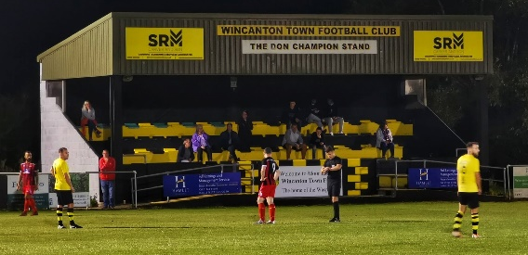
Midweek Action: All three Western League sides were knocked out of the FA Cup in Tuesday’s ties, with tough away matches proving too much to overcome. Cribbs squandered a half-time lead during their 3-1 defeat at Chichester City, while Shepton Mallet were beaten 3-0 by Swindon Supermarine at the Webbswood Stadium. Clevedon came closest to progressing away at Winchester City, but goals from Cameron Allen and Mitch Osmond weren’t quite enough to overhaul the three-goal deficit that the Seasiders found themselves in early in the second half. In the Premier Division, Roman Glass St George secured a third consecutive victory, beating Chipping Sodbury Town 2-0 at The Ridings. Goals from Rhys Sarson and Ben Bament in the second half were enough for the Glass whose run of victories have coincided with a treble of clean sheets. Early leaders Plymouth Parkway were unable to maintain their winning start at Bolitho Park after they were held to a goalless draw by fellow Devon outfit Buckland. Parkway hit the bar and the post during the second half, but weren’t able to find the back of the net during a meeting of two of September’s top sides. Hallen’s Rob Latham struck in stoppage time to help the Bristol side salvage a 2-2 draw in their home clash against Keynsham Town. Having earlier levelled through Jordan Whittaker, Hallen fell behind once more midway through the second half, but following a goalmouth scramble, Latham struck in the 92nd minute to claim a share of the spoils. Bridport followed up their thrilling win in the FA Vase with an impressive 2-0 victory at home to Bridgwater Town. Having lost the corresponding fixture 6-0 last season, Bridport produced a strong performance to register their first league win of the campaign with goals coming in either half from Liam Sayers and Lewis Clarke. Portishead Town maintained their bright start in the First Division, capturing a third league win after beating Longwell Green Sports 3-2. Two goals from Joe Cattermole and a Nathan Trueman header led Posset to their latest victory against the luckless Longwell Green who have suffered defeats against three teams who currently reside in the top four. Wincanton Town finally got into the winner’s circle thanks to a 4-0 win at home to Bishops Lydeard. Goals from Louis Irwin and Mike Taylor put Town two goals ahead at the interval, with a double from Toby Dolton Cole rounding out the victory during the second half.
The scene at Wincanton Town, during their win over Bishops Lydeard. Image courtesy of Jack Rowlands (jackrowlands123).
Welton’s Dawid Regula went one better than Cole, scoring all three of his sides goals in to help lift them to a 3-1 win over Sherborne. After Ashley Clarke had given the Zebras an eighth minute lead, Regula was fouled in the box before converting the subsequent penalty to level the scores just before the break. Regula doubled his tally 15 minutes from time to give Welton their first lead of the night, before the frontman completed his hat-trick in stoppage time after turning home Lewis Russell’s corner. The other two fixtures were decided by late winners, with Almondsbury and Bristol Telephones both prevailing by two goals to one. At Stockwood Lane, Bristol Telephones ended their losing start to the season, coming from behind to beat Cheddar. With the Cheesemen leading through Joe Woodley’s header, Ali Boyer drew the home side level, before then scoring with the final kick of the game to claim the dramatic late win. Meanwhile in Gloucestershire, Matt Paton’s goal nine minutes from time helped Almondsbury claim victory over Oldland Abbotonians to bring an end to their three-match losing streak.
There was disappointment in Wednesday’s FA Cup ties, with Bitton and Tavistock both knocked out by Southern League opponents in dramatic circumstances. Bitton twice led during their fixture away at Larkhall Athletic, before conceding in stoppage time to eventually fall to a 3-2 defeat. Goals from Josh Egan and Ashley Kington at the beginning of either half had put Bitton in front, but Larkhall responded well on each occasion, before booking their spot in the second qualifying round thanks to an injury time winner from Dan Demkiv. Tavistock were denied progression to the next round after suffering penalty heartbreak at the hands of Gosport Borough. Goals from Josh Grant and Jack Crago had twice levelled the scores for the Lambs after falling behind, but the spot kicks didn’t go their way, and it was the visitors from Hampshire who move on. It was better news for Devon side Exmouth Town who claimed a 2-1 win away at Street in one of the two Premier Division matches that same evening. Having led at the interval through Aaron Denny, Exmouth conceded a penalty early in the second half, but Robbie Powell saved the spot kick to help maintain their advantage. The away side then went straight down the other end and went two-up thanks to Mark Lever, so despite Leighton Thomas scoring for the Cobblers 17 minutes from time, it was Exmouth who held on for the three points. Bradford Town produced a late flurry to secure a 4-2 win away at Cadbury Heath in a highly entertaining game at Springfield. An excellent headed finish from Sam Crumb had given the Heath a slender 1-0 lead at the break, which was soon cancelled out by the Bobcats who drew level within a minute of the restart. The hosts regrouped and went ahead again midway through the second half when a Ben Brooks found enough space from ten yards out to fire into the back of the net. With less than 15 minutes left on the clock, Bradford struck their second equaliser of the night through Aaron Witchell, before Jake Brown took over the contest, scoring twice in the space of three minutes to complete the turnaround. Ashton & Backwell leapfrogged opponents Lebeq United up into top spot of the First Division after securing a last-gasp 3-2 victory at Oaklands Park. In a tight affair between two sides who have started the season brightly, it was the Stags who made it four wins on the bounce with a last-minute winner from the in-form Saul Jarret condemning Lebeq to their first defeat of the campaign.
Premier Division: Early league leaders Plymouth Parkway are now the only side without a loss to their name after beating previous unbeatens Brislington 4-0 on Saturday afternoon. Having been slow to start over the past couple of weeks, Parkway made amends in Bristol, going ahead in the early stages through Billy Palfrey. A second goal on the half hour from Callum Hall handed them control at the break, with leading scorer Ryan Richards then putting the result beyond doubt 18 minutes from time. There was still time for Matt Wright to add a late fourth for the Devon side who extended their run of clean sheets to five matches. It was a strong day all round for the county of Devon, with Exmouth Town securing a 3-1 win away at Bridgwater. After an own goal had put the visitors in front after 15 minutes, Exmouth doubled their advantage a couple of moments later thanks to a strong finish from Jordan Harris. Bridgwater made the perfect start to the second half, pulling a goal back through Sam Towler, but it was Exmouth who struck the crucial fourth goal, with Aaron Denny smashing home just before the hour mark. There was also a big win for Tavistock, for whom Liam Prynn scored a first half hat-trick during their 5-2 win over Hallen. The Lambs flew out of the blocks and were two goals to the good inside the opening ten minutes thanks to usual contributors Jack Crago and Josh Grant. A response came from the away side through Jordan Whittaker, before Prynn took over the contest, scoring a 20-minute treble to hand Tavistock a 5-1 half-time lead. Sacha Tong got a late consolation for the away side but the result was never in doubt as Tavistock earned their first victory since September 5th. Buckland couldn’t make it four out of four for the county, with a resolute Chipping Sodbury Town holding out for a goalless draw at Homers Heath to earn their first point of the season. Shepton Mallet came out on top in a seven-goal thriller at home to Bitton to earn their first league victory this term. There was only one goal in a relatively quiet opening half, with Joe Morgan finishing off a counter-attack to put Shepton in front. There were signs of things to come in the opening passages of the second half, with Morgan doubling Shepton’s advantage, before Aysa Corrick responded for Bitton following an excellent run and cross from Callum Ball. The floodgates were now well and truly open, and after Matt Morris had restored the home side’s two-goal lead, Bitton went straight down the other end and responded once again with Ryan Bath firing home. The 205 fans in attendance were treated to an epic second half, and the regular sequence of scoring continued with Liam Bishop tapping home for Bitton to pull his side to within a goal once more after Tyson Pollard had struck the home side’s fourth. There was still plenty of time for Bitton to draw level, but they couldn’t quite find a fourth of their own, meaning Shepton ran out 4-3 victors on the occasion of James Billing’s 250th appearance for the club.
Bridgwater attempt to defend a set piece during their clash with Exmouth Town, courtesy of John Pool.
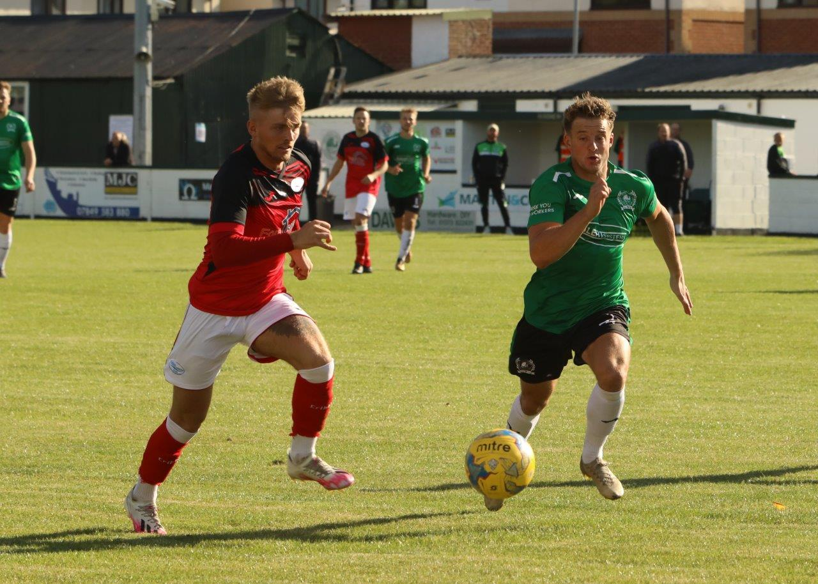
Street are now up into second spot, after second half efforts from Kyle Strange and Leighton Thomas helped them beat Wellington by two goals to nil. There was also a big home win for Odd Down, with the Bath-side moving into the top half following their 4-1 triumph over Bridport. A strike towards the end of the first half from Tom Burgess edged the hosts in front, before Will Hunter and Joe Jarvis each scored soon after the interval to put them three goals to the good. An own goal gave Bridport a glimmer of hope, but Odd Down wouldn’t be denied and second half substitute Dylan Hatt scored a fourth in stoppage time. The points were shared at Trowbridge Road between Bradford and Clevedon, with the visitors clinging on to a draw in stoppage time thanks to an excellent point-blank save from Harley Wilkinson. In a topsy-turvy encounter, Ethan Feltham slipped the ball home after just seven minutes, before Bradford levelled when Aaron Witchell scored for the second game in succession. A Ross Lye cross was turned home by Jake Brown to complete the turnaround, but Clevedon’s Archie Ferris pounced on a loose ball in the box to make it 2-2 in the 62nd minute. Both teams had a couple of chances to steal the points, and the best fell to Morgan Marsh in the 95th minute, but Wilkinson did enough to keep him at bay. Westbury United clung on to a 2-1 win over Cribbs, with Jack Biddiscombe’s first half double giving the Wiltshire outfit all three points despite the visitors best efforts which saw Steve Murray trim the deficit before the break. Roman Glass St George extended their winning run to four matches with a late 1-0 victory at home to Cadbury Heath. The Glass looked like they would be made to pay for Ryan Radford’s failed penalty attempt in the 59th minute, but with time winding down, star forward Ben Bament added to his ever-increasing early season goal tally to score the vital winner five minutes from time.
Action from Westbury’s Premier Division clash with Cribbs, courtesy of Martin Pearce.
First Division: Ashton & Backwell United secured their third away win on the bounce, capitalising on a fast start to beat Sherborne Town 3-1 at Raleigh Grove. A pair of goals inside the opening ten minutes from Ben Jones and Jordan Scadding put the Stags in command, before Alex Murphy halved the deficit. A third and final goal midway through the second half from Calum Townsend wrapped up the win for Ashton & Backwell who now enjoy a five-point lead atop the division.

Second spot still belongs to Lebeq United despite their 3-2 defeat at the hands of Wincanton Town. Two late goals from the visitors made the scoreline a little less one-sided, with Wincanton dominating for large swathes of the match, and Dan Wise proving to be too hot to handle, scoring a match-winning hat-trick. The result of the day definitely belongs to Corsham Town who stormed to a 7-2 triumph away at Radstock. The home side just weren’t at the races, and trailed by three goals before finally getting on the scoresheet after 31 minutes through Scott Gregory. For Corsham, Jamal Chevolleau bagged a hat-trick, with Leigh Rogers also striking twice for the rampant visitors. A second half effort from James Rustell stemmed the flow slightly, but Corsham didn’t slow down, and ran out big winners with James Vincent and Gary Higdon also finding the back of the net for the Wiltshire side.
Just like Corsham, there are a couple of other sides who have won both of their league fixtures so far, including Wells City. Their second victory came at home to Hengrove on Saturday afternoon, goals in either half from Tom Hill helping them win by two goals to nil. Bishop Sutton are the other side with six points from six after a late penalty saw them win 2-1 away at Warminster. Sutton were one goal ahead at the interval thanks to Oaklan Buck’s opener, before Warminster levelled early in the second half thanks to Francois Allen. It was the visitors who claimed the third and final goal from the spot, with Callum Baker keeping his cool to finish with aplomb from 12 yards. Calne Town are doing even better than those sides on six points, with the Lilywhites now having tasted victory in all three of their league contests so far this term. An own goal midway through the first half put them ahead of Longwell Green, before Matty Jenkins wrapped up the victory when he scored three minutes from time. Welton also have nine points from a possible nine, after substitute Kyle Box made an instant impact to lead them to a 1-0 win away at Bishops Lydeard. After entering the field during the second half, Box took over set piece duties, and curled home an excellent free kick from 25 yards out with one of his first touches to clinch the hard-fought win. Cheddar were 3-0 winners away at Devizes, with Adam Wright scoring twice, before Callum Ham struck in the closing stages to round out the victory. Almondsbury followed up their midweek win with another three points at home to Bristol Telephones, with Stuart Alexander, Ashley Knight and Matt Davies all scoring during their first half to hand them a relatively simple 3-0 triumph.
On last week’s podcast, Mitch Hodge discussed his ambitions for Cadbury Heath, while Cheddar manager, Shaun Potter, joined the show to explain why his side are taking every game as it comes. There is also an interview with Western League COVID officer George McCaffery who explains the latest FA guidance. To listen, head to the following webpage: http://toolstationleague.com/podcast-episode-3/

Latest Results
Tuesday 22nd September 2020
FA Cup – First Round Qualifying
Chichester City 3-1 Cribbs
Swindon Supermarine 3-0 Shepton Mallet
Winchester City 3-2 Clevedon Town
Premier Division
Bridport 2-0 Bridgwater Town 100
Chipping Sodbury Town 0-2 Roman Glass St George 59
Hallen 2-2 Keynsham Town 123
Plymouth Parkway 0-0 Buckland Athletic 300
First Division
Almondsbury 2-1 Oldland Abbotonians 61
Bristol Telephones 2-1 Cheddar 42
Portishead Town 3-2 Longwell Green Sports 68
Welton Rovers 3-1 Sherborne Town 91
Wincanton Town 4-0 Bishops Lydeard

Wednesday 23rd September 2020
FA Cup – First Round Qualifying
Larkhall Athletic 3-2 Bitton
Tavistock 2-2 (4-5 pens) Gosport Borough 223
Premier Division
Cadbury Heath 2-4 Bradford Town 147
Street 1-2 Exmouth Town 77
First Division
Lebeq United 2-3 Ashton & Backwell United 63

Saturday 26th September
Premier Division
Bradford Town 2-2 Clevedon Town 124
Bridgwater Town 1-3 Exmouth Town 238
Brislington 0-4 Plymouth Parkway 216
Buckland Athletic 0-0 Chipping Sodbury Town 154
Odd Down 4-1 Bridport 64
Roman Glass St George 1-0 Cadbury Heath 105
Shepton Mallet 4-3 Bitton 205
Street 2-0 Wellington 107
Tavistock 5-2 Hallen
Westbury United 2-1 Cribbs 72
First Division
Almondsbury 3-0 Bristol Telephones 42
Bishops Lydeard 0-1 Welton Rovers
Calne Town 2-0 Longwell Green Sports 95
Devizes Town 0-3 Cheddar 102
Oldland Abbotonians P-P Portishead Town
Radstock Town 2-7 Corsham Town
Sherborne Town 1-3 Ashton & Backwell United 111
Warminster Town 1-2 Bishop Sutton
Wells City 2-0 Hengrove Athletic 52
Wincanton Town 3-2 Lebeq United 79
Upcoming Fixtures
Tuesday 29th September 2020
Premier Division
Bitton vs Cribbs 19:30KO
Bridgwater Town vs Buckland Athletic 19:45KO
Chipping Sodbury Town vs Hallen 19:45KO
Keynsham Town vs Bradford Town 19:45KO
Odd Down vs Brislington 19:45KO
First Division
Bishop Sutton vs Calne Town 19:30KO
Hengrove Athletic vs Devizes Town 19:30KO
Wincanton Town vs Welton Rovers 19:30KO
Wednesday 30th September 2020
Premier Division
Cadbury Heath vs Street 19:30KO
Clevedon Town vs Shepton Mallet 19:30KO
Exmouth Town vs Bridport 19:30KO
Roman Glass St George vs Westbury United 19:30KO
Wellington vs Plymouth Parkway 19:45KO
First Division
Bishops Lydeard vs Portishead Town 19:30KO
Radstock Town vs Oldland Abbotonians 19:30KO
Sherborne Town vs Wells City 19:30KO
Saturday 3rd October (3pm kick-off unless noted)
Premier Division
Bitton vs Odd Down
Bradford Town vs Exmouth Town
Bridport vs Chipping Sodbury Town
Brislington vs Buckland Athletic
Clevedon Town vs Keynsham Town
Cribbs vs Cadbury Heath
Hallen vs Wellington
Plymouth Parkway vs Shepton Mallet
Tavistock vs Roman Glass St George
Westbury United vs Bridgwater Town
First Division
Ashton & Backwell United vs Radstock Town
Bishop Sutton vs Bishops Lydeard
Calne Town vs Wells City
Cheddar vs Corsham Town
Devizes Town vs Bristol Telephones
Hengrove Athletic vs Wincanton Town
Lebeq United vs Oldland Abbotonians
Longwell Green Sports vs Sherborne Town
Portishead Town vs Warminster Town
Welton Rovers vs Almondsbury

