Round-ups:
#2
Season 2020/21
Midweek Action: Wells City made a winning start to their league campaign on Monday evening, scoring in the dying moments to beat Bishops Lydeard 2-1 at the Athletic Ground. City went ahead in a tight contest through Mark Randall, but the visitors hit straight back when Guy Burns’ cross was met by the head of Cahil Roberson to set up a thrilling final 15 minutes. Both teams went close in the closing stages, but it was Wells who eventually forced home a winner, with Charlie Moon scoring six minutes into stoppage time to snatch all three points.
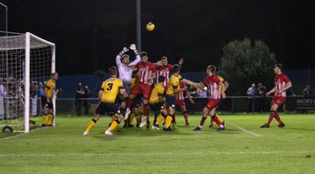
Bridgwater rebounded from their opening day defeat with a 2-1 victory at home to Clevedon in one of five Premier Division fixtures on Tuesday night. After the prolific Jack Taylor had put the Robins in front, Clevedon levelled the scores less than two minutes later when Ethan Feltham finished well. A wicked set-piece proved to be the deciding factor in an open contest, with Josh Wadham whipping a free-kick into the corner of the net after 31 minutes to hand Bridgwater all three points. The first Devon derby of the season ended in victory for Plymouth Parkway who defeated Exmouth Town 2-0 in front of sold out Bolitho Park. Having gone close on a couple of occasions in the early stages, Parkway finally went ahead in the 28th minute when an excellent cross from off-season signing Harrison Davis found Ryan Lane at the back post who stabbed the ball home. With 20 minutes remaining, the home side finally wrapped up victory, with Mikey Williams sliding the ball into the net to maintain their winning start. In a tight contest at St Mary’s Field, a first half strike from Ed Butcher proved to be the difference as Street edged out Bridport by a goal to nil. The points were shared in the other two matches, with Keynsham keeper Ash Clarke saving a late penalty to preserve their 1-1 draw with Cribbs, while Shepton Mallet’s home clash against Wellington ended goalless.
Action from Plymouth Parkway’s midweek clash with Exmouth Town. Image courtesy of Dave Crawford (DCrawfordPhoto)
In the pick of Tuesday’s First Division offerings, Ashton & Backwell United produced an excellent comeback, overturning a two-goal half-time deficit to defeat Longwell Green 3-2 at the Lancer Scott Stadium. Having struggled during the opening 45 minutes, Ashton got themselves back in the game thanks to an own goal, before Saul Jarret struck to make it 2-2. The Stags’ comeback was complete in the final ten minutes when Calum Townsend converted a penalty, but the drama didn’t end there, and Longwell Green nearly snatched a point when they hit the post, and then had an effort cleared off the line during a dramatic stoppage time period. Sam Downes was Bishop Sutton’s match-winner in their 1-0 victory over Almondsbury, while Portishead made it back-to-back victories, with Jack Sell among their scorers during a 3-0 triumph over Cheddar. Another side to register their second win in the space of four days were Warminster, with a re-taken penalty eight minutes from time capping their 2-1 defeat of Wincanton Town. The Red & Blacks took the lead inside ten minutes through Jack Miluk, before the home side got back on level terms through Matt Garner, who scored for the second consecutive match. As the game entered the closing stages, Miluk was heavily involved once again when he was fouled in the area to earn a spot kick. The taking duties fell to Ian Jeffery, and after having his first effort ruled out for encroachment, he stepped up for a second time and found the back of the net once more to secure the win. Bristol Telephones’ home fixture with Calne Town was abandoned with the hosts leading by two goals to nil due to floodlight issues.
Cadbury Heath recorded their second win of the campaign, holding off a late challenge from Hallen to win 2-1 at Springfield. Ben Brooks followed up his opening day hat-trick with the opening goal on Wednesday evening, before Tony Rennie doubled the Heath’s tally on the hour mark. Hallen had been reduced to ten men inside 15 minutes following an early red card, but to their credit they kept battling, and they set up a dramatic finale when former Heath-frontman Sacha Tong pulled a goal back ten minutes from time. Westbury were the big winners of the night, with Callum Demkiv scoring twice, adding to goals from Jamie Jordan and Jordan Pinder in their 4-0 victory over Chipping Sodbury Town. Honours were even in the second Devon derby of the week, with Tavistock and Buckland drawing 1-1 at Langsford Park. The hosts made a fast start, scoring with their first attack through Josh Grant, but Buckland grew into the contest, and in first half stoppage time they managed to level the scores through Ryan Bush. The other Premier Division clash that evening also finished level, with Bradford and Odd Down sharing four goals at Trowbridge Road. Lee Davidson headed home from a corner midway through the first half to put the Bobcats in front, before Shea Manning struck to make it 1-1 as the game headed for half-time. Josh Clark then added to his goal on Saturday to make it 2-1 to the Bath side, only for Bradford to hit back and grab a point thanks to Jake Brown’s 75th minute effort. In the First Division, Radstock rebounded from their opening defeat with a 2-0 win at home to Sherborne, while Connor Hartley’s equaliser 15 minutes from time helped Lebeq register a 1-1 draw at home to Hengrove.

FA Cup: Bitton’s frantic start to the season continued on Saturday, after they overturned a two-goal deficit to beat Bridgwater 3-2 at Fairfax Park. The home side looked to be in the ascendancy after 20 minutes when goals from Tom Ellis and Mike Duffy put them two goals to the good. Bitton get themselves hope at the beginning of the second half when Liam Bishop smashed the ball home, and they were soon back on level terms when Joe McLennan produced a fine curling effort from outside the box less than two minutes later. The game’s deciding goal came with just over 20 minutes left on the clock, when Ashley Kington’s pin-point free kick found the back of the net to help Bitton complete the unlikely turnaround. Clevedon also produced a fightback to book their spot in the next round, scoring twice in the final half hour to beat Sherborne 2-1. The First Division outfit took the lead ten minutes into the second half, when Ashley Clarke headed home a corner, with Clevedon responding with a set-piece goal of their own which was finished well by Glen Hayer. That set up an entertaining finish, and it was the away side who provided a moment of magic to secure the win, with Finlay Biggs picking the ball up in his own half before curling home an unstoppable effort to break Zebra hearts. A couple of Sherborne’s adversaries were also knocked out at the second hurdle, with Wells City falling to a 3-0 defeat away at Bideford, while Corsham were beaten 2-0 by Winchester Town of the Southern League.

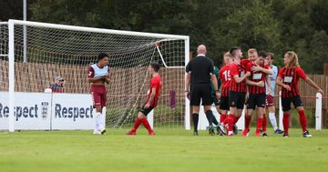
Shepton Mallet produced an excellent performance to beat Willand Rovers 1-0 in a result which should boost their confidence following a couple of draws in the league so far. Keeping their opponents scoreless will have been one of the most pleasing aspects of the result, with the decisive goal coming 18 minutes from time when Asa White slotted home a brilliant free-kick to dispatch the Devon side. Other sides from that county enjoyed mixed fortunes in their ties, with Tyler Elliot among the scorers in Tavistock’s 2-1 victory over the higher-ranked Mangotsfield, while Exmouth suffered a 2-0 defeat at home to Melksham. Early goals seem to be a pattern for Cribbs in the FA Cup season, and after seeing off Newent in the previous round, a goal inside five minutes on Saturday was the catalyst for their 2-0 victory over Berkhampstead in the preliminary round. It was Steve Murray who notched soon after 3pm on Saturday to put Cribbs in front, and after maintaining their clean sheet throughout, a late second for Matt Spiller capped an outstanding afternoon for the Bristol side. At Springfield, Cadbury Heath could not maintain the lead which Matt Huxley’s header afforded them, eventually suffering a 5-1 defeat at home to Bristol Manor Farm.
Tavistock celebrate their late winner away at Mangotsfield, courtesy of Dave Crawford (DCrawfordPhoto)
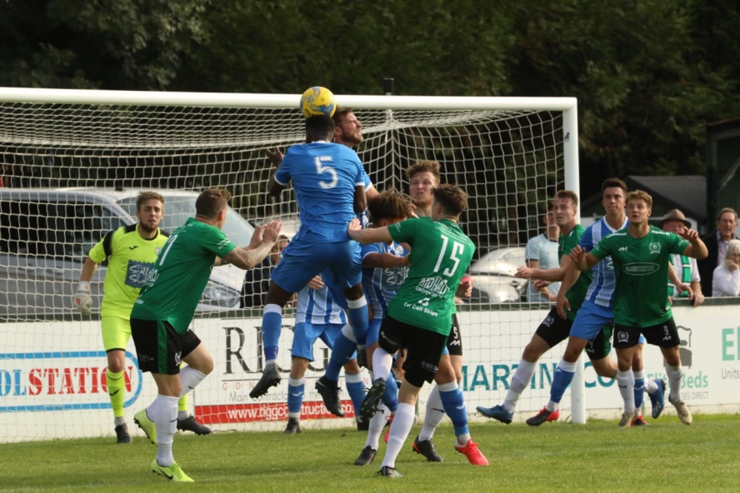
Premier Division: Plymouth Parkway sit pretty with nine points from nine atop the league after beating Chipping Sodbury Town 4-0 on Saturday afternoon. Having held out for the majority of the first half, Chipping Sodbury’s defence were finally broken down in the 43rd minute when a towering header at the back post from Jordan Bentley put the Devon side in front. Two goals in the space of five minutes from brothers Mike and Levi Landricombe made it 3-0 midway through the second half, before Ryan Richards added a late fourth for Parkway. Another side who have made a strong start to the season are Street, and they struck four times after the break to beat Roman Glass St George 5-1 at The Tannery Ground. Having fallen behind in the 20th minute to Sandro Costanza’s well-taken opener, Roman Glass got themselves level at the interval when Liam Harding laid on an assist for Ben Bament. Street took no time at all in asserting themselves at the beginning of the second half, with quick-fire goals from Ed Butcher and Oscar Latas making it 3-1 within five minutes of the restart. An unfortunate own goal from Harding extended Street’s advantage further, before Kyle Strange added the finishing touches to their big win in the closing stages. Westbury United joined Street on seven points, after a Dan Price goal midway through the first half helped them edge to a 1-0 victory at home to Odd Down. Ryan Bush goals either side of the interval saw Buckland Athletic secure a 2-1 win over Keynsham Town at Homers Heath. Bush struck a lovely volley in first half stoppage time to break the deadlock, before doubling the hosts advantage in the opening five minutes of the second half. Keynsham hit back through Craig Wilson to set up an entertaining second half, and just when it looked like Bush would cap the victory with a hat-trick, he saw his 78th minute penalty saved. In a game delayed due to travel issues, Bradford Town and Wellington both remain winless in the league following a 1-1 draw at Trowbridge Road. The hosts started well, and after hitting the crossbar inside the opening minute, they went ahead a couple of moments later when Luke Burman’s cross ricocheted into the back of the visitors net off a Tangerine defender. Wellington responded well however, and after earning a corner, Bobcat keeper Marko Radovanovic was pressurised into making a mistake and ended up seeing the ball inadvertently end up in his own net to make it one apiece. There was a stalemate in the fixture between Brislington and Hallen at the Poplar Insulation Stadium, where the home side ended the game with nine men.
Goalmouth action from Westbury United’s 1-0 win at home to Odd Down. Image courtesy of Martin Pearce.
First Division: Having suffered two surprising defeats to open the season, Cheddar hi t back with a bang on Friday night, beating Wincanton 7-1 at Bowdens Park. An early penalty from Callum Ham set the ball rolling, before Robbi Maggs doubled the home side’s advantage inside the opening ten minutes. The Cheesemen continued to push forward in search of more goals, and after Kris Bell had extended the lead to three, Ham and Maggs each struck for the second time to make it 5-0 at the end of a truly dominant opening half. Wincanton gained some brief respite, pulling a goal back at the beginning of the second period, but Cheddar’s star duo weren’t to be denied, with Ham and Maggs both finding the back of the net once more to claim twin hat-tricks on a memorable night in Somerset. Warminster Town extended their winning start, beating Bishops Lydeard 4-1 to condemn their visitors to a third consecutive defeat. Francois Allen has really hit the ground running this season, and after he had opened the scoring, full back Joel Sisson doubled Warminster’s advantage in the 26th minute on his way to a man-of-the-match performance. Jack Miluk is another of Warminster’s early season positives, and after he scored their third, Lydeard pulled a goal back only for Allen to complete his double in the closing stages to make it 4-1. Ashton & Backwell United followed up their victory during the week by win 5-1 away at Almondsbury. Calum Townsend scored a double for the away side, joining teammate Saul Jarret on the scoresheet for the second time in the space of five days. There were further goals from Jacob Spence and George Jones during the one-sided victory, with Almondsbury’s lone strike coming from Ashley Knight towards the end of the opening 45 minutes. The other four fixtures in the First Division also fell in favour of the visiting sides, with Calne defeating Oldland Abbotonians 2-1 thanks to brace of first half goals from Nick Mills and the ever-reliable Stuart Windsor who struck inside the opening minute. 2-1 was also the result at Stockwood Lane, where Radstock Town scored twice in the closing stages to cap a come-from-behind win against Bristol Telephones. Ali Boyer had put the Phones in position to gain their first win of the season, but the away side found a second wind, drawing level through James Rustell who knocked home the rebound after originally seeing his penalty saved. With time running out, a draw looked likely, but Radstock’s Simon Millard had other ideas, unleashing a thunderbolt from all of 30 yards to cap an excellent late win. Welton Rovers were another side to pinch all three points at the death, with Dawid Regula scoring his first goal for the club in a 2-1 win at Portishead. Joe Garland’s 18th minute flicked header had been cancelled out by the hosts, but then in the first minute of stoppage time, Regula was in the right place at the right time to force home a dramatic late winner for the Green Army. Things were a little more straight forward for Lebeq United, who retained their unbeaten start following a 3-0 win over Longwell Green at Shellards Road. Rick Davis struck a brace for the second Saturday in succession for the unbeaten Lebeq, with Shah Bhakerd also adding to the goal he scored in last weekend’s opening day thrashing of Cheddar.

Midweek Results
Monday 7th September 2020
First Division
Wells City 2-1 Bishops Lydeard 70
Tuesday 8th September 2020
Premier Division
Bridgwater Town 2-1 Clevedon Town 293
Bridport 0-1 Street 120
Keynsham Town 1-1 Cribbs 109
Plymouth Parkway 2-0 Exmouth Town 293
Shepton Mallet 0-0 Wellington 145
First Division
Ashton & Backwell United 3-2 Longwell Green Sports 95
Bishop Sutton 1-0 Almondsbury 52
Bristol Telephones A-A Calne Town
Portishead Town 3-0 Cheddar 67
Wincanton Town 1-2 Warminster Town 102
Wednesday 9th September 2020
Premier Division
Bradford Town 2-2 Odd Down 111
Cadbury Heath 2-1 Hallen 174
Tavistock 1-1 Buckland Athletic
Westbury United 4-0 Chipping Sodbury Town 92
First Division
Lebeq United 1-1 Hengrove Athletic 24
Radstock Town 2-0 Sherborne Town 87

Weekend Results
Friday 11th September 2020
First Division
Cheddar 7-1 Wincanton Town 82

Saturday 12th September
Premier Division
Bradford Town 1-1 Wellington 89
Brislington 0-0 Hallen 102
Buckland Athletic 2-1 Keynsham Town 121
Chipping Sodbury Town 0-4 Plymouth Parkway 90
Street 5-1 Roman Glass St George 70
Westbury United 1-0 Odd Down 98
First Division
Almondsbury 1-5 Ashton & Backwell United 82
Bristol Telephones 1-2 Radstock Town 39
Longwell Green Sports 0-3 Lebeq United 209
Oldland Abbotonians 1-2 Calne Town 63
Portishead Town 1-2 Welton Rovers 69
Warminster Town 4-1 Bishops Lydeard
FA Cup
Bideford 3-0 Wells City
Bridgwater Town 2-3 Bitton
Cadbury Heath 1-5 Bristol Manor Farm
Cribbs 2-0 Berkhampstead
Exmouth Town 0-2 Melksham Town
Shepton Mallet 1-0 Willand Rovers
Sherborne Town 1-2 Clevedon Town
Tavistock 2-1 Mangotsfield United
Winchester City 2-0 Corsham Town

WESTERN LEAGUE ISSUES MESSAGE TO FANS: LETS KEEP PLAYING, KEEP WATCHING AND FOLLOW THE GUIDANCE
The Toolstation Western League is asking fans to support their local football clubs on and off the field this season by observing the Covid-19 guidance. Whilst specific guidance varies from Club to Club, depending on their facilities, supporters are being asked to observe social distancing and avoid close contact with others not in their social or support bubble.
If fans need to access any of the ground’s amenities, such as toilets, food and drink outlets, they should check to see if any of them are not in use, and plan accordingly. Maintaining good hand hygiene, using sanitiser dispensers is also advised. Sadly, fans are still being urged to take extreme care when singing or celebrating, avoiding hugs, high-fives and any close contact with anyone not in their household.
Like all its Clubs, the Western League has appointed a Covid Officer. Since his appointment George McCaffery has been supporting Club Officials with their Covid questions. Unlike professional entertainment venues, Non-league football is run by an army of volunteers, who must now ensure their games are Covid compliant, along with the host of other responsibilities they’ve agreed to undertake on a match day.
George’s message to fans is simple, “let’s keep playing, keep watching and follow the guidance.
We all have a part to play in defeating the virus, especially fans. Don’t wait to be told what to do. Use your common sense and support your local Club by helping the volunteers make sure that everything is Covid compliant. If you have any concerns about how a Club is implementing its Covid-19 Risk Assessment, please contact a Club Official, either in person or by email.
Remember that whatever your hope for your Club this season, Covid-19 is the one opponent we all want to beat.”

Ian, Tom & guests recap all the latest news and results from around the Western League. Be sure to follow along with each broadcast available at the following link: http://toolstationleague.com/podcasts/

Upcoming Fixtures
Tuesday 15th September 2020
Premier Division
Brislington vs Westbury United 19:30KO
Buckland Athletic vs Bridport 19:30KO
Cribbs vs Clevedon Town 19:45KO
Hallen vs Bitton 19:30KO
Keynsham Town vs Cadbury Heath 19:45KO
Odd Down vs Street 19:45KO
Wednesday 16th September 2020
Premier Division
Bradford Town vs Chipping Sodbury Town 19:30KO
Exmouth Town vs Tavistock 19:30KO
Roman Glass St George vs Shepton Mallet 19:30KO
Wellington vs Bridgwater Town 19:45KO
Saturday 19th September (3pm kick-off unless noted)
FA Vase First Qualifying Round
Bodmin Town vs Keynsham Town
Bridport vs St Austell
Corsham Town vs Brockenhurst
Cowes Sports vs Devizes Town
East Cowes Athletic vs Westbury United
Exmouth Town vs Mousehole
Ilfracombe vs Portishead Town
Newquay vs Street
Odd Down vs Brislington
Radstock Town vs Longwell Green Sports
Shepton Mallet vs Bishop Sutton
Sidmouth Town vs Cheddar
St Blazey vs Bishops Lydeard
Wellington vs Hengrove Athletic
Wells City vs Godolphin Atlantic
Welton Rovers vs Cullompton Rangers
Les Phillips Cup – Quarter Final
Tavistock vs Warminster Town
Premier Division
Bitton vs Bradford Town
Bridgwater Town vs Hallen
Buckland Athletic vs Cadbury Heath
Clevedon Town vs Roman Glass St George
Plymouth Parkway vs Cribbs
First Division
Ashton & Backwell United vs Wincanton Town
Lebeq United vs Bristol Telephones
Sherborne Town vs Oldland Abbotonians
Sunday 20th September
FA Vase First Qualifying Round
Newport (IoW) vs Calne Town 15:00KO

