Round-ups:
Season 2020/21
#1
FA Cup: Following an extraordinarily long hiatus, competitive football finally returned on the first day of September, with a healthy batch of ties in the extra-preliminary round of the FA Cup. When the Premier League returned to such fanfare earlier in the summer, it was noted how goalkeepers may have struggled to hit peak form as quickly as their outfield adversaries. That can’t be said for Corsham’s Sam Thomson however, with the stopper saving playing a starring role in their shootout victory over Farnham Town. After the game had finished 2-2 at the end of 90 minutes, Thomson thwarted three Farnham spot kicks as Corsham prevailed 4-3 on penalties. Bitton were another side to win on penalties, knocking out fellow Western League side Buckland after their fixture finished 1-1, but Plymouth Parkway and Chipping Sodbury had no such luck after falling to defeat in their shootouts. Cribbs shot out of the blocks in their 3-1 win at home to Newent, with Dan Webb scoring inside ten seconds of their game kicking off at the Lawns. Further goals from Steve Murray and Ross McErlain settled the score, handing Cribbs an almost perfect start to the new campaign. Mitch Osmond’s 63rd minute penalty helped Clevedon claim a 1-0 victory away at Portland United, with another Somerset outfit, Wells City, also moving on to the next round thanks to a 2-0 win at home to Bovey Tracey. Josh Wadham’s second half strike saw Bridgwater Town toppled Millbrook by one goal to nil, while Joe Morgan notched a brace in Shepton’s 3-0 win at home to Torrington. There was late heartbreak for Wellington, who conceded twice in the closing stages before then suffering defeat on penalties in their home tie against Bodmin Town. Things also didn’t go to plan for Hallen, Westbury Calne and Odd Down who each suffered one-sided defeats to end their hopes of a cup run this year. Goals from Ben Brooks and Liam Oswin led Cadbury Heath to a 2-0 win away at Brislington, with Exmouth Town joining them in the next round after Dave Rowe, Aaron Denny and Jordan Harris all scored in their 3-1 triumph away at Keynsham.
On Wednesday evening, Sherborne Town made a strong start to their campaign, defeating Street 2-1 at Raleigh Grove following goals from Dan Newens and Haydn Hodges. Tavistock also progressed at the expense of Bradford Town, with Josh Grant putting them ahead in the first half, before Jack Crago doubled the advantage soon after their visitors had been reduced to ten men. Roman Glass St George fell to a 2-1 defeat at home to Flackwell Heath, and Bridport were also knocked out following a 2-1 defeat away at Willand Rovers.

FA Vase: Bitton’s quest to reach Wembley came to a heart-breaking end after they conceded a late extra-time goal in their tie away at Consett. Having waited months to complete their Vase campaign, Bitton were within touching distance of forcing a penalty shootout before Calvin Smith struck in the 114th minute to set up a spot in the final for the north-west outfit.

Premier Division: League football returned with a bang on Saturday, where 74 goals were shared among the 16 Premier and First Division fixtures to take place. Ten of those goals came at Springfield, where hosts Cadbury Heath secured a 7-3 victory over Wellington. It was Jake Thomas who broke the deadlock for the home side, firing home from a tight angle after just 17 minutes to open his account for the Heath. Ben Brooks doubled the lead just after the half hour mark, before Thomas struck for the second time to put the home side in complete command. After Jesse Howe had pulled a goal back from the spot, Cadbury Heath kicked back into life after the interval, with Brooks scoring twice in the space of three minutes to notch an opening day hat-trick. Luke Bryan and Loui Ward added further goals for the free-scoring hosts, either side of a pair of late goals form Tangerine duo Jamie Vaughan-Ryall and Jason Quick. Another of the heavy scorers on day one were Tavistock, with the Devon side flying out of the blocks on their way to a 5-1 win away at Chipping Sodbury Town. It took all of five minutes for Tavy to go ahead, with last season’s top scorer Jack Crago picking up where he left off six months previously by finding the back of the net. Two goals in ten minutes from Tallan Burns stretched the away side’s lead out to three by half-time, with Crago then making it 4-0 soon after the interval. A late consolation from Josh Pandolfino got the Sods on the board, but it was Tavistock who had the last word, with Luke Brown notching their fifth. It would be tough to pick a game of the day, but one of the most dramatic occurred in Bristol where Brislington eventually came out on top, 4-3 winners over Bradford Town. Having scored the only goal of a quiet opening half, Neikell Plummer capitalised on a mistake at the back to give Brislington a two-goal lead three minutes into the second half. A George Box volley gave Bradford hope of a comeback, which they completed on the hour mark when Ross Lye levelled things from the penalty spot. However, the home side hit back, and despite having a man in the sin bin, they moved back ahead 20 minutes from time when Kye Simpson rolled the ball home after beating the offside trap. Almost instantly, Bradford drew level once again, with Lye slotting home his second penalty in quick succession after Jake Brown had been fouled for the second time. It was the home side who scored the decisive seventh goal of a highly eventful contest when Mason Dagger’s cross was met by the head of Danny Barwood six minutes from time. Things were a little easier for Cribbs who strolled to a 6-1 victory over Bridport at the Lawns with Matt Spiller striking a hat-trick for the home side. Dan Webb added two goals before the interval to continue his excellent start to the campaign, before laying on an assist for Ross McErlain who also scored for the second time this week.
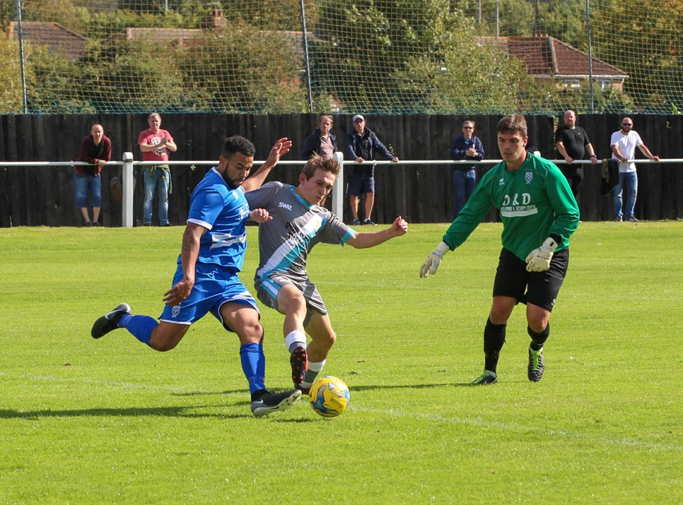
Plymouth Parkway enjoyed a strong start to their season away at Hallen, with Ryan Richards grabbing a treble during their 4-1 victory. Having headed the visitors in front towards the end of the first half, Richards struck twice in the opening three minutes of the restart to put the result beyond doubt. Another side to hit four on the opening day were Buckland, who eventually saw off the challenge of Bridgwater to prevail 4-2 at Homer’s Heath. Goals from Jamie Passmore and Austen Booth saw Buckland lead 2-1 at the interval, with Jack Taylor doing the business once again for Bridgwater. The away side drew level for the second time via an own goal, but Buckland weren’t to be denied, and after retaking the lead from the spot through Ben Carter, the same man then fired home another penalty to help his side run out relatively comfortable victors. In Bath, Josh Clark’s goal gave Odd Down a 1-0 win over Keynsham, while Street came back from two goals down to draw 2-2 at home to Shepton Mallet. Efforts from Matty Morris and Tyson Pollard had put Mallet in control, but after being reduced to ten men the away side opened the door for Street who pulled a goal back through Jacob Dickens on the hour mark before claiming a share of the spoils when Sam Smith headed home five minutes from time. Clevedon were another side to claim a late point, with an earlier penalty blunder costing Westbury during their 1-1 draw at the Hand Stadium. Having earlier put his side in front, Callum Demkiv fired his spot kick over the bar, and Clevedon took full advantage in the closing stages when a reverse pass from Morgan Davies found its way to Jay Murray who stroked the ball home.
Action from Plymouth Parkway’s 4-1 victory over Hallen courtesy of James Healey.

First Division: Lebeq provided one of the stories of the opening round, beating Cheddar by five goals to one in Somerset. After surging into a two-goal lead inside the opening ten minutes, Lebeq had added a third before Danny Griffiths pulled a goal back for the Cheesemen towards the end of the first half. Lebeq powered home after the interval, scoring twice more to confirm the big win, with Rick Davis claiming a double for the visitors. Another side to win on their travels were Corsham Town who took advantage of an early red card to beat Bishops Lydeard 3-0. After new signing Gary Higdon had volleyed the Quarrymen into a 16th minute lead, their task became a touch easier when their hosts were reduced to ten men. A second goal from Higdon strengthened Corsham’s grip on the contest, with a late long-range strike from Will Stead capping a fine team performance.
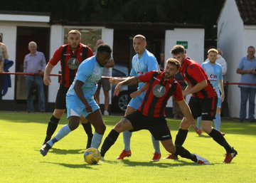
Warminster Town opened their account with a 3-1 win at home to Radstock. Taking just two minutes to go ahead through Francois Allen, Warminster kept their visitors under pressure throughout the first half with Jack Miluk and George Butler stretching their lead. A dream debut from Josh Bright helped Calne Town claim all three points thanks to a 3-1 victory over Ashton & Backwell United. After Ashton’s Harry Walker had cancelled out Matty Jenkins’ opener, Bright restored Calne’s lead towards the end of the first half with a composed lobbed finish over the on-rushing keeper. With one goal separating the sides throughout the second half, the game remained on a knife-edge until Bright struck once more in the closing stages to wrap up the win. Matt Davies was the hero for Almondsbury, scoring twice in the final 20 minutes to overturn a one-goal deficit in their 2-1 win over Wincanton. Town led for the majority of the contest following Matt Garner’s seventh minute finish, but Almondsbury stayed in the battle and drew level in the final quarter through Davies. Then, with less than ten minutes left on the clock, Enis Akgun slipped the ball across and Davies was on hand to double his tally and helped complete the late turnaround. Oldland Abbotonians also started out with a 2-1 win, after goals from Owen McCallum and Harry Pruett either side of the interval helped them beat Bristol Telephones who had earlier equalised from the spot through Jacob Saunders. Second half efforts from Louie Elliot and Jack Sell led Portishead Town to a 2-0 victory away at Sherborne Town, while the fixture between Hengrove and Bishop Sutton was abandoned following a serious injury.
Warminster and Radstock battle for possession during the home side’s 3-1 victory in their First Division clash.
Latest Results
Tuesday 1st September 2020
FA Cup – Extra Preliminary Round
Brislington 0-2 Cadbury Heath
Buckland Athletic 1-1 (3-5 pens) Bitton
Corsham Town 2-2 (4-3 pens) Farnham Town
Cribbs 3-1 Newent
Hamworthy United 3-0 Calne Town
Keynsham Town 1-3 Exmouth Town
Millbrook 0-1 Bridgwater Town
Odd Down 1-4 Helston Athletic
Plymouth Parkway 1-1 (4-5 pens) Saltash United
Portland United 0-1 Clevedon Town
Shepton Mallet 3-0 Torrington
Wellington 2-2 (3-4 pens) Bodmin Town
Wells City 2-0 Bovey Tracey
Westbury United 0-2 Binfield
Wednesday 2nd September 2020
FA Cup – Extra Preliminary Round
Roman Glass St George 1-2 Flackwell Heath
Sherborne Town 2-1 Street
Tavistock 2-0 Bradford Town
Willand Rovers 2-1 Bridport
Saturday 5th September 2020
FA Vase Semi Final
Consett 1-0 Bitton
Premier Division
Brislington 4-3 Bradford Town 124
Buckland Athletic 4-2 Bridgwater Town 161
Cadbury Heath 7-3 Wellington 79
Chipping Sodbury Town 1-5 Tavistock 88
Clevedon Town 1-1 Westbury United 96
Cribbs 6-1 Bridport 75
Hallen 1-4 Plymouth Parkway 118
Odd Down 1-0 Keynsham Town 97
Street 2-2 Shepton Mallet 168
First Division
Almondsbury 2-1 Wincanton Town 95
Bishops Lydeard 0-3 Corsham Town 102
Calne Town 3-1 Ashton & Backwell United 176
Cheddar 1-5 Lebeq United 89
Hengrove Athletic A-A Bishop Sutton
Oldland Abbotonians 2-1 Bristol Telephones 44
Sherborne Town 0-2 Portishead Town 104
Warminster Town 3-1 Radstock Town 174

Midweek Fixtures
Monday 7th September 2020
First Division
Wells City vs Bishops Lydeard 19:30KO
Tuesday 8th September 2020
Premier Division
Bitton vs Brislington 19:30KO
Bridgwater Town vs Clevedon Town 19:45KO
Bridport vs Street 19:45KO
Keynsham Town vs Cribbs 19:45KO
Plymouth Parkway vs Exmouth Town 19:45KO
Shepton Mallet vs Wellington 19:30KO
First Division
Ashton & Backwell United vs Longwell Green Sports 19:30KO
Bishop Sutton vs Almondsbury 19:30KO
Bristol Telephones vs Calne Town 19:45KO
Corsham Town vs Oldland Abbotonians 19:45KO
Portishead Town vs Cheddar 19:30KO
Wincanton Town vs Warminster Town 19:30KO
Wednesday 9th September 2020
Premier Division
Bradford Town vs Odd Down 19:30KO
Cadbury Heath vs Hallen 19:30KO
Tavistock vs Buckland Athletic 19:30KO
Westbury United vs Chipping Sodbury Town 19:30KO
First Division
Lebeq United vs Hengrove Athletic 19:30KO
Radstock Town vs Sherborne Town 19:30KO

Ian, Tom & guests will return for a fourth season of the podcast, recapping all the latest news and results from around the Western League. Be sure to follow along all season, with each broadcast available at the following link: http://www.toolstationleague.com/podcasts.php

Weekend Fixtures
Friday 11th September 2020
First Division
Cheddar vs Wincanton Town 19:30KO
Saturday 12th September (KICK OFF AT 3.00PM UNLESS NOTED)
FA Cup
Bideford vs Wells City
Bridgwater Town vs Bitton
Cadbury Heath vs Bristol Manor Farm
Cribbs vs Berkhampstead
Exmouth Town vs Melksham Town
Shepton Mallet vs Willand Rovers
Sherborne Town vs Clevedon Town
Tavistock vs Mangotsfield United
Winchester City vs Corsham Town
Premier Division
Bradford Town vs Wellington
Brislington vs Hallen
Buckland Athletic vs Keynsham Town
Chipping Sodbury Town vs Plymouth Parkway
Street vs Roman Glass St George
Westbury United vs Odd Down
First Division
Almondsbury vs Ashton & Backwell United
Bristol Telephones vs Radstock Town
Longwell Green Sports vs Lebeq United
Oldland Abbotonians vs Calne Town
Portishead Town vs Welton Rovers
Sherborne Town vs Clevedon Town
Warminster Town vs Bishops Lydeard

